**Algorithm and Data Analysis** (*Crowdee: An Online Android-based Establishment Crowd Tracking Application with Geo fencing and Go-To Planner*)

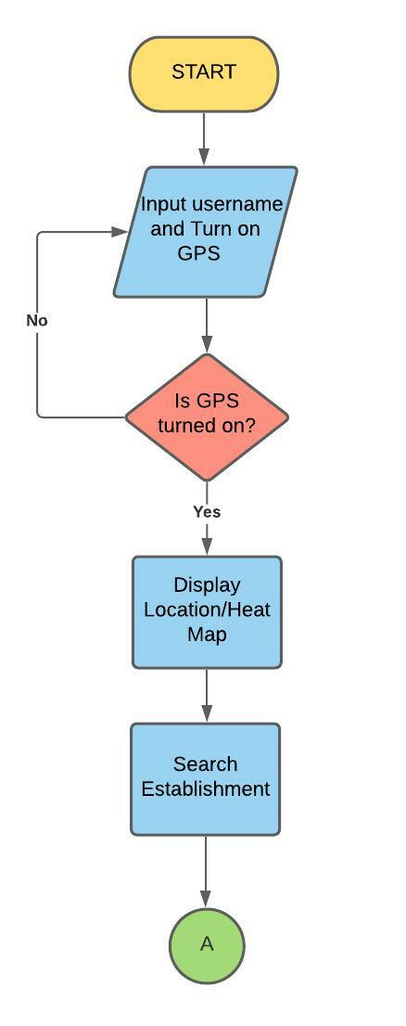

Explanation:

To access the application, the user needs to input their username and turn on the built-in GPS of their android device. After providing the necessary data, the system will now verify if the user's location is turn on, if not, the system will not allow the user to access the application but, if the GPS is on, the system will direct the user to Heat Map interface.

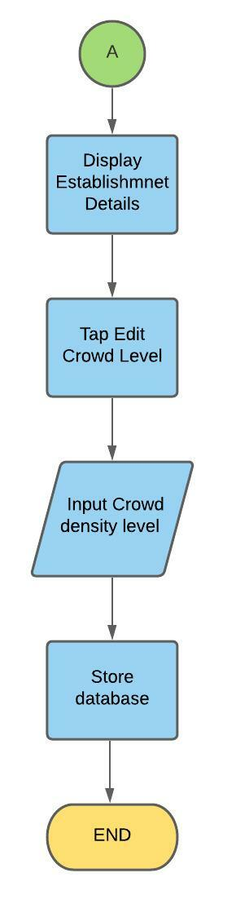

Explanation:

The user can search for their preferred establishment, and the system will display the establishment details. Tapping the edit crowd level allows the user to evaluate the crowd density of the establishment by inputting the crowd density level. This data will later be store in the database.