**NOTE: Fill this document according to the requirements that you have identified in your analysis and brain storming.**

Software Requirements Specification

For

**CROWDEE: AN ONLINE ANDROID-BASED ESTABLISHMENT CROWD TRACKING APPLICATION WITH GEO FENCING AND GO-TO PLANNER**

**Version 1.0 approved**

**Prepared by Ningala, Leirah Mae M.**

**Gabriel, Gracielle Anne D.**

**Table of Contents**

**Table of Contents ii**

**Revision History ii**

**1. Introduction 1**

1.1 Purpose 1

1.2 Document Conventions 1

1.3 Intended Audience and Reading Suggestions 1

1.4 Project Scope 1

1.5 References 1

**2. Overall Description 2**

2.1 Product Perspective 2

2.2 Product Features 2

2.3 User Classes and Characteristics 2

2.4 Operating Environment 2

2.5 Design and Implementation Constraints 2

2.6 User Documentation 2

2.7 Assumptions and Dependencies 3

**3. System Features 3**

3.1 System Feature 1 3

3.2 System Feature 2 (and so on) 4

**4. External Interface Requirements 4**

4.1 User Interfaces 4

4.2 Hardware Interfaces 4

4.3 Software Interfaces 4

**5. Other Nonfunctional Requirements 5**

5.1 Performance Requirements 5

5.2 Safety Requirements 5

5.3 Security Requirements 5

5.4 Software Quality Attributes 5

**6. Other Requirements 5**

**Appendix A: Glossary 5**

**Appendix B: Analysis Models 6**

**Appendix C: Issues List 6**

**Revision History**

|  |  |  |  |
| --- | --- | --- | --- |
| **Name** | **Date** | **Reason For Changes** | **Version** |
|  |  |  |  |
|  |  |  |  |

# Introduction

## Purpose

Establishment Crowd Tracking Application is an Android-based tracking of crowds on different establishments here in Nasugbu, Batangas, for the user’s convenience, this application will be having a Go-To Planner for scheduling things ahead of time and can be access through the use of internet. In this time of pandemic, researchers come up with this study to help people to be sensitive over some crowded places or establishments. In the area of Nasugbu, some establishment can’t control the density of people, this application might help the owners and workers of each establishments to maintain social distancing on their area. This study will not just benefit those person that has an Android phones but as well as the residents that has no devices at all.

## Document Conventions

*<Describe any standards or typographical conventions that were followed when writing this SRS, such as fonts or highlighting that have special significance. For example, state whether priorities for higher-level requirements are assumed to be inherited by detailed requirements, or whether every requirement statement is to have its own priority.>*

## Intended Audience and Reading Suggestions

This study aims to develop a crowd tracking Android application that uses Geo Fencing with a Go-To Planner feature known as Crowdee, that could help the people within Nasugbu, Batangas to avoid jam-packed areas. This system would be considered useful to the following:

*Establishment Owners.* For managing and controlling the crowd. The owners will benefit on this study by monitoring the crowd level on their establishments to implement health protocol and for people’ safety.

*Residents of Nasugbu, Batangas***.** The study definitely would help people in Nasugbu, Batangas to avoid crowded places. As part of this research, the residents are aided in finding an area that is jam-packed in the midst of Covid-19 pandemic, to prevent mass reunification and to ensure their health.

*PNP/LGU*. Philippine National Police/ Business Permit and Licensing Office, This study would be useful to the PNP/LGU when it comes on mitigating crowded places on each establishments. They easily track or monitored those location whether it is crowded or not and its Location.

## Project Scope

This study might help the people of Nasugbu and the Establishments within this area to maintain COVID-19 protocols, like social distancing and avoiding overcrowded places. With Geo Fencing and Go-To Planner, it will be easier for the user to track the crowd around the area he/she are in and plan everything in time to avoid wasting of time waiting in some crowded areas. The Go-To Planner will be based on the system’s initial data to test its usability and capabilities. Initial data will be gathered at every establishment’s working hours. The proposed application can be access through user’s mobile devices, specifically Android phone. But for broad crowd tracking, like the residents with no Android phones, the researchers tend to implement a ‘Scan me first’ policy in which a resident that has no android phone will be given a QR Code and will be scanned within the vicinity of the establishment for the system to recognize them as well. This research is not valid for COVID-19 contact tracing because of its limited information, and with the establishments around the area of Nasugbu, Batangas that will be embedded to this application. The system is not applicable for other municipality, because the researchers decided to exclusively implement the proposed system to mainly focus only in the municipality of Nasugbu.

## References

Barnes A.,Muller S.,Iddawela Y., (2020, June 1). *Oxford student launches app to help social distancing*. Cherwell. <https://cherwell.org/2020/05/17/oxford-student-launches-app-to-help-social-distancing/>

Pandey S., Barik R., Gupta K., Arthi, S. R. (2021). Technical Advancements of Machine Learning in Healthcare, Studies in Computational Intelligence. *Pandemic Drone with Thermal Imaging and Crowd Monitoring System (DRISHYA)*, *936*, 307–325. https://www.researchgate.net/publication/349680088_Pandemic_Drone_with_Thermal_Imaging_and_Crowd_Monitoring_System_DRISHYA

Uma Maheswari G., Persis Urbana IVY B., Kumar, Suganya, P. J. P. (2014). International Journal of Applied Engineering Research. *Android Based Task Scheduler and Indicator*, *9*(22), 10185–10196. <https://www.researchgate.net/publication/291318134_Android_based_task_scheduler_and_indicator>.

Haddock, W. J. (2016). Geo-fencing Technologies and Security. *Geo-Fencing Technologies and Security*, 1. http://www.infosecwriters.com/Papers/JHaddock_Geofencing.pdf

Özdemir,Tugrul, Z. B. (2019). : Geofencing on the Real-Time GPS Tracking System and Improving GPS Accuracy with Moving Average, Kalman Filter and Logistic Regression Analysis. : *: Geofencing on the Real-Time GPS Tracking System and Improving GPS Accuracy with Moving Average, Kalman Filter and Logistic Regression Analysis*, 1–6. https://www.researchgate.net/publication/337985439_Geofencing_on_the_Real-Time_GPS_Tracking_System_and_Improving_GPS_Accuracy_with_Moving_Average_Kalman_Filter_and_Logistic_Regression_Analysis

Pongpaichet, Singh, Jain, Pentland, S. V. R. A. (2014, December). *Situation Fencing: Making Geo-Fncing personal and Dynamic*. Research Gate. https://www.researchgate.net/publication/279840116_Situation_fencing_making_geo-fencing_personal_and_dynamic

Abbas A. H., Habelalmateen M. I., Audah,Alduais, S. L. N. A. M.. (2019). GPS based location monitoring system with geo-fencing capabilities. *GPS Based Location Monitoring System with Geo-Fencing Capabilities*, *2173*, 0. https://www.researchgate.net/publication/337194171_GPS_based_location_monitoring_system_with_geo-fencing_capabilities

Agadakos I., Polakis J.,Portokalidis, G. (2017, June). *Techu: Open and Privacy-Preserving Crowdsourced GPS*. Research Gate. https://www.researchgate.net/publication/317633386_Techu_Open_and_Privacy-Preserving_Crowdsourced_GPS_for_the_Masses

Shen, M. (2019, January). *Beyond Rebalancing: Crowd-Sourcing and Geo-Fencing for Shared-Mobility Systems*. Research Gate. https://www.researchgate.net/publication/330697585_Beyond_Rebalancing_Crowd-Sourcing_and_Geo-Fencing_for_Shared-Mobility_Systems

Li K., Yun C., Kanhere, S. (2018, November). *An Experimental Study for Tracking Crowd in Smart Cities*. Research Gate. https://researchgate.net/publication/329053502_An_Experimental_Study_for_Tracking_Crowd_in_Smart_Cities

# Overall Description

## Product Perspective

“Crowdee: An online Android-based establishment crowd tracking application with Geo Fencing and Go-To Planner”, part of its technical perspective, explaining the creation of an online Android Application Development.

Based on Invonto, Mobile app Development Article, An Android Application Development is the process of designing and constructing an application that can be reached via a smartphone and an internet access by utilizing an online android-based interface. Developers often begin by planning a mobile application to conquer a specific challenge, then layout the application. In contrast to responsive/mobile websites, which can be accessed by browsers, mobile apps can be downloaded from various portals such as the Google Play Platform, App Store, or another platform depending on what type of operating system.

Accessing applications are way more convenient if it is available on Smartphones or gadgets. Manages and manipulates databases and archives using android application development tools and Programming languages like Python, Kotlin and JavaScript. Programming Languages, a core pillar of the Platform that specifies how content is created and constructed, in conjunction with the visually appealing and engaging application usually a result of having an efficient User Experience (UX) and User Interface (UI), for instant attraction of the design to the Smartphone. Mobile Application/ Android Application has unique features compared to Mobile Websites. Mobile Applications have easier access to content and more interactive experiences. Several new figures affirm the usefulness of smartphone applications. For the database, MySQL is a relational database management framework that uses Structured Query Language (SQL) to handle, process, and retrieve information. In this android application, the Researchers intended to use SQLite for the Database. SQLite is a SQL database server that is integrated. SQLite, unlike some other SQL databases, does not have its own server operation. SQLite monitors and analyzes to standard database server. A single database file contains an entire SQL database, including tables, indexes, triggers, and displays. The following are some of the useful tools and frameworks expected to developing software:

* Android API: An Application Programming Interface (API) is a series of rules (called "code") and parameters that programs can use to associate with one another. APIs enable users to communicate with one another. They may improve the user interface and could also help the app gain attention.

*(https://www.infoworld.com/article/3269878/what-is-an-api-application-programming-interfaces-explained.html)*

* IDE for Android Development: IDE( Integrated Development Environment) is a tool that used by the programmers to integrate, manipulate, change numbers of codes to build an application that is for Smartphones or any Smart devices.

*(https://developer.android.com/studio/intro)*

## Product Features

Crowdee, a modern crowd monitoring technology based on the popular Android crowd tracking system, is will be unveiled. An Android-based online crowd tracking software for the Residents of Nasugbu, Batangas and Establishments within that includes Geo Fencing and a Go-To Planner.

We used the agile development process to create an accurate and coherent project. It is an implementation methodology that establishes the measures and procedures for implementing the structure. This method of presentation provides a valuable framework for researchers to adopt as they refine the proposed structure. Based on Alistair Cockburn, widely regarded as one of the early proponents of agile, and developed the Crystal system for IBM in 1991. He opted to concentrate on designing principles for team coordination and cooperation rather than developing detailed step-by-step planning plans that will operate across the board for teams participating with each project.

## User Classes and Characteristics

|  |  |
| --- | --- |
| **Group of Respondents**  (Residents of Nasugbu, Batangas) | **Frequency** |
| 18-25 years old | 50 |
| 26-40 years old | 25 |
| 41-59 years old | 25 |
| **TOTAL** | **100** |

Depicts the group of respondents by age, 18-59 years old. The researchers limit the age till 59 years old only for the safety of the residents that 60 years old and above, and will cluster the respondents for convenient and efficient gathering of data.

## Operating Environment

*Software Requirements*

The software requirements were the applications that led to the system's architecture, programming, and development. It included scripting that included codes, commands, and even instructions that aided the usability.

Following were the software used:

|  |  |
| --- | --- |
| **Particulars** | **Software** |
| Desktop Operating System | 64 bit architecture OS |
| Programming Language | Java |
| Database | SQLite |
| IDE | Android Studio |
| Mobile Phone OS | 5.0 – 9.0 versions |

Table demonstrates the software standards required to provide the capabilities. A 64 bit OS will be the computer operating system that the researchers will be using to run the system, and Android Studio has a built in emulator for testing the whole application and it is the program where the scripts will be written. Java was the programming language that researcher’s will use to create the applications. Android Studio also comes up with a database containing and modifying records.

*Hardware Requirements*

The hardware requirements will be the device specifications used to create the crowd tracking application for establishments with geo fencing and go to planner. It displays all relevant information about the hardware use to build and manage the application, as well as the features of the said system.

The following are the hardware use:

|  |  |
| --- | --- |
| **Particulars** | **Specification** |
| Processor | 2 GHz |
| RAM | 3 Gb |
| Graphics Resolution | 1080 X 1920 |
| Mobile Phone | Android Version, 2 Gb RAM |
| GPS Sensor | Built-in GPS on Mobile Phone |

This table demonstrated the hardware needed to implement the proposed project The hardware specifications listed are essential to the project because they were all required to enter and process data into the established frameworks.

## Design and Implementation Constraints

“Crowdee: An online Android-based establishment crowd tracking application with Geo Fencing and Go-To Planner”, part of its technical perspective, explaining the creation of an online Android Application Development. Accessing applications are way more convenient if it is available on Smartphones or gadgets. Manages and manipulates databases and archives using android application development tools and Programming languages like Python, Kotlin and JavaScript. Programming Languages, a core pillar of the Platform that specifies how content is created and constructed, in conjunction with the visually appealing and engaging application usually a result of having an efficient User Experience (UX) and User Interface (UI), for instant attraction of the design to the Smartphone. Mobile Application/ Android Application has unique features compared to Mobile Websites. Mobile Applications have easier access to content and more interactive experiences. Several new figures affirm the usefulness of smartphone applications. For the database, MySQL is a relational database management framework that uses Structured Query Language (SQL) to handle, process, and retrieve information.

## User Documentation

## Assumptions and Dependencies

*<List any assumed factors (as opposed to known facts) that could affect the requirements stated in the SRS. These could include third-party or commercial components that you plan to use, issues around the development or operating environment, or constraints. The project could be affected if these assumptions are incorrect, are not shared, or change. Also identify any dependencies the project has on external factors, such as software components that you intend to reuse from another project, unless they are already documented elsewhere (for example, in the vision and scope document or the project plan).>*

# System Features

## Manage Location

3.1.1 Description and Priority

Both types of users can access the system by inputting location information into the system using the built-in GPS of their android phones. Managing location includes accessing the google map or location interface of the application. (High Priority)

3.1.2 Stimulus/Response Sequences

Module 1: Taps Turn on Location Switch (User/Admin)

* Users can provide current location in the system.
* This switch can notifies the user to turn on the built-in GPS in their android phone.

Module 2: Select Home tab (User/Admin)

* Users can already view the Location/Heat Map Interface.

3.1.3 Functional Requirements

REQ-1: Built-in GPS of Android phones

REQ-2: Google Map API

REQ-2: Heat Map API

REQ-4: Mobile Phone OS of 5.0 – 9.0 versions

## Track Crowd Density

3.2.1 Description and Priority

Residents of Nasugbu (users) can input crowd density level information into the system. They can also monitor the crowd density level based on the working hours of an establishment. While system administrators can filter the most crowded area in a specific location. This feature also allows the system administrators to track or monitor every establishment with the most crowded area. (High Priority)

3.2.2 Stimulus/Response Sequences

Module 1: Taps Detect Crowded Areas Button (Admin)

* Admin can already locate filtered areas with the most crowded.

Module 2: Taps Edit Crowd Level Button (User)

* Users can already access the Establishment Crowd Level Interface.

Module 3: Taps Save Button (User)

* Users can already input required crowd level information.

3.2.3 Functional Requirements

REQ-1: Mobile Phone OS of 5.0 – 9.0 versions

## GO-TO Planner

3.3.1 Description and Priority

In managing tasks, the system allows residents of Nasugbu to create and organize tasks on the system’s planner. (High Priority)

3.3.2 Stimulus/Response Sequences

Module 5: Taps Add to Planner Button (User)

* Users can already access the Planner Interface.

Module 7: Taps Add Task Button (User)

* Users can already input required tasks details.

3.3.3 Functional Requirements

REQ-1: Mobile Phone OS of 5.0 – 9.0 versions

# External Interface Requirements

## User Interfaces

* The user authentication interface of the system. In this interface, the user can view the system logo. This interface allows the user to fill out the required information to access the system by tapping the proceed button. Users will input their username and turn on their GPS location.
* The user’s the side menu bar. This interface contains user information and three different tabs: the home tab, the Go-To tab, and the settings tab. These three different tabs lead to different interfaces. The home tab directs the users to the location/heat map interface. The Go-To Planner tab directs the users to the Go-To Planner interface. And the settings tab will direct the users to the settings interface.
* The location map interface, also known as the heat map interface, is where users can access the Google Map service embedded into the system. This interface allows the users to view and locate different locations and establishments. There is only one button in the interfaces that will let users access establishments around the specific area.
* Establishment Interface. the establishment's details such as the establishment name, establishment location, and the initial crowd density level of the establishment that will be based on the previous input of another user and grouped into the working hours of the establishment. There are two buttons in the interface: the edit crowd level button and the add to planner button. The edit crowd level button will direct the user into the establishment crowd level interface. And the add to planner button permits the users to access the planner interface.
* Planner interface of the system. It contains the user information and the task details. This interface allows the user to add, delete and alter tasks. It also allows user to mark tasks they're done with that will be stored in an archive of the system database. The left interface shows the notification if the user successfully inserts task details.
* The establishment crowd level interface that permits the users to insert crowd level information. This interface will automatically detect the current time the user will insert the crowd level information. It also has one button that allows to save the user’s input into the establishment records database.

## Hardware Interfaces

Hardware Requirements and Specification

|  |  |
| --- | --- |
| **Particulars** | **Specification** |
| Processor | 2 GHz |
| RAM | 3 Gb |
| Graphics Resolution | 1080 X 1920 |
| Mobile Phone | Android Version, 2 Gb RAM |
| GPS Sensor | Built-in GPS on Mobile Phone |

## Software Interfaces

|  |  |
| --- | --- |
| **Particulars** | **Software** |
| Desktop Operating System | 64 bit architecture OS |
| Programming Language | Java |
| Database | SQLite |
| IDE | Android Studio |
| Mobile Phone OS | 5.0 – 9.0 versions |

# Other Nonfunctional Requirements

## Safety Requirements

User’s information like username and tasks are excluded when gathering filtered data for the admin users.

## Security Requirements

* To access the application the users, need to provide necessary information like their username, location, and department for admin users. All information gathered can be stored in the system database.
* User’s information like username and tasks are excluded when gathering filtered data for the admin users.

**Appendix A: Glossary**

*Android***.** A software operating system, the environment where the applications and software on your devices reside.

*Android application***.** A software application running on the Android platform is an Android app. As the Android platform is a design for mobile devices, a standard Android app is available for an Android OS smartphone or tablet PC.

*API***.** An Application Programming Interface is a collection of code for programming that allows data to transmit between software products. The terms for data sharing are also used.

*Crowd Sourcing*. The practice of obtaining needed services, ideas, or content by soliciting contributions from a large group of people and especially from the online community rather than from traditional employees or suppliers.

*Crowd tracking***.** Refers to a system application that can determine and supervise the crowd density in a specific area or location.

*DBMS***.** Database Management System**,** Refers to the technological approach used for optimizing, managing, storing, and collecting data from databases.

*Framework.* It serves as a framework for software developers to design applications for a given platform.

*Geo-fencing***.** Refers to system functionality that can indicate a radius parameter from the user’s location to specify the area coverage of the data in the system.

*Go-To planner***.** Refers to system feature that can provide user an event tracker and organizer for a person’s go-to places on day-to-day basis.

*GPS***.** Global Positioning System, Refers to global satellite navigation system for the position, speed, and time sync. GPS helps you to get where you are and get to your destination from your location.

*Hardware*. Defined as the physical components of a computer and its associated equipment. Motherboards, hard disks, and RAM are examples of internal hardware equipment. Monitors, keyboards, mice, printers, and scanners are examples of external hardware equipment.

*IDE***.** An integrated development environment allows the developers to consolidate the various elements of software programming.

*Internet***.** Refers to a worldwide communication of network that transmits a variety of information and media to linked devices. It operates by using the Internet Protocol (IP) and Transport Control Protocol (TCP) network for packet routing.

*Java.* A portable, object-oriented, interpreted programming language.

*MySQL***.** Refers to the database used by the proponents.

*OS.* Operating System*,* a software which performs all the basic tasks like file management, memory management, process management, handling input and output, and controlling peripheral devices such as disk drives and printers.

*QR Code.* A quick response (QR) code is a type of barcode that stores information as a set of pixels in a square-shaped grid and can be easily read by a digital computer.

*Software*. A series of commands or systems that tells a machine how to perform specific tasks

*UI*. User Interface, the point of human-computer interaction and communication in a device. This can include display screens, keyboards, a mouse and the appearance of a desktop.

**Appendix B: Analysis Models**

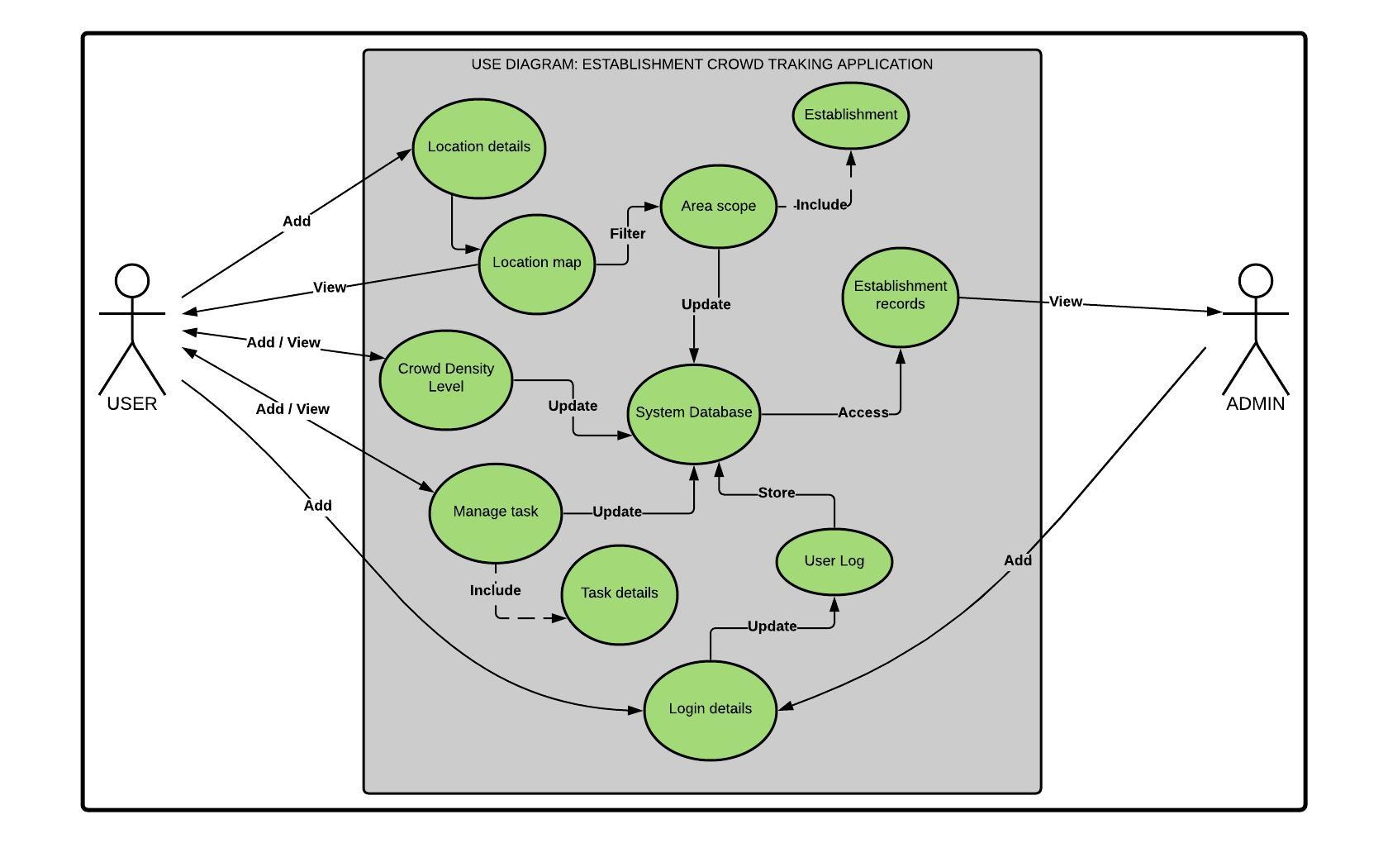

Use Case Diagram of the Proposed System

The figure illustrates the case diagram representing the user interactions with the designed device that demonstrates the user's relationship with the user's various use scenarios. It has two actors: the user and the admin that have the privilege of different features on the system presented in the diagram. The user will insert the user's location, which the tool can use to determine the user's position on the map. The system allows the user to view their position, and with Geo-fencing, the system can filter the user's location to identify the establishment near them. Furthermore, a user can access and alter data on crowd density and task plans. The admin can log in to the system and add its data in the user log. Admin can only view the establishment records and user logs. Use cases area scope, establishment records, estimated crowd density, and login details can be store in the system database.

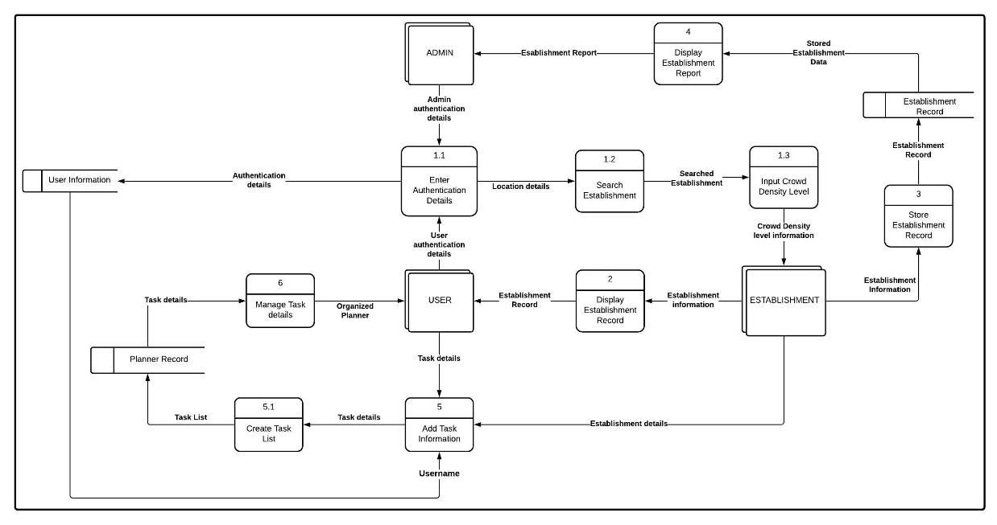

Diagram 0 of the Proposed System

The figure contains diagram 0 of the proposed system. The diagram demonstrates the expanded method given in figure 3.7. It is consists of necessary processes and data that achieve the probable output needed by the entity, which are the user, the establishment, and the admin. And those processes are broken down into several divisions to illustrate how the data get translated into usable information.

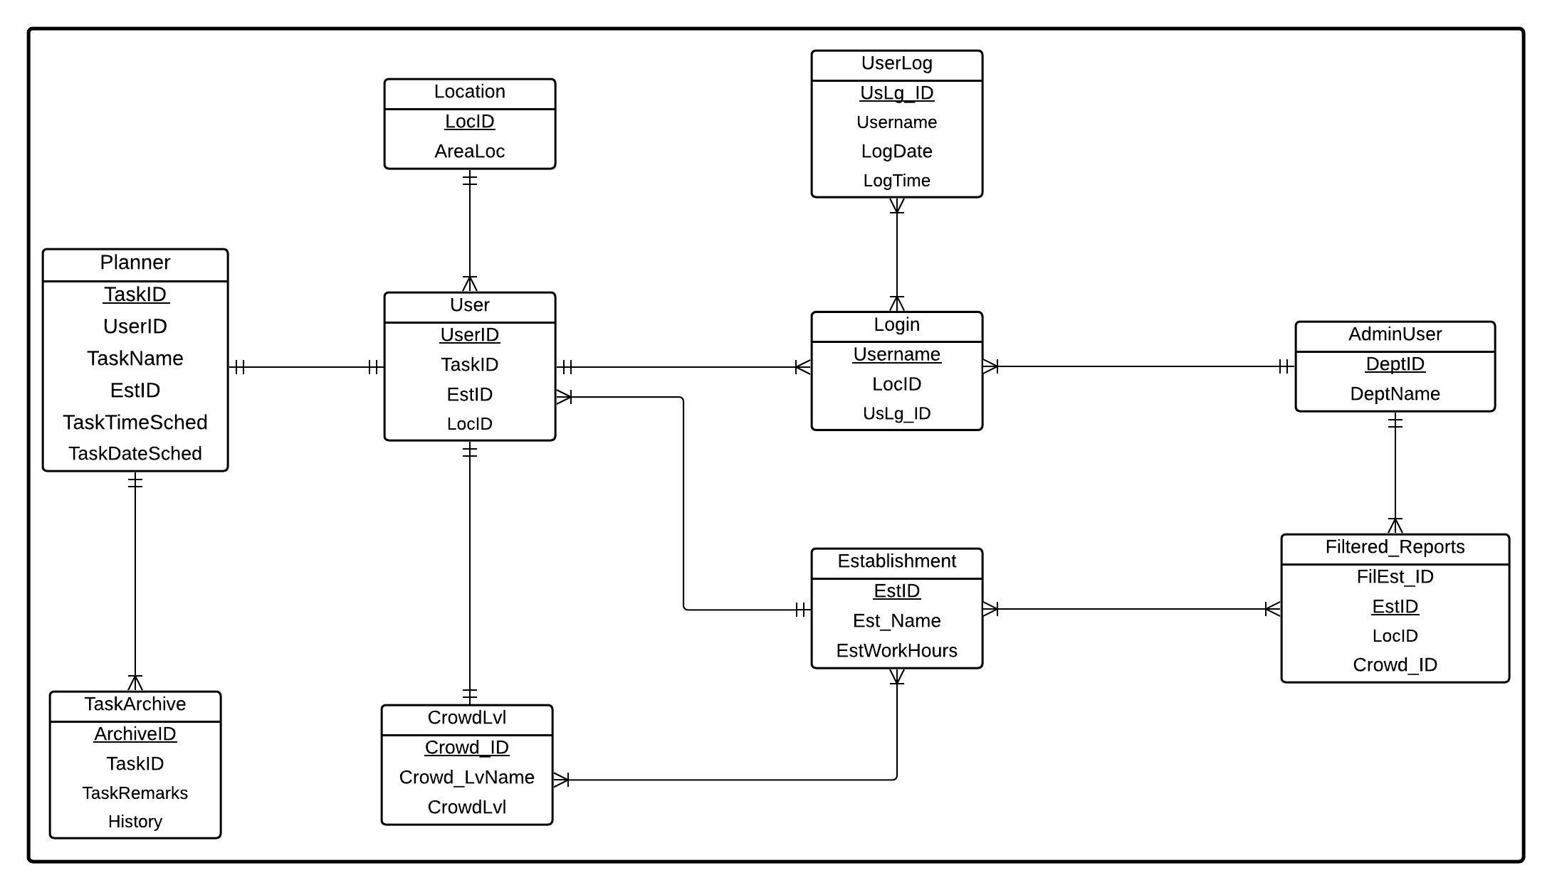Entity Relationship Diagram (ERD) of the Proposed System

The ERD of the proposed system shows the probable relationship between its entities in the database. It demonstrates the possible tables that can implement the system where the fields in each table are required. This ERD serves as the primary database structure whereas, the fields and data in the various system modules are not redundant.