**MS Vehicle System**

**Created by:** Marcos Ismael Schultz

**Age:** 20

**Fórum:** [www.schultzgames.com](http://www.schultzgames.com)

**Email:** [marcos11-24@hotmail.com](mailto:marcos11-24@hotmail.com)

'MS Vehicle System' is a complete controller for vehicles that use the wheel collider component. The system includes the following features listed below:

* Scene controller, allowing you to get out and get into vehicles in a simple way.
* Automatic and manual gears system for the vehicle.
* Joystick and control buttons for mobile devices.
* Controller for cameras, including 8 different modes of handling.
* Complete torque distribution system for the vehicle, allowing precise adjustment.
* Fully adjustable brake system.
* Realistic and adjustable suspension system.
* Simulators of trawl and air friction, gravity and rotation.
* Completely complete lighting system including main lights, flashing lights, warning lights, brake lights, reverse lights, among others.
* Steering wheel system for the vehicle, allowing separate control of each wheel.
* Fuel System.
* Complete mirror system on all demonstration vehicles.
* Damage system to the vehicle, causing it to be kneaded.
* Complete system of sounds for the vehicle, including wind sounds, brakes, engine, lights, horn, reverse gear, beats, bumps, terrain, among others.
* System that allows to adjust the friction and the torque of the vehicle in each terrain separately.
* Complete system of skid marks, allowing you to adjust the trail width, opacity, and color depending on each terrain.
* Complete particle system, including wheel dust, exhaust fumes, smoke damage, among others.
* And much more.

'MS Vehicle System' also includes several sample scenes and includes 5 demonstration vehicles, which allows you to test all systems.

The asset also comes with several pre-fabricated objects (prefabs), making it easy to use the system with objects already configured.

**How to use:**

To use the system, you must first have a 3D model of a properly rotated and staggered vehicle, that is to say that the vehicle's rotation must be pointed towards the Z axis of the vehicle's main transform. Likewise, the wheels of the vehicle must also be rotated so that the Z axis of its transform is in the same direction as the Z axis of the main transform of the vehicle.

It is also good that the vehicle has scale 1 in all its meshes and transform. This implies in the main transform of the vehicle to have the scale (1,1,1), as well as all other transform of the vehicle, to the wheels ... This makes the simulation of physics more realistic.

Having the vehicle properly adjusted in rotation and scale, it is necessary to add a collider to the vehicle, to simulate physics and collisions. It is recommended that the collider cover the wheel rims to avoid surreal impacts. The image below illustrates the ideal position of the collider.

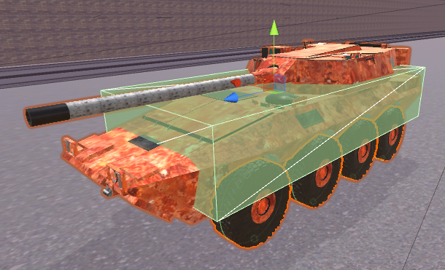

After that, the 'MS Vehicle Controller' component must be added to the vehicle main transform.

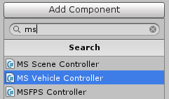

By doing this, the script will automatically add the 'Rigidbody' component to the main vehicle's transform, to simulate the physics of the vehicle.

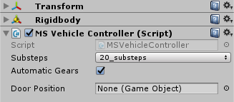

After doing all this, it's time to add the 'WheelCollider' component to each wheel of the vehicle by simply creating an empty object in the position of the center of the wheel, and adding to this object the 'WheelCollider'.

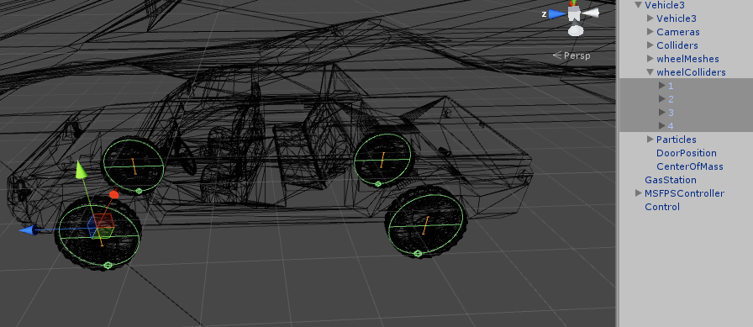

Now click on the main transform of the vehicle, go to the 'MS Vehicle Controller' component and configure the vehicle as you want, associating the wheels in their places, configuring the torques, among other things.

Having your vehicle set up, you also need to have a Controller for the scene, as it is responsible for informing the vehicle of the player's preferences. To do this, simply drag the prefab 'Control' to the scene. The prefab is in MSVehicleSystem> Prefabs.

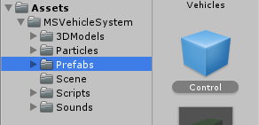

After that, click the 'Control' that was added to the scene and configure it in the inspector, according to each variable.

The entire system has 'Tooltips' in the variables, making the system easy to implement, and helping to avoid errors. These Tooltips provide warnings that help the user to implement the system. To see the warnings, just rest your mouse over some variable, and the warning will appear.

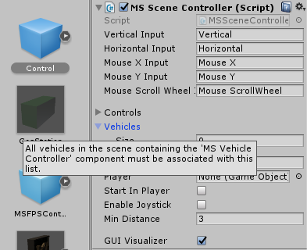

Setting up the vehicle correctly as the 'Tooltips' indicate, and configuring the 'Control' object as their Tooltips indicate, the system should already work properly. If something is wrong, the system will provide alert warnings indicating what is wrong.

For the vehicle to have sounds, particles, lights, among other things, just follow the tips that the script provides in each variable, through the 'Tooltips'.

The scene controller also has an enum called "SelectControls", which allows you to choose between three types of control, being them, buttons(mobileButton), joystick(mobileJoystick) and keyboard keys(windows), so you can implement games for computer as well as for mobile devices.

To help understand how the entire system works, the feature contains several demo scenes, with examples of how the system works. The scenes are:

**Low Settings:** A scene configured with lighter settings, especially in relation to the lights.

**Manual Gears:** A scene configured with a vehicle only, to control the vehicle in manual gears.

**Mobile Button:** A scene set up with just one vehicle, with mobile controls, via buttons.

**Mobile Joystick:** A scene set up with just one vehicle, with mobile controls, via joystick.

**No Lights:** A scene set with vehicles without lights. The meshes of the lights will be illuminated normally, but the vehicles will not emit lights.

**Realistic Automatic:** A scene configured with a vehicle with automatic gears and an FPS player, allowing the player to enter and exit the vehicle, and also control it.

**Scene Drift:** A scene set with a vehicle that skips more than normal, ideal for drift.

**Vehicles Arcade:** A scene configured with 5 vehicles with automatic gears and an FPS player, allowing the player to enter and exit the vehicles, and test each one.

**Vehicles Extremum:** A scene with only one vehicle, which does not take damage. This vehicle has excessive torque. It's a scene to be entertained.

**Vehicles Only:** A scene with only vehicles, allowing to test each one.

The asset also features a day and night system, allowing you to better see how the vehicle's lights work.

In the 'Control' object, there is an option called 'GUI Visualizer', which when checked, provides vehicle information such as speed, damages, and other information.

In the 'Scenario' object of each scene, there is a component called 'ExampleScene', and there is a variable called 'Instructions'. When this variable is checked, instructions on how to control the vehicle will appear on the screen.

The asset carries other prefabs besides the vehicles, the scenario and the main controller. In addition, it brings an object called 'GasStation', which is a trigger, every time a vehicle passes through it, the vehicle gains fuel.

Another prefab that the asset brings is an FPS controller, to represent a player.

**Possible problems:**

It is possible that the scene gets heavy when using the asset, and this happens due to the simulation of vehicle lights. This is totally normal because lights tend to weigh heavily, especially if they are calculating shadows in real time.

To alleviate this problem, the vehicle controller allows you to disable the shading and change the rendering mode, leaving the lights lighter.

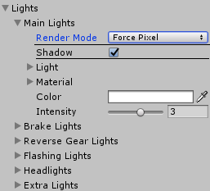

Another feature that the 'MS Vehicle System' code has to make lights lighter, is to simulate the illumination of the meshes separately ... In this way, you can have meshes of lights in a vehicle without the need for lights. The 'NoLights' sample scene demonstrates this setting.

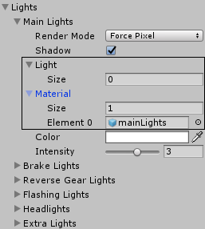

In addition, some heavy system resources can be disabled by simply deactivating a controller variable within the class. As for example, the classes 'Damage', 'Sounds' and 'SkidMarks'.

The wheelCollider component does not present a very realistic simulation when using actual values for the wheels, so it is advisable to leave each wheel with the mass at half the mass value of the vehicle. For example, if the vehicle has mass of 1000, each wheel must have a mass of 500, to give more realistic results.