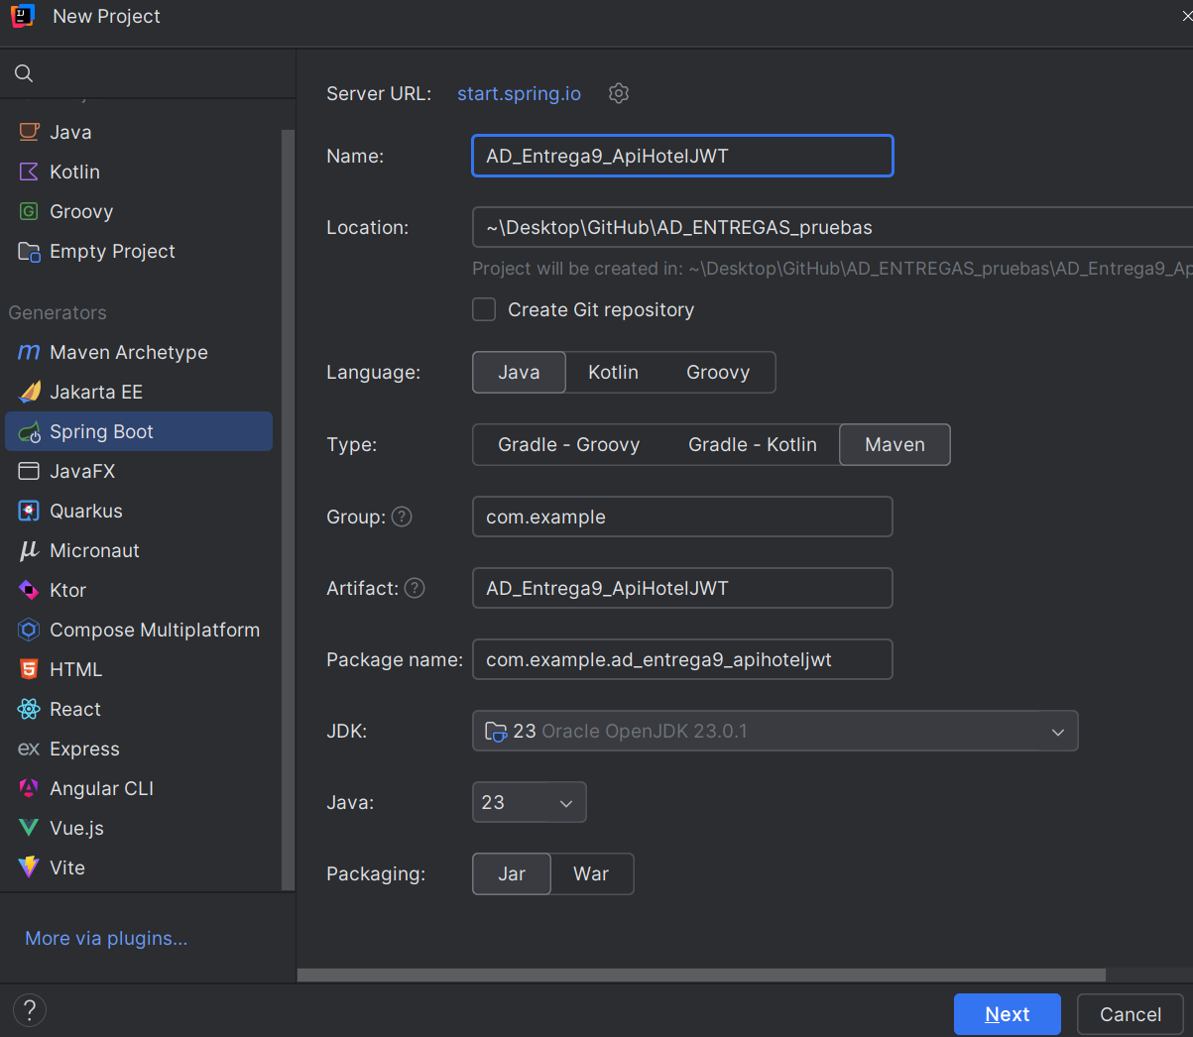

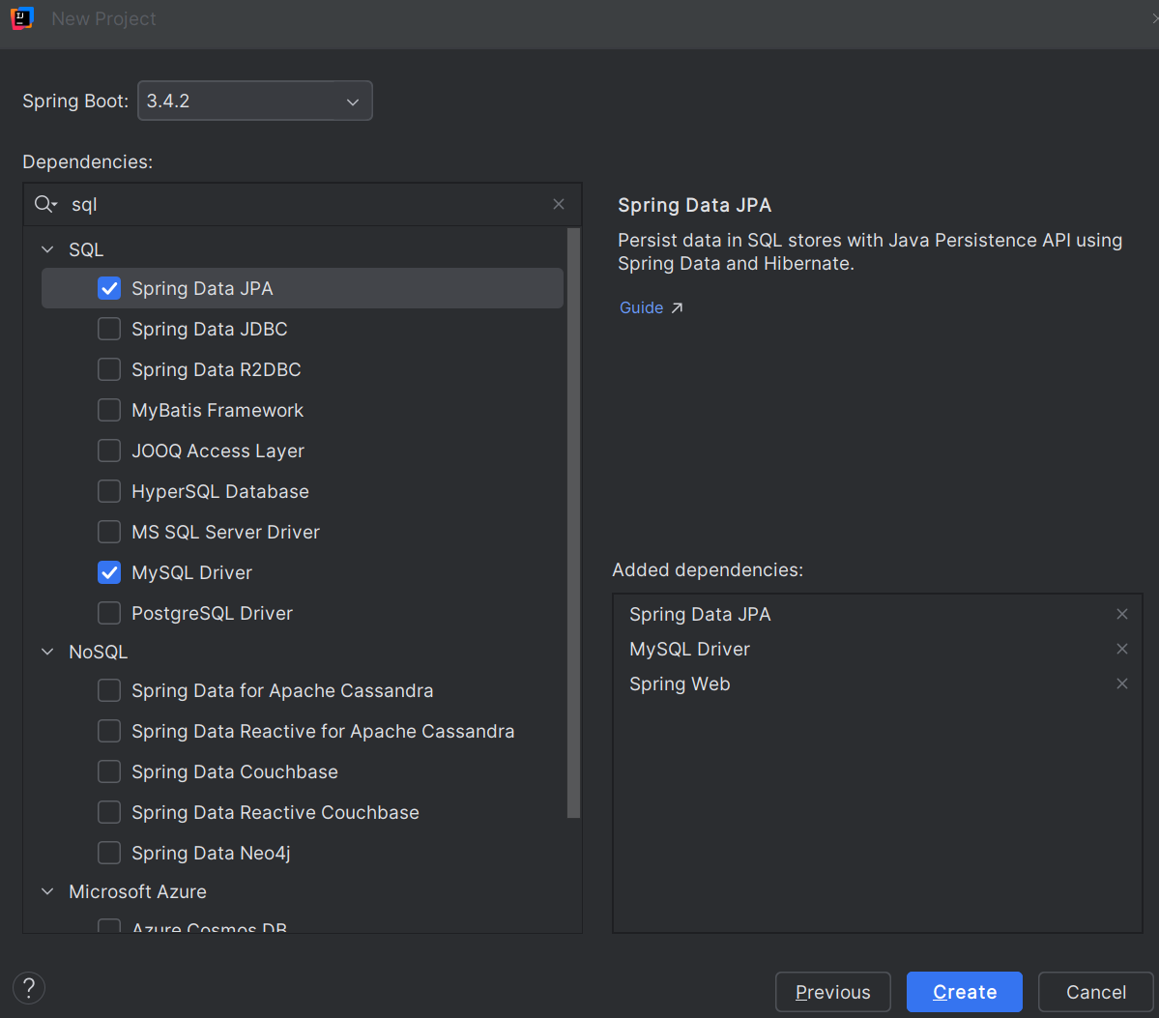

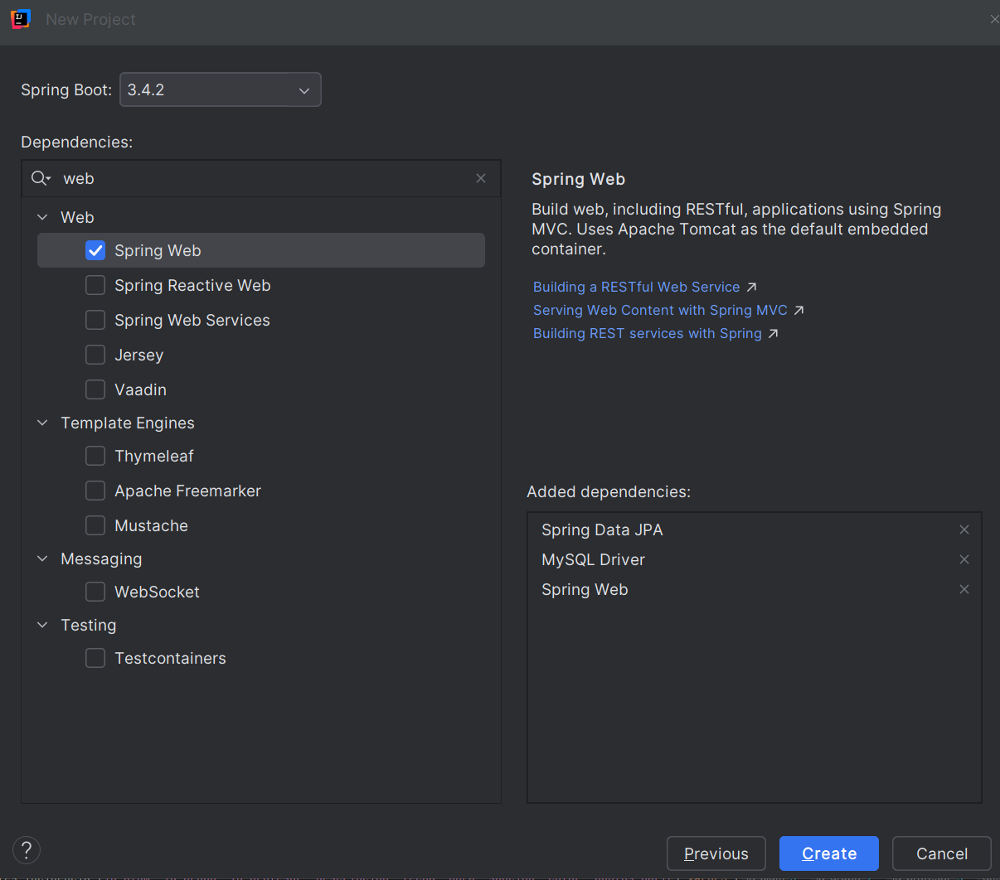

1. pom
2. properties
3. carpetas
4. base de datos en mySql
5. entities
6. Repositories
7. Services
8. controllers