**Nelson Mandela: Carrying on his Legacy**

**(exercise to accompany UN in Action programme)**

[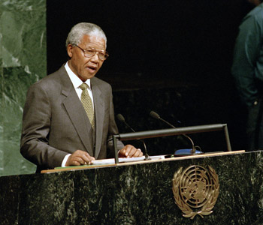](http://www.unmultimedia.org/radio/english/wp-content/uploads/2014/07/mandela-ga.jpg)

**Nelson Mandela. UN Photo/Evan Schneider**

***Pre-viewing***

The programme, *Nelson Mandela: Carrying on his Legacy* honours the lifeand achievements of Nelson Mandela,

The programme describes the different visions of Mandela. What are some different roles Nelson Mandela played in life? What do you remember Nelson Mandela for?

***Discussion***

As you watch the programme, consider the questions below:

What are some ways Mandela is described in the programme?

When did Mandela first speak at the UN? Why was this event so important?

***Before second viewing***

As you watch the programme, listen for the following lines from the programme: (if the underlined words are unfamiliar, see if you can get the meaning from the context of the sentence):

***Lines from the programme, with vocabulary focus***

1) Millions of people mourned when Nelson Mandela passed away.

2) But most of all Mandela will be remembered for the personal sacrifice he made to free the people of South Africa who had suffered under the Apartheid regime

3) *“I will continue to entertain the hope that there has emerged the cadre of leaders in my own country and region, on the continent, and in the world which will not allow that any should be denied their freedom..”-*Nelson Mandela

4) On this day the Nelson Mandela Foundation and the UN encourage the public to contribute 67 minutes of public service – the number of years Mandela dedicated to a life in the service of humanity.

5) “Mandela leaves behind many legacies – including his work to eradicate HIV and AIDS.

6) Mandela helped bring a taboo subject in South Africa to the forefront.

7) *"I can understand when some say we will never see his like again. But I see it differently. Because whenever people stand up for human rights; wherever people speak out for freedom and reach out for reconciliation – that is Nelson Mandela.” --*Secretary-General Ban Ki-Moon

***Post-viewing activities:***

Did you catch all of the lines of programme narration and dialogue reviewed before the second viewing?

What question did Bill Clinton ask Mandela?

a) What was Mandela’s answer? What do you think of Mandela’s answer?

b) What personal tragedy did Nelson Mandela suffer?

c) How many people are still infected with HIV-AIDS each year?

d) What goal is mentioned by Michel Sidibe, Executive Director of UNAIDS?

e) Are there other questions you would like to bring up for discussion? Decide with your partner and write a question here:

***Paraphrase and make revisions to the script:***

Work with a partner, and think of ways to paraphrase the above lines that contain underlined words. Write these new lines and check them with other class participants and the instructor.

Revise the script:

***Practice and perform the revised script (as programme is shown again with sound turned off)***

With your partner, practice and perform the script that now contains your revised lines.

[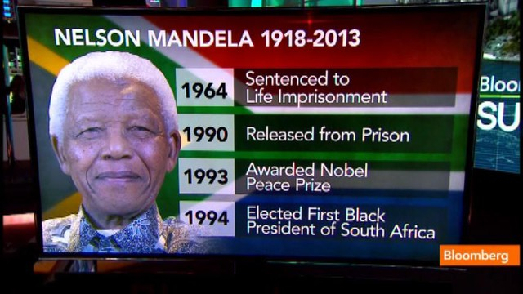](http://www.businessweek.com/videos/2013-12-06/the-legacy-of-nelson-mandela)

UN TV link: UN Youtube channel)

http://www.youtube.com/watch?v=HbVD3x-Yt7E

UN Radio link:

http://www.unmultimedia.org/radio/english/2014/07/nelson-mandela-carrying-on-his-legacy/#.VHIx995Ciu4

P. Duffy