Timothy Leishman Word Count: 00,000

Pocatello, Idaho, 83202

[leistimo@isu.edu](mailto:leistimo@isu.edu)

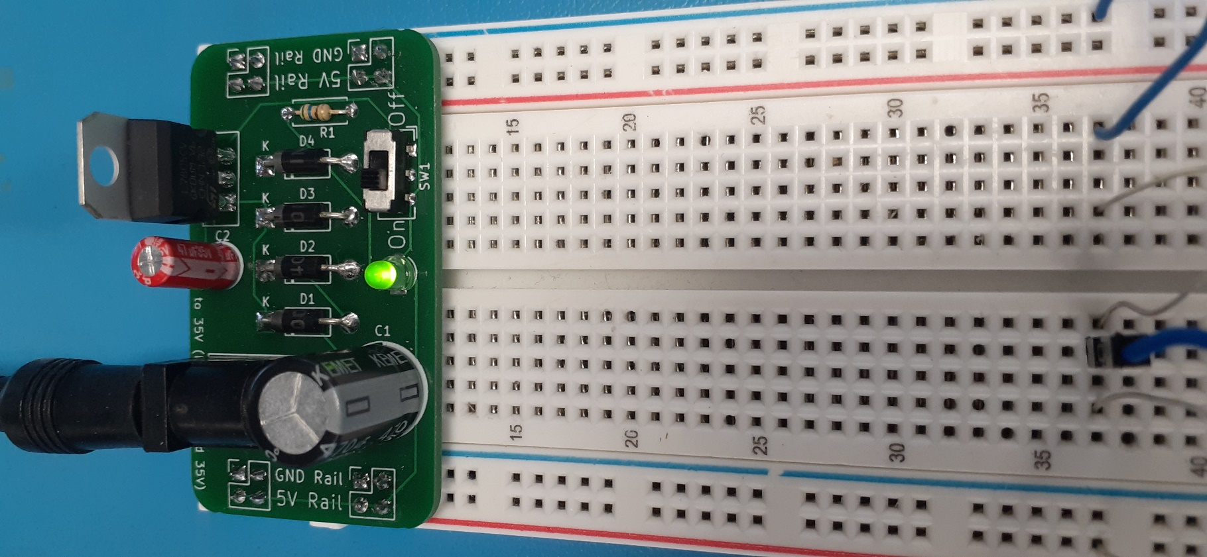

**Breadboard Power Supply**

**Timothy Leishman**

*Senior Instructor, Robotics Engineering Technology*

*Idaho State University*

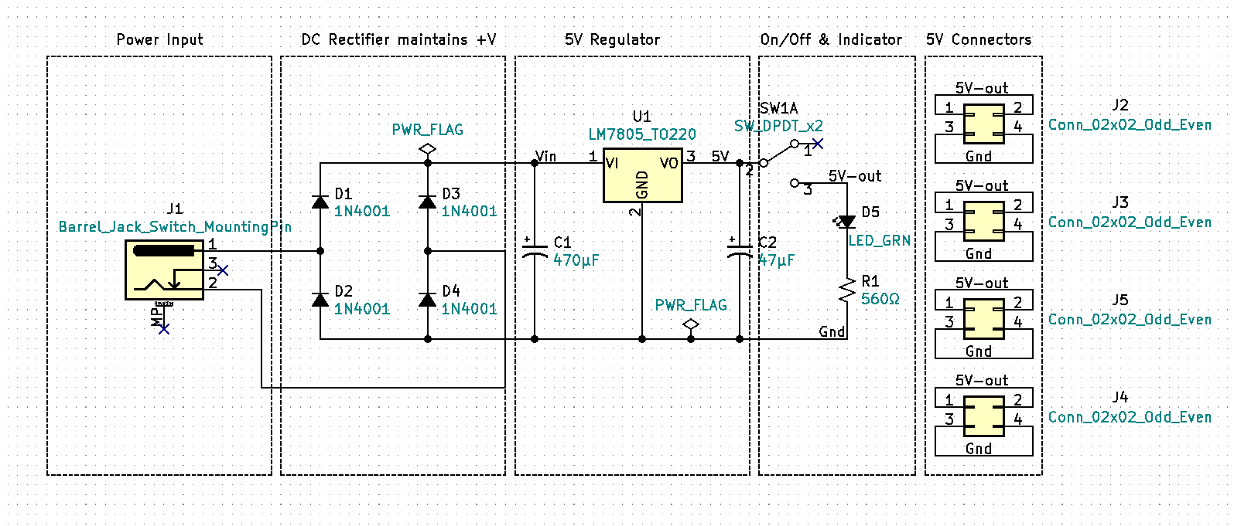**Introduction**

Figure . Breadboard Power Supply Schematic

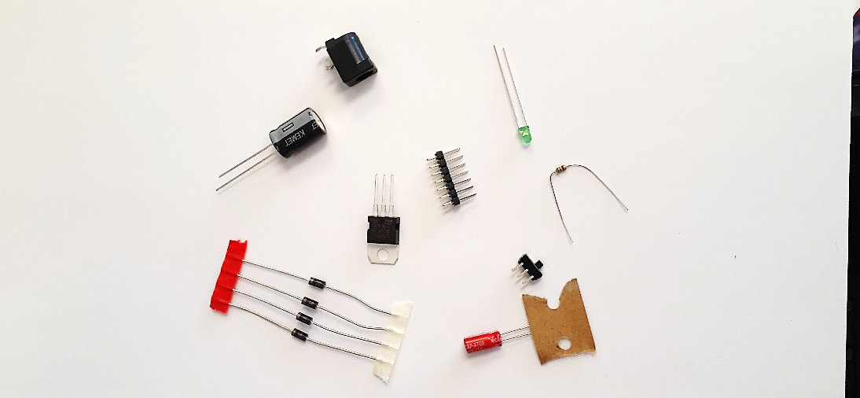The electronic circuit design process involves defining the problem, determining a solution, circuit calculations & schematic development, acquiring the needed components, circuit testing (often referred to as breadboarding), PCB or printed circuit board development, PCB assembly, and final testing. Typically, the breadboarding stage is done using a bench top or Laboratory DC Power Supply. Once the breadboarding phase is complete and the circuit is functionally operational, we often need to replace the laboratory DC power supply with a dedicated power source. A power source can be as simple as a 9V battery or may include purchasing a dedicated high-power rack mount Power Supply subsystem. Often, we can design our own power supplies using basic components rather than buying off the shelf units.

Figure . Electronic Components

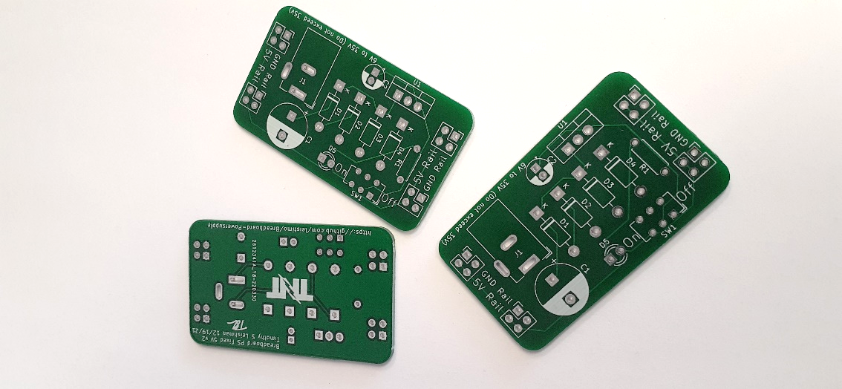While the power supply may not be the most exciting aspect of your electronic projects it is a crucial and foundational component. Poor power supply design can lead to intermittent circuit problems, premature circuit failures, and worst of all frustration. Understanding how power supplies function will make you a better electronic troubleshooter. The Breadboard Power Supply will give you the ability to safely build and test circuits. This small project will also help you develop your soldering skills and expose you to the circuit and PCB development process. Learning how to safely design and build dedicated power supplies will bring life to your current and future electronic projects.

Figure . Printed Circuit Boards (PCBs)

**A Problem named Covid**

Besides the pandemic, Covid created an instant demand for online at home learning. Suddenly electronics students everywhere lost access to Laboratory Bench Test Equipment and the direct supervision of a Lab Instructor. Modestly priced oscilloscopes, function generators, and laboratory DC power supplies exist and I encourage advanced students to acquire these tools as they can. However, the introductory student will not likely have access to these type of tools at home and for them the Breadboard PS along with a DMM will provide a, affordable and safe, at home circuit prototyping opportunity.

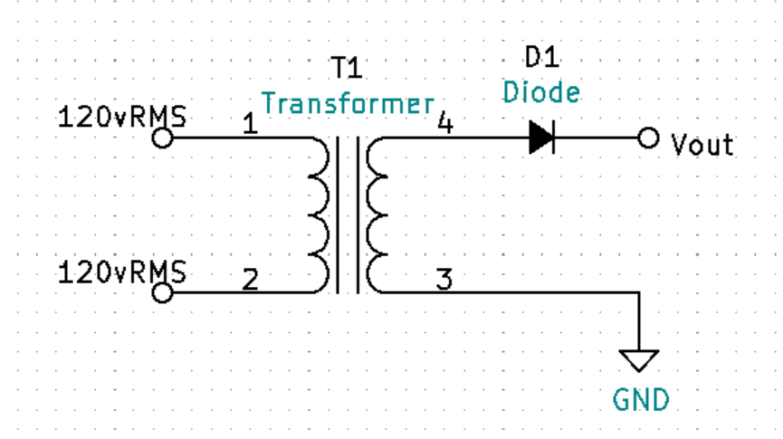**Intro to DC Power Supplies**

Figure . Basic Unregulated Half-Wave Rectification

The wall outlet at your house is 120-volt rms. 120vrms is dangerous. The protection circuit breaker which acts like a safety switch, turning off the voltage, has the maximum current rating at 15 amps to 20 amps. Death can occur from as low as 100mA or 0.1Amps. The circuit breaker at your house is not designed to save your life, it is designed to prevent the wiring in your home from heating up and starting a fire. Do not mess 120v wall power it can kill you.

Wall voltage is AC (Alternating Current) voltage. Most of what we do in electronics is DC (Direct Current). Examples of DC devices include: your computer, cell phone, Arduino, Raspberry Pi, and all things battery powered. The motors in your RC car are DC. However, some motors are designed to operate using single phase AC or industrial three phase AC power. Because our wall power is AC and our electronic circuits are mostly DC we will need to convert wall Alternating Current to Direct Current. The process of converting AC to DC is called Rectification.