Go to Link <https://www.desmos.com/calculator>

Log in

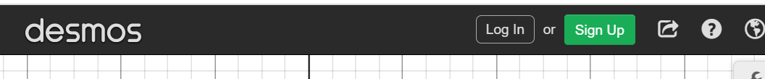



Name the graph by clicking the save button and naming your name + “Desmos Test”







Enter the equation "y=mx+b" and add sliders for m & b.

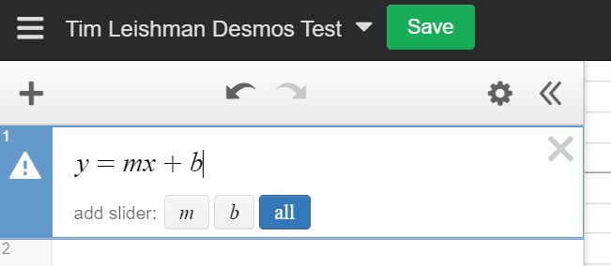



Play with the sliders and observe the graph. Set the sliders to y = 1, b = 0

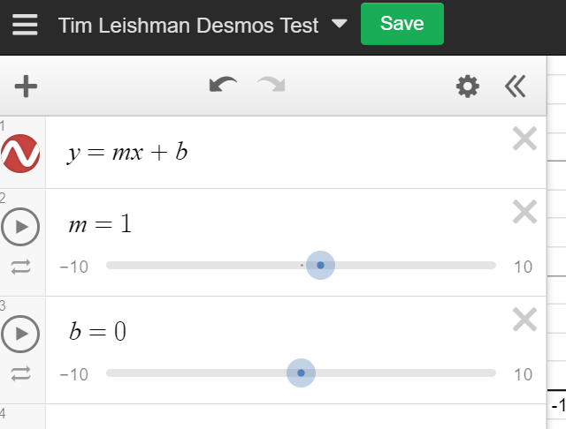



Use the Snipping Tool to capture the image including your name, the equation, and the graph

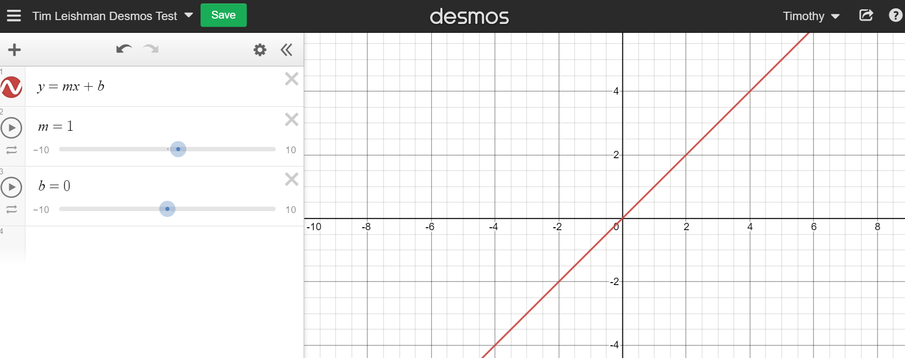

Submit the image to complete the assignment.