Suppose I have the function y=3x+4.

We may identify the format of the function as the Slop-Intercept Form.

* y = mx + b

Find points to Plot on the graph

* The point at which the line crosses the y axis of the graph is known as the

**y-intercept**

* At the **y intercept** x = 0
  + y = 3x+4
  + **y intercept** = 3(0) + 4
  + **y intercept** = 4
  + **y intercept** = (0,4)
* The point at which the line crosses the x axis of the graph is known as the

x-intercept

* At the **x intercept** y = 0
  + y = 3x+4
  + 0 = 3(x intercept) + 4
  + -4 = 3(x intercept)
  + $\frac{-4}{3}=$ x intercept
  + x intercept = $\frac{-4}{3}$
  + x intercept = $(-\frac{4}{3}, 0)$ OR (-1.333,0)
* Plot the points (0,4) and (-1.333,0) and connect the dots forming a line (image on next page)
* Notice that in the formula y = mx + b, that when x is 0,
* **b is the y intercept**.
* Now what does m represent. We can solve for m by picking any point on the line and solving. Lets pick the points (-1, 1).
  + y = mx + b
  + 1 = m(-1) + 4
  + 1-4 = m(-1)
  + -3 = m(-1)
  + -3/-1 = m
  + m = 3, yes it does the original formula was in-fact y=**3**x+b !!!, this math works at any point along the straight line.
* **m is the slope of the line:**
  + **m = $\frac{The Change in y}{The change in x}$ OR $\frac{y1-y2}{x1-x2}$ OR $\frac{∆y}{∆x}$**
  + If we compare points (-1, 1) to (0,4)
    - We get **m = $\frac{1-4}{-1-0}$ = $\frac{-3}{-1}$ =**
    - **m = 3, yes it does!**
* And that is the beauty of the Slope-Intercept form

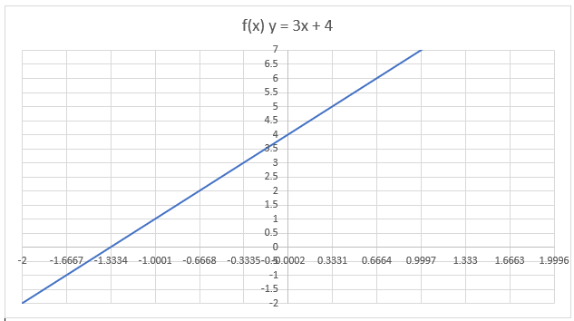

**Imagine yourself questioning, “What does all this, (Analytical Geometry), have to do with intro to calculus”?**

**I’m glad you asked!**

First let’s review our original function. y = 3x + 4

In calculus we can take the derivative of the function to find $\frac{dy}{dx}$ of the function

* If $y=ax^{n}$ then $\frac{dy}{dx}=anx^{n-1}$
  + y is y & x is x
  + a is the number in front of x
  + n is the exponent of x
* Now we can rewrite the formula for clarification
  + $y = 3x^{1} + 4x^{0}$ then $\frac{dy}{dx}=3\left(1\right)x^{1-1}+4(0)(NA)$
$\frac{dy}{dx}=3x^{0}+0$

$\frac{dy}{dx}=3(1)+0$

$\frac{dy}{dx}=3$

* **Now we can see that the derivative $\frac{dy}{dx}$ is equal the slope $\frac{∆y}{∆x}$** 
  + $\frac{dy}{dx}$**= $\frac{∆y}{∆x}$**
* **Therefore, the Derivative of a function is equal to the slope (instantaneous slope).**