**The Sales Situation of Liquors in Different Regions in Iowa 2017**

**Progress Report**

|  |  |  |
| --- | --- | --- |
| Lei Teng lete3485@colorado.edu | Mingxuan Zhang mizh1382@colorado.edu | Yuxiang Wang yuwa4103@colorado.edu |

**ABSTRACT**

Nowadays, alcoholic beverage becomes one of the most important things in our life. People use liquors in many different ways. Such as cooking, medicine, etc. But for most of us, alcoholic beverage is used for drinking and then release our pressure. And what we will do in this project is to analysis the sales situation of liquors in different regions.

**KEYWORDS**

Liquors, alcoholic beverage

**1 INTRODUCTION**

More specifically, our project works for analyzing the name, date, kind, price, quantity, and location of sales of individual containers or packages of containers of alcoholic beverages in 2017 to get the sales situation and drinking behaviors of people in different regions.

**2 Problem Statement**

**2.1 Sales Situation**

**2.1.1 Description**

For the sales situation, we can analyze the data to gain some correlation results. Such as the total amount of alcoholic beverage sold and consumed in months, years and regions. The alcoholic beverage sells best in different regions. Which region has the most liquors’ store. By analyzing the correlation of price and locations, we can get the region which has the highest price. By analyzing the correlation of date (months, years), and sales volume, we can get the tendency of months and years in different regions. Analyzing the correlation of name (or kind) and price to get the alcoholic beverage which gains the maximum profit. Analyzing the correlation of date and price to get the distribution in different regions, etc.

**2.1.2 Specific Questions**

* Which kind of alcoholic beverage gains the maximum profit?
* The tendency of sales volume of those popular alcoholic beverage.
* The distribution of prices.
* Get the frequent 1-item set for the category of liquor.
* Giving the minimum support to find out the popular liquor store.
* Among these stores, find out the most popular liquors.
* Then find out the joint probability of people buy a specific alcoholic beverage in a specific liquor store.

**2.2 Drinking Behavior**

**2.2.1 Description**

For the drinking behavior, according to the results of sales situation, such as the total sales amount of alcoholic beverage, can tell us people in which region drink the most alcoholic beverage or in which season people drink more. Also, from the dataset, we can get different sales rate of different alcoholic beverage in a specific region, then we will know which alcoholic beverage is the most popular in that region.

**2.2.2 Specific Questions**

* Which alcoholic beverage is the most popular in different regions?
* People in which region drink more alcoholic beverage?
* Figure out some other drinking behaviors for people in different regions.

**3 Literature survey/Prior work**

**3.1 Prior work describe**

**3.1.1 Previous work (1)**

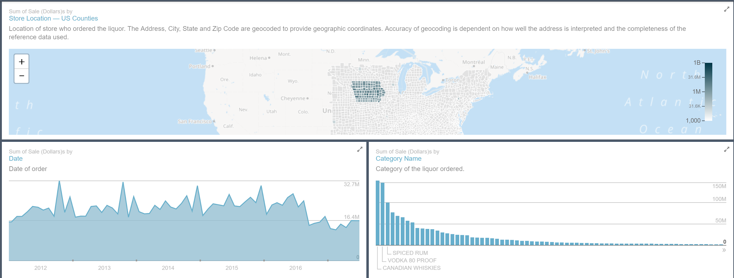

**Figure 1 [1]**

Figure 1: This work is about Iowa Liquor Sales in Dollars. It contains a map and two plots, which give us the sales in dollars respect to locations and times and categories.

**3.1.2 Previous work (2)**

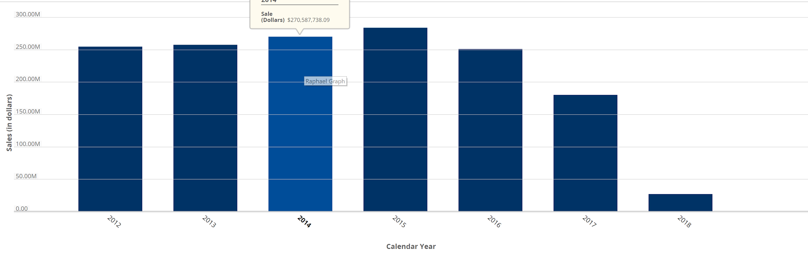

**Figure 2 [2]**

Figure 2: This work gives us the histogram about Iowa Liquor Sales in Dollars by Year.

**3.1.3 Previous work (3)**

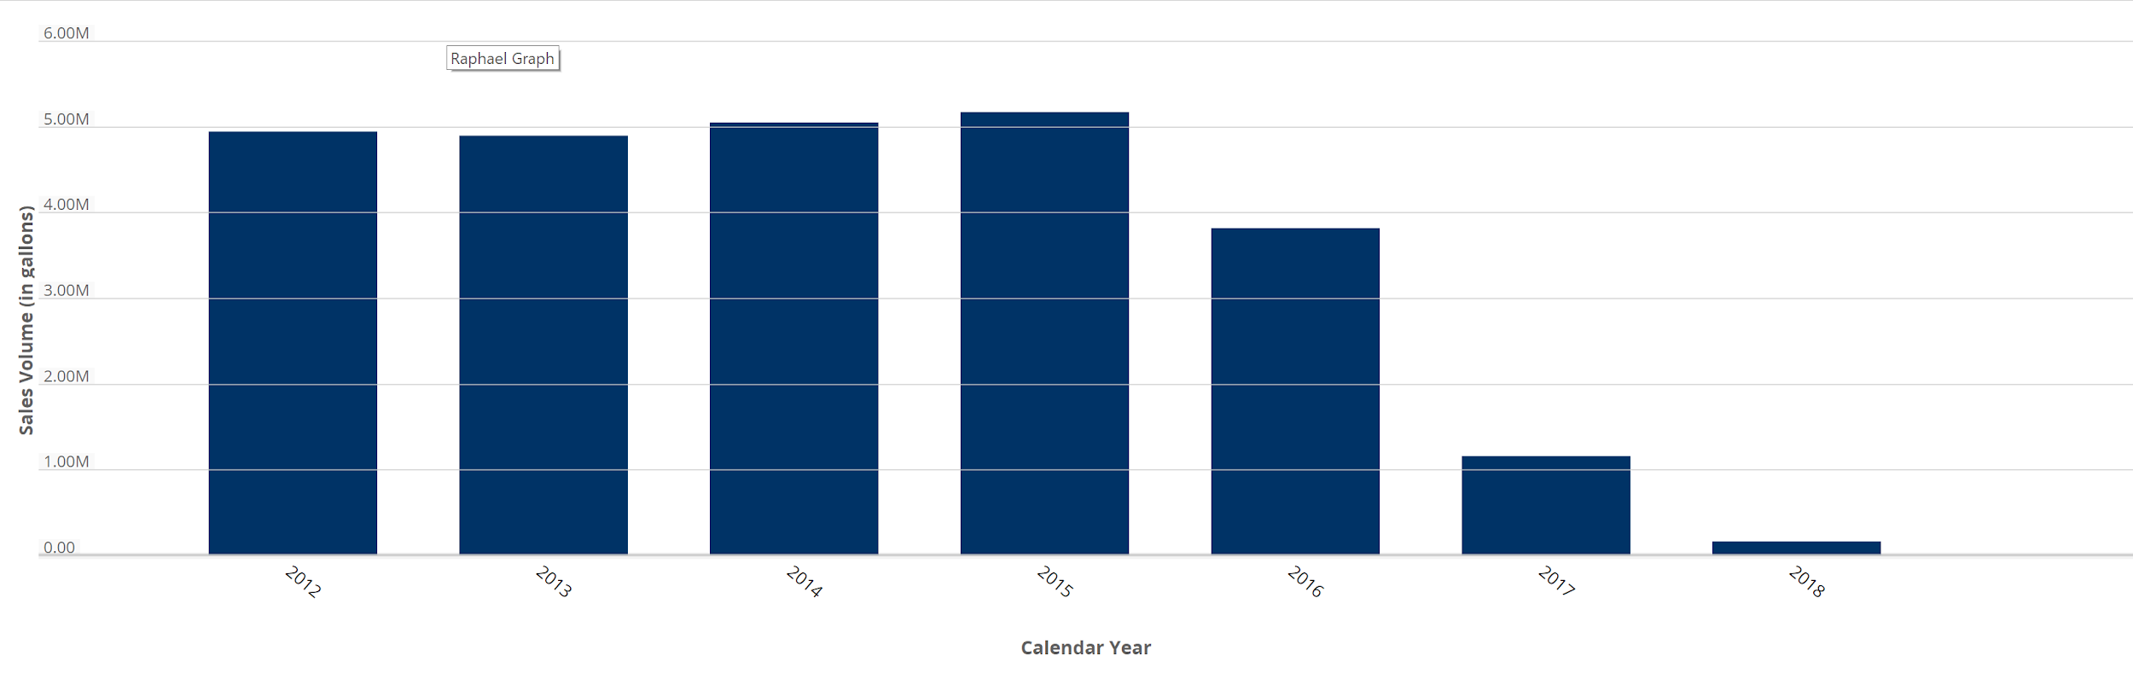

**Figure 3 [3]**

Figure 3: This work gives us the histogram about Iowa Liquor Sales in Gallons by Year.

**3.1.4 Previous Work (4)**

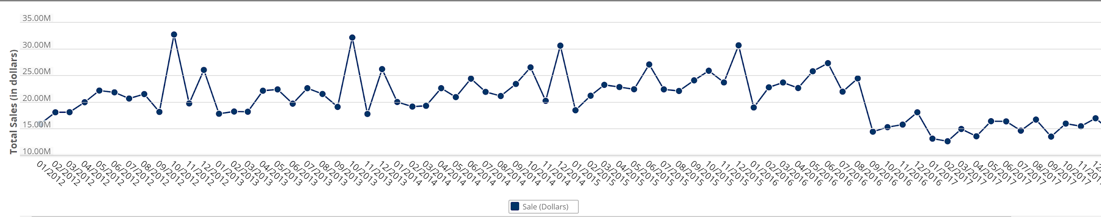

**Figure 4 [4]**

Figure 4: This work gives us the histogram about Iowa Liquor Sales in Gallons by Year.

**3.1.5 Previous Work (5)**

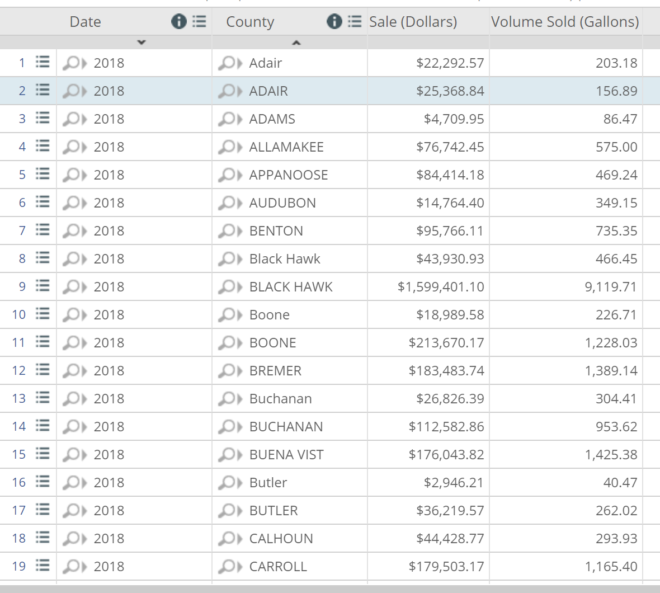

**Figure 5 [5**]

Figure 5: This work gives us the table about Iowa Liquor Sales by Year and County. In this table, we can get the sales in gallons and dollars in different time and county.

**4 Proposed Work**

**4.1 Data Cleaning**

For missing data, our approach is to Fill in it automatically with attribute mean.

**4.2 Data Integration**

Since we only have one database, we don’t have to do the data integration.

**4.3 Data Reduction**

There are 24 attributes in the dataset. Since we don’t need all 24 attributes, we have to do Dimensionality reduction. We will remove irrelevant attributes like Invoice/Item Number. We also have to remove redundant attributes, for example, Volume Sold (Liters) and Volume Sold (Gallons) are redundant attributes, we will use Volume Sold(Liters) instead of Volume Sold (Gallons).

**4.4 Graphic Analysis**

We will use histogram to analysis Iowa Liquor Sales in Dollars by Year, which is similar to previous (2), and we also use histogram to analysis Iowa Liquor Sales in Gallons by Year, which is similar to previous work (3).

We also can get the distribution for different liquors by using histogram.

And we will plot bar charts for total liquors sales respect to different cities.

Finally, plot the histogram for the distribution of prices.

**4.5 Pattern Finding**

We will get what is the best liquor in some major cities, we will also get the support and confidence.

For pattern finding, we focus on the following two questions:

1. What is the most popular liquors in the whole data set.
2. We will use different min supports to find frequent 1-item set.

And we believe as the course is going on, we will have more skills/goals for our project. These works are our basic goals for now.

**5 Data Set**

URL: <https://www.kaggle.com/residentmario/iowa-liquor-sales/data>[6]

This dataset contains information on the name, kind, price, quantity, and location of sale of sales of individual containers or packages of containers of alcoholic beverages.

Our datasets have around 12 million objects and 24 different attributes [7]:

Invoice/Item Number: Concatenated invoice and line number associated with the liquor order.

Date: Date of order.

Store Number: Unique number assigned to the store who ordered the liquor.

Store Name: Name of store who ordered the liquor.

Address: Address of store who ordered the liquor.

City: City where the store who ordered the liquor is located.

Zip Code: Zip code where the store who ordered the liquor is located.

Store Location: Location of store who ordered the liquor.

County Number: Iowa county number for the county where store who ordered the liquor is located.

County: County where the store who ordered the liquor is located.

Category: Category code associated with the liquor ordered.

Category Name: Category of the liquor ordered.

Vendor Number: The vendor number of the company for the brand of liquor ordered.

Vendor Name: The vendor name of the company for the brand of liquor ordered.

Item Number: Item number for the individual liquor product ordered.

Item Description: Description of the individual liquor product ordered.

Pack: The number of bottles in a case for the liquor ordered.

Bottle Volume (ml): Volume of each liquor bottle ordered in milliliters.

State Bottle Cost: The amount that Alcoholic Beverages Division paid for each bottle of liquor ordered.

State Bottle Retail: The amount the store paid for each bottle of liquor ordered

Bottles Sold: The number of bottles of liquor ordered by the store.

Sale (Dollars): Total cost of liquor order (number of bottles multiplied by the state bottle retail).

Volume Sold (Liters): Total volume of liquor ordered in liters.

Volume Sold (Gallons): Total volume of liquor ordered in gallons.

**6 Evaluation Methods**

**6.1 Graphic evaluation**

**6.1.1** **Compare to previous work**

Since we use histogram to analysis Iowa Liquor Sales in Dollars by Year, which is similar to previous work (2), and we also use histogram to analysis Iowa Liquor Sales in Gallons by Year, which is similar to previous work (3). We can compare the graphic to previous work (2) and (3) to check if we are right.

**6.1.2 Compare to intra-dataset mining result**

For the question ‘People in which region drink more alcoholic beverage?’, we use two different ways to get the final result. We can compare these two results to check if they are matched. This can proof our results are correct if they are mostly matched.

**6.2 Pattern Finding evaluation**

Compare to the previous work (1) to check if our result is correct.

Do some simple online surveys to see if our conclusion for “the best liquors in some major cities” is correct or mostly correct.

**7 Tools**

***7.1 Pandas***

***7.2 Numpy***

***7.3 Python***

***7.4 Matplotlib***

***7.5 JupyterNotebook***

***7.6 Overleef***

**8 Milestones**

**8.1 Milestones completed**

**8.1.1 Milestone 1**

Do data cleaning work – Complete

Complete date: 3/17

For the data cleaning, what we have done is to find out those data which are ‘NULL’ by the mean value of that attribute.

**8.1.2 Milestone 2**

Do data reduction work - Complete

Complete date: 3/31

Since our data set has 24 attributes, some of them are not useful for our data analyzing, so we have to do the data reduction to delete those attributes, thus, we can improve our efficiency and insure that our results are correct. The attributes we deleted are: ‘Store location’, ‘County number’, ‘Category’, ‘County’, ‘Category Name’, ‘Invoice/Item Number’.

**8.1.3 Milestone 3**

**8.1.3.1**

Complete the graphic analysis to find some other behaviors for the people in Iowa.

Firstly, we get 5 numbers summary of the ‘Bottles Sold’ to get the basic information and check if there is any outlier.

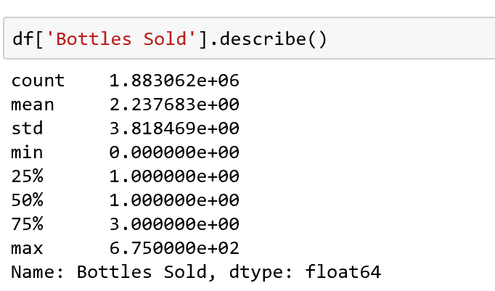

**Figure 7**

Figure 7: 5 numbers summary of ‘Bottles Sold’

**8.1.3.2**

Then we get the two histograms of ‘Packs’ and ‘Bottle sold’ to find out usually, people are willing to consume how many packs and how many bottles of alcoholic beverages in each time.

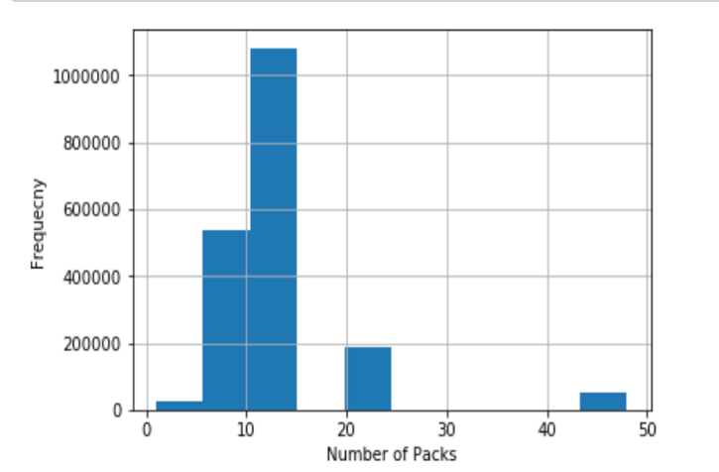

**Figure 8**

Figure 8: The histogram of the frequency of different numbers of bottles sold in each consumption.

**8.1.3.3**

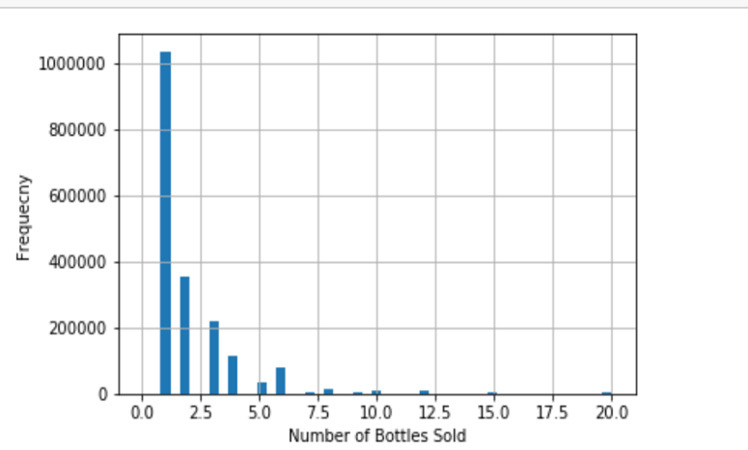

**Figure 9**

Figure 9: The histogram of the frequency of different numbers of bottles sold in each consumption.

**8.1.4 Milestone 4**

Complete the histogram of the attribute ‘Category Number’ to find out the approximate number the category number, which means we can know which kind of alcoholic beverage is the most popular in Iowa in 2017. It can be used in the further evaluation of the question of the most popular alcoholic beverage.

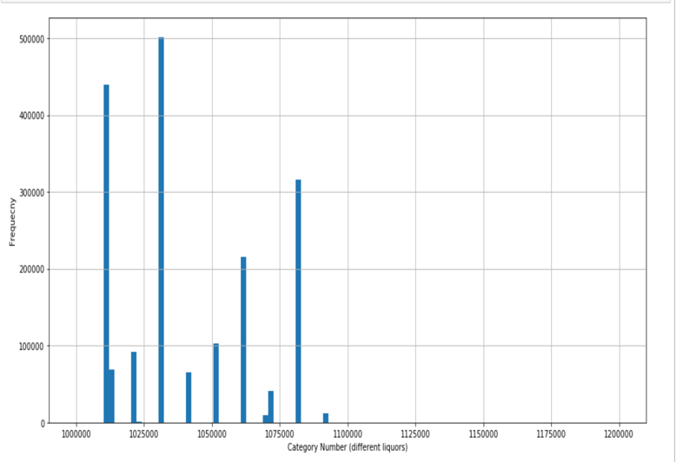

**Figure 10**

Figure 10: The category number distribution of liquors in Iowa in 2017

**8.2 Milestones To do**

**8.2.1 Milestone 5**

Complete the graphic analysis to find which alcoholic beverage is the most popular in different regions.

Since each region has its specific zip code, we can extract the data by the attribute ‘zip code’. Then for the data has same zip code, we sort the data by ‘Bottles Sold’ to find the most popular alcoholic beverage in that region.

**8.2.2 Milestone 6**

Complete the graphic analysis to find people in which region drink the most alcoholic beverage.

For this question, firstly, we extract the data by the attribute ‘zip code’. Then we use building function ‘groupby’ in python to get the sum of ‘Volume Sold(Gallons) for each region. Finally, we sort the total volume sold for each region to get in which region people drink most alcoholic beverage.

What’s more, we can use simply get the histogram by the attribute ‘zip code’, to get the frequency of zip code appeared in total transaction. This helps us find which region makes the most number of consumption.

Then we can compare two results, if they are mostly matched, then our result is correct.

**8.2.3 Milestone 7**

Get the profit of each kind of alcoholic beverage by subtracting sales price by the cost of each kind of alcoholic. Then multiply by total sale amount to get which kind of alcoholic beverage gains the maximum profit.

Complete the histogram to get the distribution of prices.

**8.2.4 Milestone 8**

Use minimum support to find out some popular alcoholic beverage, then choose some of these to get the histogram of the specific sales volume of each alcoholic beverage, then we can extract the high frequency part of the histogram, to predict the tendency of the sales situation of each alcoholic beverage.

**8.2.5 Milestone 9**

Complete the data analysis to find out the popular liquor store.

Among these stores, find out the most popular liquors.

Then find out the joint probability of people buy a specific alcoholic beverage in a specific liquor store.

**8.2.5 Milestone 10**

Use 3 ways to evaluate our results.

1. Compare to previous work.
2. Compare to intra-dataset mining result
3. Pattern Finding evaluation

**8.2.6 Milestone 11**

Finish the 1st draft of the final report;

Prepare for the final presentation

Due date: 4/28

**8.2.7 Milestone 12**

Finish the final version of the final report

Due date: 4/30

**9 Results So Far**

**9.1 Five numbers summary**



**Figure 7**

From the five numbers summary, we know the overall data distribution and make sure the couple of outliers.

**9.2 Drinking & Consumption Behavior**



**Figure 8**

The 5-10 packs is the most popular ways to consume.

**9.3 Drinking & Consumption Behavior**

Usually, people are willing to consume 1 to 2 bottles of alcoholic beverages in each time.

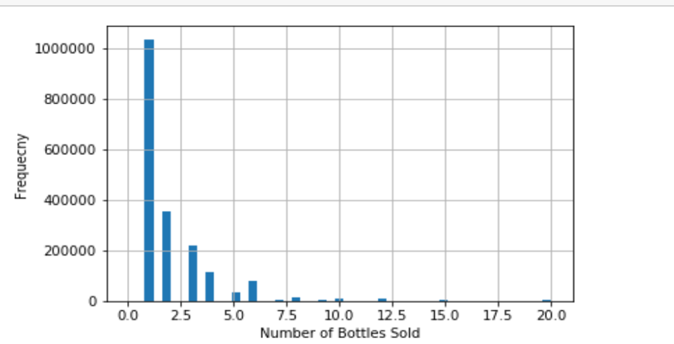

**Figure 9**

**9.4 Drinking & Sales Situation**

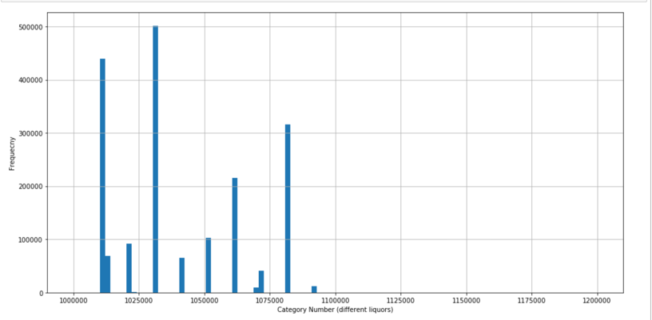

**Figure 10**

Draw the histogram of the attribute ‘Category Number’ to find out the approximate number the category number, which means we can know which kind of alcoholic beverage is the most popular in Iowa in 2017. It can be used in the further evaluation of the question of the most popular alcoholic beverage.

**REFERENCES**

|  |
| --- |
| 1. Iowa Liquor Sales in Dollars   <https://data.iowa.gov/Economy/Iowa-Liquor-Sales-in-Dollars/8epw-u33y> |
| 1. Iowa Liquor Sales in Dollars by Year   <https://data.iowa.gov/Economy/Iowa-Liquor-Sales-in-Dollars-by-Year/wwyw-7at4> |
| 1. Iowa Liquor Sales in Gallons by Year   <https://data.iowa.gov/Economy/Iowa-Liquor-Sales-in-Gallons-by-Year/7uuv-irpi> |
| 1. Total Liquor Sales in Iowa by Month   <https://data.iowa.gov/Economy/Total-Liquor-Sales-in-Iowa-by-Month/xiyh-fbvw> |
| 1. Iowa Liquor Sales by Year and County   <https://data.iowa.gov/Economy/Iowa-Liquor-Sales-by-Year-and-County/ahiv-u4uz>   1. Kaggle data set of Iowa Liquor sales   <https://www.kaggle.com/residentmario/iowa-liquor-sales/data> |
| 1. Iowa Liquor Sales   <https://data.iowa.gov/Economy/Iowa-Liquor-Sales/m3tr-qhgy> |