One approach is to have the final target machine be LLVM (which gives you lots of targets); then have some intermediate machines with transforms between machines.

i strongly recommend having support for delimited continuations at the language and abstract machine level, ala Oleg's interpretation of the Dybvig, Peyton-Jones, Sabry monadic presentation of delimited continuations.

Following Oleg's approach you begin with an abstract machine like this

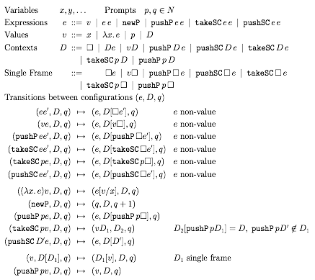

Show that this can be safely compiled to a machine like this

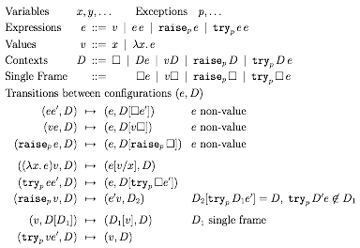

Then show that this can be safely compiled to LLVM.

This makes bytecode vs native really just where you stop in the compilation chain. It also gives you lots and lots of target architectures for native compilation. Additionally, it sets you up to have a smooth transition from the external to the internal concurrency models. The delimcc machine provides the support for native speed threads but with a nice typing scheme.

