Texas State’s Budget Justification
Salaries at Texas State University
- PI
- 66% in summer for two summers
- 25% of academic year
- will oversee all components of the project, work with students diligently, perform the work promised, and disseminate results
- will be responsible for setting up hardware and installing software on Texas State site
- Graduate student
- will work closely with the PI, assist with encoding, and perform research
- Undergraduate students (2)
- will work closely with the PI in performing research, learning grid computing techniques, and assisting in matters of practical importance
Equipment at Texas State University
- The 8 node Apple workgroup cluster
- needed for performing computations first for the Complexity Analysis component, as described in the narrative.
- The methods of the Complexity Analysis component are parallelizable (one or two nodes will generate complexes, while the others run the homology algorithm).
- the cluster will be used to test scaling methods implemented on the Biosimilarity server to this machine (see Biosimilarity LLC’s separate budget justification)
- All of the students will have access to this cluster.
- The work group cluster comes with Xgrid (to distribute computing tasks) and a software development environment. Software overhead is minimal. Managing the cluster does not require expert knowledge.
- includes service and support contract
- 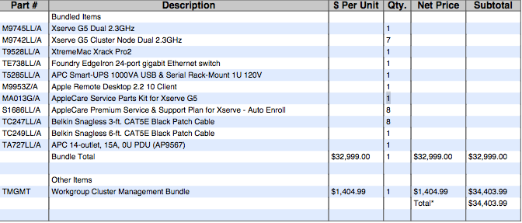
Travel for Texas State University personnel
- PI
- two visits to Biosimilarity LLC site in Seattle for oversight and collaboration on project components (October and April)
- two domestic conferences
  - one mathematical (joint mathematics meetings of the AMS and MAA), with co-PI
  - one concurrency (e.g. SIAM or ACM)
- Two international concurrency meetings in the first summer (CONCUR and ETAPS), with co-PI
- three international conferences in the second summer (CONCUR, ETAPS, and an international mathematics conference), with co-PI
- Graduate student
  - Regional conference in the Spring of first year
  - Summer conference in the second summer
- Undergraduate students
  - Regional conference in the Spring of first year
  - Summer conference in the second summer
Materials and Supplies at Texas State University
- gridMathematica software ($800)
- provides a high-level programming interface for the team, especially for generating graphical representations of the complexes of interest that arise in the complexity analysis component.
- the cost quoted covers expanding the Texas State Mathematica site license to include gridMathematica. Support for the software is available due to the site license.
- Apple cinema display ($2499)
- allows investigators to see simultaneously results of complexity analysis for a given complex and a graphic of the given complex (perhaps more than one)
- will also be useful in developing the website interface, as well as in the typing of other dissemination materials (slides and articles), which will be done primarily in LaTeX.
- Instructional materials ($1000)
- books for the students in knot/braid theory and pi-calculus.
- Long-distance telephone charges
  - $900 first year and $250 second year, for PI and co-PI to engage in the work of the project when at a distance

