Manuscript submitted to Water Resources Research

Cybernetics of Hydro Systems: A Unified Control-Theoretic Framework
for Water Network Operations

Xiaohui Lei¹*

¹ School of Water Resources, Hebei University of Engineering, Handan 056038, China
*Corresponding author: Xiaohui Lei (lxh@iwhr.com)

Key Points:
• All water conveyance and distribution systems—across irrigation, hydropower, urban supply, navigation, and inter-basin transfer—share a structurally isomorphic six-element controlled dynamical system representation, enabling cross-sector transfer of control methods.
• Eight governing principles organized into an Operational Tetrad and a Resilience Tetrad, with formally identified inter-principle tradeoffs, provide the theoretical core for transitioning water infrastructure from manual scheduling to autonomous operation.
• The irreversibility of water system failures—floods, droughts, contamination—demands a dedicated control science that cannot be borrowed wholesale from automotive or aerospace paradigms.

Abstract
Water infrastructure constitutes one of the largest classes of engineered systems on Earth, yet its operational intelligence remains at the manual-supervisory level—decades behind automotive, aerospace, and power systems. A fundamental reason is the absence of a unified control-theoretic framework. This paper proposes Cybernetics of Hydro Systems (CHS) as such a framework, advancing a preliminary theoretical foundation introduced by the author in Chinese-language publications (Lei, 2024a, 2024b). We demonstrate structural isomorphism: all water systems share a common six-element mathematical structure (Plant, Actuator, Sensor, Disturbance, Constraint, Objective) and are governed by eight principles organized into an Operational Tetrad (feedback, decoupling, order reduction, emergence) and a Resilience Tetrad (robustness, coordination, adaptation, hierarchy). We argue that the irreversibility of water system failures constitutes a fundamental challenge absent from most other control domains, demanding a dedicated science rather than direct method transfer. An illustrative state-space control design for a canonical canal pool demonstrates operational applicability. CHS is positioned as the theoretical foundation for a third revolution in water infrastructure science: from planning to real-time operating.

Plain Language Summary
Humanity has built vast networks of canals, pipelines, and dams worth trillions of dollars. But operating them—deciding when to open a gate or respond to a flood—still relies mostly on human experience. Cars are learning to drive themselves, aircraft fly on autopilot, and power grids self-balance, yet water systems lag far behind. A key reason is that water failures are irreversible: you cannot un-flood a city or un-dry a river. This makes it dangerous to simply copy automation approaches from other industries. We propose a unifying theory called Cybernetics of Hydro Systems (CHS), showing that all water systems share the same mathematical control structure and can be understood through eight operating principles. CHS provides a scientific foundation for safely and progressively automating water infrastructure.

Keywords: water network control; autonomous operation; structural isomorphism; model predictive control; cyber-physical systems; irreversibility

1 Introduction
Water infrastructure constitutes one of the largest classes of engineered systems on Earth. Globally, more than 500,000 km of inter-basin and intra-basin water conveyance channels are in operation, alongside millions of kilometers of pressurized urban distribution networks (UNESCO, 2024). In China alone, the South-to-North Water Diversion Project spans over 2,700 km of primary channels and tunnels, transferring up to 45 billion cubic meters annually (Lei et al., 2024). The cumulative global investment in water infrastructure is estimated at several trillion dollars. Yet a striking asymmetry persists: the science of designing and constructing water infrastructure is mature, while the science of operating it in real time remains nascent.
This gap is not merely technological—it is paradigmatic. The automotive sector’s progression from cruise control to advanced driver-assistance systems has been guided by coherent control theory and formalized through the SAE J3016 autonomy levels (SAE International, 2021). Aerospace fly-by-wire systems are certified through DO-178C (RTCA, 2011) and underpinned by decades of flight control science. Power system operations rest on foundations laid by Kundur (1994), where automatic generation control maintains frequency stability across continental-scale grids. The water sector possesses no comparable unifying framework. Canal automation, reservoir optimization, urban demand management, and hydropower scheduling have evolved as disconnected disciplinary silos, each developing bespoke solutions without a shared theoretical language.
The quantitative evidence of this gap is sobering. A cross-sector comparison (Lei, 2024a) found that operational autonomy of water conveyance systems worldwide remains at Level 0–Level 1—equivalent to manual driving with minimal assistance—while automotive has achieved Level 2–3 and commercial aviation operates at Level 4–5 in cruise phases. Global non-revenue water losses average 30% in distribution networks, with rates exceeding 50% in parts of the developing world. Pumping operations in water systems consume 2–3% of global electricity, yet operate with energy efficiency 20–40% below theoretical optima. Flood response in manually operated canal networks requires hours to days, while the hydrological events demanding response unfold on timescales of minutes to hours. These figures reveal not a marginal performance shortfall but a fundamental paradigm deficit.
Why has the water sector lagged so persistently? We identify a structural reason deeper than institutional inertia or technological delay: the irreversibility of failure. Water systems occupy a unique position in the landscape of controlled dynamical systems. Unlike an automobile that drifts from its lane and can be corrected, or a power grid whose frequency deviation can be restored, water system failures are characteristically irreversible on operational timescales. A levee breach cannot be un-flooded. An ecological flow violation that kills aquatic organisms cannot be undone. A contamination event that enters a distribution network cannot be recalled. Sediment deposition that blocks a canal cannot be cleared while the system operates. This irreversibility has a profound theoretical consequence: trial-and-error learning—the foundation of reinforcement learning and much of data-driven AI—is not merely inefficient but unacceptable. Safety constraints are not soft penalties in an objective function but absolute barriers that must never be crossed. A control system must possess provable safety guarantees before its first deployment, not after thousands of training episodes.
This irreversibility thesis explains three structural consequences. First, it explains why the water sector has been conservative about automation: operators intuitively understand that the cost of control failure exceeds any efficiency gain. Second, it explains why direct transfer of methods from automotive or aerospace domains is insufficient: those domains tolerate learning from near-misses in ways that water infrastructure cannot. Third, it establishes why water systems require a dedicated control science—one that places irreversibility, constraint inviolability, and provable safety at its theoretical center, rather than treating them as add-ons to performance optimization. Cybernetics of Hydro Systems (CHS) is proposed as this science.
The term “cybernetics” deliberately evokes Wiener’s (1948) original vision of a transdisciplinary science of communication and control. We acknowledge that the term receded from mainstream usage after the 1970s, supplanted by more specialized branches. But Wiener’s original ambition—a unified science that identifies common control principles across physically disparate domains—is precisely the intellectual mission of CHS. The preliminary theoretical foundation, including the principles of feedback and decoupling and a four-element technical system, was first proposed by the author in Chinese-language publications (Lei, 2024a). Companion papers introduced the concept of autonomous water networks with multi-level intelligence classification (Lei, 2024b), an X-in-the-Loop verification methodology (Lei, 2024c), and the multi-scale model reduction pathway from static water balance to dynamic control (Lei, 2024d). The present paper substantially extends this prior work in four directions: (1) expanding from two to eight governing principles organized into dual tetrads with formally identified inter-principle tradeoffs, (2) introducing the six-element Plant–Actuator–Sensor–Disturbance–Constraint–Objective formalization with a structural isomorphism proposition across five subsectors, (3) articulating the irreversibility thesis as the fundamental theoretical justification for a dedicated water control science, and (4) providing an illustrative mathematical control design and positioning CHS within the international landscape.
2 Three Revolutions in Water Infrastructure Science
The intellectual history of water infrastructure science can be understood as three paradigmatic revolutions, each transforming the fundamental relationship between engineers and water systems (Figure 1).
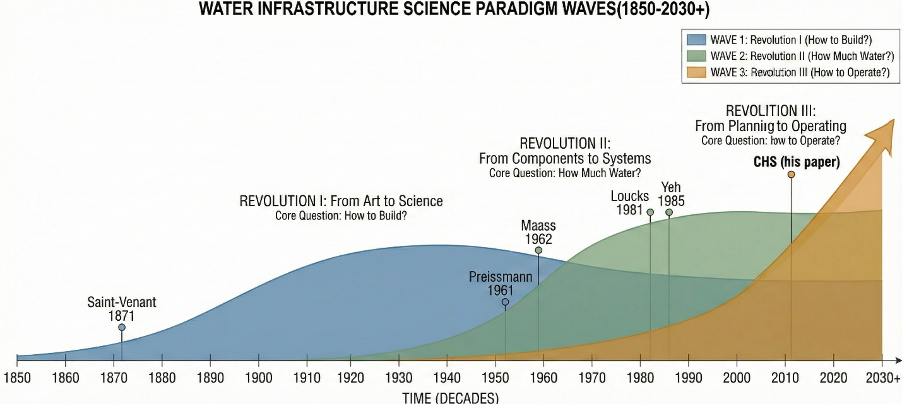
Figure 1: Three Revolutions in Water Infrastructure Science
2.1 Revolution I: From Art to Science (1850s)
For millennia, water infrastructure was designed and operated by empirical art. The first revolution came with the mathematization of water flow. Saint-Venant’s (1871) open-channel equations, Preissmann’s (1961) implicit numerical scheme, and Streeter and Wylie’s (1967) water hammer analysis transformed hydraulics from craft to quantitative science. In parallel, control theory itself was born when Maxwell (1868) analyzed the centrifugal governor, followed by Nyquist’s (1932) stability criterion, Bode’s (1945) frequency-domain methods, and Kalman’s (1960) state-space revolution. These two trajectories—hydraulic science and control science—developed largely in parallel for a century, with their first substantive intersection occurring in canal automation. Buyalski et al. (1991) developed the EL-FLO algorithm at the U.S. Bureau of Reclamation. Schuurmans (1997) applied robust control at Delft. Litrico and Fromion (2009) published the first comprehensive treatise deriving transfer functions from Saint-Venant dynamics. Van Overloop (2006) developed real-time MPC for irrigation. Cantoni et al. (2007) and Mareels et al. (2005) advanced the Australian school of large-scale irrigation control. These contributions established canal automation as a recognized subfield, but remained limited to open-channel irrigation systems.
2.2 Revolution II: From Components to Systems (1960s)
The second revolution shifted the governing question from “How to build?” to “How much water?” The pioneering works of Maass et al. (1962), Loucks et al. (1981), and Yeh (1985) established water resource systems analysis, applying operations research, dynamic programming, and stochastic hydrology to optimize water allocation. Labadie (2004) and Giuliani et al. (2016) extended these approaches to multireservoir systems with multiobjective tradeoffs. This revolution was transformative: it replaced component-level thinking with system-level optimization. But it operated predominantly in a static or quasi-static paradigm—rule curves, seasonal planning, offline optimization. Operations were addressed through pre-computed strategies rather than real-time feedback. Lei (2024d) provides a detailed analysis of this paradigm’s limitations and the theoretical necessity of transitioning from static water balance to dynamic control.
2.3 Revolution III: From Planning to Operating (2020s)
The third revolution, now emerging, shifts the question to “How to operate?”—real-time control under uncertainty with hard safety constraints. Three forces drive this revolution: the maturation of SCADA, IoT, and digital communication infrastructures; the growing complexity of multi-source, multi-user, interconnected water networks; and the intensification of climate extremes that render pre-computed operating rules obsolete. CHS is proposed as the theoretical foundation for this third revolution. It builds upon the first two: hydraulic models from Revolution I provide plant dynamics; optimization methods from Revolution II inform objectives and constraints. CHS adds the closed-loop, real-time, feedback-driven, safety-guaranteed operational layer.
2.4 Related Frameworks and the Gap CHS Addresses
Several frameworks have addressed aspects of what CHS encompasses. The hydroinformatics paradigm (Abbott, 1991) emphasized computational methods but did not adopt control-theoretic formulation. The smart water networks concept (SWAN, 2022) focuses on data-driven decision support—an IT perspective rather than a control science perspective. The digital twin paradigm (Savic, 2022) provides simulation platforms but lacks closed-loop control architecture. What has been missing is a framework that adopts control theory as its primary disciplinary lens, demonstrates structural isomorphism across water subsectors, identifies universal governing principles, places irreversibility and constraint inviolability at its theoretical center, and defines a verifiable pathway from manual to autonomous operation. CHS fills this gap.
3 Water Systems as Controlled Dynamical Systems: The Six-Element Formalization
The foundational claim of CHS is that every water conveyance and distribution system can be formally represented as a controlled dynamical system with six elements (Figure 2). This formalization extends the four-element technical system introduced in Lei (2024a) by explicitly distinguishing the physical Plant from its controllable Actuators and observable Sensors, and by elevating Disturbances, Constraints, and Objectives to first-class elements.
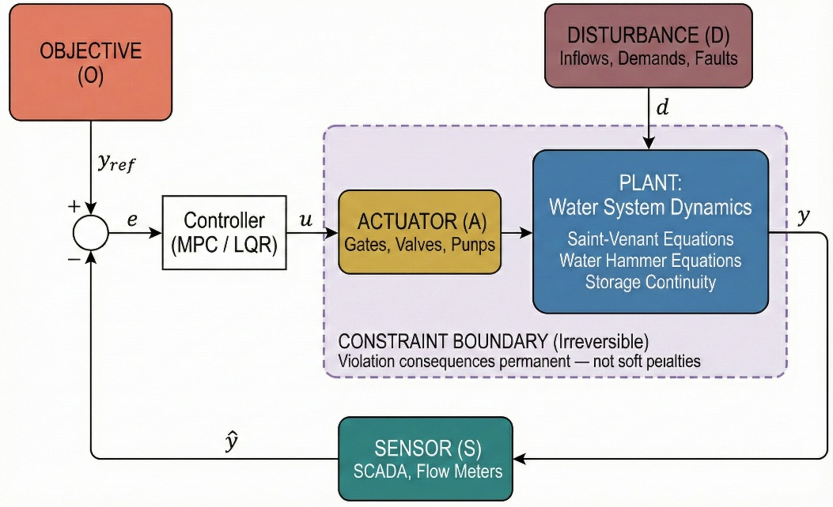
Figure 2: The CHS Six-Element Controlled Dynamical System Architecture
3.1 Unified State-Space Representation
We state the structural isomorphism claim as a formal proposition.
Proposition 1 (Structural Isomorphism). Any water conveyance or distribution system can be represented in the following unified state-space form:
dx/dt = f(x, u, d; θ) [Plant dynamics, parameterized by θ]
y = h(x; θ) + v [Sensor model with noise v]
u ∈ U(x; θ) [Actuator feasibility set]
g(x, u; θ) ≤ 0 [Constraint set]
J = ∫L(x, u, y_ref; θ)dt [Objective functional]
where x(t) is the state vector (water levels, pressures, flows), u(t) is the control input (gate openings, pump speeds), d(t) is the disturbance (inflows, demands), y(t) is the measured output, and θ is a parameter vector encoding the specific physical characteristics of each subsector. The critical implication is that the state-space topology—the causal structure connecting states, inputs, outputs, disturbances, and constraints—remains invariant across subsectors. Only the parameter vector θ changes. A control algorithm developed for one subsector is therefore transferable to another by re-parameterization, a potential that has been systematically underexploited because the water community has organized around application domains rather than operational science.
The six elements constituting this representation are as follows. The Plant (P) is the physical system governed by conservation laws: Saint-Venant equations for open channels (Saint-Venant, 1871; Cunge et al., 1980), water hammer equations for pressurized systems (Streeter & Wylie, 1967), and the storage continuity equation for reservoirs. The Actuator (A) comprises controllable elements—sluice gates, radial gates, valves, variable-speed pumps, turbines—that are characteristically slow (minutes), spatially distributed, and subject to rate constraints. The Sensor (S) consists of measurement systems including SCADA water level gauges, flow meters, and pressure transducers, with key limitations of noise, latency, spatial sparsity, and vulnerability to failure, necessitating state estimation. The Disturbance (D) encompasses exogenous inputs: hydrological inflows, time-varying demands, ice formation, sediment transport, and equipment failures. The Constraint (C) imposes hard and soft bounds: maximum and minimum water levels, ecological flow requirements, navigation depths, water quality standards, and actuator rate limits—often legally mandated and, critically, involving irreversible consequences if violated. The Objective (O) defines multi-dimensional performance criteria: delivery reliability, energy efficiency, flood protection, water quality maintenance, and operational smoothness (Loucks & van Beek, 2017).
3.2 Cross-Sector Instantiation
Table 1 demonstrates the six-element structure across five water subsectors. Lei (2024a) first noted this isomorphism for four subsectors; Table 1 extends to include inter-basin transfer as a fifth domain. The isomorphism implies that methods developed in canal automation (where the most mature control theory exists) are systematically transferable to hydropower cascade scheduling, urban pressure management, navigation waterway regulation, and inter-basin transfer coordination—a transfer that the CHS framework makes explicit and tractable.

Table 1. Six-element controlled dynamical system structure across five water subsectors, demonstrating structural isomorphism (Proposition 1).
Element | Irrigation  Canal | Hydropower  Cascade | Urban Water  Supply | Inland  Waterway | Inter-Basin  Transfer
Plant (P) | Saint-Venant  open-channel  unsteady flow | Reservoir storage  + turbine  characteristics | Pressurized pipe  network (water  hammer eqs.) | Saint-Venant  with vessel-  induced waves | Saint-Venant  + pipe flow  (hybrid)
Actuator (A) | Check gates,  radial gates,  turnouts | Turbine wicket  gates, spillway  gates | Valves, VFD  pumps, PRVs | Lock gates,  weirs, barrage  gates | Gates, pumps,  tunnels, inverted  siphons
Sensor (S) | Water level  gauges, flow  meters | Reservoir level,  turbine flow,  power meters | Pressure sensors,  flow meters,  AMI meters | Water level,  lock position  sensors | Multi-point level,  flow, and quality  sensors
Disturbance (D) | Rainfall-runoff,  crop demand  variability | Hydrological  inflows, price  signals | Demand variation,  pipe bursts | Flood events,  vessel traffic  patterns | Source variability,  multi-user  demand
Constraint (C) | Max/min canal  levels, delivery  targets | Min ecological  flow, max/min  reservoir levels | Min pressure  head, max  leakage | Navigation depth,  flood control  levels | Min ecological  flow, max level,  ice limits
Objective (O) | Delivery equity,  water productivity | Energy revenue,  flood control,  ecological flow | Pressure stability,  energy efficiency | Lock throughput,  flood safety | Reliable transfer,  energy min,  water quality

4 The Eight Principles of Cybernetics of Hydro Systems
Building on the six-element formalization, we identify eight principles governing water system operations (Figure 3). The preliminary CHS framework (Lei, 2024a) identified feedback and decoupling as two foundational principles. Here we expand this to a comprehensive system of eight, organized into two tetrads: the Operational Tetrad addresses how to achieve stable, efficient control; the Resilience Tetrad addresses how to maintain performance under uncertainty. Crucially, these principles are not independent—they exhibit fundamental tradeoffs that define the design space of any water control system.
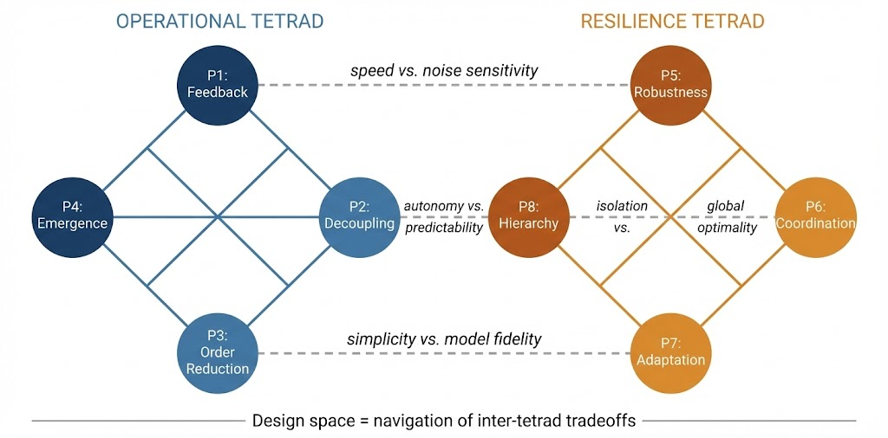
Figure 3: Eight Principles — Dual Tetrad with Tradeoffs
4.1 The Operational Tetrad
4.1.1 Principle 1: Feedback
Feedback—continuously measuring system state and adjusting control actions to reduce discrepancy between actual and desired states—is foundational to CHS. Without feedback, water system operation is open-loop scheduling: a pre-computed plan executed without regard to actual system response. Two factors amplify the necessity of feedback in water systems beyond most industrial applications: disturbances are large and poorly predictable (inflows varying by orders of magnitude between seasons and between dry and flood years), and long transport delays—hours to days in major conveyance systems—mean that consequences of errors accumulate far downstream before becoming observable at the point of control. CHS emphasizes multi-scale feedback: fast local loops for safety (seconds), medium-speed loops for pool-level regulation (minutes), and slow outer loops for system-wide coordination (hours), as recognized by Clemmens and Schuurmans (2004).
4.1.2 Principle 2: Decoupling
Water networks are inherently coupled: a gate adjustment at one location propagates both upstream (backwater effect) and downstream (flow disturbance), creating cascade effects across dozens of interconnected pools. The decoupling principle requires minimizing inter-subsystem disturbance propagation through local volume compensation. Litrico and Fromion (2009) demonstrated that downstream control inherently provides better decoupling by exploiting pool storage as a buffer—a result with deep implications for control architecture design. CHS generalizes this: in any water network, natural storage elements (canal pools, reservoir zones, pipeline elastic capacity) should be systematically exploited as local disturbance absorbers, a principle first articulated in the preliminary CHS framework (Lei, 2024a).
4.1.3 Principle 3: Order Reduction
The governing equations of water systems are partial differential equations—infinite-dimensional dynamical systems. A 100-km canal pool discretized at 1-km intervals yields approximately 200 state variables; a network of 50 such pools yields 10,000. Real-time MPC cannot operate on the full PDE model. Order reduction addresses this through a principled hierarchy of models, established by Litrico and Fromion (2009) and elaborated for the CHS framework in Lei (2024d): the full Saint-Venant model (SV, ∞-dimensional, valid at all time scales); the Integrator-Delay-Zero model (IDZ, 3rd order, capturing dominant dynamics at minutes-to-hours); the Integrator-Delay model (ID, 2nd order, neglecting the backwater zero); the Integrator model (I, 1st order, neglecting delay); and the Static Water Balance (SWB, algebraic, steady-state at days-to-weeks). Figure 4 illustrates this hierarchy and its correspondence to the control architecture layers.
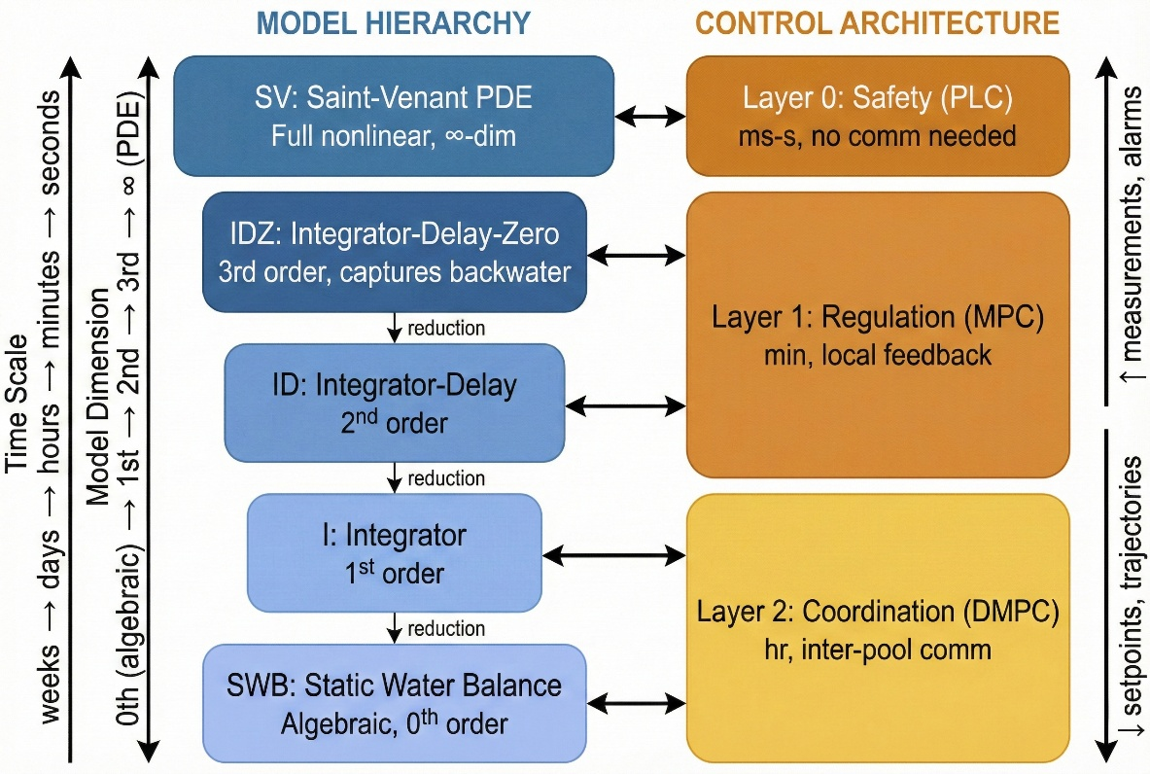
Figure 4: Multi-Scale Model Hierarchy and Control Architecture
4.1.4 Principle 4: Emergence
Emergence refers to system-level behaviors arising from interactions among locally controlled subsystems. In water networks, emergence can be positive—autonomous pool controllers achieving network-wide flow balance without explicit central coordination—or negative—individually stable controllers producing network-level oscillations through hydrodynamic coupling. Multi-agent systems theory (Wooldridge, 2009) provides the analytical framework. The design challenge is defining local interaction rules and communication protocols that guarantee desirable emergent behavior, connecting to consensus algorithms and distributed optimization (Nedic & Ozdaglar, 2009).
4.2 The Resilience Tetrad
4.2.1 Principle 5: Robustness
Robustness maintains acceptable performance despite uncertainties in the plant model, sensor measurements, and disturbance forecasts. In water systems, channel roughness changes with sediment deposition and vegetation growth, sensor calibration drifts, and hydrological forecasts carry substantial errors beyond 24–48 hours. Schuurmans (1997) was among the first to apply robust control theory to canal regulation. CHS elevates robustness from a property of individual controllers to a system-level architectural requirement: the entire multi-layer architecture—including coordination mechanisms, communication protocols, and degradation modes—must be robust.
4.2.2 Principle 6: Coordination
Coordination aligns distributed controllers for system-wide objectives under constraints of spatial distribution, limited communication bandwidth, and jurisdictional boundaries. CHS frames this through distributed MPC (DMPC): each subsystem solves a local optimization problem while exchanging boundary information with neighbors to ensure network-level consistency (Negenborn et al., 2009; Maestre & Negenborn, 2014). The South-to-North Water Diversion Middle Route, with 64 check gates over 1,432 km, exemplifies the need: centralized MPC is computationally intractable for this scale; distributed architecture with one controller per pool is scalable and physically aligned with the system structure (Lei et al., 2024).
4.2.3 Principle 7: Adaptation
Adaptation modifies control behavior when operating conditions exceed the design envelope. This includes slow changes (aging infrastructure, climate trends, urbanization) and abrupt disruptions (extreme floods, equipment failures, water quality emergencies). The Operational Design Domain (ODD) concept from autonomous vehicles (SAE International, 2021; ISO, 2022) is central to the CHS approach: for each autonomy level, the conditions for autonomous operation are explicitly defined, and the system transitions to a lower automation level or human control when approaching ODD boundaries. The autonomous water network architecture proposed in Lei (2024b), which defines Water Network Intelligence Levels WN-L0 through WN-L5, operationalizes this principle by specifying the ODD for each autonomy level.
4.2.4 Principle 8: Hierarchy
Hierarchy organizes the control system in multiple layers operating at different temporal scales and spatial resolutions: Layer 0 (Safety)—local PLCs providing interlocks and emergency shutdowns at millisecond response without requiring communication; Layer 1 (Regulation)—pool-level or zone-level MPC controllers at minute-scale response; Layer 2 (Coordination)—system-wide optimization and scheduling at hourly scale. This structure mirrors proven architectures in other infrastructure domains: primary/secondary/tertiary frequency control in power systems, stability augmentation/autopilot/flight management in aerospace, and shop floor/production/enterprise resource planning in manufacturing. CHS formalizes this hierarchy for water networks and defines the information interfaces between layers—upward (measurements, state estimates, alarms) and downward (setpoints, trajectories, mode commands).
4.3 Principle Interactions and Fundamental Tradeoffs
A critical feature distinguishing CHS from a mere taxonomy is that the eight principles are not independent design knobs to be individually maximized. They exhibit fundamental tradeoffs that define the feasible design space. We identify four primary tensions between the tetrads:
Feedback–Robustness tension (P1–P5). Faster feedback improves disturbance rejection but amplifies sensor noise and model uncertainty. In water systems with large transport delays, aggressive feedback gains can destabilize the control loop—a phenomenon well-documented in canal control (Schuurmans, 1997). The resolution lies in model-based feedback (MPC) that explicitly accounts for delay and uncertainty, rather than high-gain reactive control.
Decoupling–Coordination tension (P2–P6). Perfect decoupling (each pool operating independently) eliminates disturbance propagation but sacrifices global optimality—water stored locally for decoupling is unavailable for system-wide redistribution. Perfect coordination requires complete information sharing and centralized optimization, which is computationally intractable and vulnerable to communication failure. The resolution is hierarchical DMPC: strong decoupling at fast timescales (Layer 1) combined with loose coordination at slow timescales (Layer 2).
Order Reduction–Robustness tension (P3–P5). More aggressive model simplification enables faster real-time computation but introduces larger modeling errors. The IDZ model neglects high-frequency dynamics present in the full Saint-Venant solution; using it for fast safety protection may miss rapid transients. CHS resolves this through scale-appropriate model selection: the full SV model for safety verification, IDZ for regulation, and Integrator or SWB for coordination—each operating at the timescale where its approximation errors are acceptable.
Emergence–Hierarchy tension (P4–P8). Greater local autonomy (emergence) reduces communication requirements and increases resilience to communication failure, but decreases system-level predictability and optimality. Stronger hierarchical control provides tighter performance guarantees but creates single points of failure and communication bottlenecks. CHS advocates a design principle of “residual autonomy”: hierarchical coordination under normal conditions, with graceful degradation to emergent local control when communication is impaired—a direct consequence of the irreversibility thesis, which demands that safety must be maintained even under communication failure.
These four tradeoffs are not independent either. The Feedback–Robustness tension interacts with the Order Reduction–Robustness tension through the choice of internal model, and the Decoupling–Coordination tension interacts with the Emergence–Hierarchy tension through the communication architecture. A complete CHS design therefore navigates a multi-dimensional tradeoff space, with the irreversibility thesis providing the ultimate design criterion: any configuration that risks constraint violation under plausible uncertainty scenarios is inadmissible, regardless of its performance optimality.

Table 2. Summary of the eight CHS principles, organized into Operational and Resilience Tetrads, with primary inter-principle tradeoffs indicated.
# | Principle | CHS Definition | Mathematical Tools | Primary Tradeoff
 |  | OPERATIONAL TETRAD
P1 | Feedback | Closed-loop disturbance  rejection and setpoint  tracking | PID, LQR, MPC,  Kalman filtering | Speed vs. noise  sensitivity  (↔ P5 Robustness)
P2 | Decoupling | Minimizing inter-subsystem  disturbance propagation via  local storage utilization | Volume compensation,  feedforward,  disturbance rejection | Isolation vs. global  optimality  (↔ P6 Coordination)
P3 | Order  Reduction | Systematic model  simplification:  SV→IDZ→ID→I→SWB | Model reduction,  frequency analysis,  singular perturbation | Simplicity vs. model  fidelity  (↔ P5 Robustness)
P4 | Emergence | Desirable network behavior  from local agent  interactions | Multi-agent systems,  consensus algorithms,  game theory | Autonomy vs.  predictability  (↔ P8 Hierarchy)
 |  | RESILIENCE TETRAD
P5 | Robustness | Maintaining performance  under model uncertainty  and sensor faults | Robust MPC, H-infinity,  min-max optimization | ↔ P1, P3  (see above)
P6 | Coordination | Aligning distributed  controllers for system-  wide optimality | DMPC, ADMM,  cooperative control | ↔ P2  (see above)
P7 | Adaptation | Modifying behavior as  conditions exceed  design envelope (ODD) | Adaptive MPC, RL,  ODD-based mode  switching | Learning vs.  irreversibility  constraint
P8 | Hierarchy | Multi-layer architecture:  safety→regulation→  coordination | Hierarchical MPC,  multi-level  optimization | ↔ P4  (see above)

5 Illustrative Application: State-Space Formulation and Control Design for a Canal Pool
To demonstrate that CHS is an operational framework and not merely a conceptual taxonomy, we present a concrete mathematical formulation for a canonical single canal pool under downstream control. This section illustrates the order reduction (P3), feedback (P1), and decoupling (P2) principles in action, within the unified state-space representation of Proposition 1.
5.1 State-Space Representation via the IDZ Model
Consider a single trapezoidal canal pool of length L, controlled by an upstream gate (inflow Q_in) and a downstream gate (outflow Q_out), with a target downstream water level y_ref. Following Litrico and Fromion (2009) and the model reduction framework established in Lei (2024d), the Saint-Venant dynamics can be reduced to the Integrator-Delay-Zero (IDZ) transfer function:
G(s) = Y(s) / U(s) = (1/A_s) · (1 + τ_z · s) / (s) · e^{−τ_d · s}
where A_s is the backwater surface area, τ_z is the zero time constant reflecting the backwater effect, and τ_d is the transport delay. Using a first-order Padé approximation for the delay and discretizing with sampling period T_s, we obtain the state-space form x(k+1) = Ax(k) + Bu(k) + B_d·d(k), y(k) = Cx(k). For a typical pool (L = 10 km, slope S_0 = 0.0001, Manning n = 0.016, base flow Q_0 = 30 m³/s, trapezoidal section with bottom width 10 m), the characteristic parameters are approximately A_s ≈ 85,000 m², τ_d ≈ 1,800 s, and τ_z ≈ 600 s.
5.2 LQR Feedback Design
The feedback principle (P1) is operationalized through linear quadratic regulator (LQR) design, minimizing J = Σ[x(k)ᵀQx(k) + u(k)ᵀRu(k)], where Q penalizes water level deviation and R penalizes gate movement. The optimal gain K from the discrete algebraic Riccati equation yields settling time of approximately 4,000 s for step disturbance rejection with less than 5% overshoot. This controller can be implemented on standard PLC hardware.
5.3 MPC Extension with Irreversibility-Aware Constraints
While LQR provides elegant full-state feedback, it cannot directly handle the Constraint element (C)—which, per the irreversibility thesis, constitutes an absolute barrier rather than a soft penalty. MPC addresses this by solving a finite-horizon constrained optimization at each time step: min Σ||y(k+j) − y_ref||²_Q + ||Δu(k+j)||²_R, subject to y_min ≤ y(k+j) ≤ y_max, u_min ≤ u(k+j) ≤ u_max, |Δu(k+j)| ≤ Δu_max. For the illustrative pool with T_s = 300 s and prediction horizon N = 12, the resulting quadratic program contains approximately 15 decision variables and 72 constraints—readily solvable in real time. Extension from a single pool to a multi-pool system invokes the coordination principle (P6) through DMPC, where the Decoupling–Coordination tradeoff (Section 4.3) is resolved through hierarchical time-scale separation. The X-in-the-Loop framework (Lei, 2024c) provides the verification methodology for validating such controllers through progressive MiL, SiL, HiL, and PiL testing.

6 Positioning CHS Within the Landscape
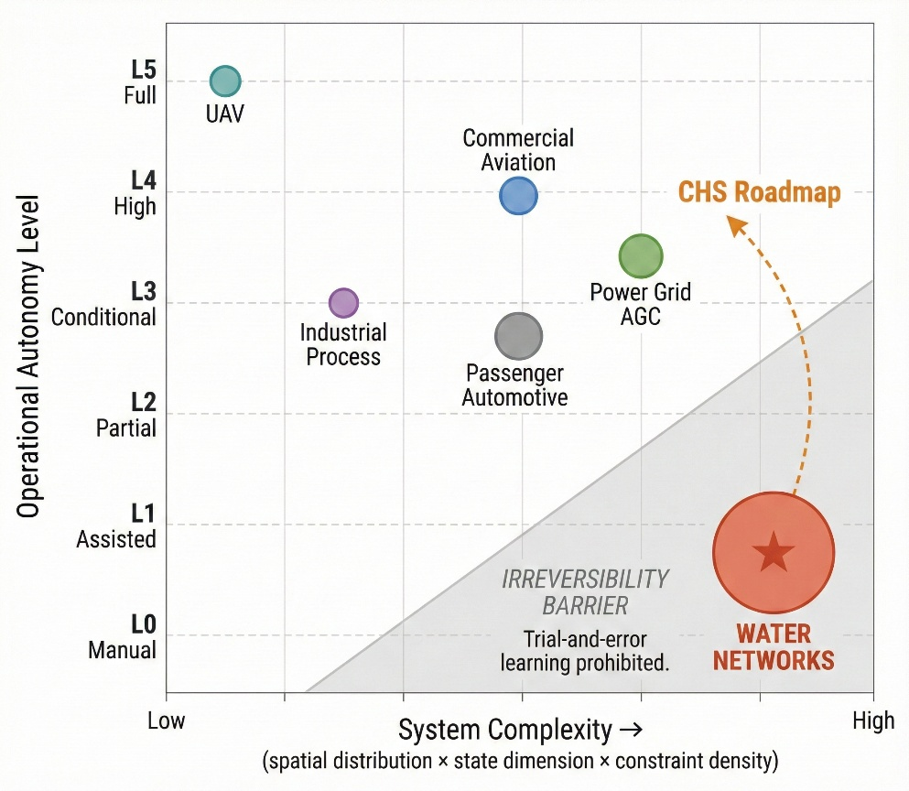
Figure 5: Cross-Sector Autonomy Positioning Map
6.1 What CHS Inherits
CHS stands on decades of foundational work (Figure 5): the canal automation community (Buyalski et al., 1991; Schuurmans, 1997; Litrico & Fromion, 2009; van Overloop, 2006; Cantoni et al., 2007; Mareels et al., 2005), the reservoir operations community (Maass et al., 1962; Yeh, 1985; Labadie, 2004; Giuliani et al., 2016), large-scale systems and distributed control theory (Jamshidi, 1983; Siljak, 1991; Zhou et al., 1996; Rawlings et al., 2017), and multi-agent systems (Wooldridge, 2009; Nedic & Ozdaglar, 2009). CHS does not claim these contributions as its own; it claims to provide the unifying structure within which they find their proper relationships.
6.2 What CHS Adds
CHS makes four contributions beyond the existing state of the art. First, unification: the structural isomorphism proposition (Section 3) demonstrates that five water subsectors share a common control-theoretic structure, enabling systematic cross-fertilization. Second, principled architecture: the eight principles with their formally identified tradeoffs (Section 4) guide design of any water network control system, replacing ad hoc engineering with principled methodology. Third, the irreversibility thesis (Section 1) provides the fundamental theoretical justification for why water systems demand a dedicated control science rather than direct method transfer from other domains. Fourth, a pathway toward autonomy: the Water Network Intelligence Levels WN-L0 through WN-L5 (Lei, 2024b), combined with the X-in-the-Loop verification methodology (Lei, 2024c), provide a graded progression with systematic verification at each stage.
6.3 The Irreversibility Challenge for AI Integration
The rapid advancement of AI has generated considerable interest in water system applications (Nearing et al., 2021; Shen et al., 2023; Karniadakis et al., 2021). The irreversibility thesis has specific implications for AI integration. Pure data-driven approaches that learn from operational experience are fundamentally constrained by the inability to explore failure states—one cannot deliberately flood a city to gather training data. CHS therefore takes a specific architectural position: physics-based models must serve as the safety-critical foundation, while AI methods serve as complementary intelligence. This dual-engine concept comprises a Physical AI engine (first-principles hydraulic models, state estimation, MPC) providing the safety-guaranteed control backbone, and a Cognitive AI engine (machine learning, natural language interfaces, anomaly detection) providing intelligent perception and decision support. Every control decision must be traceable to physical equations and verifiable against physical constraints. This distinguishes CHS from purely data-driven smart water approaches and reflects hard-won lessons from autonomous driving, where the tension between end-to-end learning and modular safety-critical architectures remains unresolved.
7 Research Agenda and Testable Predictions
CHS provides the theoretical foundation for Water Systems Operation Science and Engineering—a discipline bridging hydraulic engineering, control science, and systems engineering. We outline four research priorities and, critically, three testable predictions that distinguish CHS from a non-falsifiable taxonomy.
7.1 Priority Research Directions
First, scalable distributed control architectures: developing DMPC algorithms that scale to hundreds of interconnected subsystems with stability and constraint satisfaction guarantees, using the South-to-North Water Diversion Middle Route (64 gates, 1,432 km) as a benchmark. Second, physics-AI integration under irreversibility constraints: how should physics constraints be enforced within machine learning architectures when training on failure states is impermissible? Third, verification and validation standards: the X-in-the-Loop framework (Lei, 2024c) provides conceptual structure, but the water sector needs standardized protocols, benchmark scenarios, and acceptance criteria comparable to ISO 26262 and SOTIF (ISO, 2022) in automotive. Fourth, institutional and human factors: the Cyber-Physical-Social Systems perspective (Wang, 2010) integrates technical capabilities with institutional readiness, regulatory frameworks, and public trust.
7.2 Testable Predictions
A theory is distinguished from a taxonomy by its ability to generate testable predictions. CHS makes three:
Prediction 1. A water network control system designed according to the CHS eight-principle architecture will achieve at least 30% reduction in water level deviation (RMS) compared to current rule-based SCADA operation under identical disturbance scenarios, while maintaining zero constraint violations—the irreversibility guarantee.
Prediction 2. Cross-sector transfer will work: an MPC controller calibrated on the IDZ model of an irrigation canal pool will, upon re-parameterization of θ, achieve acceptable regulation performance on a hydropower reservoir pool or an urban pressure zone without algorithmic modification—a direct test of Proposition 1.
Prediction 3. The Decoupling–Coordination tradeoff (P2–P6) predicts an optimal ratio of local storage utilization to inter-pool communication bandwidth. This ratio can be empirically measured across different canal systems and should fall within a theoretically predicted range determined by pool geometry and delay characteristics.
Falsification of any of these predictions would require revision of the CHS framework, thereby satisfying the Popperian criterion of scientific falsifiability.
8 Conclusions
This paper has proposed Cybernetics of Hydro Systems (CHS) as a unified control-theoretic framework for water network operations. Three intellectual contributions define its scope.
First, the irreversibility thesis: water system failures are characteristically irreversible on operational timescales, which fundamentally distinguishes water control from automotive, aerospace, and industrial process control, and demands a dedicated science that places constraint inviolability at its theoretical center.
Second, structural isomorphism: all water conveyance and distribution systems share a common six-element mathematical structure (Proposition 1) and are governed by eight principles organized into Operational and Resilience Tetrads with formally identified inter-principle tradeoffs.
Third, a scientific agenda: CHS generates testable predictions that can be empirically validated or falsified, distinguishing it from descriptive classification.
CHS extends the preliminary Chinese-language framework (Lei, 2024a, 2024b, 2024c, 2024d) in four significant directions: expanding from two to eight principles with inter-principle tradeoff analysis, introducing the six-element formalization with structural isomorphism, articulating the irreversibility thesis, and providing illustrative mathematical control design. The framework is offered as a foundation for community engagement. Just as Kundur’s Power System Stability and Control (1994) provided a unified foundation for power system operations, and SAE J3016 provided a shared vocabulary for autonomous driving, CHS aims to provide a common theoretical language for the global community of water system operators, researchers, and engineers confronting the third revolution in water infrastructure science.
Open Research
This paper is a theoretical and review contribution. No new experimental data were generated. The Chinese-language source publications (Lei, 2024a, 2024b, 2024c, 2024d) are available through CNKI.
Acknowledgments
This work was supported by the National Key R&D Program of China (Grant Nos. [to be inserted]) and the National Natural Science Foundation of China (Grant Nos. [to be inserted]). The author thanks Academician Hao Wang for long-term mentorship in water resources systems science and the members of the IAHR Working Group on Water System Operations for stimulating discussions.
References
Abbott, M. B. (1991). Hydroinformatics: Information technology and the aquatic environment. Avebury Technical.
Bode, H. W. (1945). Network analysis and feedback amplifier design. D. Van Nostrand.
Buyalski, C. P., Ehler, D. G., Falvey, H. T., Rogers, D. C., & Serfozo, E. A. (1991). Canal systems automation manual (Vol. 1). U.S. Department of the Interior, Bureau of Reclamation.
Cantoni, M., Weyer, E., Li, Y., Ooi, S. K., Mareels, I., & Ryan, M. (2007). Control of large-scale irrigation networks. Proceedings of the IEEE, 95(1), 75–91. https://doi.org/10.1109/JPROC.2006.887289
Clemmens, A. J., & Schuurmans, J. (2004). Simple optimal downstream feedback canal controllers: Theory. Journal of Irrigation and Drainage Engineering, 130(1), 26–34. https://doi.org/10.1061/(ASCE)0733-9437(2004)130:1(26)
Cunge, J. A., Holly, F. M., Jr., & Verwey, A. (1980). Practical aspects of computational river hydraulics. Pitman.
Giuliani, M., Castelletti, A., Pianosi, F., Mason, E., & Reed, P. M. (2016). Curses, tradeoffs, and scalable management: Advancing evolutionary multiobjective direct policy search to improve water reservoir operations. Journal of Water Resources Planning and Management, 142(2), 04015050. https://doi.org/10.1061/(ASCE)WR.1943-5452.0000570
ISO. (2022). ISO 21448:2022 Road vehicles—Safety of the intended functionality (SOTIF).
Jamshidi, M. (1983). Large-scale systems: Modeling and control. North-Holland.
Kalman, R. E. (1960). A new approach to linear filtering and prediction problems. Journal of Basic Engineering, 82(1), 35–45. https://doi.org/10.1115/1.3662552
Karniadakis, G. E., Kevrekidis, I. G., Lu, L., Perdikaris, P., Wang, S., & Yang, L. (2021). Physics-informed machine learning. Nature Reviews Physics, 3(6), 422–440. https://doi.org/10.1038/s42254-021-00314-5
Kundur, P. (1994). Power system stability and control. McGraw-Hill.
Labadie, J. W. (2004). Optimal operation of multireservoir systems: State-of-the-art review. Journal of Water Resources Planning and Management, 130(2), 93–111. https://doi.org/10.1061/(ASCE)0733-9496(2004)130:2(93)
Lei, X. (2024a). Cybernetics of hydro systems: Principles and prospects [in Chinese: 水系统控制论：原理与展望]. [Journal name and DOI to be inserted].
Lei, X. (2024b). Next-generation autonomous smart water network architecture and key technologies based on autonomous driving concepts [in Chinese: 基于无人驾驶理念的下一代自主运行智慧水网架构与关键技术]. [Journal name and DOI to be inserted].
Lei, X. (2024c). X-in-the-Loop testing framework for autonomous smart water networks [in Chinese: 自主运行智能水网的在环测试体系]. [Journal name and DOI to be inserted].
Lei, X. (2024d). Disciplinary perspectives on water resources systems analysis: From static water balance to dynamic control [in Chinese: 水资源系统分析学科展望：从静态平衡到动态控制]. [Journal name and DOI to be inserted].
Lei, X., Wang, H., & Liao, W. (2024). Hierarchical distributed control for the South-to-North Water Diversion Middle Route. [To be inserted].
Litrico, X., & Fromion, V. (2009). Modeling and control of hydrosystems. Springer. https://doi.org/10.1007/978-1-84882-624-3
Loucks, D. P., Stedinger, J. R., & Haith, D. A. (1981). Water resource systems planning and analysis. Prentice-Hall.
Loucks, D. P., & van Beek, E. (2017). Water resource systems planning and management: An introduction to methods, models, and applications. Springer. https://doi.org/10.1007/978-3-319-44234-1
Maass, A., Hufschmidt, M. M., Dorfman, R., Thomas, H. A., Jr., Marglin, S. A., & Fair, G. M. (1962). Design of water-resource systems: New techniques for relating economic objectives, engineering analysis, and governmental planning. Harvard University Press.
Maestre, J. M., & Negenborn, R. R. (Eds.). (2014). Distributed model predictive control made easy. Springer. https://doi.org/10.1007/978-94-007-7006-5
Mareels, I. M. Y., Weyer, E., Ooi, S. K., Cantoni, M., Li, Y., & Nair, G. (2005). Systems engineering for irrigation systems: Successes and challenges. Annual Reviews in Control, 29(2), 191–204. https://doi.org/10.1016/j.arcontrol.2005.08.001
Maxwell, J. C. (1868). On governors. Proceedings of the Royal Society of London, 16, 270–283. https://doi.org/10.1098/rspl.1867.0055
MWR (Ministry of Water Resources, China). (2022). Guiding opinions on vigorously promoting smart water conservancy construction [in Chinese: 关于大力推进智慧水利建设的指导意见].
Nearing, G. S., Kratzert, F., Sampson, A. K., Pelissier, C. S., Klotz, D., Frame, J. M., Priber, C., & Gupta, H. V. (2021). What role does hydrological science play in the age of machine learning? Water Resources Research, 57(3), e2020WR028091. https://doi.org/10.1029/2020WR028091
Nedić, A., & Ozdaglar, A. (2009). Distributed subgradient methods for multi-agent optimization. IEEE Transactions on Automatic Control, 54(1), 48–61. https://doi.org/10.1109/TAC.2008.2009515
Negenborn, R. R., van Overloop, P. J., Keviczky, T., & De Schutter, B. (2009). Distributed model predictive control of irrigation canals. Networks and Heterogeneous Media, 4(2), 359–380. https://doi.org/10.3934/nhm.2009.4.359
Nyquist, H. (1932). Regeneration theory. Bell System Technical Journal, 11(1), 126–147. https://doi.org/10.1002/j.1538-7305.1932.tb02344.x
Preissmann, A. (1961). Propagation des intumescences dans les canaux et rivières. In Proceedings of the 1st Congress of the Association Française de Calcul (AFCAL), Grenoble, France, 433–442.
Rawlings, J. B., Mayne, D. Q., & Diehl, M. (2017). Model predictive control: Theory, computation, and design (2nd ed.). Nob Hill Publishing.
RTCA. (2011). DO-178C: Software considerations in airborne systems and equipment certification.
SAE International. (2021). J3016: Taxonomy and definitions for terms related to driving automation systems for on-road motor vehicles (Revision J3016_202104).
Saint-Venant, A. J. C. B. de. (1871). Théorie du mouvement non-permanent des eaux, avec application aux crues des rivières et à l’introduction des marées dans leur lit. Comptes Rendus des Séances de l’Académie des Sciences, 73, 147–154, 237–240.
Savic, D. (2022). Digital water developments and lessons learned from automation in the car and aircraft industries. Engineering, 9(2), 35–41. https://doi.org/10.1016/j.eng.2021.05.013
Schuurmans, J. (1997). Control of water levels in open channels (Doctoral dissertation). Delft University of Technology.
Shen, C., Appling, A. P., Gentine, P., Bandai, T., Gupta, H., Tartakovsky, A., Baber, M., Bisht, G., Boyce, S., Brenowitz, N., et al. (2023). Differentiable modelling to unify machine learning and physical models for geosciences. Nature Reviews Earth & Environment, 4(8), 552–567. https://doi.org/10.1038/s43017-023-00450-9
Siljak, D. D. (1991). Decentralized control of complex systems. Academic Press.
Streeter, V. L., & Wylie, E. B. (1967). Hydraulic transients. McGraw-Hill.
SWAN (Smart Water Networks Forum). (2022). About SWAN. Retrieved from https://www.swan-forum.com
UNESCO. (2024). The United Nations World Water Development Report 2024: Water for prosperity and peace. UNESCO.
van Overloop, P. J. (2006). Model predictive control on open water systems (Doctoral dissertation). Delft University of Technology.
Wang, F.-Y. (2010). The emergence of intelligent enterprises: From CPS to CPSS. IEEE Intelligent Systems, 25(4), 85–88. https://doi.org/10.1109/MIS.2010.104
Wiener, N. (1948). Cybernetics: Or control and communication in the animal and the machine. Hermann & Cie / John Wiley & Sons.
Wooldridge, M. (2009). An introduction to multiagent systems (2nd ed.). Wiley.
Yeh, W. W.-G. (1985). Reservoir management and operations models: A state-of-the-art review. Water Resources Research, 21(12), 1797–1818. https://doi.org/10.1029/WR021i012p01797
Zhou, K., Doyle, J. C., & Glover, K. (1996). Robust and optimal control. Prentice Hall.

Figure Captions
Figure 1. Three revolutions in water infrastructure science. Revolution I (1850s): mathematization of hydraulics transformed design from art to science. Revolution II (1960s): systems analysis enabled optimization of water allocation across interconnected infrastructure. Revolution III (2020s): Cybernetics of Hydro Systems provides the theoretical foundation for real-time, feedback-driven, safety-guaranteed autonomous operation.

Figure 2. The CHS six-element controlled dynamical system architecture. All water systems share this feedback loop structure: Objective (O) provides reference signals; the Controller computes control actions; the Actuator (A) implements them on the Plant (P); the Sensor (S) measures the response; Disturbance (D) enters the Plant externally; and Constraint (C) imposes absolute operational boundaries reflecting the irreversibility thesis.

Figure 3. The eight CHS principles organized into dual tetrads with inter-principle tradeoffs. The Operational Tetrad (blue) addresses control effectiveness; the Resilience Tetrad (orange) addresses robustness under uncertainty. Dashed lines between tetrads indicate the four fundamental tradeoffs (Section 4.3) that define the feasible design space.

Figure 4. Multi-scale model hierarchy (left) and corresponding control architecture layers (right). Each reduced-order model operates at the timescale where its approximation errors are acceptable. The hierarchy implements the order reduction principle (P3) and the hierarchy principle (P8) simultaneously.

Figure 5. Cross-sector autonomy positioning map. Water networks occupy a unique position: highest system complexity combined with lowest operational autonomy, bounded by the irreversibility barrier. The CHS roadmap indicates the trajectory toward higher autonomy enabled by the framework proposed in this paper.

