CHS Water Resources Research (v9) — Figure Generation Prompts
共5张图。每张提供：英文主提示词（可直接复制到Midjourney/GPT-4o/Ideogram）、中文设计说明、技术规格。 WRR单栏宽度约84mm，双栏约174mm。建议所有图均按双栏宽度设计。

Figure 1 — The CHS Six-Element Controlled Dynamical System Architecture
主提示词（English Prompt）
Create a professional control engineering block diagram for a Water Resources Research journal paper showing a closed-loop feedback control architecture with six labeled elements.
The diagram should use a classic control-system feedback loop layout. Starting from the left side, an element labeled "O — Objective" provides reference signals (water level setpoints, flow targets, environmental constraints). These reference signals enter a summing junction where they are compared with feedback measurements. The error signal flows rightward into a large block labeled "C — Controller" (representing the CHS hierarchical distributed control stack: Layer 0 safety, Layer 1 regulation, Layer 2 coordination, Layer 3 planning). The controller output (control commands) flows rightward into a block labeled "A — Actuator" (gates, pumps, valves, turbines). The actuator output flows into the main process block labeled "P — Plant" (governed by Saint-Venant equations, the largest block in the diagram). The plant output (water levels, flows, pressures) flows rightward and then downward through a block labeled "S — Sensor" (water level gauges, flow meters, pressure transducers, SCADA telemetry). The sensor output feeds back leftward to the summing junction, completing the feedback loop.
Additionally, a separate input enters the Plant block from above, labeled "D — Disturbance" (rainfall, demand changes, equipment failures), drawn with a dashed red arrow to distinguish it from controlled signals.
Around the entire feedback loop, draw a prominent boundary envelope with a bold dashed line labeled "Constraint Envelope (OS1: Failure Irreversibility)" in dark red or orange. This envelope represents the absolute operational boundaries that must never be violated. Place small warning shield icons at key constraint points (maximum water level, minimum ecological flow, maximum pipe pressure).
Color coding: Plant block in deep blue (#1565C0), Actuator in green (#4CAF50), Sensor in amber (#FFA000), Controller in dark blue (#0D47A1), Objective in purple (#7B1FA2), Disturbance arrow in red (#F44336), Constraint envelope in dark orange (#E65100). All blocks should have rounded corners and clean flat vector style.
At the bottom of the figure, display the formal notation: Σ = (P, A, S, D, C, O) with a caption "Definition 2: Water Control System".
Style: academic engineering diagram suitable for AGU journals. White background. Sans-serif font (Helvetica or Arial). Clean lines with consistent 2pt stroke weight. Dimensions 174mm wide by 90mm tall at 300 dpi.

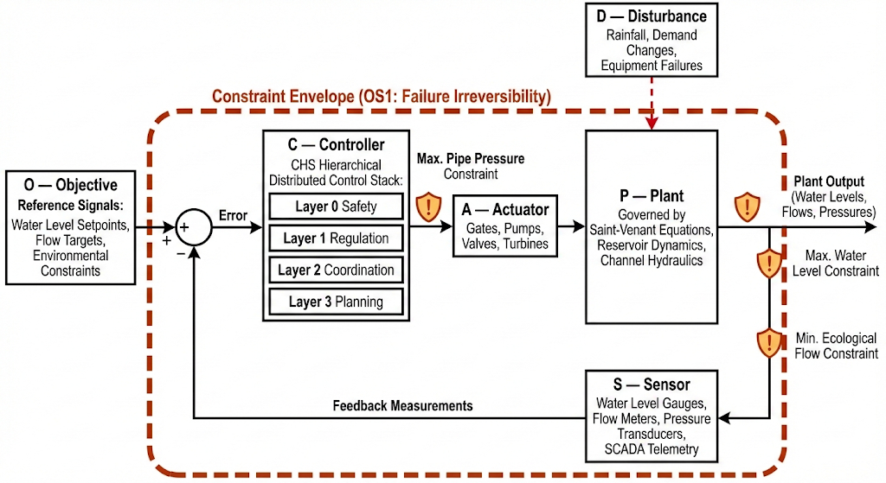

中文设计说明
这是CHS理论的"定义图"——用经典控制工程语言表达水系统的通用架构。核心设计要点：
（1）布局采用标准的反馈控制框图结构（参考《过程控制》教科书经典布局），但在六个要素的呈现上做了水利领域定制——每个方框内标注水利具体实例（如P框内写Saint-Venant方程，A框内标注闸门/水泵/阀门/水轮机等），使水利读者立即感到"这跟我的系统对得上"。
（2）扰动D用虚线红色箭头从上方进入P模块，视觉上与受控信号（黑色实线）明确区分。
（3）约束包络线是全图最重要的视觉创新——用醒目的橙红色虚线边框围住整个控制回路，代表OS1（失效不可逆性）所要求的"绝对不可违反"的运行约束。这是CHS区别于其他控制理论的关键特征：约束不是优化目标的一部分，而是外在的、不可谈判的物理边界。
（4）底部公式 Σ = (P, A, S, D, C, O) 将图与论文§3.1 Definition 2形成明确对应。
技术规格
- 尺寸：174 × 90 mm（WRR双栏宽度）
- 分辨率：300 dpi（印刷）/ 600 dpi（在线）
- 格式：矢量优先（EPS/PDF/SVG），备选高分辨PNG
- 字号：方框标签≥9pt，注释≥7pt
- 推荐工具：PPT/Illustrator手绘（精确控制方框和箭头位置），AI工具仅做配色参考

Figure 2 — The Unified Model Hierarchy
主提示词（English Prompt）
Create a sophisticated academic diagram for Water Resources Research showing a five-level model reduction hierarchy for water system dynamics, organized as two parallel branches that merge at the top and bottom.
The diagram has a vertical axis representing model complexity, decreasing from top to bottom. The top level is labeled "Level 5: Linearized Saint-Venant (LSV)" and represents the most detailed model. Each subsequent level below represents a principled mathematical reduction.
The left branch is labeled "Family α — Integrating Processes (open channels with free outflow)" and is colored in shades of blue. It contains four levels descending: Level 5 LSV at the top (shared with both branches); Level 4 IDZ (Integrator-Delay-Zero) with transfer function G(s) = (1 + τₘs) · e^(−τᵈs) / (Aₛ · s); Level 3 ID (Integrator-Delay) with G(s) = e^(−τᵈs) / (Aₛ · s); Level 2 I (Pure Integrator) with G(s) = 1 / (Aₛ · s); and Level 1 SS (Steady-State) at the bottom showing the algebraic mass balance Q_in = Q_out.
The right branch is labeled "Family β — Self-Regulating Processes (channels with downstream control)" and is colored in shades of teal or green. It contains: Level 5 LSV shared at top; Level 4 Self-Regulating IDZ with transfer function H(s) = (1 − KXs) / (1 + K(1−X)s); Level 3 and below merging back into the integrating branch as special cases.
Between the two branches at Level 4, draw a prominent horizontal double-headed arrow labeled "Muskingum–IDZ Duality (Corollary 1)" connecting the IDZ model on the left to the Muskingum model on the right. Add a small annotation: "H(s) ≈ first-order MacLaurin of G_sr(s)".
At the very bottom, draw a separate horizontal band labeled "Actuator Reduction (Lemma 3)" showing four actuator icons (gate, pump, valve, turbine) all mapping to the same linearized boundary condition: ΔQ = αΔu + β_up ΔH_up + β_dn ΔH_dn. Use a green accent color for this band.
Between each level, draw downward arrows labeled with the specific mathematical operation: "set τₘ → 0" between Level 4 and 3, "set τᵈ → 0" between Level 3 and 2, "set ddt → 0" between Level 2 and 1.
On the right side of the figure, add a vertical arrow labeled "Increasing model fidelity" pointing upward, and below it "Increasing computational speed" pointing downward.
Along the left margin, add the corresponding control layer labels: "L3 Planning" aligned with Level 1–2, "L2 Coordination" aligned with Level 2–3, "L1 Regulation" aligned with Level 3–4, "L0 Safety" below Level 1 at the actuator band. Connect these with horizontal dashed lines to indicate the model–layer correspondence (Theorem 3).
Style: clean academic vector diagram. White background. Blue gradient for Family α, teal/green gradient for Family β. Mathematical notation in italic serif font. All other text in sans-serif. Dimensions 174mm wide by 130mm tall at 300 dpi.
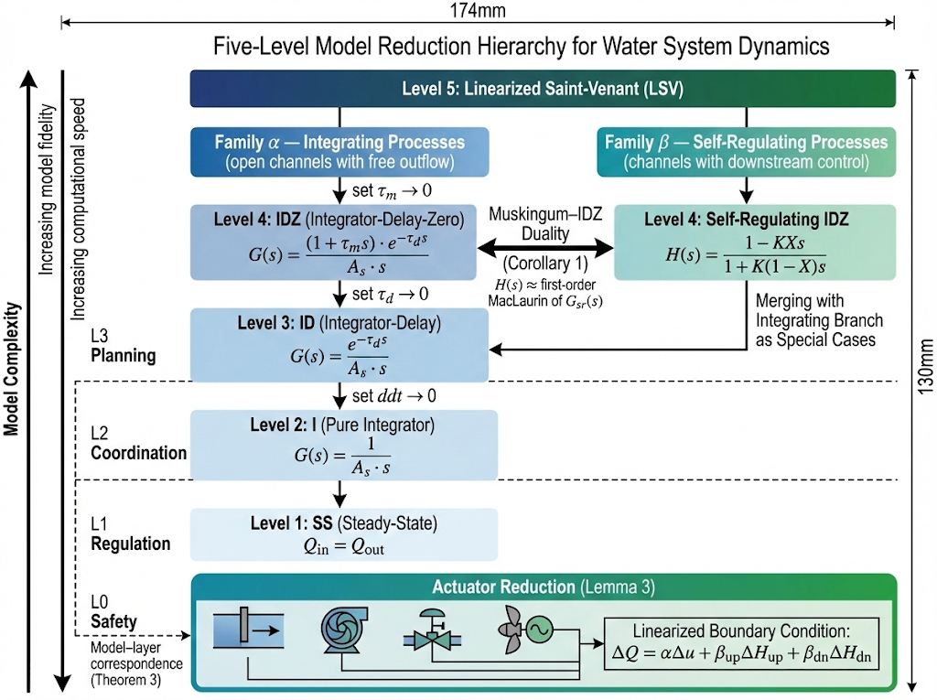
中文设计说明
这是WRR论文数学核心的视觉表达——Theorem 2（统一传递函数族）的图形化呈现。设计有三层信息需要同时传达：
（1）纵向降阶逻辑：从上到下，五级模型通过三次数学简化（消τₘ→消τᵈ→消导数项）逐步降低复杂度。每次降阶的数学操作需要在箭头旁明确标注，让读者理解这不是随意分层而是有数学支撑的原理性降阶。
（2）横向双族对偶：Family α（积分型，自由出流）与Family β（自调节型，受控下游）在Level 4通过Muskingum–IDZ对偶性桥接。这是论文最核心的数学发现之一——水文学的Muskingum和渠道自动化的IDZ其实是同一物理的对偶表示。双向箭头需要醒目标注Corollary 1。
（3）模型-控制层级对应：左侧标注L0-L3控制层级与模型层级的对应关系（Theorem 3），用虚线连接。这传达了CHS的设计哲学：不是选一个"最好的"模型，而是在不同控制层级选"刚好足够精细"的模型。
底部的执行器降阶带（Lemma 3）补充了植被动态之外的执行器边界条件统一，使图完整覆盖"对象+执行器"两个维度。
技术规格
- 尺寸：174 × 130 mm
- 分辨率：300 dpi
- 格式：矢量优先
- 配色：Family α蓝色系(#1565C0→#64B5F6)，Family β绿色系(#00897B→#80CBC4)，执行器带(#4CAF50)
- 特殊要求：数学公式需清晰可读，建议用LaTeX渲染后嵌入

Figure 3 — Model–Layer Correspondence
主提示词（English Prompt）
Create a dual-column correspondence diagram for Water Resources Research showing how model complexity levels map to control architecture layers in water systems.
The left column is titled "Model Hierarchy (Plant Dynamics)" and contains five stacked horizontal bars of decreasing width from top to bottom, representing decreasing model complexity. The bars are colored in a blue gradient from deep blue at top to light blue at bottom. From top to bottom: "Level 5: Linearized Saint-Venant (PDE, full dynamics)" with timescale label "seconds"; "Level 4: IDZ / Muskingum (transfer function)" with "minutes"; "Level 3: Integrator-Delay (reduced TF)" with "minutes–hours"; "Level 2: Pure Integrator (ODE)" with "hours–days"; "Level 1: Steady-State (algebraic)" with "days–years". Between each pair of bars, show a small downward arrow with the label of the specific mathematical reduction (e.g., "eliminate zero dynamics", "eliminate transport delay", "eliminate storage dynamics").
The right column is titled "Control Architecture (Decision Layer)" and contains four stacked horizontal bars, colored in an orange-to-amber gradient. From bottom to top: "Layer 0: Safety Floor (PLC interlocks, ms)" with a red shield icon; "Layer 1: Real-time Regulation (MPC, s–min)" with a feedback loop icon; "Layer 2: Coordination (DMPC, min–h)" with a network icon; "Layer 3: Planning (Nested Optimization, d–yr)" with a calendar icon.
Between the two columns, draw dashed horizontal arrows connecting each model level to the control layer(s) that use it. Level 5 connects to Layer 1 (most detailed model for fastest regulation). Level 4 connects to Layer 1 (primary regulation model). Level 3 connects to Layer 2 (coordination). Level 2 connects to Layers 2 and 3. Level 1 connects to Layer 3. These arrows should be labeled "Theorem 3" collectively.
At the bottom, include a horizontal timescale ruler spanning from "ms" on the left to "years" on the right, with logarithmic spacing, showing how both model fidelity and control layer temporal scope are organized along the same time axis.
Add an annotation box: "Design Principle: 'Just Precise Enough' — each layer uses the simplest model whose approximation errors are acceptable at that temporal scope."
Style: symmetric, balanced dual-column layout. White background. Blue for models, amber/orange for control layers. Clean vector style suitable for AGU journals. Dimensions 174mm wide by 110mm tall at 300 dpi.
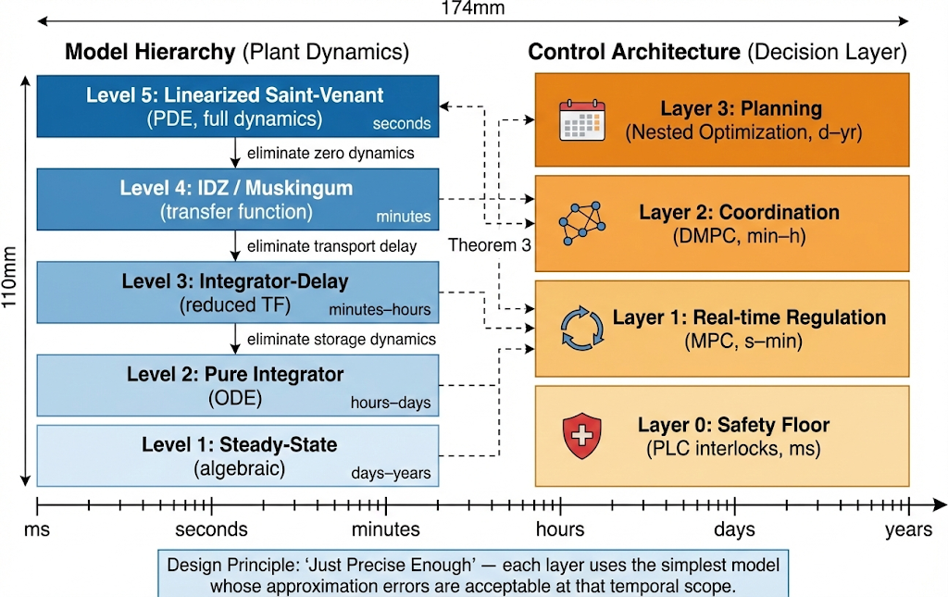
中文设计说明
这张图是Theorem 3的直接可视化——模型层级与控制层级的一一对应关系。核心设计理念：
左侧模型层级用蓝色梯度从深到浅表示复杂度递减，右侧控制层级用橙色梯度表示决策速度递减。两列之间的虚线箭头是全图关键——它们传达了CHS的"刚好足够精细"（Just Precise Enough）设计原则：不是用最精确的模型做所有事，而是在每个控制层级选用"误差在该时间尺度可接受"的最简模型。
底部时间尺做为统一的参照轴，把模型保真度和控制决策范围都锚定在同一个时间维度上，帮助读者理解为什么ms级安全保护只需要阈值逻辑（最简模型），而s-min级实时调节需要IDZ传递函数（中等模型）。
这张图与Figure 2互补但不重复：Figure 2展示"降阶的数学路径"，Figure 3展示"降阶的工程意义"（为什么降、降到哪一级、给谁用）。
技术规格
- 尺寸：174 × 110 mm
- 分辨率：300 dpi
- 格式：矢量优先
- 配色：模型列蓝色系(#1565C0→#90CAF9)，控制列橙色系(#E65100→#FFB74D)
- 推荐工具：PPT/Illustrator手绘效果最好

Figure 4 — The Eight CHS Principles: Dual Tetrads with Tradeoffs
主提示词（English Prompt）
Create an elegant academic diagram for Water Resources Research showing eight governing principles organized into two groups of four, with tradeoff relationships between them.
The layout consists of two concentric or adjacent quadrilateral shapes (tetrads), arranged as follows.
On the left side, draw a square or diamond shape labeled "Operational Tetrad" colored in blue (#1565C0). At each of its four vertices, place a labeled node: top vertex "P1: Feedback" with a small circular arrow icon; right vertex "P2: Decoupling" with a scissors or separation icon; bottom vertex "P3: Order Reduction" with a downward compression icon; left vertex "P4: Emergence" with an upward branching network icon. Each node should have a one-line description: P1 "Close the loop: measure → compute → actuate"; P2 "Isolate disturbances locally via storage buffering"; P3 "Match model complexity to control timescale"; P4 "Local rules produce global coordination patterns".
On the right side, draw a similar square or diamond labeled "Resilience Tetrad" colored in amber/orange (#FF8F00). Its four vertices: top "P5: Robustness" with a shield icon and description "Guarantee performance under worst-case uncertainty"; right "P6: Coordination" with connected nodes icon and "Align distributed subsystem actions toward global objectives"; bottom "P7: Adaptation" with a learning curve icon and "Update parameters and models as conditions change"; left "P8: Hierarchy" with a layered pyramid icon and "Nest control loops by timescale: fast inner, slow outer".
Between the two tetrads, draw four dashed diagonal lines connecting specific principle pairs that exhibit fundamental tradeoffs. Each line should be labeled: P1–P5 "Feedback bandwidth vs. robustness margin" (faster feedback improves tracking but reduces stability margin); P2–P6 "Local autonomy vs. global coordination" (more decoupling reduces communication need but limits system-wide optimality); P3–P7 "Model simplicity vs. adaptation fidelity" (simpler models are faster but less adaptable to changing conditions); P4–P8 "Emergent behavior vs. hierarchical oversight" (emergence enables scalability but complicates top-down guarantees). These four tradeoff lines should cross in the center to form a visual "X" or diamond pattern.
Below the diagram, add a small legend: "Blue = Operational Tetrad (control effectiveness); Orange = Resilience Tetrad (robustness under uncertainty); Dashed lines = fundamental inter-principle tradeoffs (Section 5.3)".
Style: clean, symmetric, visually balanced. White background. No photographs. Flat vector design with subtle gradients. Academic quality suitable for AGU journals. Dimensions 174mm wide by 100mm tall at 300 dpi.
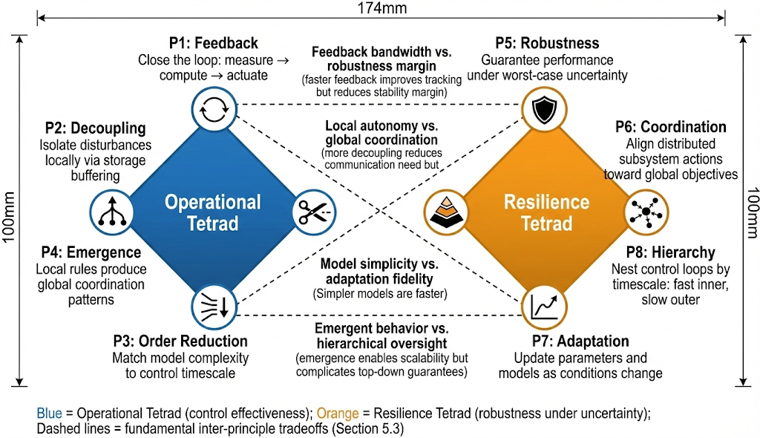

中文设计说明
这张图将CHS的八项原理从文字表格（Table 3）转化为视觉化的结构关系图。核心设计理念：
（1）双四元组结构：运行四元组（蓝色，关注"控制做得好不好"）和韧性四元组（橙色，关注"出问题时撑不撑得住"）分别形成一个四边形，四个顶点分别对应四个原理。这种布局传达了CHS原理不是一个线性列表，而是两组有内在逻辑的对称结构。
（2）权衡关系线：连接两个四元组的四条虚线是全图最重要的信息——CHS原理之间不是"越多越好"的简单叠加，而是存在根本性的权衡取舍。例如P2（解耦：让子系统尽量独立）与P6（协调：让子系统对齐全局目标）之间的矛盾是分布式控制的核心设计张力。四条权衡线交叉形成的"X"图案也暗示了工程设计中的"不可能三角"思维。
（3）图标选择：每个原理配一个小图标，帮助读者在不阅读文字的情况下直觉理解原理含义。图标风格需统一（线条图标，不要填充式图标）。
技术规格
- 尺寸：174 × 100 mm
- 分辨率：300 dpi
- 格式：矢量优先
- 配色：运行四元组(#1565C0 深蓝)，韧性四元组(#FF8F00 琥珀橙)，权衡线(#757575 中灰虚线)
- 特殊要求：左右对称，两个四元组大小相同

Figure 5 — Water Systems Autonomy Levels (WSAL)
主提示词（English Prompt）
Create a visually compelling academic infographic for Water Resources Research showing the Water Systems Autonomy Levels, a five-level classification for water network automation maturity. The design should evoke the well-known SAE J3016 autonomous driving levels but be adapted specifically for water infrastructure, reflecting the unique constraints of failure irreversibility and the impossibility of controlled testing.
The layout uses an ascending staircase or stepped-bar visualization progressing from left at WSAL-1 to right at WSAL-5. Each step is progressively higher than the previous one, representing increasing autonomy. The color gradient progresses from cool gray at WSAL-1 through increasingly saturated blues to deep navy at WSAL-5.
WSAL-1 is labeled "Remote Monitoring" in gray (#9E9E9E). The human role reads "Full manual control; all decisions by operators". The system capability reads "Data acquisition, display, and alarm annunciation". The technology label is "SCADA only". Show a small icon of a human operator sitting at a console with monitoring screens.
WSAL-2 is labeled "Assisted Control" in light blue (#64B5F6). The human role reads "Confirms all commands; handles all scenario transitions". The system capability reads "HDC executes control for predefined typical scenarios". The technology label is "SCADA + HDC (partial Layer 1)". Show an icon of a human reviewing AI recommendations on screen. Add a prominent star badge reading "Current frontier" with example annotations "Shaoping cascade MPC" and "Jiaodong multi-timescale integration".
Between WSAL-2 and WSAL-3, insert a visually emphasized callout spanning the gap between the two steps. This callout should have a contrasting gold or amber border (#FFA000) and be labeled "CRITICAL NEAR-TERM TRANSITION". Include the text: "Requires systematic xIL verification (MiL → SiL → HiL → PiL) to certify ODD boundaries, enabling operators to release manual control within certified conditions. This is the 'letting go' moment — analogous to SAE Level 2 → Level 3 in driving."
WSAL-3 is labeled "Conditional Autonomy" in medium blue (#1E88E5). The human role reads "Monitors ODD boundaries; intervenes only at boundary approach". The system capability reads "Autonomous operation within certified ODD; automatic fallback at boundaries". The technology label is "SCADA + HDC + xIL verification".
Between WSAL-3 and WSAL-4, add a secondary callout labeled "Architectural Transition: HDC → MAS" with the annotation "Adding Cognitive Intelligence for scenario recognition, goal assembly, and autonomous mode switching".
WSAL-4 is labeled "High Autonomy" in deep blue (#1565C0). The human role reads "Strategic oversight; rare intervention for novel scenarios". The system capability reads "MAS handles most scenarios including novel ones via cognitive reasoning". The technology label is "SCADA + MAS (HDC + Cognitive AI)". Show a multi-agent network icon.
WSAL-5 is labeled "Full Autonomy" in navy (#0D47A1). The human role reads "Strategic governance only". The system capability reads "Self-expanding ODD through continuous learning; handles all foreseeable conditions". The technology label is "SCADA + MAS (full ODD + self-evolution)". Show a fully autonomous network icon with expanding boundary.
Along the bottom, draw a horizontal arrow labeled "ODD Coverage" expanding from "Limited predefined scenarios" on the left to "All operating conditions" on the right. Along the right edge, draw a vertical arrow labeled "Required Verification and Trust" increasing from bottom to top.
At the very bottom of the staircase (below WSAL-1), draw a horizontal bar spanning the full width labeled "Layer 0 Safety Floor: PLC Interlocks — ALWAYS ACTIVE regardless of WSAL level" with a red shield icon (#F44336) and annotation "No upper-layer decision may override (OS1: Failure Irreversibility)".
Add two annotation boxes in the margins: (1) Near WSAL-2→3 gap: "Near-term priority: xIL verification enables operators to 'let go' with confidence"; (2) Near WSAL-3→4 gap: "From HDC to MAS: adding a Cognitive AI engine alongside Physical AI".
Style: infographic quality suitable for AGU journals. Clean and modern with subtle gradients. White background. English text throughout. Sans-serif font. Color palette restricted to grays and blues with gold/amber accent for the critical transition callout and red accent for the safety floor. Dimensions 174mm wide by 110mm tall at 300 dpi.
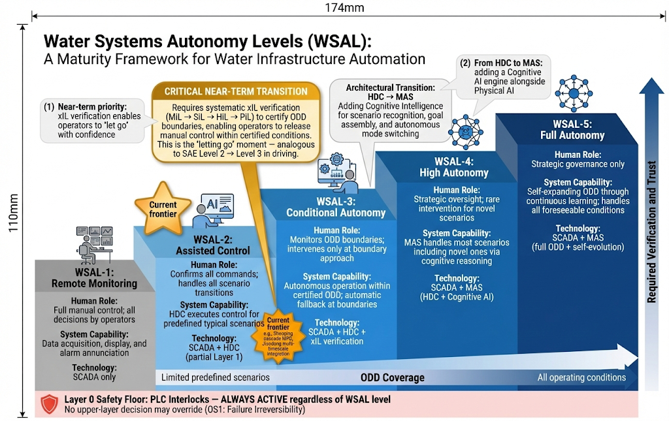
中文设计说明
这是WRR论文最具政策影响力的图——为全球水利行业提供一个"自动化成熟度量表"。核心设计要点：
（1）视觉隐喻：阶梯式上升暗示难度递增。WSAL-2→3的台阶间距应当最大（表示近期最难跨越的挑战），WSAL-4→5间距也较大（表示远期愿景的不确定性）。每一级的颜色加深暗示自主程度提升。
（2）两个关键转折点：WSAL-2→3用金色/琥珀色边框强调"关键近期转型"——这是整个水利行业从"人确认每一条指令"到"系统自主运行、人只监督边界"的质变时刻，其核心使能技术是xIL验证体系。WSAL-3→4用次级标注强调"架构质变"——从纯物理模型控制（HDC）到加入认知智能（MAS）。
（3）Layer 0安全底线：底部红色横条贯穿全图宽度，传达一个不可妥协的设计原则：无论自主等级多高，PLC硬连锁保护永远在线运行，任何上层决策都不能覆盖它。这是水系统OS1（失效不可逆性）在架构层面的体现。
（4）与SAE J3016的关联与区别：读者会自然联想到自动驾驶分级，但WSAL有三个水利特有设计：桶原理（整体等级=最低子系统等级）、安全底线不可逾越、ODD边界管理（因为水系统不能像汽车那样"靠边停车"）。
技术规格
- 尺寸：174 × 110 mm
- 分辨率：300 dpi
- 格式：矢量优先
- 配色：灰(#9E9E9E)→浅蓝(#64B5F6)→中蓝(#1E88E5)→深蓝(#1565C0)→藏蓝(#0D47A1)，关键转折琥珀(#FFA000)，安全底线红(#F44336)

统一设计规范
配色方案（全5张图统一）
语义角色 | 色值 | 应用场景
Plant / Model / Physical AI | #1565C0 (Deep Blue) | Figure 1 Plant框、Figure 2 Family α、Figure 3 模型列、Figure 5 WSAL高级别
Actuator / Safety / ODD | #4CAF50 (Green) | Figure 1 Actuator框、Figure 2 执行器带
Sensor / Feedback | #FFA000 (Amber) | Figure 1 Sensor框、Figure 3 控制列
Controller / Objective | #0D47A1 / #7B1FA2 (Navy / Purple) | Figure 1 Controller框和Objective框
Disturbance / Safety Floor | #F44336 (Red) | Figure 1 扰动箭头、Figure 5 L0安全底线
Resilience Tetrad | #FF8F00 (Amber Orange) | Figure 4 韧性四元组
Critical Transition | #FFA000 (Gold Amber) | Figure 5 WSAL-2→3转折标注
Background | #FFFFFF (White) | 所有图
Auxiliary lines / text | #757575 / #212121 | 辅助线、正文
工具选择策略
Figure 1（六元架构图）：控制框图布局高度规则化，推荐PPT或Illustrator手绘，AI工具难以精确控制信号流箭头走向。
Figure 2（模型层级图）：信息密度最高（数学公式+双分支+执行器带+控制层级对应），推荐分解为两步——先用AI工具（如Claude Artifacts）生成基本布局概念图，再在Illustrator中精修公式排版和对齐。
Figure 3（模型-控制对应图）：左右对称结构相对简单，PPT SmartArt + 手动调整即可。关键是保证左右两列的水平对齐关系精确。
Figure 4（八原理双四元组图）：几何对称性要求高，推荐在Illustrator中用网格精确绘制两个四边形和连接线。AI工具适合生成配色和风格参考。
Figure 5（WSAL分级图）：最适合AI辅助生成初始概念——阶梯式信息图的视觉语言已在自动驾驶领域有大量先例。建议先用GPT-4o/Midjourney生成概念稿，再在PPT中手动重建以确保标注文字的精确位置。
WRR投稿图片要求
WRR（AGU期刊）对图片的具体技术要求：线条图（如本文全部5张）需要至少600 dpi，灰度或彩色均可；文件格式接受TIFF、EPS、PDF；图中最小字号不小于6pt；线条最小宽度0.5pt；颜色建议同时适合彩色印刷和灰度打印（确保在灰度模式下各元素仍可区分）。建议最终提交前在灰度模式下检查所有图的可辨识性。

Nature Water Perspective — Figure Generation Prompts
共3张图，每张提供英文主提示词 + 中文补充说明 + 技术规格。 建议工具：Midjourney / GPT-4o / Ideogram（概念布局）→ PPT / Illustrator（精修标注）

Figure 1 — Three-Phase Evolution of Water Resources Systems Analysis
主提示词
Create a professional academic figure for a Nature-family journal showing the three-phase evolution of water resources systems analysis, using a horizontal timeline layout.
The figure has three distinct phases arranged left to right along a timeline arrow spanning from 1950s to the present.
Phase I occupies the left zone with a warm sand or beige background tint. Its header reads "Water Balance and Planning Design, 1950s to 1980s". The central question displayed prominently is "What to build?" Below the header, show a simplified dam cross-section icon and a storage-yield curve. Include milestone labels for Rippl 1883 and Harvard Water Program 1962. At the bottom, display a timescale badge reading "Annual" and a small mathematical notation showing the algebraic mass balance equation delta-S equals Q-in minus Q-out.
Phase II occupies the center zone with a teal or muted green background tint. Its header reads "Optimal Allocation and Integrated Management, 1990s to 2010s". The central question is "How much to allocate?" Show a network graph icon with nodes and weighted edges, plus a small Pareto frontier curve. Milestone labels include IWRM and multi-objective optimization. The timescale badge reads "Monthly to Annual" and the math notation shows an optimization formulation min f(x) subject to constraints.
Phase III occupies the right zone with a deep blue background tint, slightly larger than the other two to emphasize its importance. Its header reads "Dynamic Control and Autonomous Operation, 2020s onward". The central question is "How to deliver in real time?" Show a closed-loop feedback diagram with circular arrows representing sense-decide-act-feedback. Milestone labels include Cybernetics of Hydro Systems and MAS architecture. The timescale badge reads "Seconds to Years" and the math notation shows the Saint-Venant partial differential equation.
Between Phase II and Phase III, add a prominent callout labeled "Paradigm Shift" with a visual emphasis element such as a gear-shift icon or a bold dividing line, to highlight that this transition represents a qualitative change from algebraic optimization to dynamic control.
Style requirements: modern data visualization aesthetic suitable for Nature or Science journals. White background. Clean visual hierarchy with limited color palette using three main colors. All text in English. Sans-serif font such as Helvetica. No photographs or realistic imagery. Flat vector style. Dimensions 180mm wide by 70mm tall at 300 dpi.
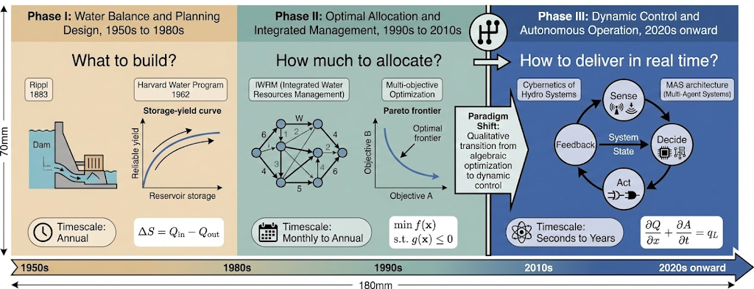
中文补充说明
这张图是论文的学科定位核心图。三个阶段分别对应WRSA的"建什么→配多少→怎么调"演进逻辑。Phase II到Phase III之间的"范式转变"标注是全文论证的关键视觉锚点——从代数优化到动态控制的质变。配色上，Phase III用深蓝色且面积略大，暗示这是文章主要贡献所在。
技术规格
- 尺寸：180 × 70 mm（Nature单栏宽度约89mm，双栏宽度约183mm，此图应横跨双栏）
- 分辨率：300 dpi（印刷质量）
- 格式：优先矢量格式（SVG/EPS/PDF），备选PNG
- 字号：标题≥9pt，正文标注≥7pt（Nature最小字号要求）

Figure 2 — Autonomous Water Network Architecture
主提示词
Create a sophisticated architecture diagram for a Nature Water journal paper showing the autonomous water network architecture. The diagram should communicate the core equation MAS equals HDC plus ODD plus Cognitive Intelligence.
The figure has two main sections: a top section showing three pillars side by side, and a bottom section showing how these pillars integrate within a single intelligent agent.
The top section contains three large rounded rectangles arranged horizontally.
The first pillar on the left uses a blue gradient and is labeled "HDC: Physical AI Engine" with the subtitle "Compute accurately". Inside this pillar, show layered horizontal bands representing the four control layers: Layer 0 for safety protection at millisecond scale, Layer 1 for real-time regulation at seconds to minutes, Layer 2 for coordination at minutes to hours, and Layer 3 for planning at days to years. Include small icons suggesting mechanistic models and optimization. Key capability labels read: state reconstruction, predictive control, and constraint enforcement.
The second pillar in the center uses a green gradient and is labeled "ODD: Operational Design Domain" with the subtitle "Define safe boundaries". Inside, show a boundary envelope diagram: a solid inner region representing verified operating conditions labeled "Certified ODD", surrounded by a dashed expanding boundary representing ODD expansion through systematic testing. Include scenario categories inside the envelope such as normal flow, pump transitions, and drought response. Key labels read: scenario classification, xIL verification, and boundary management.
The third pillar on the right uses a purple gradient and is labeled "Cognitive Intelligence: Cognitive AI Engine" with the subtitle "Think clearly". Inside, show interconnected nodes suggesting a knowledge graph, a brain or neural network icon, and a dialogue bubble representing LLM reasoning. Key capability labels read: scenario recognition, goal assembly, emergency reasoning, and explainability.
Below the three pillars, show them converging with arrows into a single large box labeled "Intelligent Agent: Dual-Engine Interaction Loop". Inside this box, illustrate a circular workflow: Cognitive AI proposes an action shown as arrow moving right, Physical AI validates the proposal against hydraulic constraints shown as arrow moving down, if there is a conflict the loop returns to Cognitive AI for revision shown as arrow moving left, and if validated the action is executed shown as arrow exiting the loop. This circular process should be visually clear and intuitive.
On the right side of the figure, add a small vertical hierarchy showing agent deployment: Cloud Agent at the top for network-wide coordination, Area Agent in the middle for regional distributed optimization, Edge Agent below for local sensing and real-time control, and a Layer 0 Safety Floor at the base marked with a shield icon for SCADA and PLC interlocks. An annotation should note that no upper-layer decision may override Layer 0 safety logic.
Display the core equation prominently: MAS = HDC + ODD + Cognitive Intelligence.
Style requirements: modern and clean design suitable for a Nature-family journal. White background. Consistent color coding with blue for HDC, green for ODD, and purple for Cognitive Intelligence throughout the figure. Use icons and visual metaphors rather than dense text blocks. Sans-serif font. No photographs. Dimensions 180mm wide by 130mm tall at 300 dpi.
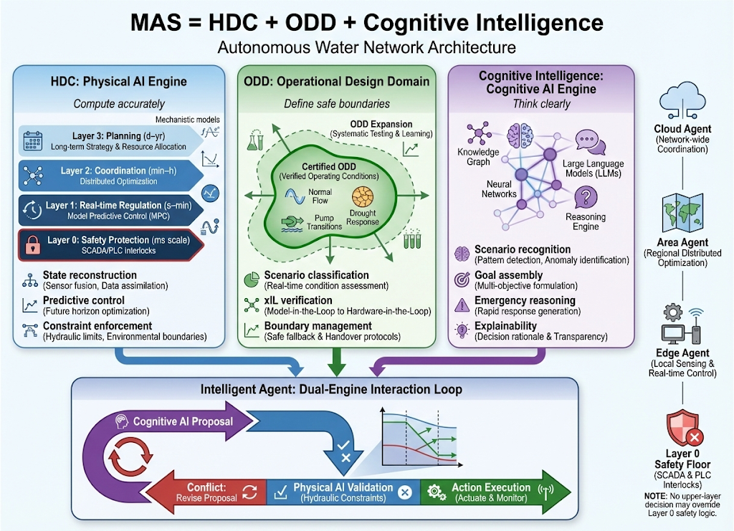
中文补充说明
这是全文最核心的架构图，需要传达三层信息：（1）MAS的三个支柱各自承担什么角色；（2）三个支柱在每个智能体内部如何交互（双引擎迭代闭环）；（3）智能体的分层部署结构（边缘→区域→云端，L0安全底线不可逾越）。
设计要点：避免传统的复杂系统架构图风格（密密麻麻的方框和箭头），Nature系列期刊偏好"少即是多"的视觉语言。每个支柱用3-4个关键词+1个视觉隐喻即可，不要塞太多文字。双引擎交互环是全图的视觉焦点，应当放在醒目位置。
技术规格
- 尺寸：180 × 130 mm（双栏宽度，可能需要占据大半页）
- 分辨率：300 dpi
- 格式：矢量优先
- 配色：蓝(#1565C0)=HDC/Physical AI，绿(#4CAF50)=ODD/Safety，紫(#7B1FA2)=Cognitive AI

Figure 3 — Water Systems Autonomy Levels (WSAL)
主提示词
Create a visually compelling academic infographic for Nature Water journal showing the Water Systems Autonomy Levels, a five-level classification framework for water network automation maturity. The design should evoke the well-known SAE autonomous driving levels but adapted specifically for water infrastructure.
The layout uses an ascending staircase or stepped-bar visualization progressing from left at Level 1 to right at Level 5. Each step is higher than the previous one, representing increasing autonomy. The color gradient progresses from cool gray at Level 1 through increasingly saturated blues to deep navy at Level 5.
Level 1 is labeled "Remote Monitoring" with a gray color. The human role description reads "Full manual control and all decisions". The system role reads "Data acquisition and display only". The technical architecture label is "SCADA". Show a small icon of a human operator sitting at a control console with multiple monitoring screens.
Level 2 is labeled "Assisted Control" with a light blue color. The human role reads "Confirms all commands and handles scenario transitions". The system role reads "HDC algorithms execute control for predefined scenarios". The architecture label is "SCADA plus HDC". Show an icon of a human reviewing AI-generated recommendations on screen. Add a prominent star badge reading "Current state of the art" with examples Shaping hydropower station and Jiaodong water transfer.
Between Level 2 and Level 3, insert a prominent visual callout spanning the gap between the two steps. This callout should be visually emphasized with a contrasting border or highlight color, labeled "Critical Near-Term Transition". Include the annotation text: "Requires systematic in-the-loop verification to certify operational design domain boundaries, enabling operators to release manual control within certified conditions."
Level 3 is labeled "Conditional Autonomy" with a medium blue color. The human role reads "Intervenes only when conditions approach ODD boundaries". The system role reads "Autonomous operation within verified ODD". The architecture label is "SCADA plus HDC plus xIL verification". Show an icon of a system operating independently with a human monitoring a boundary alert indicator.
Between Level 3 and Level 4, add a secondary callout labeled "Architectural Transition: HDC to MAS" with the note "Adding Cognitive Intelligence for scenario recognition and autonomous mode switching."
Level 4 is labeled "High Autonomy" with a deep blue color. The human role reads "Strategic oversight with rare intervention". The system role reads "MAS handles most scenarios including many novel situations via cognitive reasoning". The architecture label is "SCADA plus MAS with HDC and Cognitive AI". Show a multi-agent network icon with several connected nodes and a human figure in the background.
Level 5 is labeled "Full Autonomy" with a navy color. The human role reads "Strategic oversight only". The system role reads "Self-expanding ODD with continuous learning and autonomous adaptation to all conditions". The architecture label is "SCADA plus MAS with full ODD coverage and self-evolution". Show a fully autonomous network icon with an expanding boundary that suggests growth.
Along the bottom, draw a horizontal arrow labeled "ODD Coverage" expanding from "Limited predefined scenarios" on the left to "All operating conditions" on the right. Along the right edge, draw a vertical arrow labeled "Required Verification and Trust" increasing from bottom to top.
Style requirements: infographic quality suitable for a Nature-family journal. Clean and modern with subtle gradients. White background. English text throughout. Sans-serif font. Color palette restricted to grays and blues only for professional consistency. Dimensions 180mm wide by 100mm tall at 300 dpi.
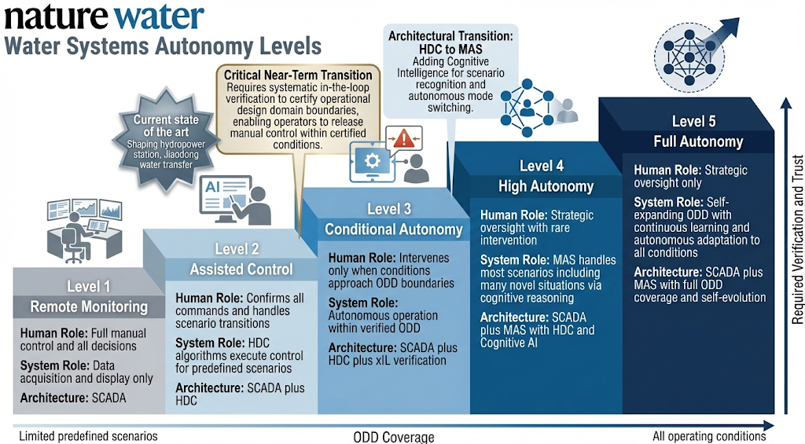
中文补充说明
这张图借鉴SAE J3016自动驾驶分级的视觉语言，但要让水利领域读者和非专业读者都能一目了然。核心信息有三个：
第一，当前全球水利系统绝大多数处于L1，前沿探索（沙坪、胶东）达到L2，这是现状基线。
第二，L2→L3是近期关键突破点，其本质是通过xIL在环测试"让系统证明自己是安全的"——这个转折点要用视觉强调（callout框、对比色边框等）。
第三，L3→L4是从HDC到MAS的架构质变，不是简单的性能提升而是增加了认知智能维度。
阶梯设计的视觉隐喻很重要：每一级的"高度"差异暗示难度递增，L2→L3的阶梯间距应当最大（表示最难跨越的近期挑战），L4→L5的间距也较大（表示远期愿景的不确定性）。
技术规格
- 尺寸：180 × 100 mm（双栏宽度）
- 分辨率：300 dpi
- 格式：矢量优先
- 配色：灰(#9E9E9E)→浅蓝(#64B5F6)→中蓝(#1E88E5)→深蓝(#1565C0)→藏蓝(#0D47A1)

通用建议
工具选择策略
对于Figure 1（时间线演进图），概念相对直观，Midjourney或GPT-4o均可生成较好的初始布局。重点关注三个阶段的配色区分和Phase II→III的范式转变标注。
对于Figure 2（MAS架构图），信息层次最复杂，建议分解为两步：先用AI生成三支柱的视觉风格和配色方案，再在PowerPoint或Illustrator中手动搭建精确的框图结构、箭头流向和标注文字。
对于Figure 3（WSAL分级图），阶梯式信息图的视觉效果最依赖布局精度，建议以AI生成的概念图为参考，在PPT中用SmartArt或手动形状重新绘制，确保五级阶梯的比例关系和callout标注的位置精确。
统一配色方案
语义角色 | 色值 | 用途
Physical AI / HDC | #1565C0 | 蓝色系，代表水/机理/控制
Safety / ODD | #4CAF50 | 绿色系，代表安全边界
Cognitive AI | #7B1FA2 | 紫色系，代表智能/认知
Disturbance / Warning | #FF7043 | 橙红色，代表扰动/警告
Background | #FFFFFF | 白色底
Auxiliary lines | #E0E0E0 | 浅灰辅助线
Text | #212121 | 近黑色正文
三张图之间保持配色一致，使论文视觉上形成统一的"设计语言"。

论文图片生成提示词 / Figure Generation Prompts

一、中国科学论文 (CHS_SciChina) — 3张图

图1：水资源系统分析三阶段演进示意图
用途：§2节，展示WRSA从静态平衡→优化配置→动态控制的学科演进
提示词（中文版）：
创建一张学术论文示意图，横向三栏布局，展示"水资源系统分析三阶段演进"。背景为淡蓝渐变。
Phase I（左栏，浅蓝底色）：标题"水量平衡与规划设计（1950s—1980s）"。核心问题标注"建什么"。图标元素：水坝截面图、水库蓄水量曲线。下方关键词：线性规划、动态规划、Rippl分析、哈佛水资源项目。时间尺度标注：年。数学符号：代数方程（质量平衡 ΔS = Qin - Qout）。
Phase II（中栏，中蓝底色）：标题"优化配置与综合管理（1990s—2010s）"。核心问题标注"配多少"。图标元素：多水库联合调度网络拓扑图、帕累托前沿曲线。下方关键词：多目标优化、IWRM、二元水循环、水资源配置。时间尺度标注：月—年。数学符号：优化方程（min f(x) s.t. Ax≤b）。
Phase III（右栏，深蓝底色）：标题"动态控制与自主运行（2020s—）"。核心问题标注"怎么调"。图标元素：闭环控制框图（感知→决策→执行→反馈）、实时波形图。下方关键词：水系统控制论、MPC、MAS、自主运行。时间尺度标注：秒—年。数学符号：微分方程（∂A/∂t + ∂Q/∂x = q）。
三栏之间用大箭头连接，箭头上标注"范式转变"。整体风格：扁平化矢量图，配色专业学术，无照片，中文标注。图片尺寸：宽180mm，高80mm，300dpi。
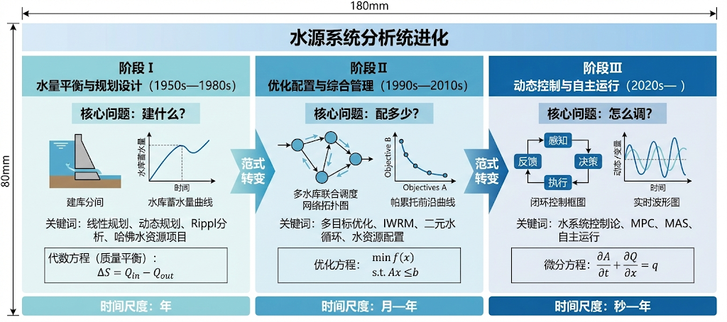
English Prompt (for AI image tools)：
Create a professional academic figure showing "Three-phase evolution of Water Resources Systems Analysis" in a horizontal three-column layout with a light-to-deep blue gradient progression.
Left column (Phase I, 1950s–1980s): Title "Water Balance & Planning". Core question: "What to build". Icons: dam cross-section, storage-yield curve. Keywords: Linear programming, Rippl analysis, Harvard Water Program. Timescale: Annual. Math: algebraic mass balance equation ΔS = Qin - Qout.
Center column (Phase II, 1990s–2010s): Title "Optimal Allocation & IWRM". Core question: "How much to allocate". Icons: multi-reservoir network topology, Pareto frontier. Keywords: Multi-objective optimization, IWRM, dualistic water cycle. Timescale: Monthly–Annual. Math: optimization min f(x) s.t. Ax≤b.
Right column (Phase III, 2020s–): Title "Dynamic Control & Autonomy". Core question: "How to operate". Icons: closed-loop control diagram (sense→decide→act→feedback), real-time waveform. Keywords: CHS, MPC, MAS, autonomous operation. Timescale: Seconds–Years. Math: PDE Saint-Venant equation ∂A/∂t + ∂Q/∂x = q.
Large arrows between columns labeled "Paradigm shift". Style: flat vector, academic color scheme (blues), no photographs. Clean sans-serif font. Size: 180mm × 80mm, 300dpi.

图2：水系统控制论六元受控系统架构
用途：§3节，展示CHS的六元组 Σ = (P, A, S, D, C, O) 控制架构
提示词（中文版）：
创建一张学术论文控制系统框图，展示"水系统控制论六元受控系统架构"。
核心结构：经典闭环反馈控制框图，但专门针对水系统定制。布局为横向流程图。
六个元素用不同颜色的圆角矩形表示：
- P（被控对象，Plant）[蓝色]：中央最大的方框，内部画出渠道/管道截面示意，标注"水力过程（Saint-Venant方程）"
- A（执行器，Actuators）[绿色]：P的左侧输入端，图标为闸门、泵站、阀门，标注"闸/泵/阀"
- S（传感器，Sensors）[橙色]：P的下方输出端，图标为水位计、流量计，标注"水位/流量/水质"
- D（扰动，Disturbances）[红色虚线]：P的上方，箭头向下指入P，标注"降雨、蒸发、需水波动、设备故障"
- C（控制器，Controller）[深蓝色]：P的左下方，标注"决策算法（HDC/MAS）"
- O（目标，Objectives）[紫色]：C的上方输入，标注"水位跟踪、流量匹配、安全约束"
信号流向：O→C（目标设定）、C→A（控制指令）、A→P（执行）、P→S（量测）、S→C（反馈，虚线），D→P（外部扰动，红色虚线箭头）。
在图的右下角标注公式：Σ = (P, A, S, D, C, O)
风格：工程学术风格，扁平矢量，白色背景，无阴影/3D效果。字体：无衬线。尺寸：180mm × 100mm，300dpi。
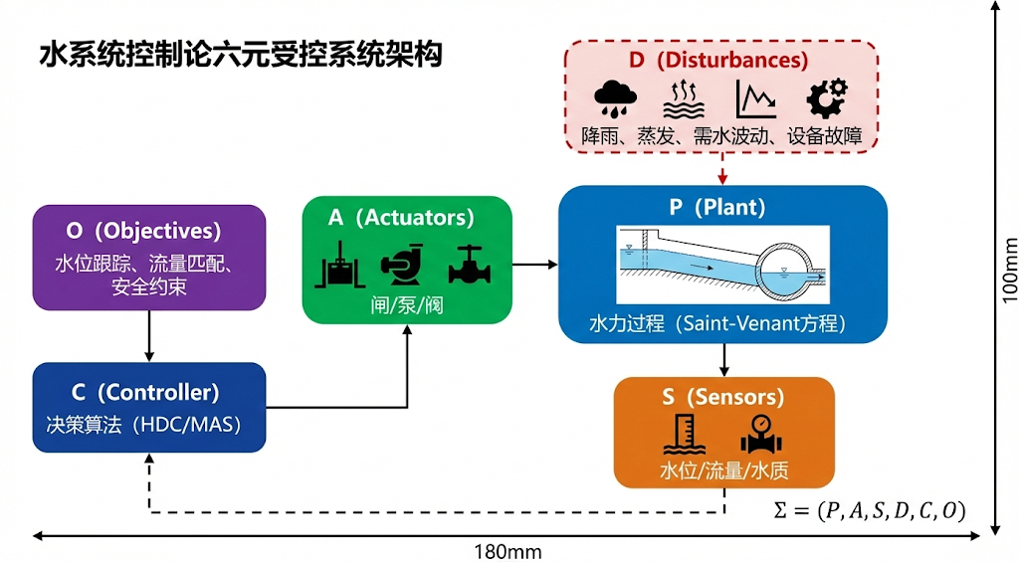
English Prompt：
Create a professional control systems block diagram for an academic paper: "CHS Six-Element Controlled System Architecture".
Layout: Classic closed-loop feedback control diagram customized for water systems. Horizontal flow.
Six elements as colored rounded rectangles:
- P (Plant) [blue, largest, center]: Shows canal/pipe cross-section, labeled "Hydraulic process (Saint-Venant equations)"
- A (Actuators) [green, left input to P]: Icons of gate, pump, valve. Label: "Gates / Pumps / Valves"
- S (Sensors) [orange, bottom output from P]: Water level gauge, flow meter icons. Label: "Level / Flow / Quality"
- D (Disturbances) [red dashed, top arrow into P]: Label: "Rainfall, evaporation, demand fluctuation, equipment failure"
- C (Controller) [dark blue, bottom-left]: Label: "Decision algorithms (HDC/MAS)"
- O (Objectives) [purple, input to C]: Label: "Level tracking, flow matching, safety constraints"
Signal flow: O→C (setpoint), C→A (command), A→P (actuation), P→S (measurement), S→C (feedback, dashed), D→P (disturbance, red dashed arrow).
Bottom-right formula: Σ = (P, A, S, D, C, O)
Style: Engineering academic, flat vector, white background, no shadows or 3D effects, clean sans-serif font. Size: 180mm × 100mm, 300dpi.

图3：模型层级—控制层级对应关系
用途：§3.5节，展示五级模型简化与四层控制架构的对应关系
提示词（中文版）：
创建一张学术双栏对照图，展示"模型层级—控制层级对应关系"。
左栏：模型层级（自上而下，从精细到粗糙） 用五个水平条带表示，颜色从深蓝（精细）渐变到浅蓝（粗糙）：
- Level i：线性化Saint-Venant方程（保留全部空间分布）
- Level ii：IDZ传递函数（积分—延迟—零点）
- Level iii：积分延迟模型
- Level iv：纯积分/线性水库
- Level v：稳态质量平衡 每级之间用向下箭头连接，标注"丢弃一个时间尺度"。
右栏：控制层级（自下而上，从快到慢） 用四个水平条带表示，颜色对应模型层级：
- Layer 0 安全保护层：PLC硬连锁，毫秒级
- Layer 1 实时调节层：单回路MPC，秒—分钟
- Layer 2 协调优化层：分布式MPC，分钟—小时
- Layer 3 计划调度层：嵌套优化，日—年
左右两栏之间用虚线箭头连接，表示模型层级与控制层级的对应关系： Level i ↔ Layer 0, Level ii ↔ Layer 1, Level iii–iv ↔ Layer 2, Level v ↔ Layer 3
右侧标注时间尺度刻度：ms → s → min → h → day → month → year
核心设计原则标注（居中）："刚好足够精细"（Just Precise Enough）
风格：对称布局，学术矢量图，蓝色系配色，白色背景，无衬线字体。尺寸：180mm × 120mm，300dpi。
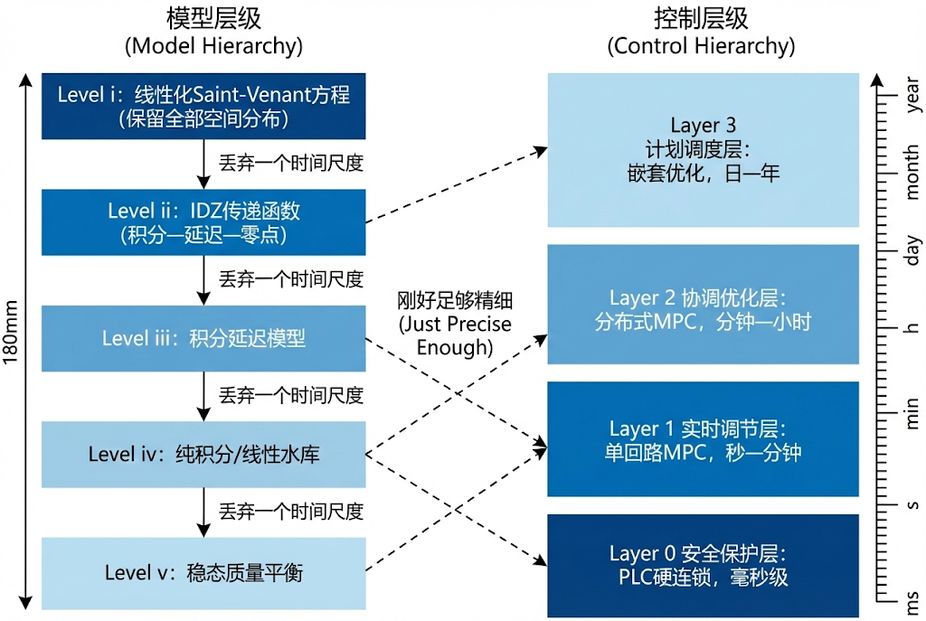
English Prompt：
Create a professional academic figure showing the correspondence between "Model Hierarchy" and "Control Hierarchy" in a dual-column layout.
Left column: Model Hierarchy (top-down, fine to coarse) Five horizontal bands, gradient from deep blue (fine) to light blue (coarse):
- Level i: Linearized Saint-Venant equations (full spatial distribution)
- Level ii: IDZ transfer functions (Integrator-Delay-Zero)
- Level iii: Integrator-delay models
- Level iv: Pure integrator / linear reservoir
- Level v: Steady-state mass balance Downward arrows between levels labeled "Discard one timescale".
Right column: Control Hierarchy (bottom-up, fast to slow) Four horizontal bands with matching colors:
- Layer 0 Safety Protection: PLC hardwired interlocks, milliseconds
- Layer 1 Real-time Regulation: Local MPC, seconds–minutes
- Layer 2 Coordination: Distributed MPC, minutes–hours
- Layer 3 Planning: Nested optimization, days–years
Dashed arrows connecting left and right columns showing correspondence.
Right edge: timescale ruler from ms to years. Center label: "Just Precise Enough" principle.
Style: Symmetric layout, academic vector, blue palette, white background, sans-serif font. Size: 180mm × 120mm, 300dpi.

