Autoencoder:
- Used to reconstruct the original images
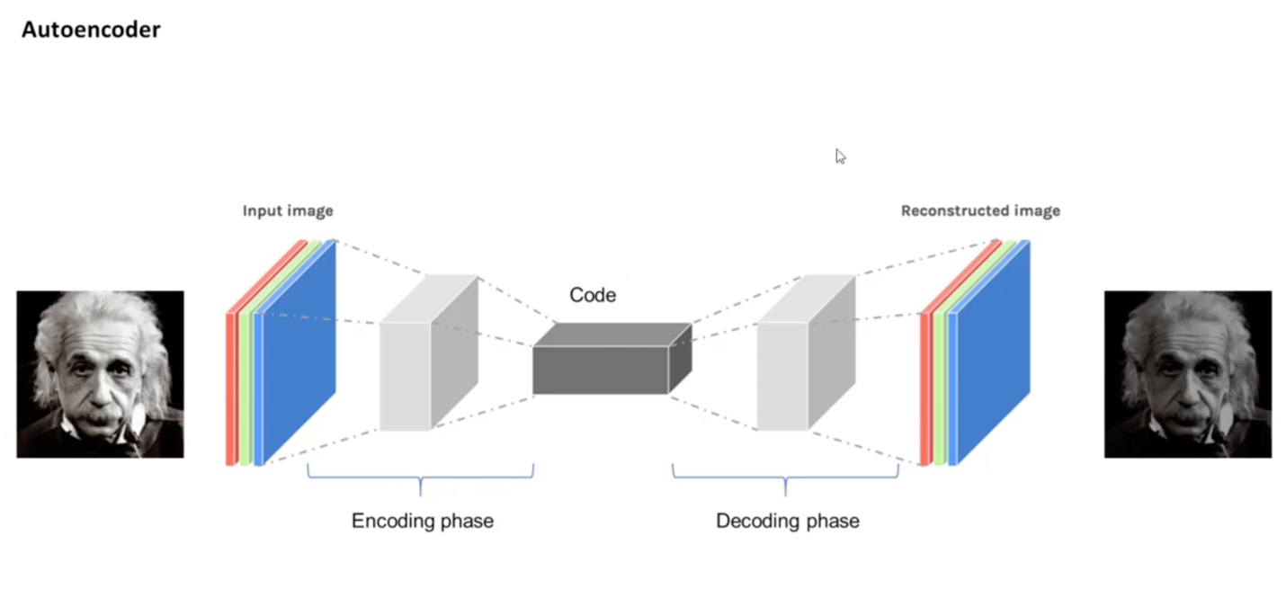
- Weights & biases adjustments

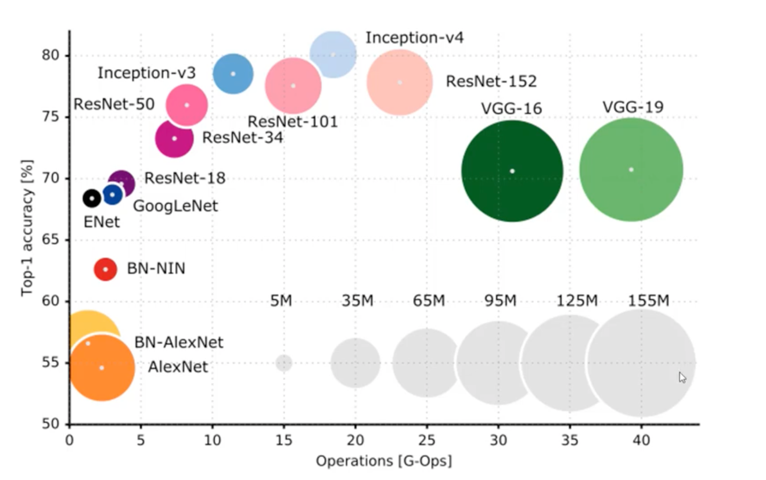

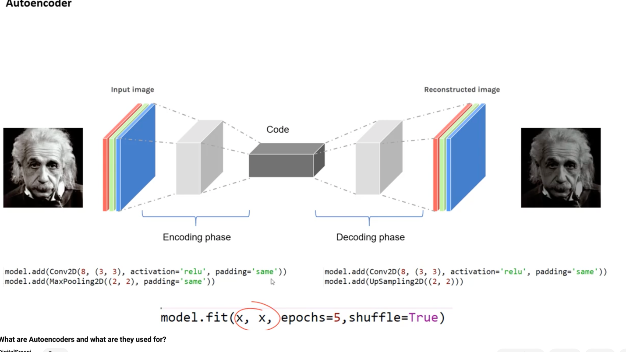

Reasons:
- Denoise
- Anormaly detections
- Domain adaptations
- Image colorization

