Key steps for stem parameter retrieval

1. open a point cloud file(\*.pcd,\*.las,\*.xyz,\*.vtx), the default file is “demo.pcd” in “pcdDemo” folder;
2. open Sub menu “Stem Diameter and Basal Area” under the menu Open menu “ParametersRetrieval”, then press the button “Stem Axis Curve Constrcution”, the stem axis curve, the stem height, stem length, and the stem parameters at the stem height 130 cm are calculated and showed in the corresponding text. The fitting result of the methods can be visualized by the “show” check box.
3. Stem parameters can be retrieved by stem height or stem length by choosing the corresponding checkbox. Then, click “Stem Parameters Retrieval”, the stem parameters are retrieved and listed.

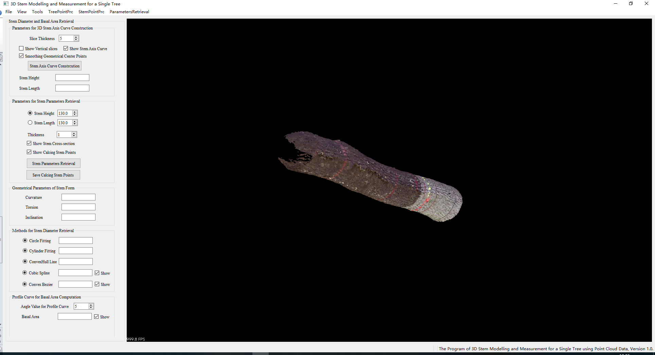

The stem parameters at the stem height 130 cm are showed as follow.

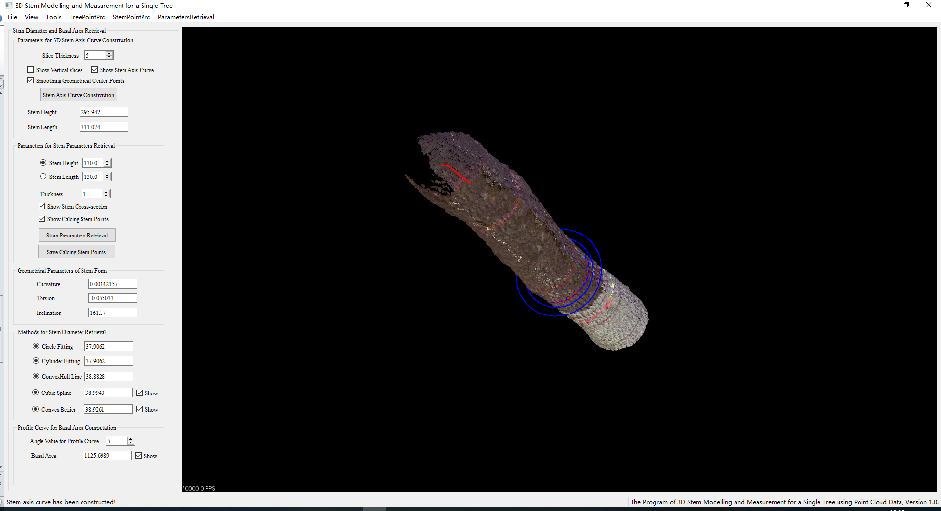

The effectiveness of fitting methods is showed as follow.

