Key steps for 3D stem model construction and stem parameter retrieval

1. open a stem point cloud file(\*.pcd,\*.las,\*.xyz,\*.vtx), the default file is “demo.pcd” in “pcdDemo” folder;
2. open Sub menu “Stem Diameter and Basal Area” under the menu Open menu “ParametersRetrieval”, then press the button “Stem Axis Curve Constrcution”, the stem axis curve is constructed by the default parameters and shown in the window with red color. And the stem parameters, such as stem height, stem length, and the stem parameters at the stem height 130 cm are calculated and shown in the corresponding text. The fitting visual effect of the methods can be visualized by the “show” check box.
3. Stem parameters can be retrieved by stem height or stem length by choosing the corresponding checkbox. Then, click “Stem Parameters Retrieval”, the stem parameters are retrieved and listed.
4. The angle value for profile curve can be chose, and then the value of basal area at the specified position is calculated.

Example:

The constructed stem axis curve is shown as follow.

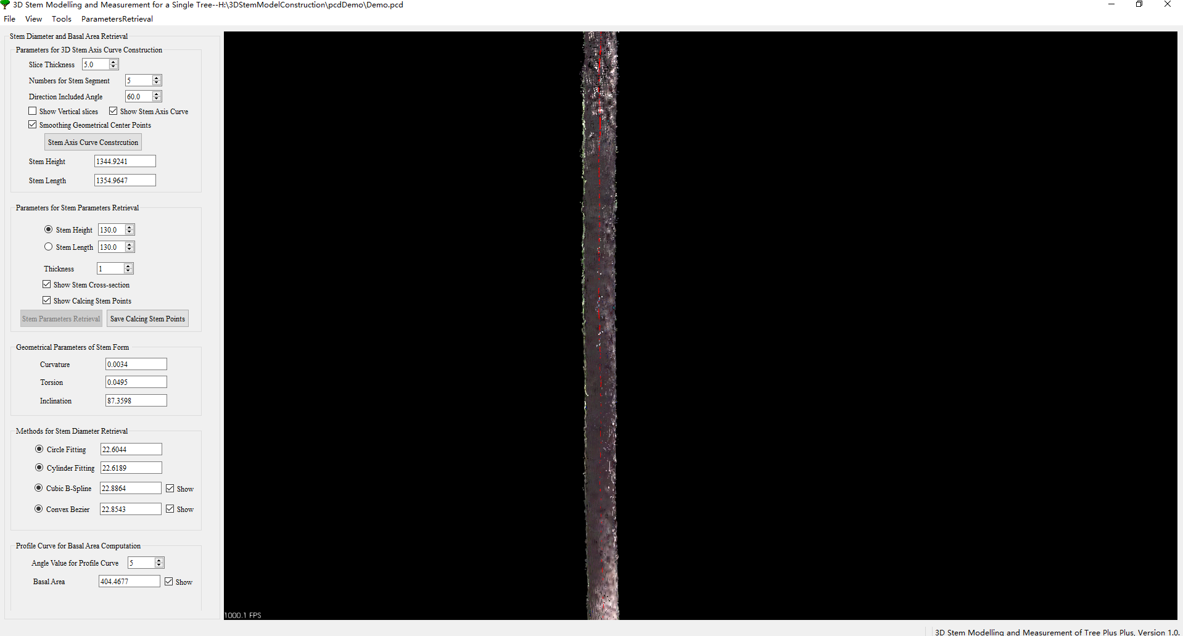

The part view of the constructed stem axis curve is shown as follow.

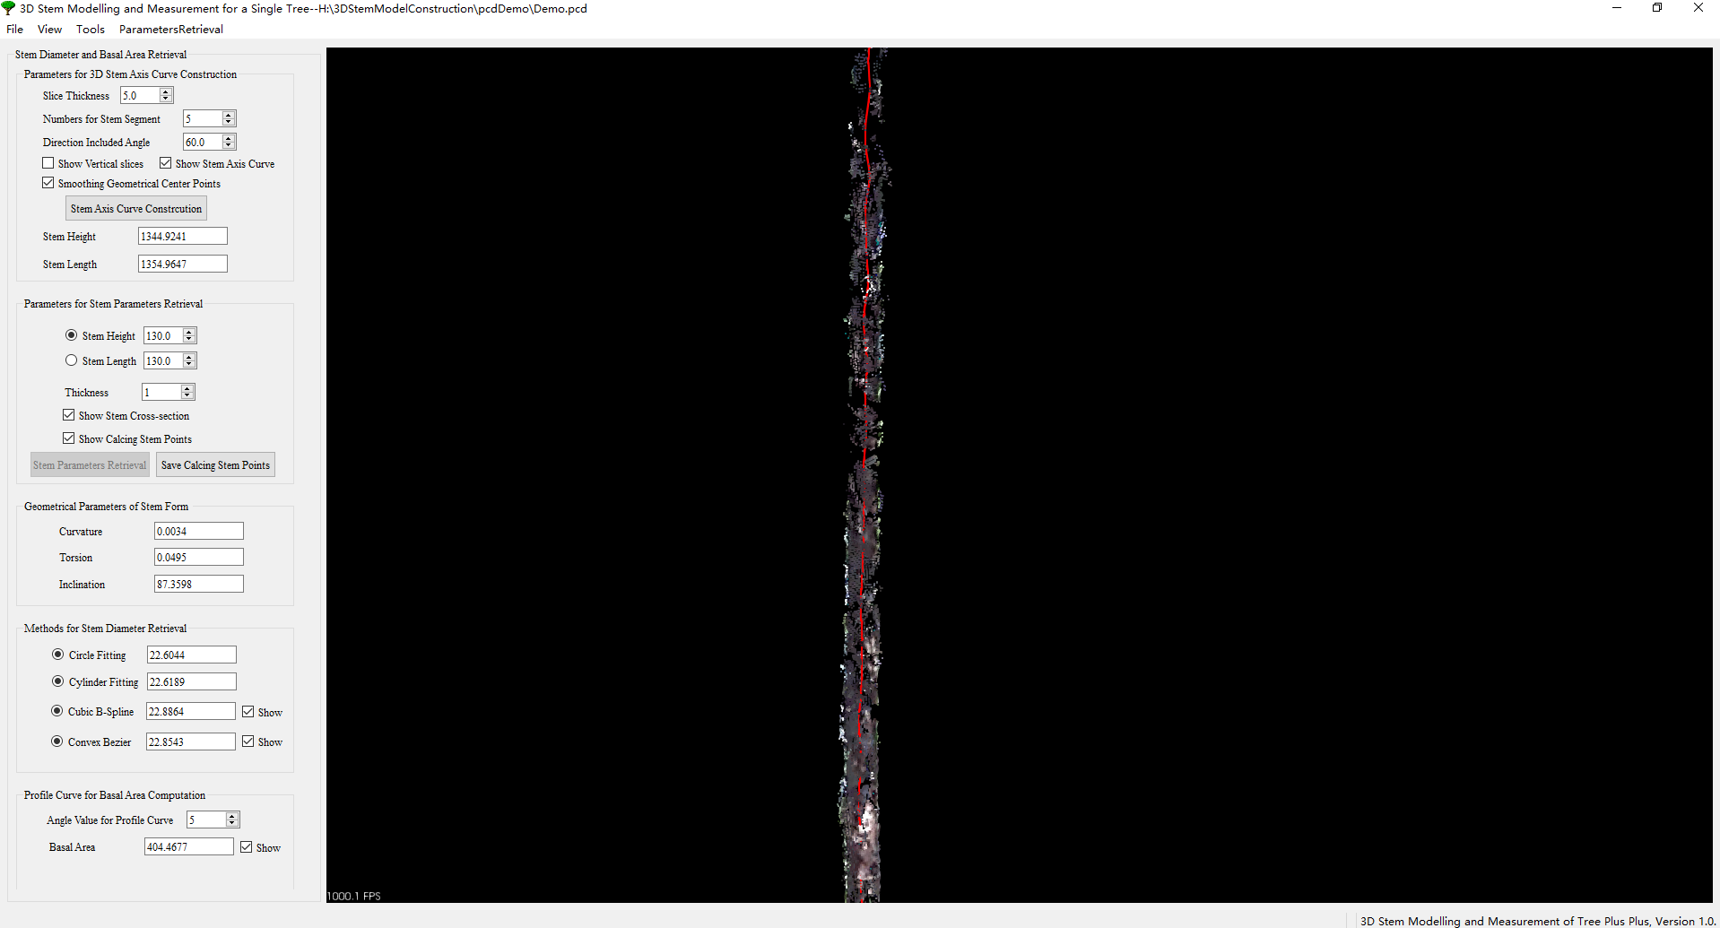

The effectiveness of fitting methods is showed as follow.

