# User Table

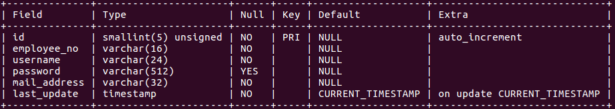

create table test(

id int unsigned not null auto_increment,

type varchar(16) not null,

original_data varchar(32) not null,

original_data_path varchar(512) not null,

last_update timestamp not null default current_timestamp on update current_timestamp,

user_id smallint unsigned not null,

primary key (id),

constraint `fk_test_user` foreign key (user_id) references user (id) on delete restrict on update cascade

);

# Release Version Table

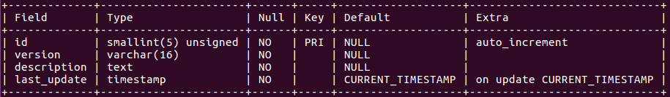

create table release_version(

id smallint unsigned not null auto_increment,

version varchar(16) not null,

description text not null,

last_update timestamp not null default current_timestamp on update current_timestamp,

primary key (id)

);

# Role Table

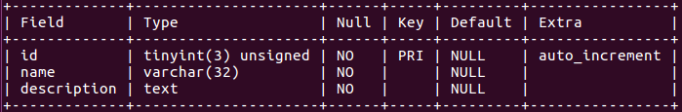

create table role(

id tinyint unsigned not null auto_increment,

name varchar(32) not null,

description text not null,

primary key (id)

);

# Permission Table

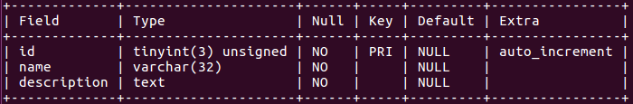

create table permission(

id tinyint unsigned not null auto_increment,

name varchar(32) not null,

description text not null,

primary key (id)

);

# User Role Table

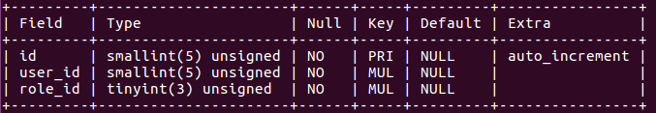

create table user_role(

id smallint unsigned not null auto_increment,

user_id smallint not null,

role_id tinyint not null,

primary key (id),

constraint `fk_user` foreign key (user_id) references user (id) on delete cascade on update cascade,

constraint `fk_role` foreign key (role_id) references role (id) on delete cascade on update cascade

);

# Role Permission Table

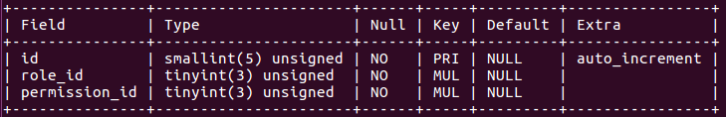

create table role_permission (

id smallint unsigned not null auto_increment,

role_id tinyint unsigned not null,

permission_id tinyint unsigned not null,

primary key (id),

constraint `fk_role_permission` foreign key (role_id) references role (id) on delete cascade on update cascade,

constraint `fk_permission` foreign key (permission_id) references permission (id) on delete cascade on update cascade

);

# Download Table

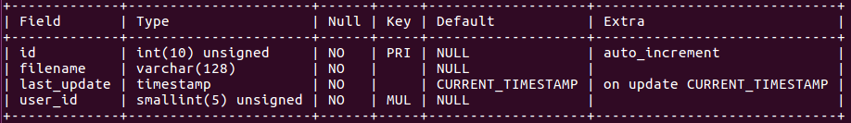

create table download(

id int unsigned not null auto_increment,

filename varchar(128) not null,

last_update timestamp not null default current_timestamp on update current_timestamp,

user_id smallint unsigned not null,

primary key (id),

constraint `fk_user_download` foreign key (user_id) references user (id) on delete restrict on update cascade

);

# Testing Table

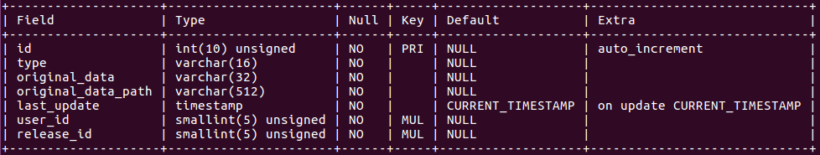

create table test(

id int unsigned not null auto_increment,

type varchar(16) not null,

original_data varchar(32) not null,

original_data_path varchar(512) not null,

last_update timestamp not null default current_timestamp on update current_timestamp,

user_id smallint unsigned not null,

release_id smallint unsigned not null,

primary key (id),

constraint `fk_test_user` foreign key (user_id) references user (id) on delete restrict on update cascade,

constraint `fk_test_release` foreign key (release_id) references release_version (id) on delete cascade on update cascade

);

# Hardware Table

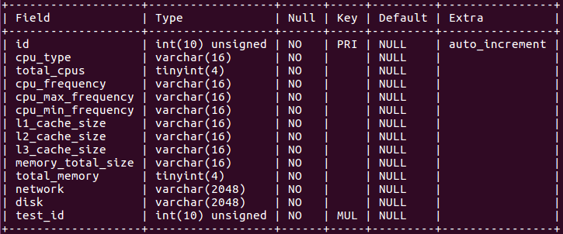

# Software Table

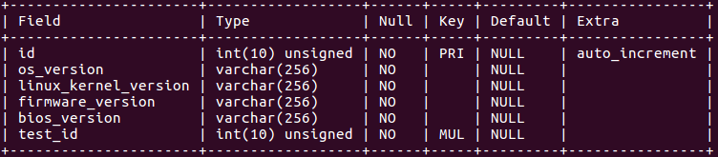

create table software(

id int unsigned not null auto_increment,

os_version varchar(256) not null,

linux_kernel_version varchar(256) not null,

firmware_version varchar(256) not null,

bios_version varchar(256) not null,

test_id int unsigned not null,

primary key (id),

constraint `fk_test_software` foreign key (test_id) references test (id) on delete cascade on update cascade

);

# Tune Table

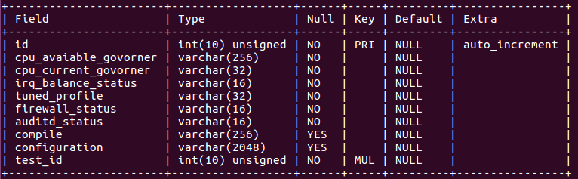

create table tune(

id int unsigned not null auto_increment,

cpu_avaiable_govorner varchar(256) not null,

cpu_current_govorner varchar(32) not null,

irq_balance_status varchar(16) not null,

tuned_profile varchar(32) not null,

firewall_status varchar(16) not null,

auditd_status varchar(16) not null,

compile varchar(256),

configuration varchar(2048),

test_id int unsigned not null,

primary key (id),

constraint `fk_test_tune` foreign key (test_id) references test (id) on delete cascade on update cascade

);

# SPEC CPU Int Table

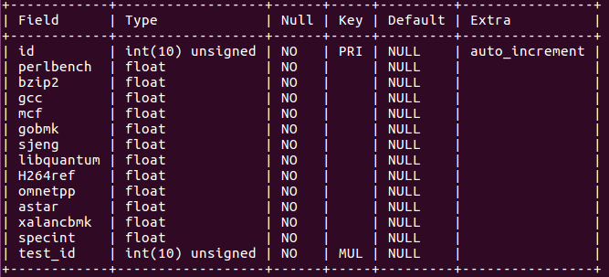

create table spec_cpu_int(

id int unsigned not null auto_increment,

perlbench float not null,

bzip2 float not null,

gcc float not null,

mcf float not null,

gobmk float not null,

sjeng float not null,

libquantum float not null,

H264ref float not null,

omnetpp float not null,

astar float not null,

xalancbmk float not null,

specint float not null,

test_id int unsigned not null,

primary key (id),

constraint `fk_test_spec_cpu_int` foreign key (test_id) references test (id) on delete cascade on update cascade

);

# SPEC CPU fp Table

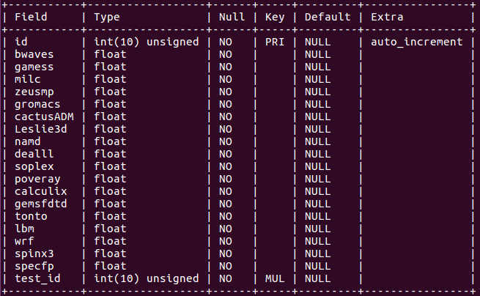

create table spec_cpu_fp(

id int unsigned not null auto_increment,

bwaves float not null,

gamess float not null,

milc float not null,

zeusmp float not null,

gromacs float not null,

cactusADM float not null,

Leslie3d float not null,

namd float not null,

dealll float not null,

soplex float not null,

poveray float not null,

calculix float not null,

gemsfdtd float not null,

tonto float not null,

lbm float not null,

wrf float not null,

spinx3 float not null,

specfp float not null,

test_id int unsigned not null,

primary key (id),

constraint `fk_test_spec_cpu_fp` foreign key (test_id) references test (id) on delete cascade on update cascade

);

# SPEC Jbb Table

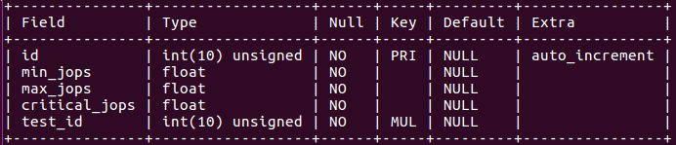

create table spec_jbb(

id int unsigned not null auto_increment,

min_jops float not null,

max_jops float not null,

critical_jops float not null,

test_id int unsigned not null,

primary key (id),

constraint `fk_test_spec_jbb` foreign key (test_id) references test (id) on delete cascade on update cascade

);

# SPEC Memory Cache Table

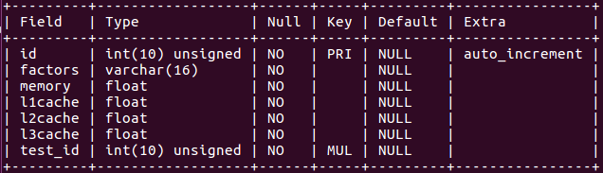

create table spec_memory_cache(

id int unsigned not null auto_increment,

factors varchar(16) not null,

memory float not null,

l1cache float not null,

l2cache float not null,

l3cache float not null,

test_id int unsigned not null,

primary key (id),

constraint `fk_test_spec_memory_cache` foreign key (test_id) references test (id) on delete cascade on update cascade

);

# SPEC Network Table

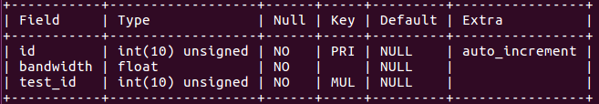

create table spec_network(

id int unsigned not null auto_increment,

bandwidth float not null,

test_id int unsigned not null,

primary key (id),

constraint `fk_test_spec_network` foreign key (test_id) references test (id) on delete cascade on update cascade

);

# SPEC Storage Table

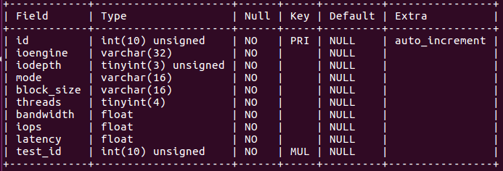

create table spec_storage(

id int unsigned not null auto_increment,

ioengine varchar(32) not null,

iodepth tinyint unsigned not null,

mode varchar(16) not null,

block_size varchar(16) not null,

threads tinyint not null,

bandwidth float not null,

iops float not null,

latency float not null,

test_id int unsigned not null,

primary key (id),

constraint `fk_test_spec_storage` foreign key (test_id) references test (id) on delete cascade on update cascade

);