

**LMbench-latency Benchmark Report**

Guizhou Huaxintong Semiconductor Technology Co., Ltd.

贵州华芯通半导体技术有限公司

Temporary Administrative Center, Guian New Area, Guizhou Province, P.R. China

贵州省贵安新区临时行政中心

©2019 Guizhou Huaxintong Semiconductor Technology Co., Ltd. All rights reserved.

**Legal Notice**

The document is:

* Confidential and proprietary to Guizhou Huaxintong Semiconductor Technology Co., Ltd. and its affiliates (“HXT Semiconductor”), and provided to designated receivers only, no public disclosure is permitted;
* Restricted to be distributed to anyone without the express written approval of HXT Semiconductor;
* Not permitted to be used, copied, reproduced, modified, disclosed in whole or in part in any manner to others without the express written permission of HXT Semiconductor;

HUAXINTONG and its logo, are trademarks or registered trademarks of HXT Semiconductor in China. All other brand names, product names, or trademarks might belong to their respective holders.

HXT Semiconductor reserves the right to alter product and services offerings, and specifications and pricing at any time without notice, and is not responsible for typographical or graphical errors that may appear in this document.

The technical data included in this document may be subject to U.S. and international export, re-export, or transfer (“export”) laws. Diversion contrary to U.S. and international law is strictly prohibited.

The Reference Evaluation Platform (“REP”) shall be solely used for evaluation on the compatibility with user’s equipment at user’s facilities and at all times user maintains full control and possession of REP (“Limited Purpose”). REP shall be used solely for the Limited Puerpose and for no other purpose and none of the REP will be used for any commercial purposes,sold,placed on the market or otherwise disposed of in any manner. It is hereby explicated that NO license to any patents, trademarks, copyrights,or other intellectual property of any third party software is provided by the RELEASE Notes.The Release Notes does not grant to any user(s) any implied rights under any licensor or third party intellectual property

.

This Release Notes may contain software code and/or materials, including, without limitation,open source software components,which are written or owned by third parties (“Third Party Software”). The Third Party Software are used for user(s)’s testing and evaluation purpose only. The user(s) shall be compliance with all copyright laws and third party licenses.

Furthermore, the user(s) shall not use, modify, compile or distribute any HXT software in any manner that would cause HXT software to become subject to any open source license terms.

©2019 HXT Semiconductor. All rights reserved.

# Benchmark Data

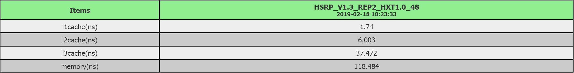

# Benchmark Chart

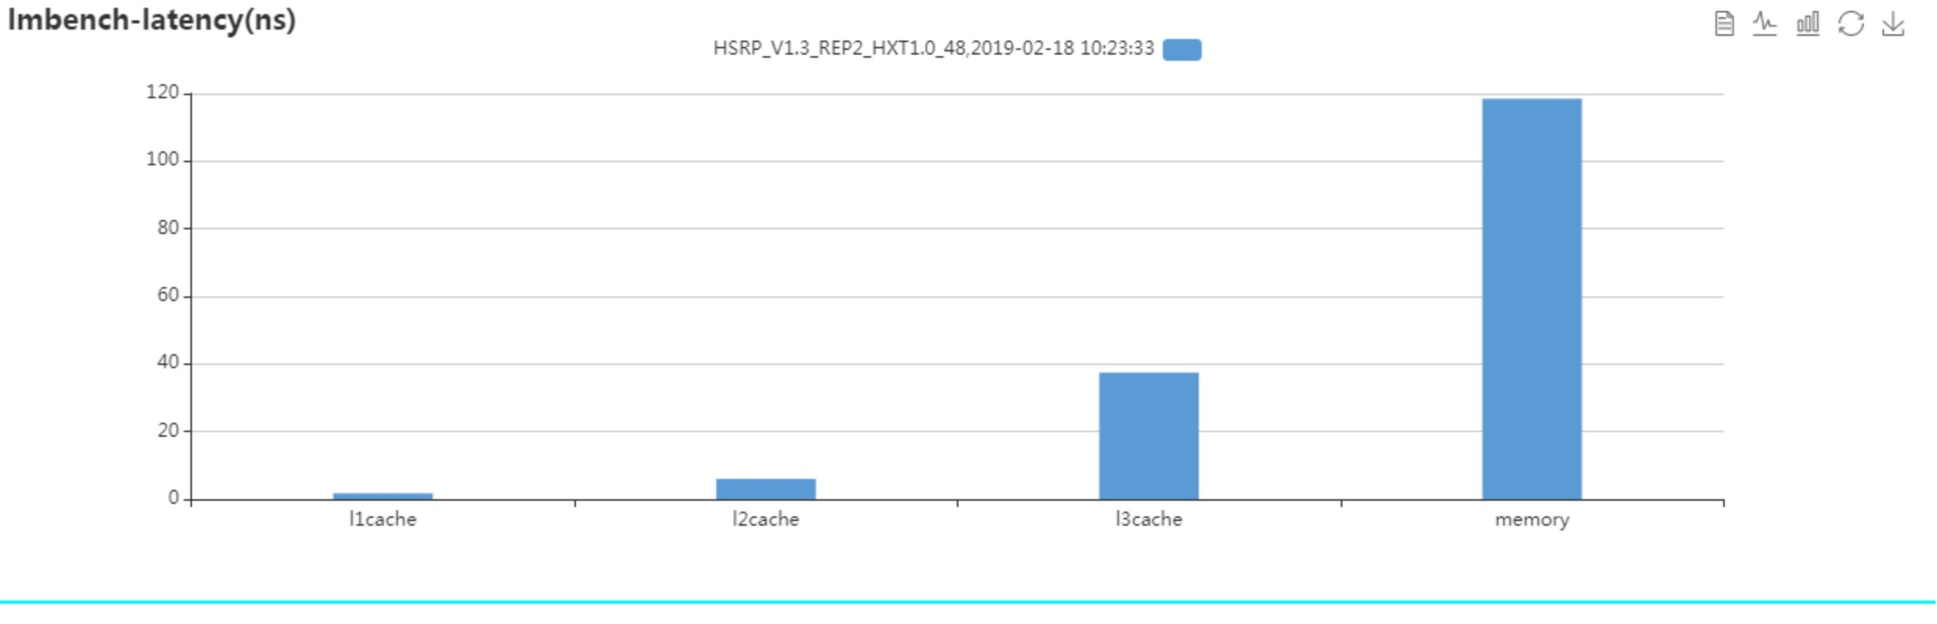

# SOC Configuration

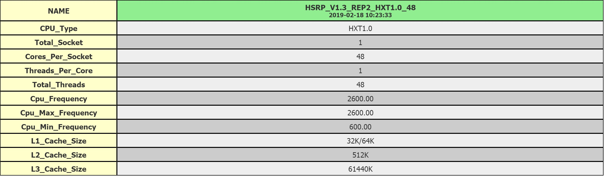

# Hardware Configuration

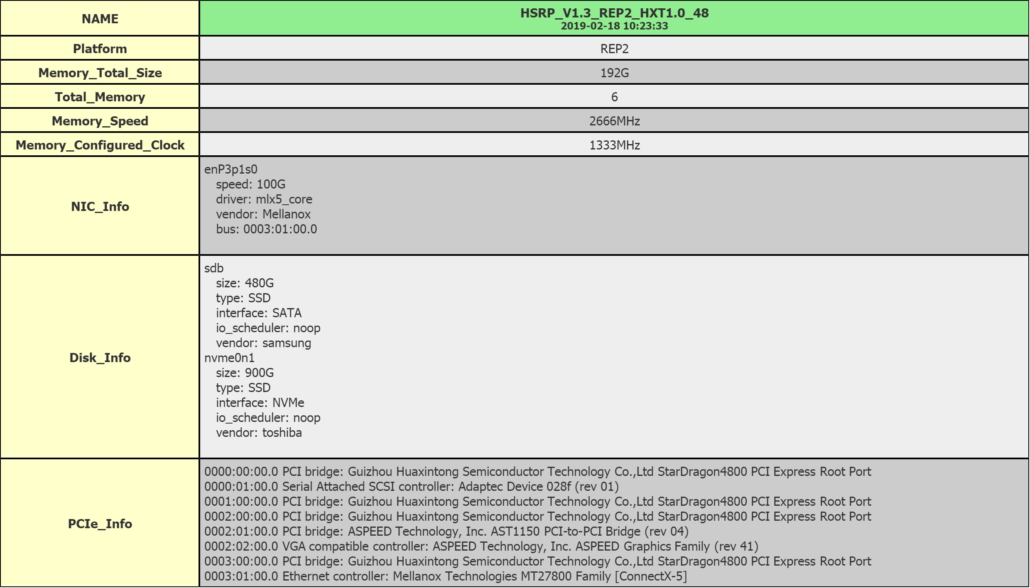

# Software Configuration

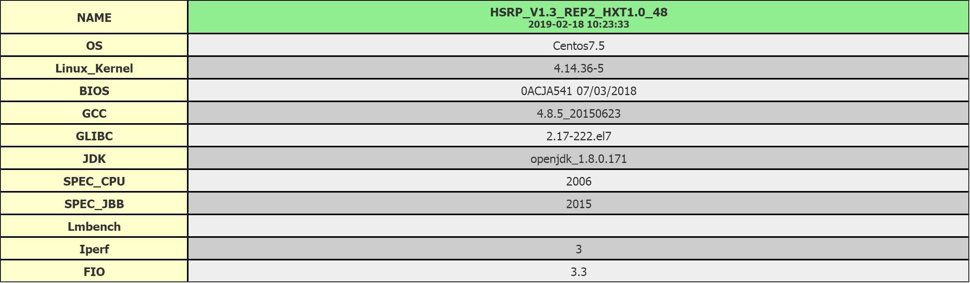

# Tune

# Customization

N/A