1. High uncertainty (standard errors), which is not generally reported. People also may not have answered honestly when asked who they were voting for.

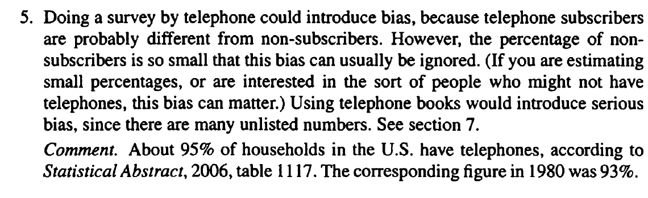



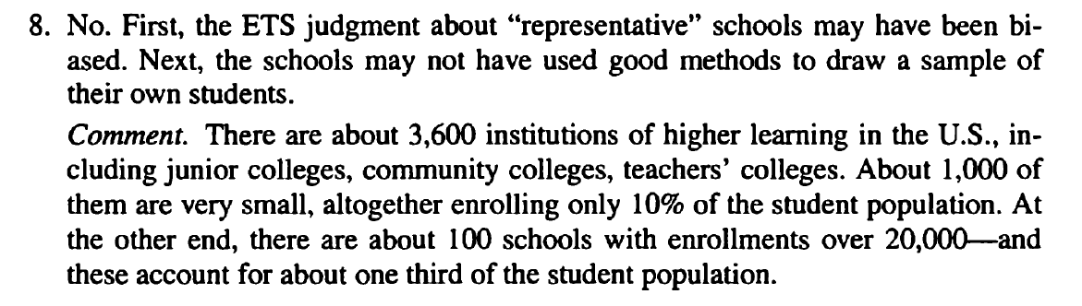

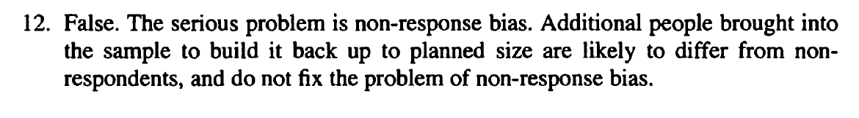



19. Review question 11

a. 10 through 20 (65 - 50 - 5, 65 - 50 + 5)

b. 40 through 50

c. To get the center of the range, take 50 from the sum and then go 5 either way

d.73% (by normal curve)