FCPAMS — Feedback, Complaint, and Participation Administration Management System

System Process Document & Flow Guide
Organization: Bansalan Cooperative
System Version: 2.0
Document Type: Process Flow Reference

1. System Overview
FCPAMS is a web-based management system that allows cooperative Members (Citizens) to submit inquiries, suggestions, requests, complaints, and surveys. Staff resolves cases, and Admins oversee, confirm, and archive all records.

2. Detailed Role Responsibilities & Problem-Solving
This section explains exactly what each role does and how they handle and solve problems within the system.

🙎‍♂️ Member (Citizen)
Goal: Report issues, seek assistance, and provide feedback.
- Action - Filing: Members use the dashboard to submit a detailed complaint or ticket. They select the category (e.g., Loan Processing, Customer Service) and describe the issue and their desired resolution.
- Action - Providing Proof: They optionally upload supporting documents (receipts, photos) to help staff understand the problem faster.
- Action - Finalizing: Once the cooperative solves the issue, the member physically signs the printed "Acceptance and Settlement of Complaint Resolution" document to signify agreement.

👨‍💻 Admin
Goal: Triage issues, oversee resolutions, enforce policy, and maintain records.
- Problem Solving - Triage (Complexity Gating): When a new complaint arrives, it is invisible to Staff. The Admin reads the complaint and determines its nature:
- SIMPLE: Straightforward issues (e.g., inquiry about balance, minor delay) that staff can handle immediately.
- COMPLEX: Serious issues (e.g., missing funds, harassment, major policy disputes) that require investigation or management intervention.
- By setting the complexity, the Admin "assigns" the complaint to the Staff queue.
- Problem Solving - Quality Control: When Staff marks a complaint as "Resolved," the Admin reviews the staff's "Resolution Remark." The Admin checks if the solution follows cooperative policies.
- Action - Archiving: The Admin confirms the resolution (moving it to CLOSED), generates the official document, and uploads the scanned signed copy to finalize the record.

🧑‍💼 Staff
Goal: Investigate, communicate, and solve the actual problems reported by members.
- Problem Solving - Investigation: Staff monitor their dashboard for "Assessed" complaints (where Admin has set a complexity). They review the member's description and uploaded documents.
- Problem Solving - Action: Staff perform the actual legwork (often outside the system):
- Contacting the specific branch involved.
- Checking internal transaction logs or physical records.
- Calling the member for clarification.
- Problem Solving - Documentation: Once a solution is reached (e.g., a refund is processed, an apology given, or an error corrected), the Staff writes a detailed Resolution Remark in the system. This remark explains what was done to solve the issue.
- Action - Resolving: Staff clicks "Mark as Resolved" which passes the complaint back to the Admin for final confirmation.

3. Authentication Flow
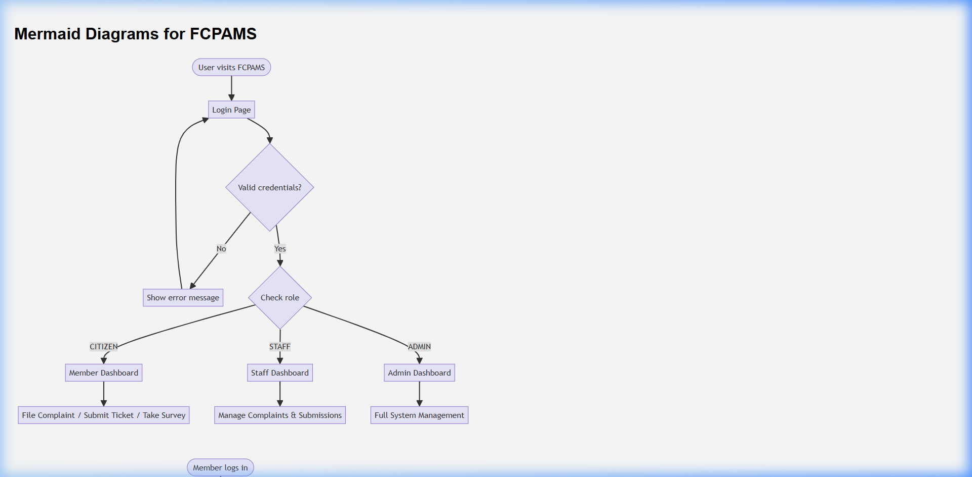
[Diagram: 1]

4. Submission (Ticket) Flow
Covers: Inquiry, Suggestion, Request
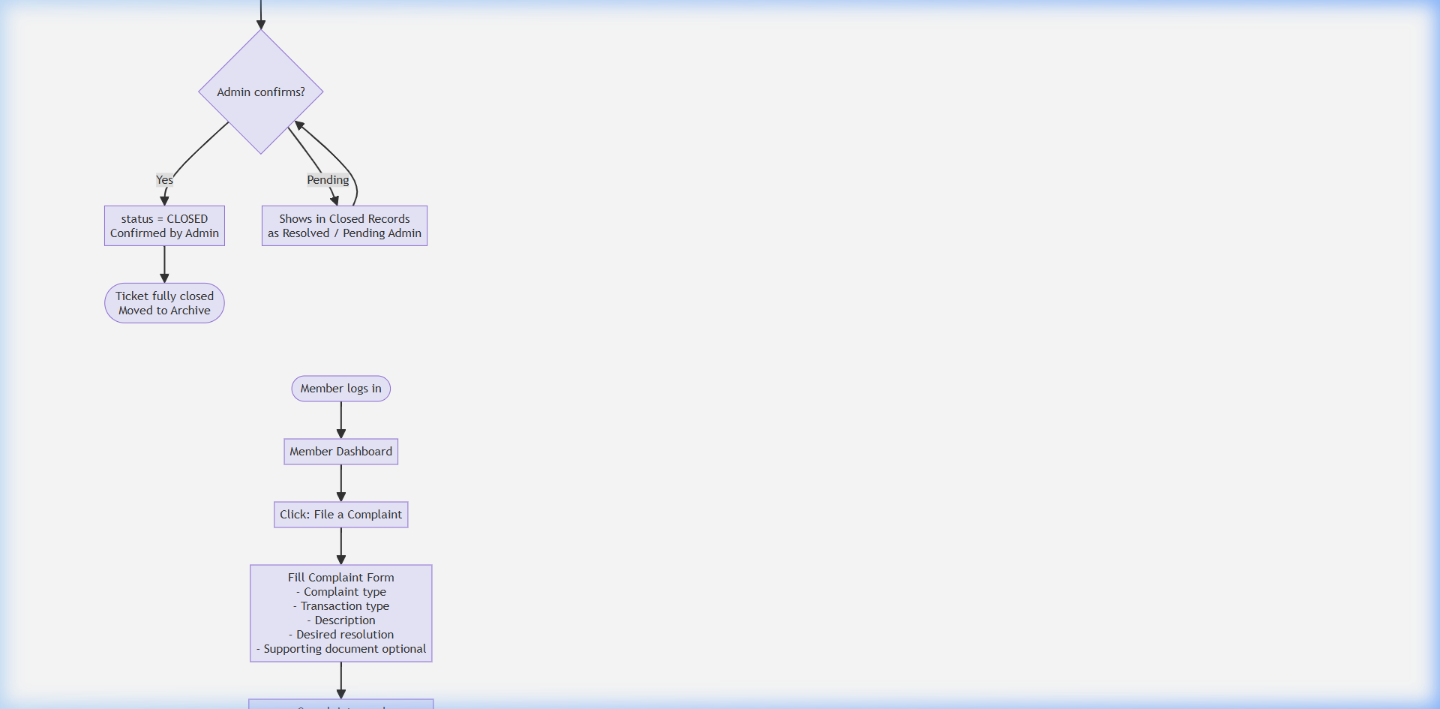
[Diagram: 2]

5. Complaint Flow (Core Process)
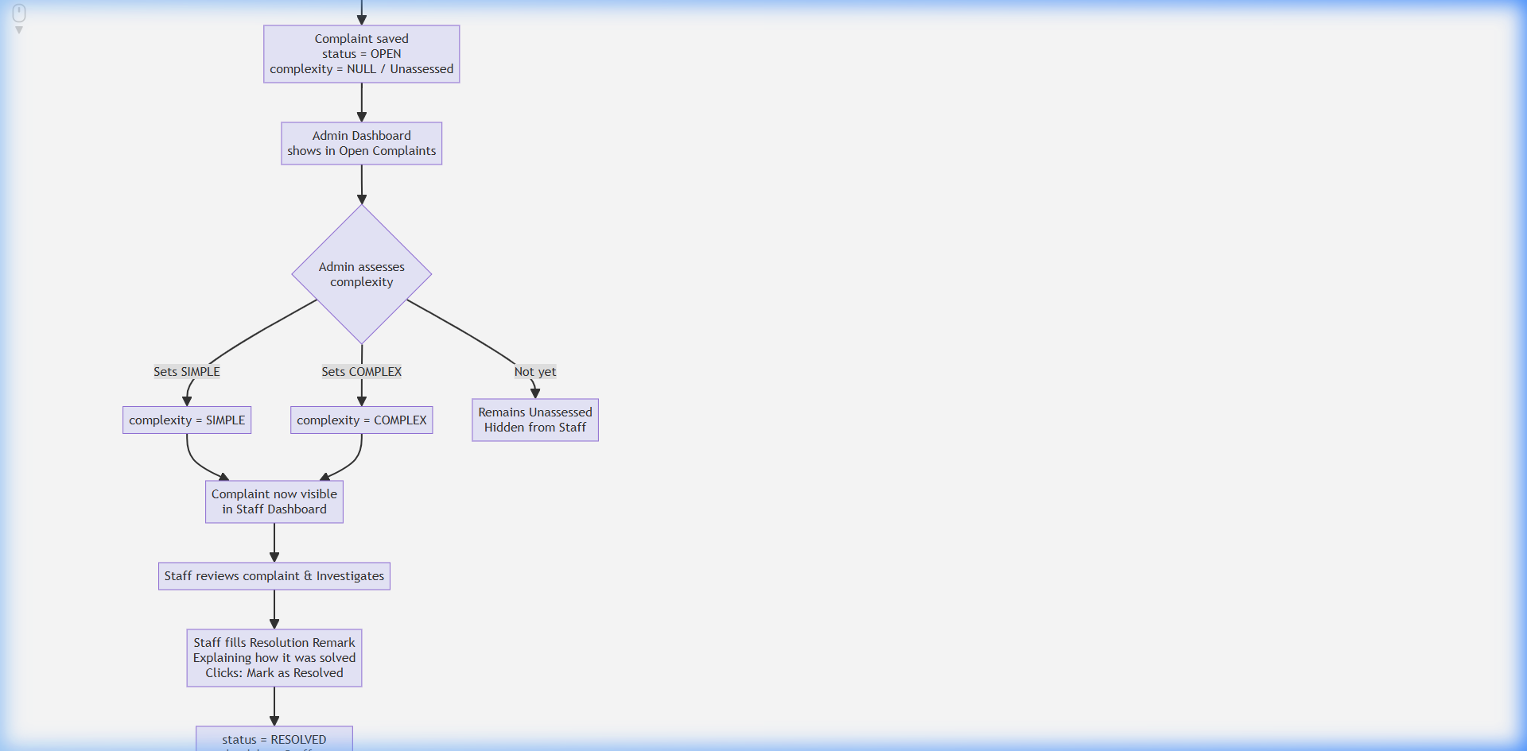
[Diagram: 3]

6. Complaint Visibility Rules
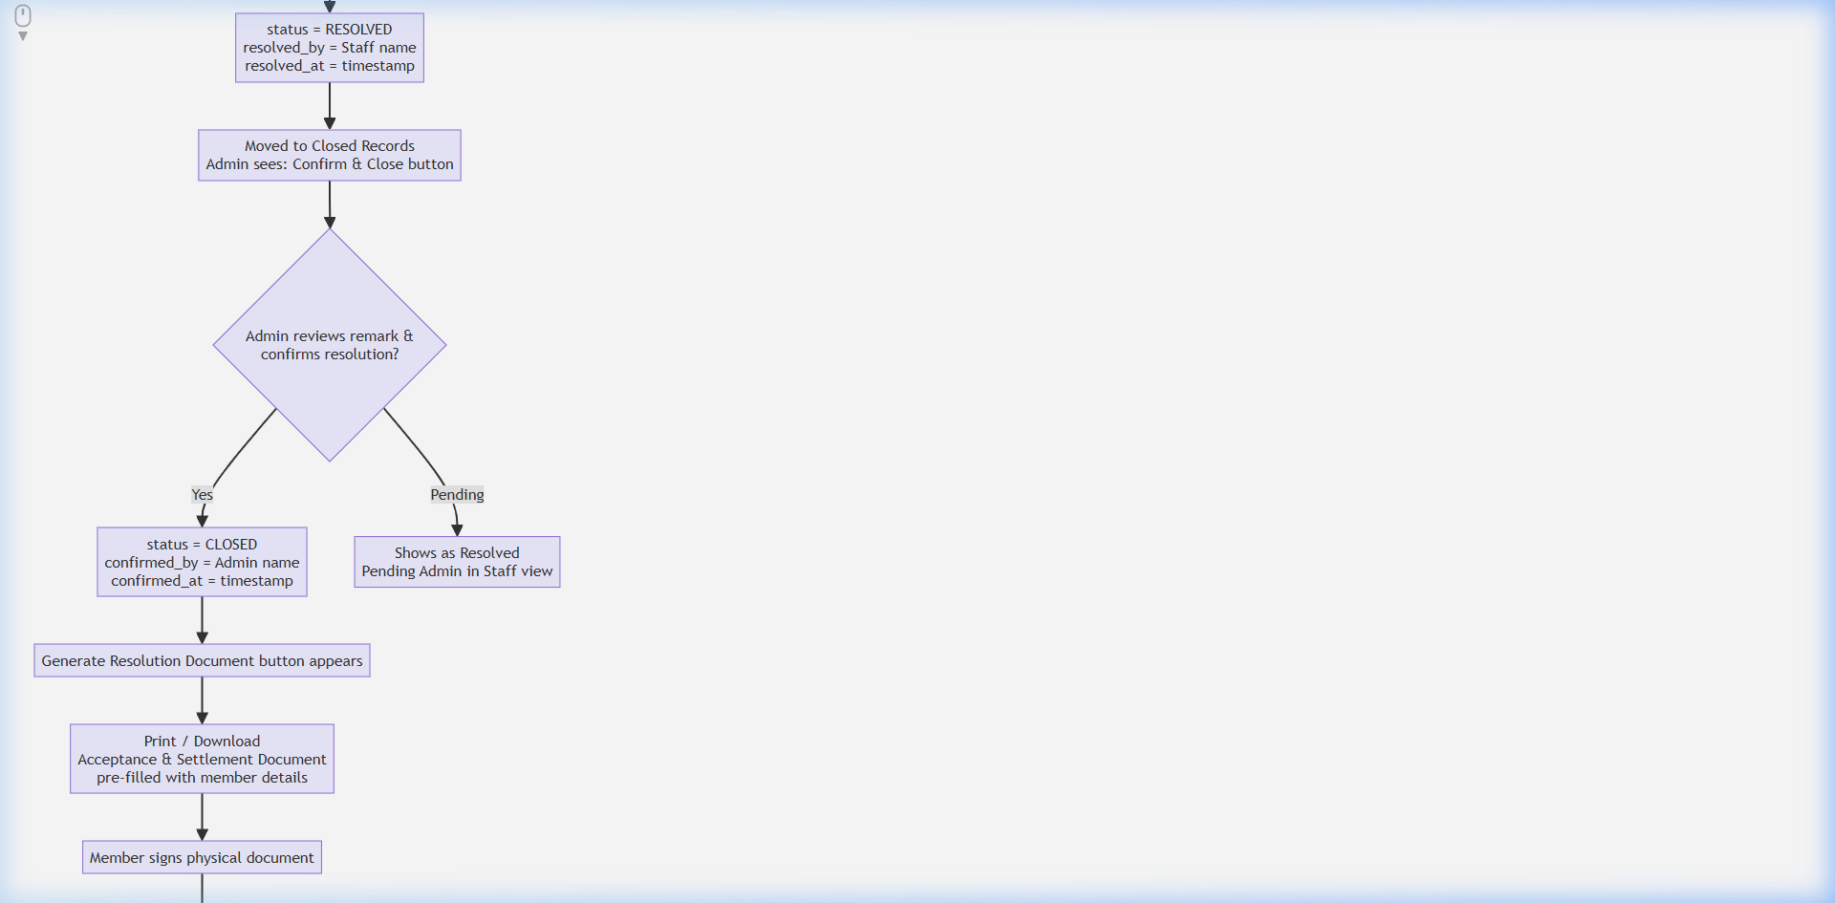
[Diagram: 4]

7. Survey Flow
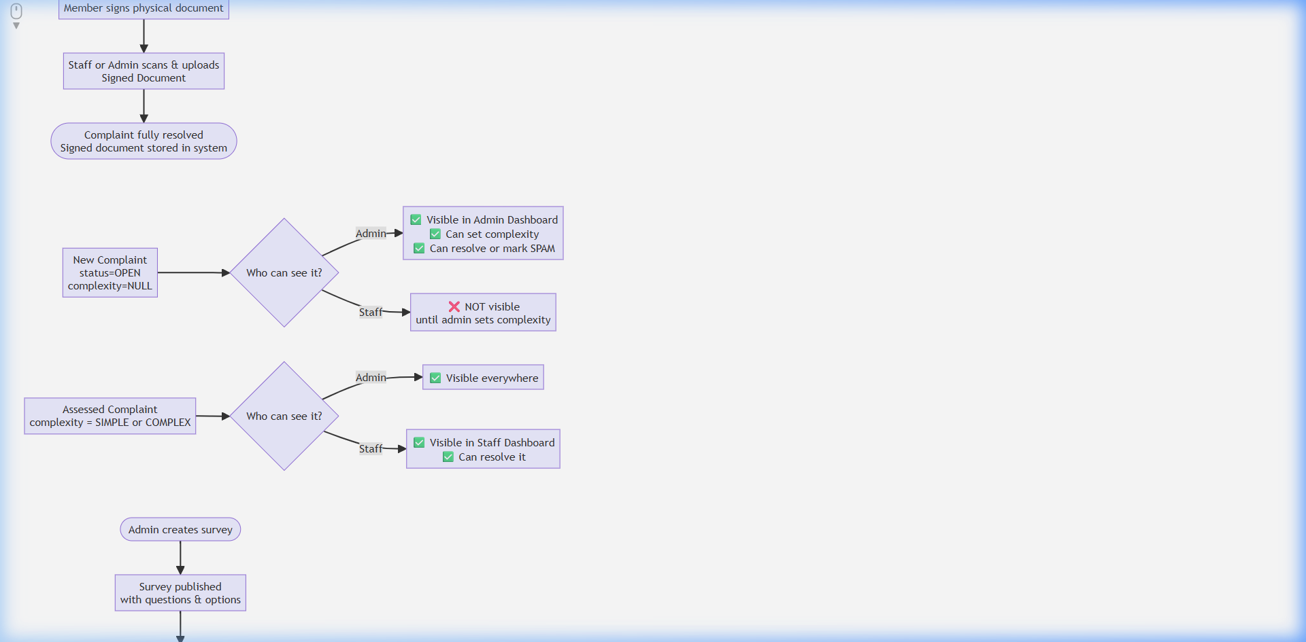
[Diagram: 5]

8. Resolution Document Workflow
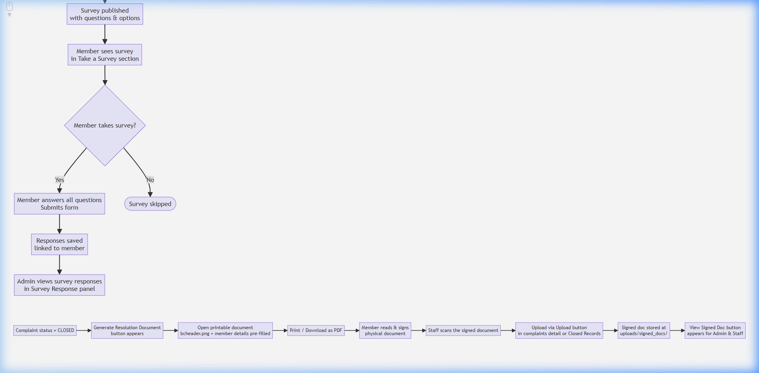
[Diagram: 6]

9. Status Lifecycle Reference

Submission (Ticket) Statuses

Complaint Statuses
[!IMPORTANT]
A complaint with complexity = NULL (Unassessed) is invisible to Staff. Admin must set the complexity before staff can process it.

Special Status

10. Complexity Rules
Complexity | Set by | Meaning | Staff can see?
NULL / Unassessed | Default on new complaint | Not yet reviewed by admin | ❌ No
SIMPLE | Admin | Straightforward resolution | ✅ Yes
COMPLEX | Admin | Requires deeper investigation | ✅ Yes

11. Report Module
Report Type | Filters Available | Key Data Shown
Complaints Report | Status, Complexity, Branch, Date | Member, phone, complaint type, transaction, resolution remark, resolved by, confirmed by
Submissions Report | Type, Branch, Date, Status | Message, requester, ticket type, resolved by
Surveys Report | Survey, Date | Question responses, branch, member
[!TIP]
All reports have a Print / PDF button. The page uses @media print to hide navigation elements and produce a clean A4 landscape printout.

12. File & Document Storage
File Type | Location | Naming Convention
Supporting documents (complaints) | uploads/ | {timestamp}_{original_name}.{ext}
Signed resolution documents | uploads/signed_docs/ | signed_complaint_{id}_{timestamp}.{ext}
System header image | images/bcheader.png | Fixed
Accepted file types: JPG, JPEG, PNG, PDF

