Lecture 3 Notes

* **Equilibrium vs. Reaction**
  + Keq is determined at equilibrium with respect to the amounts of products vs. reactants
    - Concentrations are not necessarily the same
    - Equilibrium means when the forward and reverse reactions occur at the same rate
    - If you take the Keq of the forward or reverse reaction, it will produce a ΔG of the same magnitude
* **Describing a Reaction**
  + Will it occur?
    - Is ΔG positive or negative?
  + In which direction?
    - Is Keq large or small?
  + How fast?
    - Is it catalyzed by an enzyme?
      * Enzyme binding/speed/inhibitors
* **Reaction rates**
  + Change in concentration over change in time
  + Reaction rates for reactants is negative
    - Decreasing in concentration through time
  + Reaction rates for products is positive
    - Increasing in concentration through time
* **Nonlinear (aka typical) reaction rates**
  + Most often hyperbolic
    - Start off quickly and taper off because you run out of either products and reactants
  + Low substrate to enzyme concentrations leads to a slow reaction
  + High substrate to enzyme concentrations leads to a fast reaction
* **Reaction velocity**
  + A good enzyme’s characteristics
    - Affinity for its substrate
    - How quickly it speeds up the reaction
  + V0 indicates how quickly things are occurring very early on in the reaction
    - It is the slope of the line of varying amounts of [S] concentration
    - It only deals with the forward reaction
      * Because early on, we can assume that the reaction E + P 🡪 ES is negligible because we have essentially no product at the beginning of a reaction and can be ignored
* **Steady state approximation**
  + The state of the enzyme substrate complex is steady (its rate of formation and breakdown is equal)
  + KM relates the rates of breakdown and formation of the enzyme substrate complex
    - KM = [S] at Vmax/2
* **Michaelis-Menten Model**
  + Only good at describing hyperbolic reactions (start off fast and then level off)
  + Assumptions
    - Steady state
      * ES formation = ES breakdown
    - At given [E] (enzyme concentration is constant)
    - Not at equilibrium (assuming we have far more substrate than enzyme; products assumed negligible)
  + Equations
    - KM measures how well does enzyme bind to its substrate
    - Kcat shows how fast is your enzyme
    - Kcat / KM = catalytic efficiency; how good is your enzyme
  + Summarized
    - KM
      * Affinity of enzyme for substrate
      * [S] at which the Vmax/2 (in units of concentration)
      * its in units of concentration
      * Independent of [S] and [E]
      * Unique to each ES complex
      * A higher KM means it needs more substrate in order to reach Vmax (we preferably want a lower KM for our enzymes to work well)
    - Kcat
      * Time per conversion
      * How fast ES proceeds to P
    - Vmax
      * Efficacy (effectiveness) of enzyme
      * Can be used to compare rates at given [S]
      * Difficult to measure accurately
        + Because actual reactions will never truly reach Vmax but only gets asymptotically close
* **Lineweaver-Birk (double reciprocal) plot**
  + If you take the inverse of the MM equation, we are able to calculate Vmax
    - Y-intercept is 1/Vmax
    - Slope = KM / Vmax
  + 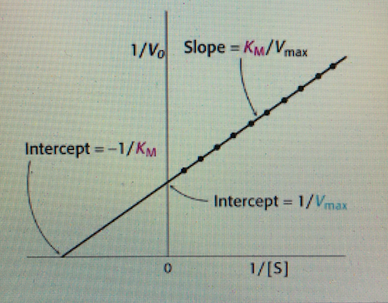
* **Enzyme regulation**
  + Binding
    - Competitive
      * Substrate cannot physically bind to enzyme
      * Vmax is unchanged
      * KM increases
      * Effectively lowers substrate concentration
    - Noncompetitive
      * Substrate can bind to enzyme but the reaction won’t occur
      * Vmax decreases
      * KM is unchanged
      * Effectively lowers enzyme concentration
    - Uncompetitive
  + Blockade
    - Direct
      * Inhibitor binds to active site
    - Allosteric
      * Inhibitor does not bind to the actual active site
  + Permanence
    - Reversible
    - Irreversible
* **Direct competitive inhibition**
  + Binds to the same active site that substrate would go to allowing no other substrate to bind to enzyme
  + Lowers concentration of substrate by blocking sites
  + Vmax remains unchanged with this inhibition
    - It just takes more and more substrate to get there
      * Thus, KM increases
  + This effectively lowers substrate concentration
* **Allosteric competitive inhibition**
  + Inhibitor will bind to site separate from active site
    - Still prevents substrate from binding to enzyme
    - Can still physically block active site
    - Can cause induced/conformational change so active site can no longer accept substrate
  + Vmax remains unchanged with this inhibition
    - It just takes more and more substrate to get there
      * Thus, KM increases
  + This effectively lowers substrate concentration
* **Allosteric noncompetitive inhibition**
  + Substrate can bind to the enzyme
  + However, inhibitor prevents enzyme from doing its job in some way
  + Vmax is significantly lowered
    - No matter how much substrate you add, reaction cannot proceed
  + This effectively lowers enzyme concentration
* **Noncompetitive vs. uncompetitive**
  + Uncompetitive
    - Substrate has to be bound to the enzyme for the inhibitor to inhibit
    - Changes Vmax and KM to equal degrees
* **Summary In Pictures**
  + 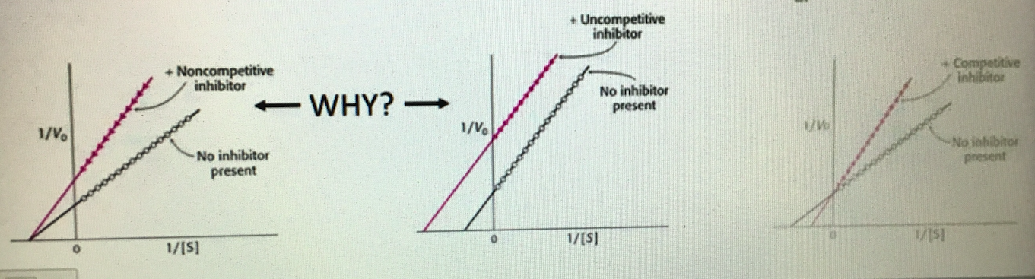
* **Irreversible inhibitors**
  + Strong binding energy- can be covalent/noncovalent
  + Found in nerve gas, penicillin, aspirin, …
  + Can be useful for drug design/manufacture
  + Can be designed based on specificity to enzyme active site
    - Group specific reagents
      * Interacts with certain functional groups
      * Not very specific as certain functional groups can be found on multiple different enzymes
    - Reactive substrate analogs
      * These inhibitors resemble the substrate and fit directly onto the active site preventing any further reactions from occurring
    - Mechanism-based inhibitors
      * These are the best one for drug development
      * Go into active site and begin the reaction with the enzyme
      * Once reaction proceeds, it becomes inactivated/destroyed
      * Can be extremely specific to an enzyme
  + Side effects are caused when irreversible inhibitors start affecting enzymes that were not the targeted enzymes