Lecture 4 Notes

* **Amino acids**
  + Most basic structure within protein
  + Amino acids are proton donors
  + Can be acids/bases (help buffer solutions when dissolved)
  + Amino group + carboxyl group + variable side chain
    - 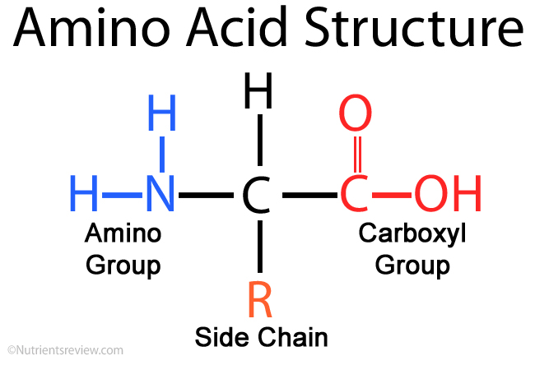
    - Variable side chain (R) determines interactions with other molecules
* **Zwitterions**
  + A molecule that can have both positive/negative charge on it
  + The charge the molecule will have depends on the pH of the solution it is in
  + PI: the pH at which the net charge is 0
* **Charge is cumulative and depends on pH**
  + A polypeptide is multiple amino acids and their charges are added together to give a net charge (positive, negative, neutral)
* **20 common amino acids**
  + The real world has upwards of 500 amino acids (only 20 encoded by humans)
  + Grouped into polar
    - Uncharged/positive/negative
  + Grouped into nonpolar
    - Simple/aromatic
* **Polypeptides are extremely variable**
  + Can vary infinitely in length
  + We can conjugate proteins to fats, sugars, metals (ie: hemoglobin)
    - Lipoproteins, glycoproteins, metalloproteins
* **Four levels of protein structure**
  + Primary/secondary/tertiary/quaternary structure
* **Primary structure**
  + The sequence of the amino acids
  + Amino acids are joined together by peptide bonds (covalent bond between carbon and nitrogen)
    - Formed through condensation reaction (releases water)
    - Forms with carboxyl terminus of one amino acid and amino terminus of another amino acid
    - When talking about a sequence of amino acids, we name them from N-terminal (amino) to C-terminal (carboxyl)
  + DNA 🡪 RNA 🡪 Protein
    - Essential dogma
    - Want to alter structure/function of protein, alter its RNA or DNA (genetic engineering)
* **Peptide bonds are rigid and planar**
  + Peptide bonds (between carbon and nitrogen) have resonance structures where electrons can jump to produce a double bond in different areas
    - This forces the peptide bond to be rigid and planar because you cannot rotate a double bond much and the double bond can jump from location to location; thus, the whole bond is stable/planar
  + However, the carbon-carbon bonds can rotate freely
  + A larger R group also leads to less mobility
    - A larger R group could interact with itself as it moves leading to less mobility as well
* **Secondary structure**
  + Semi local hydrogen bonds between amino acids within the same peptide
  + β sheet
    - When long strands of amino acids double back on one another in a ladder formation forming sheets and hydrogen bonding with itself
    - These β sheets can be orientated parallel/antiparallel to one another (whether or not N-C terminal is going in the same direction)
      * Parallel strands have to reach further to H bond whereas its easier for antiparallel strands
    - Silk is a common example of a β sheet
    - β sheets contain a lot of Gly and Ala
      * Their R groups are small allowing for a lot of maneuverability
  + α helix
    - Coils of H bonds between every 4th amino acid within a single peptide chain (within a peptide strand)
    - Helix stability is determined by…
      * Electrostatic interactions
      * Bulkiness of nearby side chains
      * Interactions between nearby side chains (covalent/noncovalent)
  + Bends, loops, and other motifs
    - Connect sections of β sheets and α helixes
    - Motifs: chunks of things that aren’t functional on their own but are repeated in many different peptides
    - Loops
      * Most important loop is the beta loop
        + An H bond between a carbon and the 3rd nitrogen away from it (forms a tight turn)
* **Tertiary structure**
  + Any kind of 3D organization
    - Bond angles contribute to 3D folding
    - The most important contribution are the hydrophobic residues
      * Hydrophobic residues will allow it to spontaneously rearrange to hide the hydrophobic regions from the aqueous environment and expose hydrophilic regions
      * Best way to predict tertiary structure
* **Thermodynamics of protein folding**
  + The folding funnel
    - The polypeptide strand wiggles into different contortions until it finds a favorable state; then other sections wiggle and such and the process continues until you reach the native structure
      * As you move down the funnel, the protein will reach semi stable intermediate structures (takes a little bit of energy to push it back down to find the native structure)
  + Native structure: state that is most functional for the polypeptide
  + Denaturation: process of going from the native structure back to the polypeptide strand
* **Protein folding experiment**
  + Adding heat to proteins will denature it thus lowering its activity
    - Removing the heat and allowing recovery will allow the protein to assume its correct conformation
    - However, sometimes a chaperone protein is necessary to help shape the protein back to its correct conformation
* **Protein folding diseases: prions**
  + Mad cow disease: caused by abnormal folding of prion proteins
    - Ingesting a mutant form of these proteins will cause the normal proteins to become mutants
  + Prion diseases are nearly always fatal
    - Cannot be treated (they’re your same proteins but just folded differently)
* **Quaternary Structure**
  + If we have 2 different peptides, how do they interact with one another
  + Two general classes of quaternary structure
    - Fibrous
      * Long strands or sheets
      * Single type of secondary structure
      * Function in support, shape, protection (ie: extracellular matrix)
      * Keratin (hair, nails, skin) results from fibrous proteins
        + Composed of α helixes that coil further around each other via ionic and Van der Waal interactions
        + Further strengthened by disulfide bonds between cysteine residues (covalent bonds between sulfur)

The number of disulfide bonds determines whether its soft or hard (hair vs. nails)

* + - * Collagen also results from fibrous proteins
        + Composed of α helixes that coil further around each other via ionic and Van der Waal interactions
        + Composed by 33% with glycine

Gives huge ability for bond rotation

Allows for compact packing making really dense strong structures (stronger than steel)

* + - Globular
      * Globs n blobs
      * Various secondary structures
      * Enzyme/regulatory proteins tend to be globular
      * Transmembrane receptor tyrosine kinases
        + Often found on neurons
* **Post-Translational Modifications**
  + Modifications that are done to final proteins after quaternary structure
  + Types of modifications
    - Phosphorylation
      * To activate/inactivate protein
    - Glycoslation/lipidation
      * Add sugars/lipids to them
    - Ubiquitination
      * Tag them to direct them to different parts of cell or to be broken down
* **Separating proteins**
  + Break cells; separate organelles
  + Fractionalization (by solubility, size, or charge)
  + Characterization, identification, electrophoresis
  + Quantification
* **Differential centrifugation**
  + This allows us to separate pieces of cells
  + When you crush cells, put them in a tube, and spin them, the heavy components will rest in the bottom while the lighter ones will be at the top
  + Nuclei are very dense
  + Soluble proteins are very light
* **Column chromatography**
  + Once we have the desired materials to look at, we can separate them further by size/charge/binding
  + Place materials in column, and run beads through that will separate them
    - By size: the beads will push certain sizes out
    - By charge: the charge on the beads can repel certain charges out
    - By binding: run material that you think enzyme will bind to
      * Best way
* **Gel electrophoresis**
  + Denature the protein and put sample in well and apply a negative charge
    - The big ones will get stuck at the top and the little ones will move to the bottom
* **2D gel electrophoresis**
  + Separates a sample first by charge and then by weight
  + Put all the proteins in a pH gradient and then apply a charge
    - Separates the protein in the x direction based on charge
    - Separates the proteins in the y direction based on size
* **Immunological identification**
  + The immune system produces antibodies with specificity to disease-causing antigens
  + Biochemists can use these techniques to make antibodies to bind to specific proteins to isolate them