Undergrad/Graduate 199/299 Research Opportunities

The California Institute for Telecommunications and Information Technology (Calit2) at UC Irvine is seeking student innovators for cutting-edge, industry focused engineering, art/technology interface, and computer science research in energy efficiency, micro-nanofabrication, and gamification research areas.

More than 200 UCI faculty and students are actively engaged in Calit2, INRF/BION (Clean rooms) and CalPlug (a division of Calit2) research on environmental, transportation, energy management, health care, education and entertainment-based projects.

# APPLICATION PROCESS AND REQUIREMENTS

Motivated applicants are welcome to apply and attend one of the orientations. Please follow these procedures to apply:

**“Introducing CalPlug/Calit2”**

**3008 Calit2 Building**

**Irvine, CA. 92697-2800**

**Wednesday, October 3rd from 4pm to 5pm**

1. Students may only receive 199/299 credit for the first quarter of research with CalPlug. No paid positions are available to new research students unless otherwise stated. Paid positions will be offered only if funding is available and to students showing high caliber research with need.
2. GPAs >3.0 are strongly desired. Students applying with lower GPAs must explain extenuating circumstances and show maintained academic improvement to be considered.
3. Students must be prepared to dedicate a minimum of 1 year (3 quarters) to research at time of application. Except in special circumstances, students with less than 5 quarters remaining ahead of graduation are ineligible from joining Calit2/CalPlug projects. Too little time remains at this point to become deeply involved in the projects.
4. Submit a one-page resume along with unofficial academic transcript and introductory letter to the Admin Team at **calplug@gmail.com**, **AND** Please copy relevant leader for the projects you are interested in: (Gago-) Dr. Sergio Gago ([**sgagomas@calit2.uci.edu**](mailto:sgagomas@calit2.uci.edu)**),** (Klo-) Dr. Michael Klopfer (**mklopfer@uci.edu**)**,** and (INRF-) Steven Martinez ([**stevenm4@@uci.edu**](mailto:anvalenc@uci.edu)**)**. Please discuss projects of interest (including Position ID) in the reply email. Send current unofficial transcript and resume. This must be done **BEFORE Friday, October 5th** to allow time for interviews and processing to meet the school’s enrollment deadline of **October 12th.**
5. Selected students will be contacted to schedule an interview. Interviews will focus on student ability, interest, availability, and project matching. Project scheduling will follow the interview.
6. Students are expected to work a minimum of 8 hours per week on research (equivalent to 2 units).
7. Students are expected to work in professional, interdisciplinary teams.
8. Students are strictly held to unit-hour requirements (4 hours/week per unit). Substantial unexcused divergence from the required time will result in an incomplete or fail grade.
9. Students are required to submit a summary report for the work performed each quarter.
10. No more than 1/3 of research work can be performed offsite from Calit2. Students must be present to gain personal and team development.
11. Students will keep timesheets and work logs during projects. Research notebooks will be maintained. A quarter-end written report is required from all 199/299 students. Reports and presentations will be used to assess grades.

# BENEFITS

* Students will obtain **hands-on research experiences** for industry leading topics under ETAD **Prof. G.P. Li**. Day-to-day supervision will be available from project leaders at Calit2/INRF and/or CalPlug.
* Students work to build maker skills while building practical career experience from other coursework.
* In addition to **199/299 course credits** during the first quarter of research, students who maintain outstanding research performance will be considered for **potential compensation** as funded projects become available.
* Designated **cubicles, project space**, **project** **supplies**, **test** **equipment,** and **computers** will be provided to students according to project needs.
* **Recommendation letters** provided to exemplary students are valuable thanks to Calit2 and CalPlug’s strong affiliation with major organizations and industry players and other UC Schools and campuses, Ex: California Energy Commission, Southern California Edison, Microsemi Corporation, and the Consumer Technology Association. More than 2 quarters of work is required to be potentially eligible for a recommendation letter. Students must present a case of impressive work completed.
* Students will develop hard as well as soft skills required for the 21st Century workforce. We seek to establish and promote students into high quality engineers and leaders. Impressive project portfolios with solid, real-world achievements are commonly the result of conducting research at CalPlug/Calit2.

# POSITIONS

We are calling for a talented group of students from engineering departments (EE/CS/ICS/MAE), Social Sciences and the School of Arts to join our team. Diversity is a must for creativity. Current positions are listed below.

**Position ID: Gago-Oct1801**

**Project: PICARD**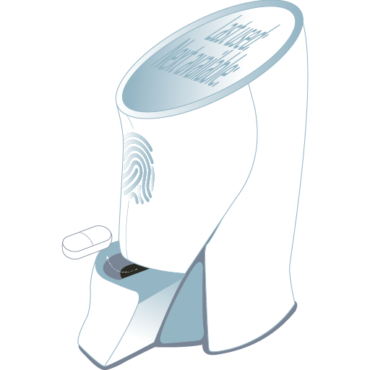

Research field: Telemedicine/Health Card/ PICARD

Main Tasks: Patient-Initiated Controlled Analgesic Recording Dispenser developers envision creating an ecosystem that will ensure prescription opioid drugs are correctly dispensed to a patient while tracking a drug’s use and effectiveness. User Interface Design and implementation/ This team mainly focuses on designing an elegant user interface for hardware system interfacing and controlling running Linux on Raspberry Pi.

Preferred but not required skills: **Java, JavaScript, Node JS, Express, QT, Git.**

**Position ID: Gago-Oct1802**

**Project: Robotics NAO/App Development**

This is a brand new project that focuses on machine learning, artificial intelligence, robotics, and app development. Students will be working on a humanoid robot, NAO. Students will contribute to NAO’s development by inventing new forms of use. We are looking for problem solvers, critical thinkers, committed attitudes, and dedicated students ONLY. Students with any more than 12-14 units of a course load will not be qualified for this project and there is a requirement of inputting 4 physical hours at site to commit to this project. If interested, please write a paragraph worth of what it means when ‘zoning out on coding’ in addition to the resume and transcript of current quarter.

**Position ID: Klo-Oct1801**

**Smartenit IoT interface**

Students will develop home automation solutions and should have some background in the Python programming language, developing front ends using Angular, and experience with SQL or Mongo Database. This project will involve interfacing Amazon’s Alexa or Google Home to perform advanced control of plug load devices.  
Skills Required:

* Python
* Angular
* SQL or Mongo Database

**Position ID: Klo-Oct1802**

**Project SIM Test**

Looking for Students with some Labview or data acquisition experience to assist with an SCE project. This is an extension of SimHome, a project that under the notion of IoT, future homes will be more automated and connected. In addition, we will need a student who is detail oriented to take measurements and run tests.

**Preferred skills: Labview, MatLAB**

**Position ID: Klo-Oct1803**

**Project Buddy**

Looking for students with experience in circuit design to assist with the development of the buddy series. Participating students should have knowledge with microcontroller based design projects and experience interfacing microcontrollers to sensors.

**Position ID: Klo-Oct1804**

**Project FPGA - Field Programmable Gate Arrays**

Students will develop high speed data acquisition modules, should have some experience programming with VHDL or Verilog and experience loading to physical FPGA boards

**Position ID: Klo-Oct1805**

**Project UI**

Development of user interfaces using Angular - multiple opportunities across multiple projects

**Position ID: INRF-Oct1801**

**Research Field:** Nanotechnology / Semiconductor / Process & Equipment Engineering

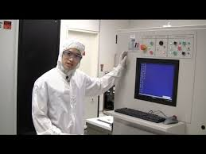Getting the very unique and special opportunity to work alongside active professional engineers and grad students in not just one but two cleanroom facilities right here on campus, students in this position will work to assist with process development and/or equipment work for semiconductor / nanotechnology research in the INRF/BiON facilities. Example areas of research include but are not limited to photolithography, characterization, etch, and deposition.

Responsibilities of student researchers will include but not be limited to device fabrication, developing and running baseline process experiments and wafer workflows, benchmarking processes and equipments ensuring performance for both internal and external customers, continuously measuring, monitoring, documenting, and working to improve equipment and process performance utilizing concepts of SPC and DOE.

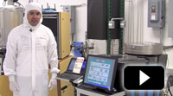The work of student researchers will add great value to the campus’s INRF/BiON facilities, enhancing the existing and future process and equipment knowledge and capabilities within the labs. Students can expect to contribute to live real world problems and applications, in a live and functional business entity right here on campus, and will have the reward of seeing the fruits of their labor help make a significant difference in a high - paced environment.

This opportunity provides a great deal of experiential learning, with practical hands on lab and real world experience combined with having the unique experience of working alongside active engineers who could definitely act as a professional reference and help make you stand out to future employers and/or academic opportunities. All this, while receiving 199/299 credit towards graduation as well.

**Main Tasks:** Develop and benchmark baseline processes for the INRF/BiON cleanroom lab processes and equipment, design and implement fabrication experiments and process controls, monitor and work to optimize fabrication process techniques

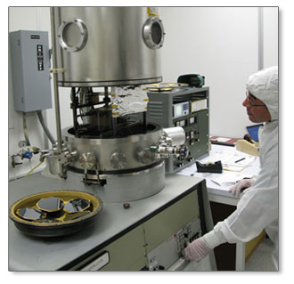Prior knowledge of nanotechnology, semiconductor processes, SPC, and/or cleanroom lab operations a plus but none is required.