PROJECT REPORT

SUMMARY

The objective of this project was to train a smart Super Mario agent that can interact with its environment to avoid attackers and collect items to gain more short and long term rewards by using reinforcement learning techniques.

METHODOLOGY
To achieve this objective, the plan is to utilize a Deep Q-Learning Network to train the agent to traverse the environment. I also explore and compare policies such as Boltzmann and Eps
Greedy (Linearly Annealed); as well as Double DQN and Dueling DQN Networks, using industry standard frameworks, such as OpenAI Gym and Keras-RL to create the custom environments and the agents.

The custom environment was created using Gym with 4 interacting items in total, with positive and negative rewards associated with each interaction.
Some of the specifics of the interactions looked like these:
Mario can continue to gain rewards either:
1. until the Fuel runs down from a 1000 to 0 (with each step);
2. or until the Lives run down to 0 (when hit by a bullet)
3. Mushrooms reset fuel to a 1000
4. Stars add more lives +10
5. Bullets are spawned at twice the rate of mushrooms/stars.
6. There are 9 actions that can be performed in total with all directions of movements (but this could also be scaled up to include defensive strategies against attackers in further iterations).
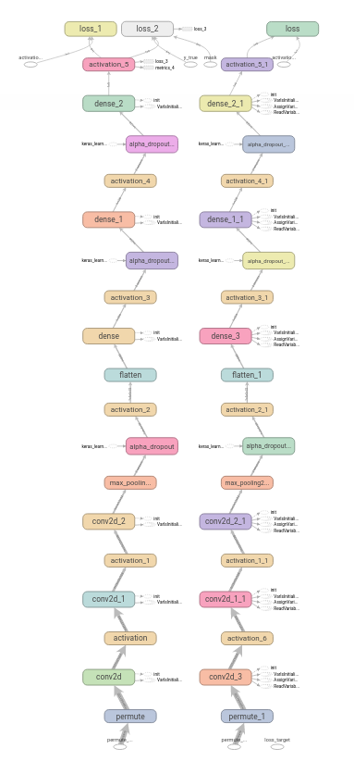
Agent is a deep neural network with Convnet layers and Dense layers. Image shown on the right.

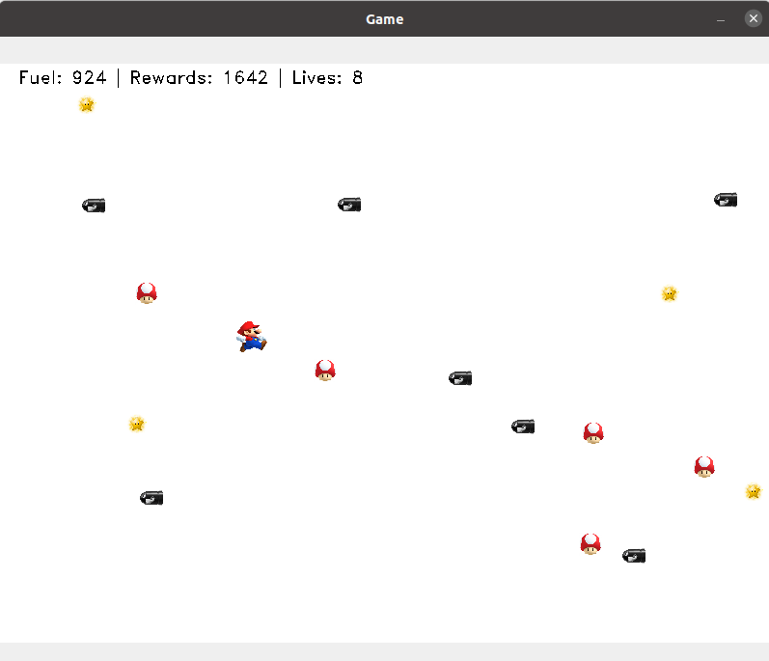
CODE

ENVIRONMENT

from IPython import display
import numpy as np
import cv2
import matplotlib.pyplot as plt
import PIL.Image as Image
import random
from collections import deque

from gym import Env, spaces
import time

font = cv2.FONT_HERSHEY_DUPLEX
AGENT_SIZE = 32
ITEM_SIZE = 24
ITEM_PROBABILITY = 0.05

class MarioWorld(Env):
def __init__(self):
super(MarioWorld, self).__init__()

# Define an observation space
self.observation_shape = (600, 800, 3)
self.observation_space = spaces.Box(low=np.zeros(self.observation_shape),
high=np.ones(
self.observation_shape),
dtype=np.float16)

# Define an action space
self.action_space = spaces.Discrete(9,)

# Create a canvas to render the environment images
self.canvas = np.ones(self.observation_shape) * 1

# Define elements present inside the environment
self.elements = []

# Maximum fuel mario can take at once
self.max_fuel = 1000

# Permissible area of helicopter to be
self.y_min = int(self.observation_shape[0] * 0.05)
self.x_min = 0
self.y_max = int(self.observation_shape[0] * 0.95)
self.x_max = self.observation_shape[1]

def get_action_meanings(self, action):
actions = {0: "East", 1: "West", 2: "South",
3: "North", 4: "North-East", 5: "North-West", 6: "South-East", 7: "South-West", 8: "Do Nothing"}
return actions.get(action)

def draw_elements_on_canvas(self):

self.canvas = np.ones(self.observation_shape) * 1

for elem in self.elements:
elem_shape = elem.icon.shape
x, y = elem.x, elem.y
self.canvas[y: y + elem_shape[1], x:x + elem_shape[0]] = elem.icon

# Add text info on the canvas
text = f" Fuel: {self.fuel_left} | Rewards: {self.ep_return} | Lives: {self.life_count}"
self.canvas = cv2.putText(self.canvas, text, (10, 20), font,
0.6, (0, 0, 0), 1, cv2.LINE_AA)

def reset(self):
# Reset the fuel consumed
self.fuel_left = self.max_fuel

# Reset the reward
self.ep_return = 0

# Number of elements
self.bullet_count = 0
self.life_count = 1
self.fuel_count = 0
self.action_buffer = deque(maxlen=10)

# Determine a place to intialise the mario in
x = random.randrange(
int(self.observation_shape[0] * 0.05), int(self.observation_shape[0] * 0.10))
y = random.randrange(
int(self.observation_shape[1] * 0.15), int(self.observation_shape[1] * 0.20))

# Intialise the mario
self.mario = Mario("mario", self.x_max,
self.x_min, self.y_max, self.y_min)
self.mario.set_position(x, y)

# Intialise the elements
self.elements = [self.mario]

# Reset the Canvas
self.canvas = np.ones(self.observation_shape) * 1

# Draw elements on the canvas
self.draw_elements_on_canvas()

# return the observation
return self.canvas

def render(self, mode="human"):
if mode == "human":
cv2.imshow("Game", self.canvas)
cv2.waitKey(10)

elif mode == "rgb_array":
return self.canvas

def close(self):
cv2.destroyAllWindows()

def step(self, action):
# Flag that marks the termination of an episode
done = False

# Assert that it is a valid action
assert self.action_space.contains(action), "Invalid Action"

# Decrease the fuel counter
self.fuel_left -= 1

# Reward for executing a step.
reward = 2

# apply the action to the mario
if action == 0:
self.mario.move(0, 5)
elif action == 1:
self.mario.move(0, -5)
elif action == 2:
self.mario.move(5, 0)
elif action == 3:
self.mario.move(-5, 0)
elif action == 4:
self.mario.move(5, 5)
elif action == 5:
self.mario.move(5, -5)
elif action == 6:
self.mario.move(-5, 5)
elif action == 7:
self.mario.move(-5, -5)
elif action == 8:
self.mario.move(random.randint(0, 2), random.randint(0, 2))

self.action_buffer.append(action)
if len(set(self.action_buffer)) == 1:
reward -= 100

# Spawn a bullet at the right edge with given probability
if random.random() < ITEM_PROBABILITY:

spawned_bullet = Bullet("bullet_{}".format(self.bullet_count),
self.x_max, self.x_min, self.y_max, self.y_min)
self.bullet_count += 1
bullet_x = self.x_max
bullet_y = random.randrange(self.y_min, self.y_max)
spawned_bullet.set_position(bullet_x, bullet_y)
self.elements.append(spawned_bullet)

# Spawn fuel at the bottom edge with given probability ITEM_PROBABILITY
if random.random() < ITEM_PROBABILITY/2:
spawned_fuel = Fuel("fuel_{}".format(self.bullet_count),
self.x_max, self.x_min, self.y_max, self.y_min)
self.fuel_count += 1
fuel_x = random.randrange(self.x_min, self.x_max)
fuel_y = self.y_max
spawned_fuel.set_position(fuel_x, fuel_y)
self.elements.append(spawned_fuel)

# Spawn life at the bottom edge with given probability ITEM_PROBABILITY
if random.random() < ITEM_PROBABILITY/4:
spawned_life = Life("life_{}".format(self.life_count),
self.x_max, self.x_min, self.y_max, self.y_min)
life_x = random.randrange(self.x_min, self.x_max)
life_y = self.y_max
spawned_life.set_position(life_x, life_y)
self.elements.append(spawned_life)

for elem in self.elements:
# If the bullet has reached the left end, perform these actions
if isinstance(elem, Bullet):
if elem.get_position()[0] <= self.x_min:
self.elements.remove(elem)
else:
elem.move(-5, 0)

if self.has_collided(self.mario, elem):
self.life_count -= 1
if self.life_count < 1:
reward = -400
done = True
self.elements.remove(self.mario)
reward += -100

if isinstance(elem, Fuel):
# If the fuel has reached the top end, perform these actions
if elem.get_position()[1] <= self.y_min:
self.elements.remove(elem)
else:
elem.move(0, -5)

if self.has_collided(self.mario, elem):
self.elements.remove(elem)
self.fuel_left = self.max_fuel
reward += 400

if isinstance(elem, Life):
# If the life has reached the top end, perform these actions
if elem.get_position()[1] <= self.y_min:
self.elements.remove(elem)
else:
elem.move(0, -5)

if self.has_collided(self.mario, elem):
self.elements.remove(elem)
self.life_count += 10

self.ep_return += 1 + reward + self.life_count * 5

self.draw_elements_on_canvas()

if self.fuel_left == 0:
done = True
return self.canvas, reward, done, {}

def has_collided(self, elem1, elem2):

elem1_x, elem1_y = elem1.get_position()
elem2_x, elem2_y = elem2.get_position()

if 2 * abs(elem1_x - elem2_x) <= (elem1.icon_w + elem2.icon_w):
if 2 * abs(elem1_y - elem2_y) <= (elem1.icon_h + elem2.icon_h):
return True

return False

class Point(object):
def __init__(self, name, x_max, x_min, y_max, y_min):
self.x = 0
self.y = 0
self.x_min = x_min
self.x_max = x_max
self.y_min = y_min
self.y_max = y_max
self.name = name

def set_position(self, x, y):
self.x = self.clamp(x, self.x_min, self.x_max - self.icon_w)
self.y = self.clamp(y, self.y_min, self.y_max - self.icon_h)

def get_position(self):
return (self.x, self.y)

def move(self, del_x, del_y):
self.x += del_x
self.y += del_y

self.x = self.clamp(self.x, self.x_min, self.x_max - self.icon_w)
self.y = self.clamp(self.y, self.y_min, self.y_max - self.icon_h)

def clamp(self, n, minn, maxn):
return max(min(maxn, n), minn)

class Mario(Point):
def __init__(self, name, x_max, x_min, y_max, y_min):
super(Mario, self).__init__(name, x_max, x_min, y_max, y_min)
self.icon = cv2.imread("assets/mario.jpg") / 255.
self.icon_w = AGENT_SIZE
self.icon_h = AGENT_SIZE
self.icon = cv2.resize(self.icon, (self.icon_h, self.icon_w))

class Bullet(Point):
def __init__(self, name, x_max, x_min, y_max, y_min):
super(Bullet, self).__init__(name, x_max, x_min, y_max, y_min)
self.icon = cv2.imread(
"assets/bullet.png") / 255.
self.icon_w = ITEM_SIZE
self.icon_h = ITEM_SIZE
self.icon = cv2.resize(self.icon, (self.icon_h, self.icon_w))

class Fuel(Point):
def __init__(self, name, x_max, x_min, y_max, y_min):
super(Fuel, self).__init__(name, x_max, x_min, y_max, y_min)
self.icon = cv2.imread(
"assets/fuel.jpg") / 255.
self.icon_w = ITEM_SIZE
self.icon_h = ITEM_SIZE
self.icon = cv2.resize(self.icon, (self.icon_h, self.icon_w))

class Life(Point):
def __init__(self, name, x_max, x_min, y_max, y_min):
super(Life, self).__init__(name, x_max, x_min, y_max, y_min)
self.icon = cv2.imread(
"assets/life.jpg") / 255.
self.icon_w = ITEM_SIZE
self.icon_h = ITEM_SIZE
self.icon = cv2.resize(self.icon, (self.icon_h, self.icon_w))

env = MarioWorld()
obs = env.reset()

while True:
# Take a random action
action = env.action_space.sample()
obs, reward, done, info = env.step(action)

# Render the game
env.render()
if done == True:
break

env.close()

AGENT

from rl.memory import SequentialMemory
from rl.policy import EpsGreedyQPolicy, LinearAnnealedPolicy, BoltzmannQPolicy
from rl.agents.dqn import DQNAgent
from rl.core import Processor
from rl.callbacks import FileLogger, ModelIntervalCheckpoint
from tensorflow.keras.optimizers import Adam
from tensorflow.keras.layers import Dense, Activation, Flatten, Convolution2D, Permute, Dropout, Input, MaxPooling2D, Activation, AlphaDropout
from tensorflow.keras.models import Sequential
from tensorflow.keras.callbacks import TensorBoard
from PIL import Image
import numpy as np
import os
from datetime import datetime
import gym
from gym_environment import MarioWorld

os.environ['TF_FORCE_GPU_ALLOW_GROWTH'] = 'true'
now = datetime.now()
time = now.strftime("%H%M%S")

ENV_NAME = 'mario_world'
env = MarioWorld()
env.seed(123)

run_id = ["dqn-bz", "dqn-eps", "dqn-double", "dqn-duel"]
LOG_DIR = f"logs/final/"

if not os.path.exists(LOG_DIR):
os.makedirs(LOG_DIR)

weights_filename = f'{LOG_DIR}dqn_{ENV_NAME}_weights.h5f'
log_filename = f'{LOG_DIR}dqn_{ENV_NAME}_log.json'

np.random.seed(123)
INPUT_SHAPE = (64, 64)
WINDOW_LENGTH = 100
input_shape = (WINDOW_LENGTH,) + INPUT_SHAPE
nb_actions = env.action_space.n
nb_steps = 60000

class ImageProcessor(Processor):
def process_observation(self, observation):
assert observation.ndim == 3
img = Image.fromarray((observation * 255).astype(np.uint8))
img = img.resize(INPUT_SHAPE).convert('L')
processed_observation = np.array(img)
return processed_observation.astype('uint8')

def process_state_batch(self, batch):
processed_batch = batch.astype('float32') / 255.
return processed_batch

def process_reward(self, reward):
return np.clip(reward, -1., 1.)

model = Sequential()
processor = ImageProcessor()

model.add(Permute((2, 3, 1), input_shape=input_shape))
model.add(Convolution2D(64, (3, 3), strides=(2, 2),
kernel_initializer="lecun_normal"))
model.add(Activation('selu'))
model.add(Convolution2D(128, (6, 6), strides=(2, 2),
kernel_initializer="lecun_normal"))
model.add(Activation('selu'))
model.add(Convolution2D(32, (3, 3), strides=(1, 1),
kernel_initializer="lecun_normal"))
model.add(MaxPooling2D(pool_size=(2, 2)))
model.add(AlphaDropout(0.25))
model.add(Activation('selu'))
model.add(Flatten())
model.add(Dense(256,
kernel_initializer="lecun_normal"))
model.add(Activation('selu'))
model.add(AlphaDropout(0.4))
model.add(Dense(128,
kernel_initializer="lecun_normal"))
model.add(Activation('selu'))
model.add(AlphaDropout(0.2))
model.add(Dense(nb_actions))
model.add(Activation('linear'))
print(model.summary())

memory = SequentialMemory(limit=nb_steps//10, window_length=WINDOW_LENGTH)
policy = LinearAnnealedPolicy(EpsGreedyQPolicy(), attr='eps', value_max=1., value_min=.05, value_test=.025,
nb_steps=nb_steps)
dqn = DQNAgent(model=model, nb_actions=nb_actions, memory=memory, nb_steps_warmup=nb_steps//40, processor=processor, enable_double_dqn=True, enable_dueling_network=False,
target_model_update=4, policy=policy, gamma=.95, train_interval=2, delta_clip=1.)
dqn.compile(Adam(lr=1e-4, epsilon=1e-08), metrics=['mae'])

callbacks = [ModelIntervalCheckpoint(
weights_filename, interval=nb_steps//20)]
callbacks += [FileLogger(log_filename, interval=nb_steps//20)]
callbacks += [TensorBoard(log_dir=LOG_DIR)]

dqn.fit(env, action_repetition=1, nb_steps=nb_steps,
visualize=False, callbacks=callbacks, verbose=2)
dqn.save_weights(weights_filename, overwrite=True)

dqn.load_weights(weights_filename)
dqn.test(env, nb_episodes=100, visualize=True)

RESULTS
The comparison seems to indicate Double DQN (with epsilon greedy policy) performed the best in the evaluation with the chosen network parameters.
Chose the Double DQN model for longer training; the model did not seem to converge and seems to get stuck on local minimas that prefer to use one or two sequential actions (left only, diagonal half way, then forward) throughout the episode, even after introducing a negative reward for repeated actions and evaluating for different network architectures and environment parameters.

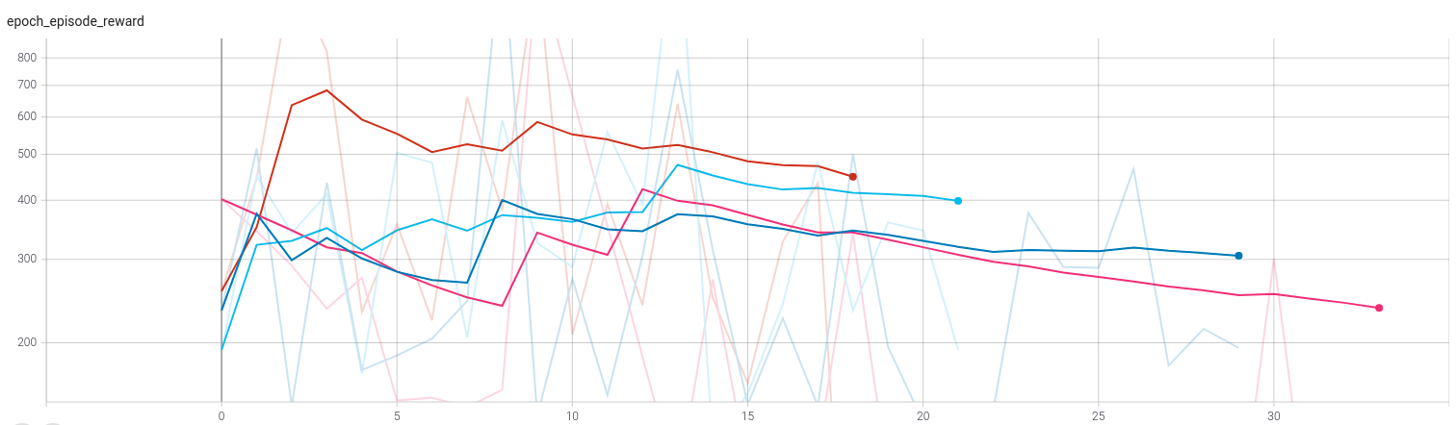
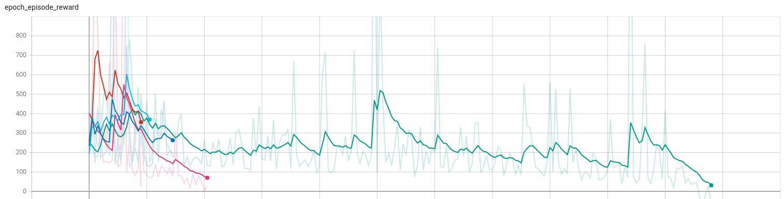
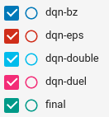

CONCLUSION
Further evaluation is required to assess if the agent could learn better with a different set of parameters and longer training windows. Given that these are higher level RL frameworks, some of which are not thoroughly documented to evaluate if there are potential parameters that could be tweaked to achieve better convergence, but those pursuits did not have any significantly different results in how the agent behaved after long training runs. Further improvements could involve larger networks, training epochs, tweaking environment item probabilities, differential rewards for different actions and a few others.

REFERENCES

https://github.com/wau/keras-rl2
https://blog.paperspace.com/creating-custom-environments-openai-gym/

REQUIREMENTS
opencv-python
pillow
gym
keras-rl2
keras==2.2.0
wandb

PRESENTATION
https://docs.google.com/presentation/d/1GLT1YA5Mg3QHtZ8bgvcXh57E9W9MrnHhDh8qp5UmVZk/edit?usp=sharing

