Employee Survey Implementation Plan
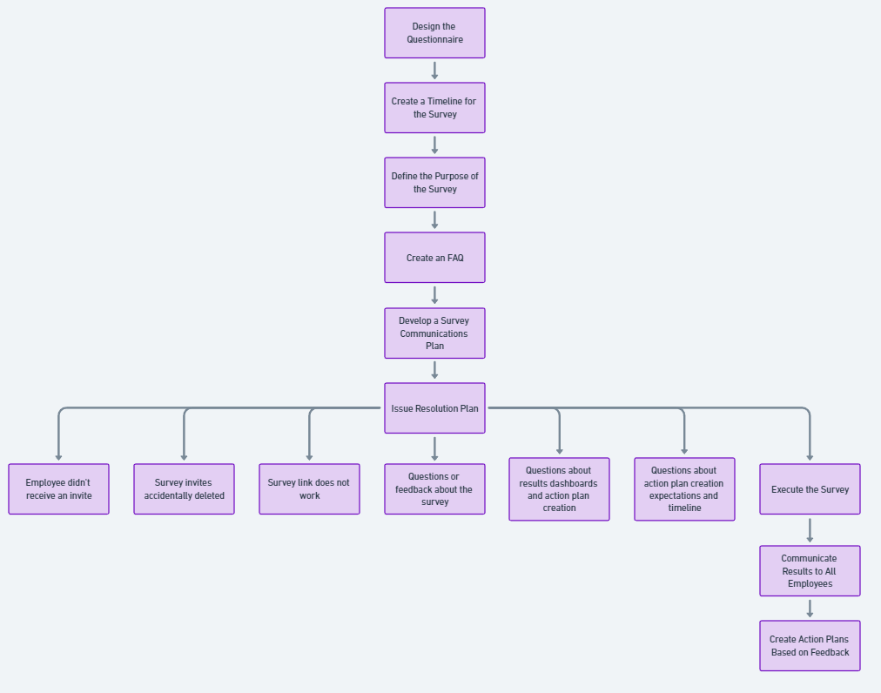
About the Employee Survey
- Your feedback is crucial – The insights you share play a vital role in the company’s success and in improving the employee experience. By achieving strong global participation, we can accurately identify opportunities to enhance our business and culture.
- Participation is confidential – We collect all responses and compile the feedback. No individual responses or participation reports are shared with anyone. All employee responses will be anonymised.
- Results will be communicated to all – The overall survey results will be presented to all employees, along with action plans and ideas for improvement.
- Feedback drives positive change – Leaders will receive aggregated reports highlighting key strengths and areas for improvement. Employees are encouraged to actively participate in initiatives that drive positive change within the organization.
- Increase survey frequency – If possible, consider sending survey questions weekly or even daily (one question per day) instead of conducting the survey once per year. This approach is more effective and will provide more accurate data for creating action plans for improvement.

Action Plan for Implementing the Employee Survey in Your Organization
- Design the questionnaire
- Create a timeline for the survey
- Define the purpose of the survey
- Create an FAQ
- Develop a Survey Communications Plan – Ensure communication is clear, concise, and sets clear expectations

Employee Survey Issue Resolution Plan
- Employee didn’t receive an invite – Establish eligibility criteria for employees and designate a point of contact (POC) for addressing these issues.
- Survey invites accidentally deleted – Ensure a POC is in place for employees to reach out for support.
- Survey link does not work – Provide a POC for technical support.
- Questions or feedback about the survey – Have a POC available for employees with questions.
- Questions about results dashboards and action plan creation – Assign a POC for support.
- Questions about action plan creation expectations and timeline – Ensure a POC is available.

Suggestions for Employee Survey Categories & Questions:
Engagement
- I would recommend [Company] as a great place to work.
- I am proud to work for [Company].
- My work gives me a sense of personal accomplishment.
- If I were offered a comparable position with similar pay and benefits at another company, I would stay at [Company].
Clarity of Direction
- I am confident in [Company]'s business outlook over the next 2-3 years.
- The [Company] Executive Team communicates a clear sense of direction and strategy.
- [Company] is effectively managed and well-run.
- The [Company] Executive Team acts in ways consistent with what they say.
- At [Company], we consider what is important for our customers when making business and design decisions.
- I can see a clear link between my work and [Company]'s goals and objectives.
Resources & Support
11. [Company]'s processes and procedures allow me to effectively meet my customers' needs.
12. I have the tools and resources to do my job well.
13. The [Company] Executive Team actively supports best practices that drive simplification across different areas of the business.
14. I am proud of [Company]’s support of the communities where we live and work.
Teamwork & Collaboration
15. At [Company], teams collaborate across different functions to improve the customer experience.
16. At [Company], people treat one another with trust and mutual respect.
Continuous Improvement
17. I am encouraged to come up with new and better ways of doing things.
18. I am confident the [Company] Executive Team will keep [Company] competing successfully.
19. My team looks for ways to change processes to improve productivity.
Empowerment
20. I am empowered to make decisions that will improve the customer experience.
21. My job makes the best use of my skills and abilities.
22. Decisions impacting my work are made with a sense of urgency.
Performance Management
23. I receive ongoing feedback that helps me improve my performance.
24. There is a clear link between performance and compensation at [Company].
25. I understand how my pay is determined.
Manager Quality
26. My manager encourages me to take appropriate risks to improve business results. 27. My manager holds our team accountable for delivering on our commitments.
28. I am confident that my manager will take appropriate action if our work group has an ongoing employee performance problem.
29. My manager recognizes me when I do a good job.
30. My manager actively uses the previous survey results to make improvements.
31. My manager takes an active interest in my growth and development.
32. My manager treats team members with trust and mutual respect.
33. My manager supports my efforts to manage my work and personal life (flexible work hours, work from home when needed/appropriate, take allotted time off).
34. My manager clearly communicates performance expectations.
35. I am comfortable discussing concerns with my manager.
Growth & Development
36. I can achieve my career goals at [Company].
37. I have opportunities to learn new skills that help me succeed.
Belonging & Inclusion
38. [Company] encourages and promotes inclusion of different backgrounds, talents, and perspectives.
39. [Company] creates an environment where people of diverse backgrounds can succeed.
40. My team has a climate in which diverse perspectives are valued.
41. I feel comfortable being myself at work.
Compensation & Benefits
42. My compensation (base pay, bonus, RSUs) is overall competitive with other employers in our industry.
43. [Company]’s stock ownership programs (RSUs and ESPP) motivate me to help the company succeed.
44. [Company] benefits offerings provide flexibility to choose what is most important to me and my family.
Open Text
45. Please share why you would consider leaving [Company].
46. What processes and procedures are preventing you from effectively meeting your customers’ needs?
47. What tools and resources are lacking and/or would enable you to perform your job well? Please specify the name of the tool.
48. What should we continue doing?
49. What suggestions do you have for improving [Company]?
50. What three individual words best describe [Company]’s culture?

