Example Bug report

Title: GPS is slow after upgrade on android 9 Oxygen 9.0.4

Description:

I recently upgraded my OnePlus 3T phone from android 8 to android 9 with Oxygen 9.0.4 via official channels and my GPS startup time since then is horribly slow. Previously the GPS caught the signal within second or two, now any application using it takes around 10-15 seconds to catch the signal.

Steps to reproduce:

1. use OnePlus 3T mobile phone EU version with android 8
2. attempt to use Waze, Google Maps and Mapy.cz apps
   1. turn on the GPS
   2. be in the open, in a park somewhere for example to avoid any structure interference
   3. open any mentioned app and wait for it to locate your position
   4. observe it takes 1-3 seconds usually
3. upgrade OS to android 9 with Oxygen 9.0.4
4. attempt to use apps from point 2
   1. make sure the GPS is turned on (it turned off during upgrade)
   2. be on the same place as in 2b
   3. open any mentioned app again and wait for it to lock on your position
   4. observe it takes much longer, around 10-15 seconds

IMPORTANT: i also noticed that when i turn off mobile internet the GPS is much faster, so it may be related.

Device used: OnePlus 3T, internal model number A3003, build number A3003_28_190625, android version 9, Oxygen version 9.0.4 latest build, date of occurance 07/07/2019, Location Praha 10 – Strašnice, open park.

Steps performed: Tested multiple times, devices was restarted, cache cleared, tested also with GPS TEST android app which confirmed that the phone can see the satelites almost instantly, but it takes 10-15 seconds until it establishes protocol and starts registering the position, also confirmed on another device of the same model the same issue.

Here are logs attached: imaginelogshereplease.log

Screenshot (taken when attempting to connect to GPS satellites for about 10 seconds – you can clearly see it is starting to connect to number 8 and 27 (two satellites), in the top left corner the red dots symbolize visible sattelites, these are visible imemdiately, but connection to them takes an unusual amount of time.

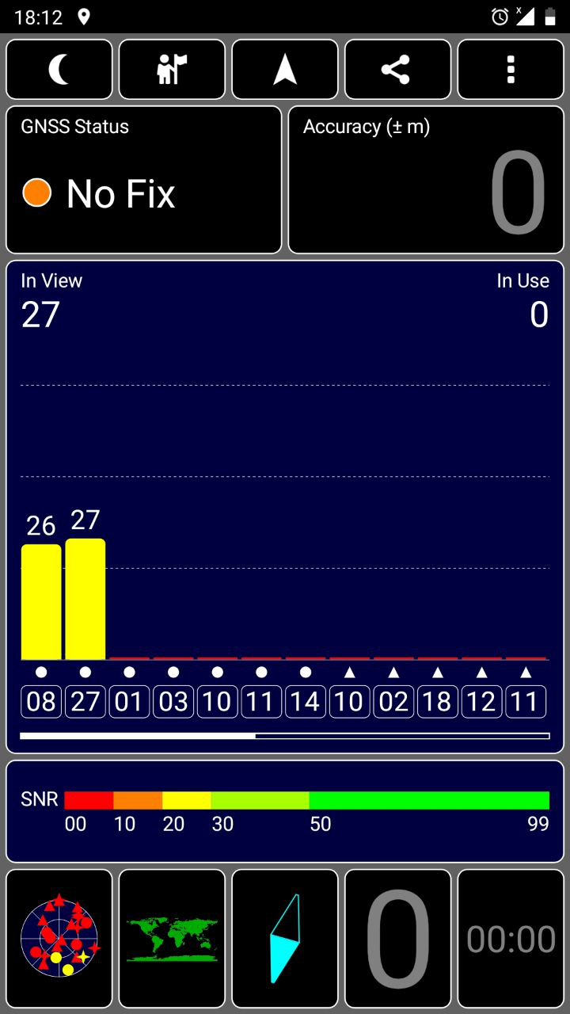

Configuration file used (if any): badconfig.xml

If virtual device then how to access it: somepath/way

#personalExperience