Wunderlust Majorca Branding

Color Palette
Color | Name | HEX
 | Yellow | #F6D64A
 | Teal | #55BCD5
 | Purple | #9B26B0
 | Blue | #499BD2
 | Dark Gray | #222222
 | Light gray | #EAEAEA
 | White | #FFFFFF
 | Black | #000000

Typography
https://fonts.google.com/share?selection.family=Molle:ital@1%7CMontserrat

Molle (h1, h2, h3)

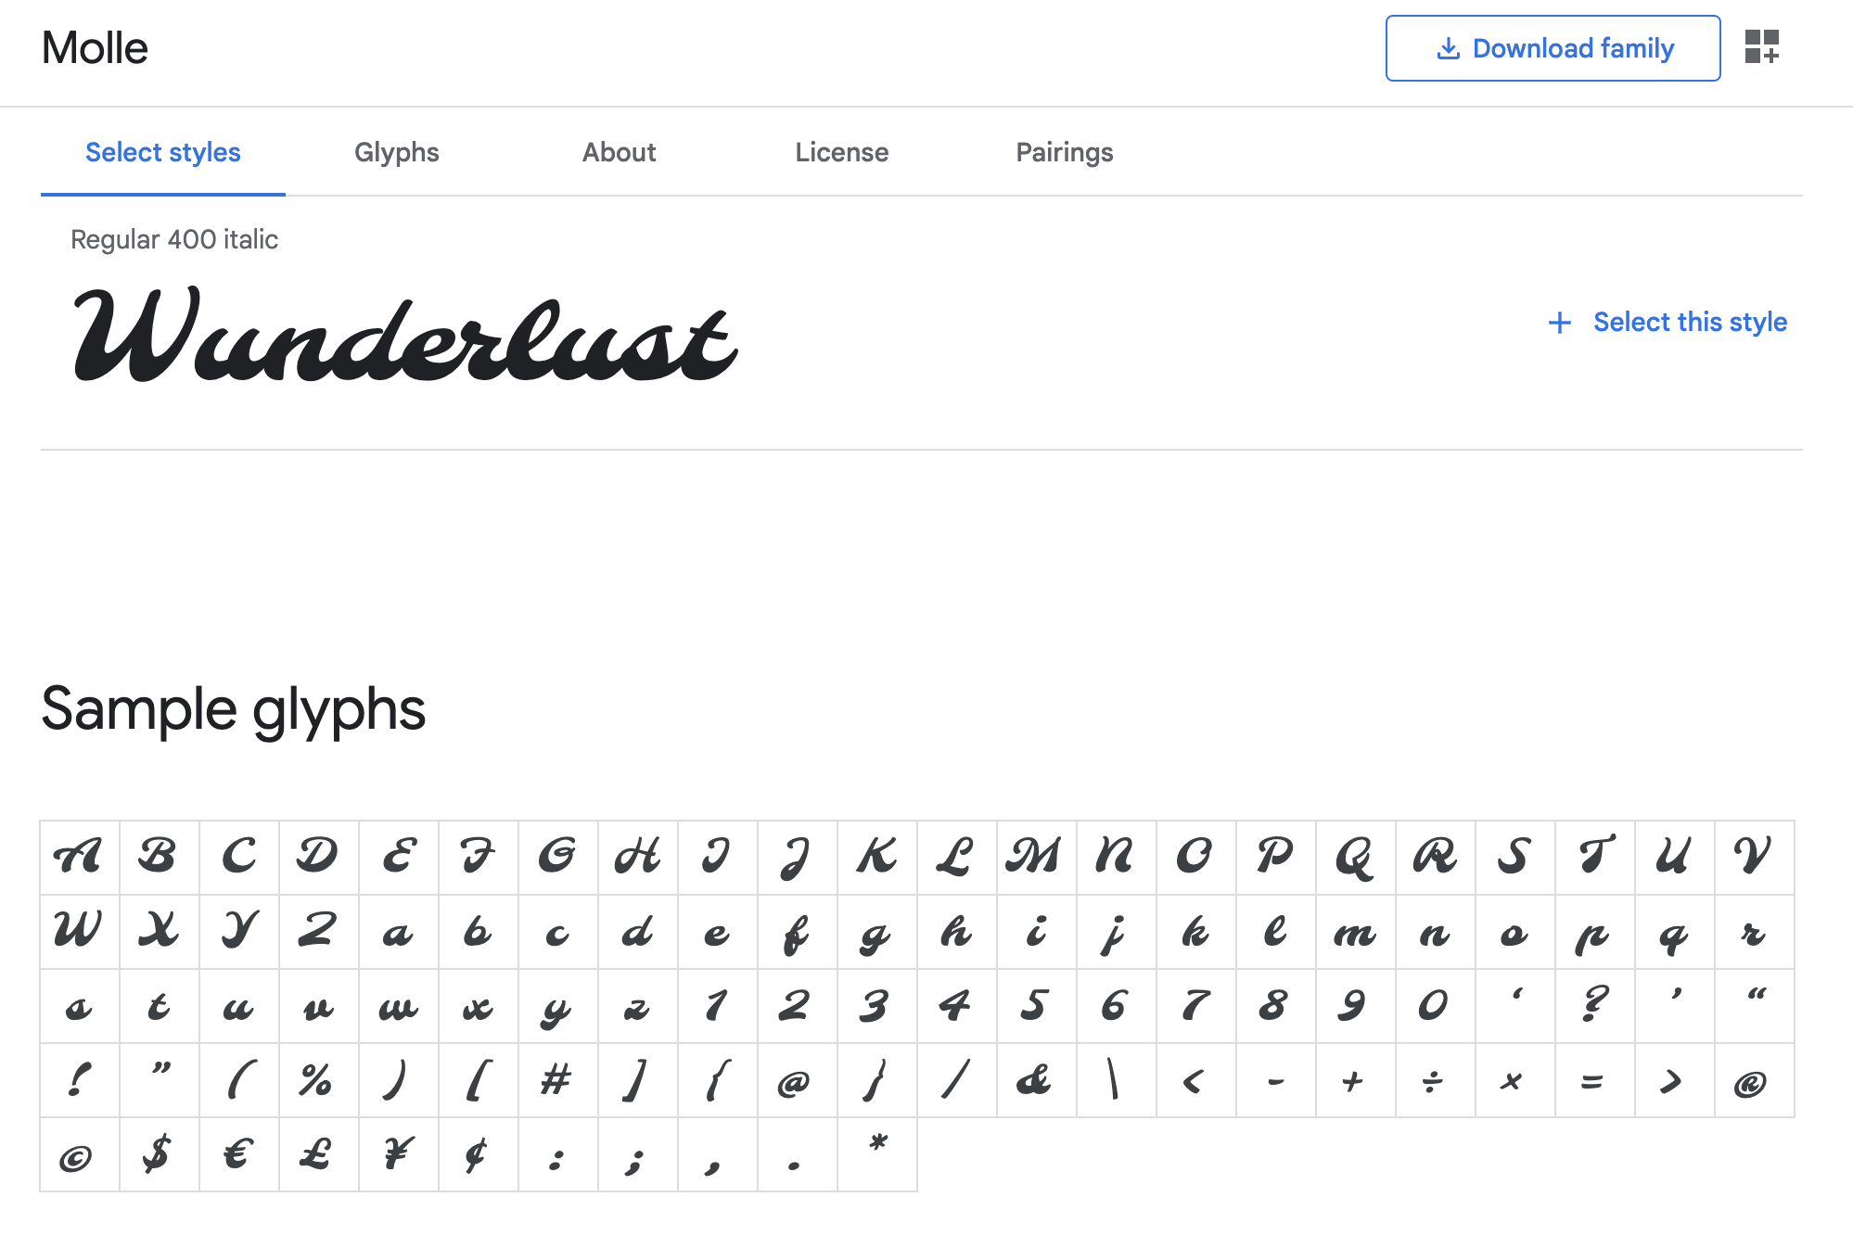

Montserrat (h4, p, q, small, nav, button, form)
