Cyclistic Bike-Share Case Study

Google Data Analytics Professional Certificate
Capstone Project

Author: Karri Lekha
Date: 26 July 2026

ASK

Business Task
Analyze how annual members and casual riders use Cyclistic bikes differently and provide data-driven recommendations to help convert casual riders into annual members.

Business Objective
The objective of this analysis is to identify differences in riding behavior between casual riders and annual members. The insights will help the marketing team develop strategies to encourage more casual riders to purchase annual memberships.

Stakeholders
Stakeholder | Role
Cyclistic Executive Team | Makes strategic business decisions
Director of Marketing | Oversees marketing campaigns
Marketing Analytics Team | Uses data insights to improve marketing strategies
Casual Riders | Target customers for membership conversion
Annual Members | Existing loyal customers

Key Business Questions
- How do annual members and casual riders use Cyclistic bikes differently?
- Why would casual riders purchase annual memberships?
- How can Cyclistic use digital media to influence casual riders to become annual members?

Success Criteria
This project will be successful if it:
- Identifies key behavioral differences between casual riders and annual members.
- Supports findings with data analysis and visualizations.
- Provides practical, data-driven recommendations.
- Helps the marketing team make informed business decisions.

PREPARE

Data Source
The dataset used for this project is the Cyclistic Bike-Share Ride Data, based on publicly available Divvy bike-share trip data from Chicago. The data contains historical ride information, including ride duration, bike type, start and end stations, timestamps, and rider type (casual or member).

Dataset License
The dataset is publicly available for educational and analytical purposes and is provided under Divvy's published data usage guidelines.

Data Storage
The dataset consists of 12 monthly CSV files stored locally in the data/raw folder of the project.

Data Organization
Each CSV file represents one month of ride data. These files will be combined into a single dataset during the data processing phase for analysis.

Data Credibility (ROCCC)
Criterion | Evaluation
Reliable | Yes – Public bike-share trip data collected from Cyclistitc (Divvy)
Original | Yes – Based on the original Divvy bike-share trip dataset
Comprehensive | Yes – Includes ride details, stations, bike types, and rider categories
Current | Yes – Uses one full year of recent ride data (October 2024 – September 2025)
Cited | Yes – Publicly available dataset with documented usage terms and source attribution

PROCESS

Tools Used
The data processing and cleaning were performed using Python in a Jupyter Notebook within Visual Studio (VS code).
The following Python libraries were used:
- Pandas – Data manipulation and cleaning
- NumPy – Numerical operations
- Matplotlib – Data visualization
- Seaborn – Statistical visualization

Data Import
The twelve monthly CSV files were imported into Python using Pandas.
All datasets were combined into a single DataFrame to create one complete dataset for analysis.

Data Cleaning
The following data cleaning steps were performed:
- Combined all 12 monthly datasets into one dataset.
- Checked for missing values.
- Removed duplicate records.
- Converted date and time columns into proper datetime format.
- Created new columns such as:
- Ride Length
- Day of the week
- Month
- Hour
- Removed rides with invalid or negative durations.
- Ensured consistent data types across all columns.

Data Validation
After cleaning, the dataset was checked to ensure:
- No duplicate records remained.
- Ride durations were valid.
- Date columns were correctly formatted.
- New calculated columns contained accurate values.
- The dataset was ready for exploratory data analysis.

Why Python Was Used
Python was selected because it efficiently handles large datasets and provides powerful libraries for data cleaning, transformation, visualization, and analysis.

ANALYZE

Exploratory Data Analysis
The cleaned dataset was analyzed to understand the behavioral differences between annual members and casual riders. Several visualizations were created to identify usage patterns across rider types.
The analysis focused on ride frequency, ride duration, seasonal trends, weekday preferences, and hourly riding behavior.

Ride Distribution
The distribution of rides showed that annual members generated a larger proportion of total rides than casual riders.
Finding:
- Annual members accounted for approximately 64% of all rides.
- Casual riders accounted for approximately 36% of all rides.
Interpretation:
Members use Cyclistic bikes more frequently than casual riders, indicating regular commuting habits.
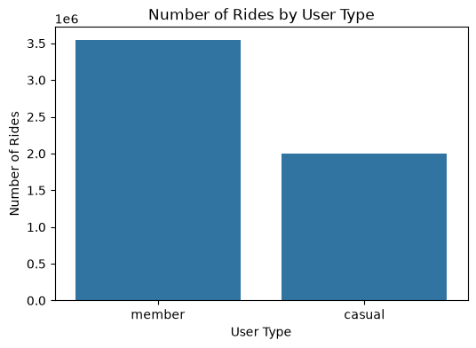
Figure 1. Number of Rides by User Type
The chart compares the total number of rides taken by annual members and casual riders during the study period.

Average Ride Length
Average ride duration was calculated for both rider types.
Finding:
- Casual riders averaged approximately 22.96 minutes per ride.
- Annual members averaged approximately 12.17 minutes per ride.
Interpretation:
Casual riders generally take longer trips, suggesting leisure or recreational use, while members typically use bikes for shorter commuting trips.
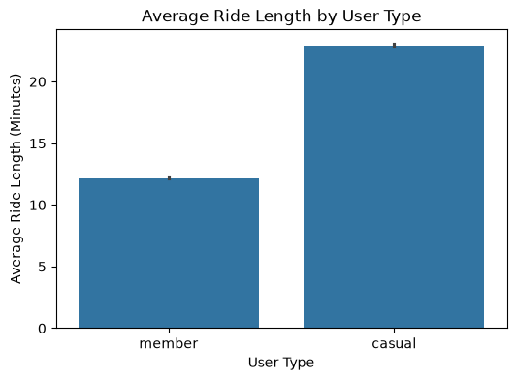
Figure 2. Average Ride Length by User Type
Figure 2 compares the average ride length of annual members and casual riders. Casual riders have a significantly longer average ride duration (approximately 23 minutes) compared to annual members (approximately 12 minutes). This suggests that casual riders primarily use Cyclistic bikes for leisure or recreational purposes, while annual members tend to take shorter, more frequent trips, likely for commuting or daily transportation.

Weekly Riding Patterns
Ride activity was analyzed across the days of the week.
Finding:
- Casual riders showed higher activity during weekends.
- Annual members maintained relatively consistent usage throughout the week.
Interpretation:
Weekend peaks indicate recreational riding among casual users, whereas members rely on bikes for routine transportation.

Figure 3. Number of Rides by Day of Week and User Type

This visualization compares the number of rides taken by annual members and casual riders across each day of the week to identify differences in riding behavior.

Business Insight
These findings suggest that weekend promotions, seasonal offers, and targeted marketing campaigns aimed at casual riders could encourage them to purchase annual memberships.

Figure 3. Number of Rides by Day of Week and User Type

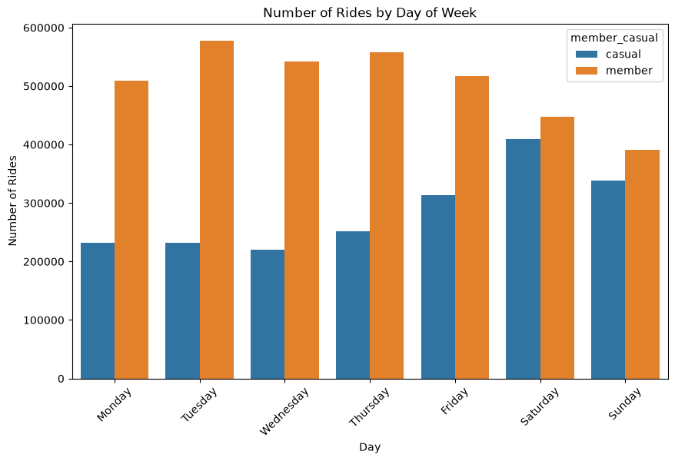

Monthly Trends
Ride frequency was compared across months.
Finding:
Both rider groups experienced increased ridership during the warmer months, particularly between June and September.
Interpretation:
Seasonal weather influences cycling activity, with higher demand during summer.
Figure 4. Number of Rides by Month and User Type
This visualization shows how ride activity changes throughout the year for annual members and casual riders, helping identify seasonal usage patterns.
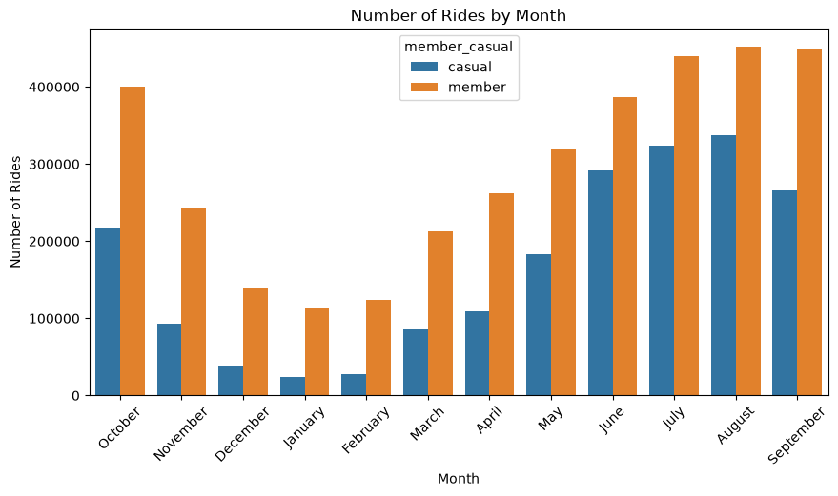
Figure 4. Number of Rides by Month and User Type
Business Insight
The increase in casual ridership during spring and summer presents an ideal opportunity for Cyclistic to launch seasonal membership promotions, free trial campaigns, and targeted marketing efforts aimed at converting casual riders into annual members.

Hourly Riding Patterns
Ride counts were analyzed by hour of the day.
Finding:
- Annual members exhibited strong peaks around 8 AM and 5–6 PM, corresponding to commuting hours.
- Casual riders showed a more gradual increase throughout the day, with activity peaking in the afternoon.
Interpretation:
The hourly patterns reinforce that members primarily commute, while casual riders cycle for leisure and flexible travel.
Figure 5. Number of Rides by Hour of Day and User Type
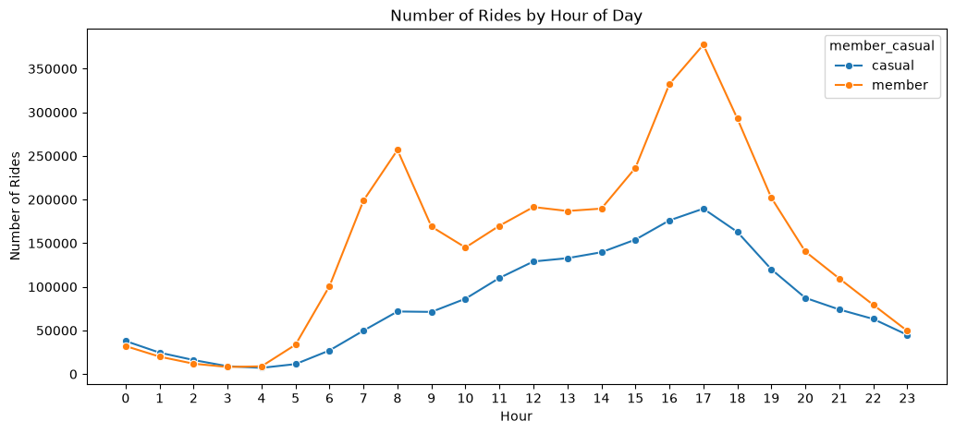

Business Insight
Since casual riders are most active during the afternoon and evening, Cyclistic can target these users with time-based promotional offers, in-app membership advertisements, and discounts during peak recreational hours to encourage conversion to annual memberships.

Summary of Analysis
The analysis revealed distinct behavioral differences between the two rider groups:
- Members ride more frequently.
- Casual riders take longer rides.
- Casual riders prefer weekends.
- Members ride during weekday commuting hours.
- Ridership increases during warmer months for both groups.

SHARE AND ACT

Key Findings
The analysis identified several important differences between annual members and casual riders:
- Annual members generated approximately 64% of all rides, while casual riders accounted for 36%.
- Casual riders had significantly longer average ride durations than annual members.
- Casual riders were most active during weekends.
- Annual members primarily rode during weekday commuting hours.
- Ridership increased during the summer months for both rider groups.

Business Insights
The results indicate that annual members primarily use Cyclistic bikes for daily commuting, whereas casual riders use the service mainly for recreation and leisure.
Because casual riders already make frequent use of the service, they represent the best opportunity for increasing annual membership conversions through targeted marketing strategies.

Recommendations
Based on the findings, the following recommendations are proposed:
- Promote annual memberships through weekend-focused marketing campaigns targeting casual riders.
- Offer discounted membership trials during peak riding months (June–September).
- Provide incentives such as ride credits or discounted memberships for frequent casual riders.
- Highlight the long-term cost savings and convenience of annual memberships.
- Develop marketing campaigns targeting tourists and recreational riders who frequently use the service.

Conclusion
This analysis demonstrates clear behavioral differences between annual members and casual riders.
Annual members primarily use Cyclistic bikes for commuting, while casual riders ride longer distances and mainly use the service for leisure and recreation.
These insights suggest that Cyclistic should focus its marketing efforts on converting casual riders into annual members through targeted promotions, seasonal campaigns, and membership incentives.
Implementing these recommendations can increase annual memberships and contribute to long-term business growth.

References
- Divvy Bike-Share Data. https://divvy-tripdata.s3.amazonaws.com/
- Google Data Analytics Professional Certificate.
- Python Software Foundation. https://www.python.org/
- Pandas Documentation. https://pandas.pydata.org/

