**Task 4**

During the lockdown, business of BookMyShow hit rock bottom. Suggest at least 2 new

features through which they can explore new options in their app and increase their revenue. Make Wireframes (using Balsamiq) portraying these features. Define value propositions of the features and their success metrics.

You will be judged based on neatness of wireframes, usability of features, creativity in problem solving. Kindly export your wireframes in .png or.jpeg format and post here.

When the pandemic hit the country, BookMyShow was one of the worst hit franchises. They came up with new features that compensated the new normal like Stream, Fanhood, and collaborated with the Events that were happening online because of this pandemic so that they both collectively earn some revenue.

**Feature 1**

The already existing but new stream feature allows people to rent or buy a new movie that is released in the theatres. Due to this pandemic friends who went to the movie now cannot watch it with their friends. So, now adding a new feature where people can watch new movies along with their friends staying at home would be a good solution for people who miss out on going to movies with their friends.

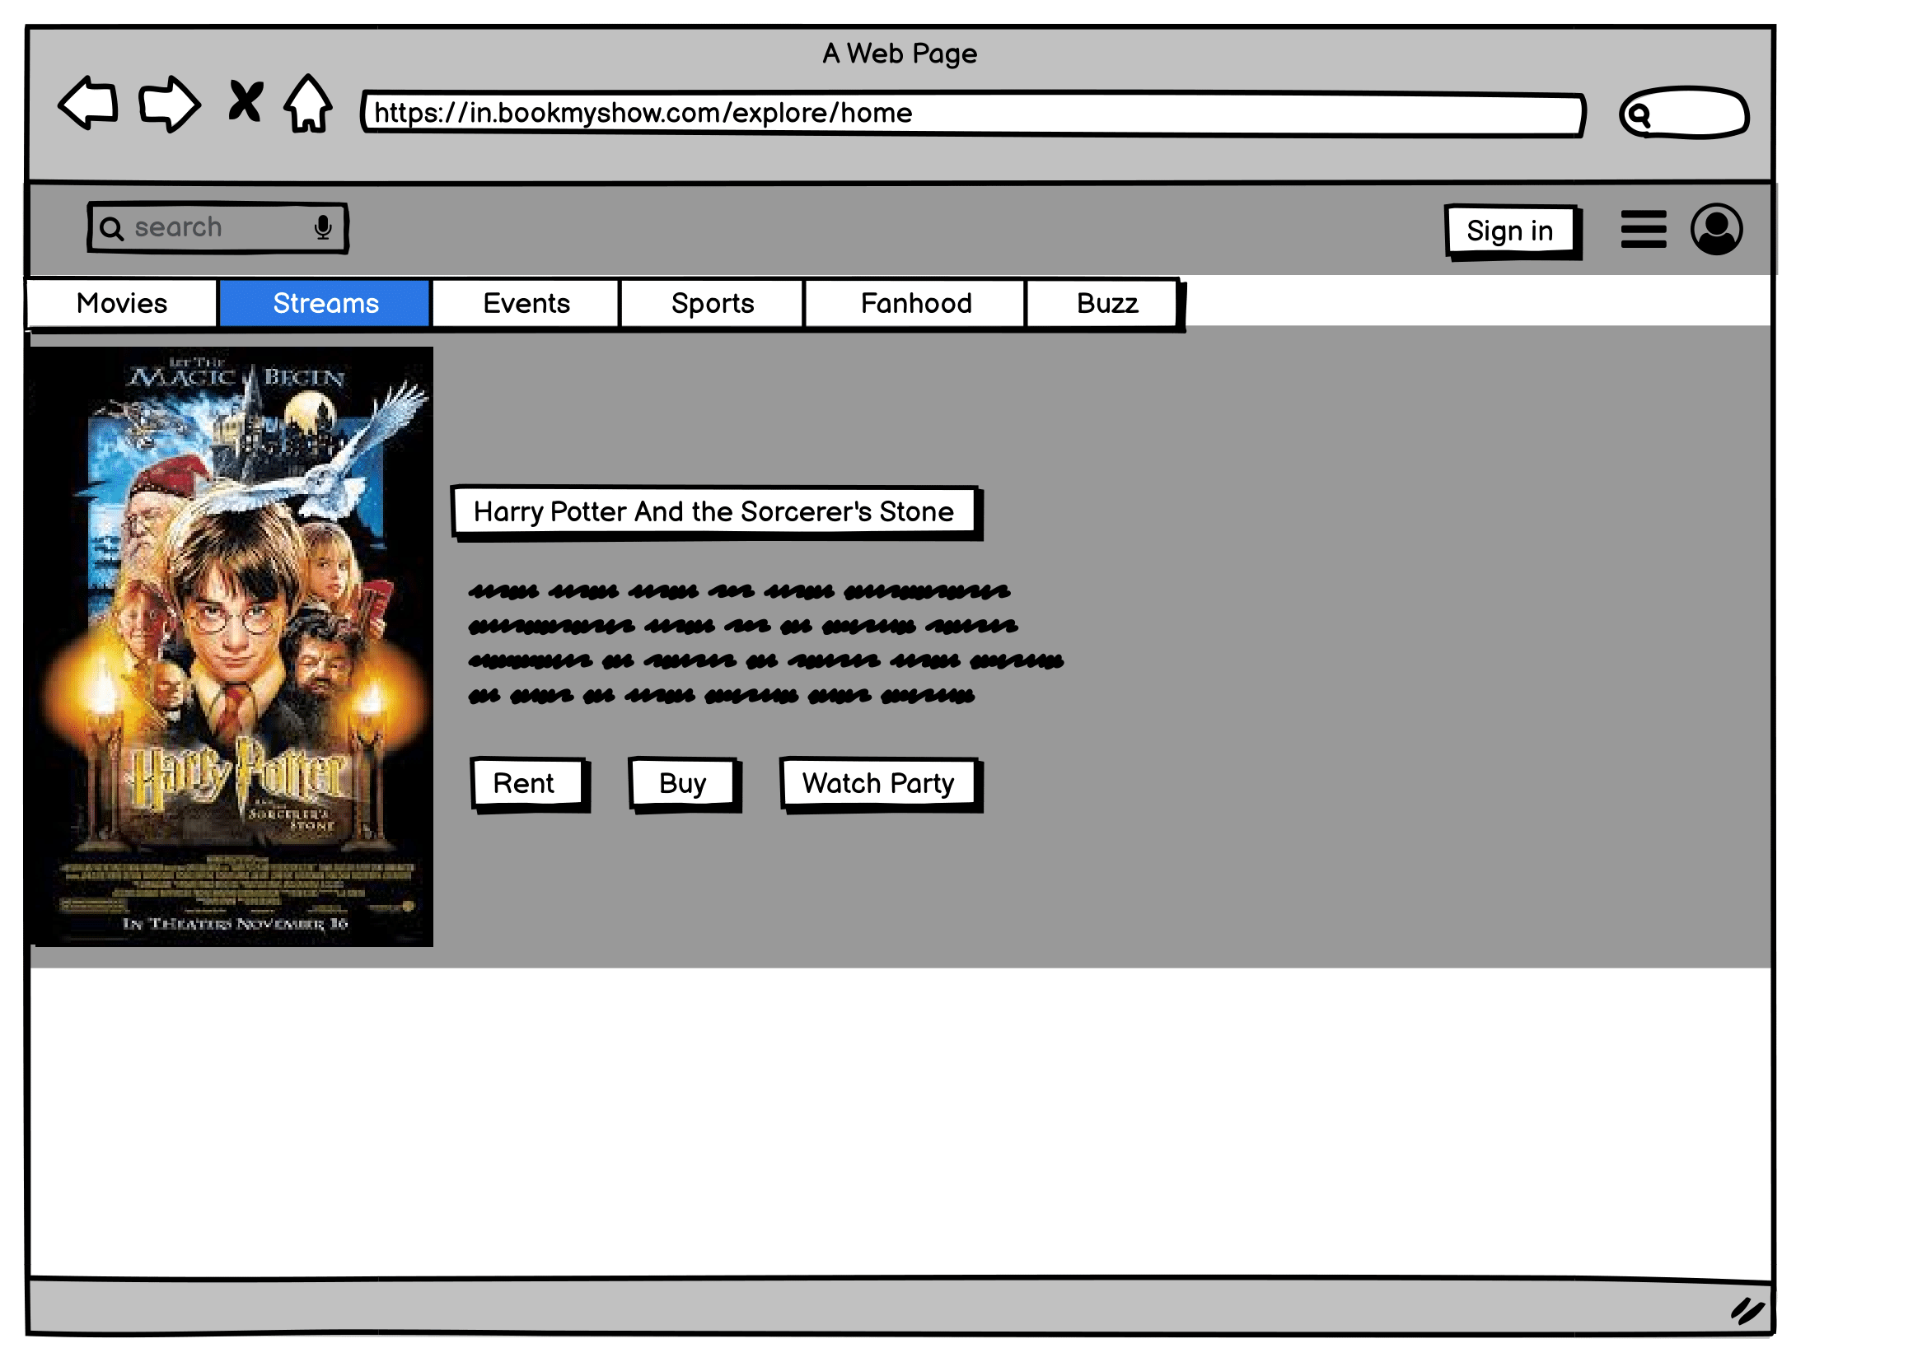

**Feature 2**

We can offer reward points which can be redeemed, after a particular sum of points are procured, as vouchers/ food coupons/ wallet money.

