Episode-wise Analysis of Orange, Purple and WhatsApp Leads
Born, Reactivated or Resubmitted Leads
Analysis period | All available lead history to the analysis date (no date-window filter applied)
Source notebook | opw_alltime_episode_bi_analysis.ipynb
Data source | Leads, lead stage history, call, web and WhatsApp logs (Athena - leadsdb-prod)
Population | 111,946 unique qualifying leads · 164,435 episodes · 12 projects

- Executive Summary

This study covers 111,946 leads and 164,435 sales episodes across five overlapping cohorts. An episode is one full attempt at a lead - it begins when the lead enters the funnel (or re-enters it) and closes when the lead is marked Not Interested. A lead with three episodes has been worked, lost and re-worked three times.
Eight findings matter most.

1. The five cohorts are not five separate audiences
68.5% of leads (76,682 of 111,946) carry more than one cohort label. The single largest group is leads that are both Purple and WhatsApp-born - 40,806 leads, more than a third of the entire base. Only 319 leads are Orange-only and only 1,622 are Purple-only. Any comparison of "Orange vs Purple vs WhatsApp" in this report is a comparison of overlapping populations, not of independent segments.

2. Orange is the smallest cohort but by far the most engaged
Orange leads (19,464) average 101.90 seconds of answered call time per episode against 50.93 seconds for Purple and 50.01 seconds for WhatsApp-born - roughly double (+51.89 seconds, +103.8% vs WhatsApp-born). They also lead on web time (342.81s vs 228.41s for Purple, +114.40s / +50.1%), WhatsApp interactions (4.80 vs 1.31) and site visit rate (5% vs 2%). This advantage survives an age check: in the 1-7 day episode-age band Orange is 69.94 seconds against ~40-45 for other cohorts; at 365+ it remains ahead at 139.54 seconds.

3. WhatsApp-born leads are the largest cohort and the weakest per episode
At 89,423 leads, WhatsApp-born is the biggest cohort, but it records the lowest WhatsApp interaction count of all five cohorts - 1.31 inbound messages per episode, against 4.80 for Orange and 3.41 for Purple. It also has the shortest episodes (5.74 days) and the lowest rate of ever starting a second episode (19%). The channel that acquires these leads is not the channel on which they subsequently converse.

4. Volume collapses after the first episode; quality of contact declines with it
Of 111,946 leads, only 33,940 (30.3%) ever start a second episode, 9,895 (8.8%) a third and 3,770 (3.4%) a fourth. Across those episodes the call pickup ratio falls monotonically from 51% to 34% (−17 percentage points, a relative decline of 33.3%) and stage movements per episode fall from 2.46 to 2.05.

5. The headline episode trend on calls is a composition illusion
Comparing all Episode-1 leads with all Episode-2 leads suggests call duration rose slightly (50.59 → 52.06 seconds, +1.47s / +2.9%). Tracking the same 33,940 leads across their own two episodes shows the opposite: 77.67 → 52.06 seconds, a fall of 25.61 seconds (−33.0%). The population figure rises only because low-engagement leads drop out of the sample. This is the single most important interpretive point in the report.

6. Falling call duration is the only behavioural change that holds up across every episode
Within-lead, answered call duration declines significantly at every transition tested: −25.61s (−33.0%) Ep1→Ep2, −19.09s (−22.1%) Ep2→Ep3, −18.10s (−19.7%) Ep3→Ep4 - all p < 0.001. By contrast, the large within-lead web-time gain at Ep1→Ep2 (+121.94s, +93.6%) does not repeat: Ep2→Ep3 (−12.76s, p = 0.43) and Ep3→Ep4 (+8.48s, p = 0.90) are not statistically distinguishable from no change.

7. Only about one in five leads is single-project Fresh - most are cross-project under masterLeadId
20,832 leads (18.6%) are Fresh-born: they exist under only one ASBL project for their masterLeadId. The 91,114 cross-project leads (81.4%) appear on two or more projects - including cases where the current project was first and other projects came later. Cross-project episodes show higher web time (298.68s vs 73.02s, +309%) and longer answered calls (59.46s vs 37.04s, +60.5%). Fresh leads still show higher WhatsApp-inbound incidence (64% vs 22%) and slightly higher continuation (36% vs 31%). Actual ASBL system age (analysis end − first born) averages 593 days for Fresh(single project) and 758 days for Cross-project - no leads in this extract are under one day old.

8. Older leads talk longer and visit more - but they are also given far longer to do it
Call duration rises mainly at the oldest episode-start ages, from 43.63 seconds in the 1-7 day band to 82.76 seconds beyond 365 days (+39.13s, +89.7%), and site visit rate moves from about 2% to 3%. Episode length is longest near Fresh/0 episode-start age (62 days) and shorter for most older bands - so older-band call gains are not simply more elapsed days in which activity can accumulate.

Strongest and weakest cohorts
Strongest per episode: Orange - highest call duration, WhatsApp interactions and site visit rate; also the oldest and most cross-project-heavy cohort.
Weakest per episode: WhatsApp-born - lowest WhatsApp engagement, shortest episodes, lowest continuation rate - despite being the largest cohort by volume.
Most distinctive: WhatsApp-resubmitted - the highest web time of any cohort (549.12s, more than double WhatsApp-born) combined with the lowest call duration (49.85s) and a 3% site visit rate. High digital interest, weak progression.

2. Cohort Definition and Population
The study begins from 368,525 candidate leads, of which 111,946 qualify by carrying at least one of the five cohort markers. These produce 164,435 episodes.
Cohort | Definition | Leads | Episodes | Episodes per lead
Orange | Lead carries an Orange timestamp | 19,464 | 36,483 | 1.87
Purple | Lead carries a Purple timestamp | 75,067 | 111,187 | 1.48
WhatsApp Born | Lead's original birth source is WhatsApp | 89,423 | 110,110 | 1.23
WhatsApp Reactivated | WhatsApp secondary-source event flagged as a reactivation | 24,350 | 62,058 | 2.55
WhatsApp Resubmitted | WhatsApp secondary-source event that is not a reactivation | 8,138 | 13,113 | 1.61
Total (unique) | At least one of the above | 111,946 | 164,435 | 1.47
Table 1 - Cohort population. Labels are not mutually exclusive, so cohort leads sum to 216,442 against a base of 111,946.
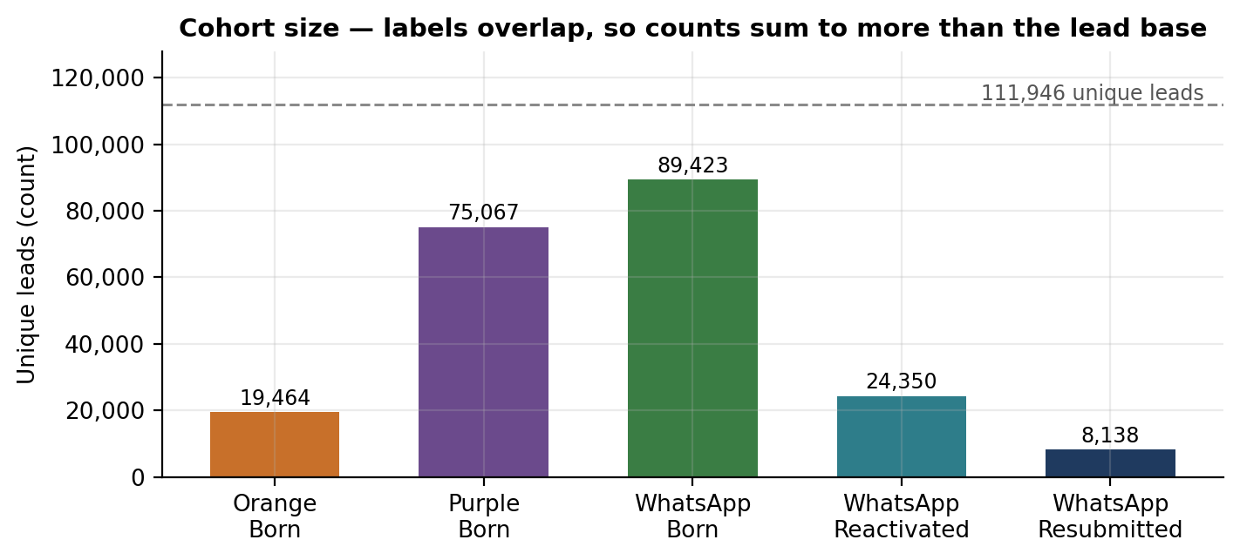
Figure 1 - Cohort sizes against the unique lead base.

2.1 Cohort overlap is the defining feature of this population
Cohort assignment is multi-label: a lead that qualifies on several markers keeps all of them. 76,682 leads (68.5%) hold two or more labels.
Label combination | Leads | Share of base
Purple + WhatsApp Born | 40,806 | 36.5%
WhatsApp Born only | 27,525 | 24.6%
Orange + Purple + WhatsApp Born | 9,404 | 8.4%
Purple + WhatsApp Reactivated | 8,692 | 7.8%
WhatsApp Reactivated only | 5,747 | 5.1%
Purple + WhatsApp Born + WhatsApp Resubmitted | 3,690 | 3.3%
Orange + Purple + WhatsApp Reactivated | 3,682 | 3.3%
Purple only | 1,622 | 1.4%
Orange only | 319 | 0.3%
Table 2 - Nine largest label combinations. Orange-only and Purple-only leads are rare.
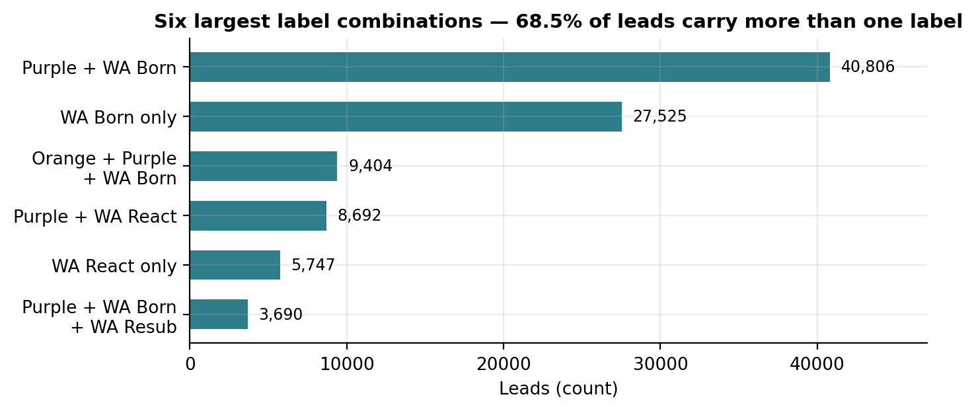
Figure 2 - Six largest label combinations by lead count.

What this means for every comparison in this report
Because only 319 leads are Orange-only and 1,622 Purple-only, the Orange and Purple cohorts are largely composed of leads that are also WhatsApp-born. Differences between cohorts are therefore differences in marker mix, not differences between clean audiences. A finding such as "Orange leads talk longer" should be read as "leads that carry an Orange marker talk longer", and those same leads usually carry other markers too.

3. Fresh-Born versus Cross-Project-Born Leads
A lead is classified by how many ASBL projects share its masterLeadId (else this lead id). Born date for age is the earlier of leads.createdAt and the earliest leadstagehistories.createdAt across all linked lead records - not globalId.
- Fresh-born - only one project under the lead's masterLeadId (or lead id). A first-and-only ASBL project identity.
- Cross-project-born - two or more projects under the same masterLeadId, including identities whose first project was the current one and who later appeared elsewhere.
Classification | Leads | Share of leads | Episodes | Average ASBL system age
Fresh-born | 20,832 | 18.6% | 32,439 | 593.32 days
Cross-project-born | 91,114 | 81.4% | 131,996 | 757.54 days
Total | 111,946 | 100% | 164,435 | 726.98 days
Table 3 - Fresh versus cross-project distribution.

3.1 Why this distinction matters
The business question is whether projects are acquiring single-project new identities or re-circulating multi-project demand. On this definition only 18.6% (20,832) are Fresh; 81.4% (91,114) are cross-project. Median ASBL system age across all leads is 600 days - this is a mature portfolio under masterLeadId linkage.
Cross-project share is high everywhere: Orange 90.16%, Purple 89.87%, WhatsApp-born 88.42%, WhatsApp-resubmitted 85.67%. WhatsApp-reactivated is the least recycled at 60.92% cross / 39.08% fresh. Orange's engagement advantage therefore sits on an almost entirely multi-project identity mix.
Cohort | Fresh % | Cross-project % | Average ASBL system age
Orange | 9.84% | 90.16% | 841.24 days
Purple | 10.13% | 89.87% | 652.95 days
WhatsApp Born | 11.58% | 88.42% | 745.95 days
WhatsApp Reactivated | 39.08% | 60.92% | 680.64 days
WhatsApp Resubmitted | 14.33% | 85.67% | 721.48 days
Table 4 - Fresh/cross mix and lead maturity by cohort.

4. Actual Lead Age in the ASBL System
Lead born date = min(leads.createdAt, earliest leadstagehistories.createdAt) for the masterLeadId identity. Three ages are reported: ASBL system age (analysis end − first born), current-project age (analysis end − project born), and age at episode (episode start − first born). globalId is not used.

4.1 The distribution is extremely skewed
Statistic | ASBL system age (analysis end − first born)
Mean | 726.98 days
Median | 600.38 days
75th percentile | 946.65 days
90th percentile | 1,502.83 days
95th percentile | 1,648.53 days
Maximum | 3,581.00 days (≈ 9.8 years)
Share under 1 day | 0.0%
Share beyond 365 days | 79.5%
Table 5 - ASBL system age, 111,946 leads.
ASBL system age averages 727 days (median 600). There are no leads under one day old in this extract; 79.5% are already beyond 365 days. Age-at-project-birth (project born − first born) can still be zero for single-project Fresh leads - that measures lag between first ASBL birth and this project record, not how long the person has existed in ASBL.
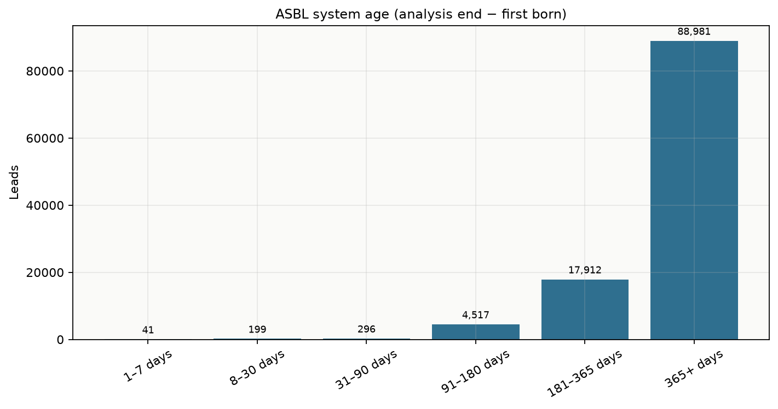
Figure 3 - ASBL system age (analysis end − first born). The 365+ bucket holds 88,981 leads (79.5% of the base).

4.2 Lead age by cohort
Average ASBL system age is high across born cohorts: Orange 841 days, WhatsApp-born 746, WhatsApp-resubmitted 721, Purple 653, WhatsApp-reactivated 681. These are ages since first born in ASBL, not zeros for Fresh identities.

4.3 Age is associated with whether a lead comes back at all
ASBL system age | Leads | Reaches a 2nd episode | Has a WhatsApp reactivation | Has a WhatsApp resubmission
Fresh / 0 days | 0 | - | - | -
1-7 days | 41 | 0% | 0% | 0%
8-30 days | 199 | 10% | 9% | 1%
31-90 days | 296 | 16% | 12% | 1%
91-180 days | 4,517 | 24% | 21% | 2%
181-365 days | 17,912 | 25% | 21% | 2%
365+ days | 88,981 | 32% | 22% | 9%
Table 6 - Continuation and recycling behaviour by ASBL system age.
Continuation rises with ASBL system age: 32% of 365+ day leads reach a second episode against 10-25% in younger bands (samples under 90 days are small). Virtually no leads have ASBL age under one day - nearly everyone already has measurable tenure.

5. Overall Cohort Comparison
The table below carries the metrics that actually separate the cohorts. All averages are per episode.
Metric | Orange | Purple | WA Born | WA React. | WA Resub.
Leads | 19,464 | 75,067 | 89,423 | 24,350 | 8,138
Episodes | 36,483 | 111,187 | 110,110 | 62,058 | 13,113
Cross-project % | 90.2% | 89.9% | 88.4% | 60.9% | 85.7%
Avg ASBL age (days) | 841.2 | 653.0 | 746.0 | 680.6 | 721.5
Avg web time (seconds) | 342.8 | 228.4 | 255.9 | 211.6 | 549.1
Avg call duration (seconds) | 101.9 | 50.9 | 50.0 | 54.2 | 49.9
Avg WhatsApp interactions | 4.80 | 3.41 | 1.31 | 3.14 | 3.62
Avg episode duration (days) | 22.5 | 9.2 | 5.7 | 37.6 | 9.7
Site visit rate | 5% | 2% | 2% | 3% | 3%
Episode has a successor | 47% | 32% | 19% | 61% | 38%
Call pickup ratio | 47% | 50% | 49% | 46% | 51%
Table 7 - Cohort comparison. Bold marks the highest or notably lowest value in each row. Rates are rounded to whole percentage points in the source analysis.
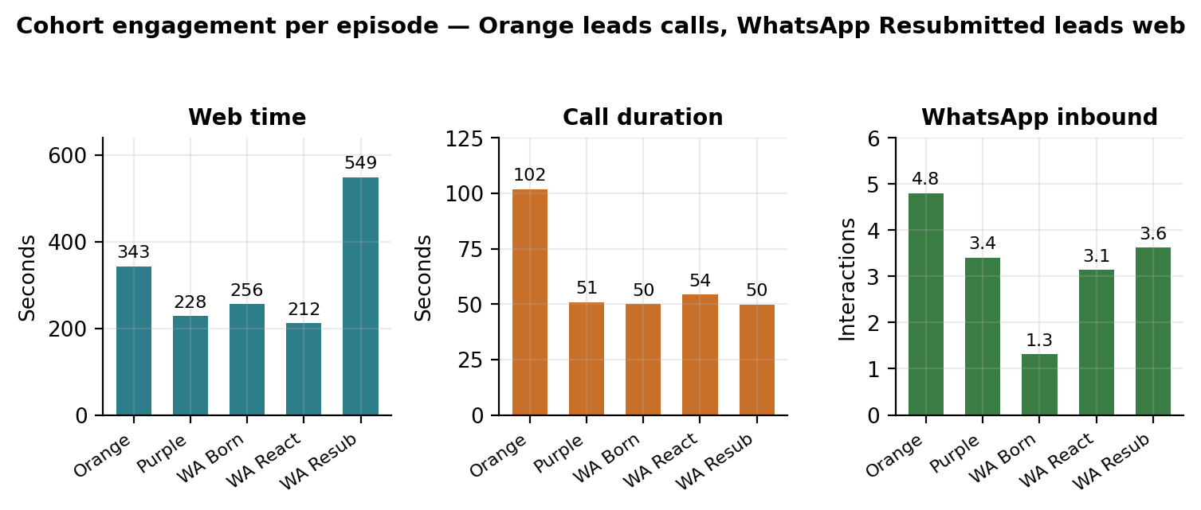
Figure 4 - Engagement per episode by cohort.

5.1 Reading the cohort table
- Orange is the telephone cohort. 101.90 seconds of answered call time per episode is roughly double every other cohort. Orange also has the highest site visit rate (5%) and the highest WhatsApp interaction count (4.80) - it is the only cohort that is strong on every channel at once.
- WhatsApp-born is the volume cohort. Largest by leads (89,423) but lowest on WhatsApp interactions (1.31), shortest episodes (5.74 days) and least likely to be worked twice (19% of episodes have a successor, against 47% for Orange).
- WhatsApp-reactivated is the long-tail cohort. Episodes last 37.58 days on average - 6.5 times the WhatsApp-born figure - and 61% of episodes are followed by another. At 2.55 episodes per lead this cohort absorbs disproportionate sales effort.
- WhatsApp-resubmitted is the anomaly. Highest web time by a wide margin (549.12s, +293.23s / +114.6% over WhatsApp-born) and the highest pickup ratio (51%), yet the lowest call duration of all five cohorts (49.85s) and only a 3% site visit rate.

5.2 Born, reactivated and resubmitted leads are not interchangeable
Group | Leads | Episodes | Web time (s) | Call duration (s) | WA interactions | Episode duration (days) | Site visit rate
Born (Orange / Purple / WA) | 105,748 | 148,702 | 225.8 | 52.1 | 2.34 | 9.1 | 2%
WhatsApp Reactivated | 24,350 | 62,058 | 211.6 | 54.2 | 3.14 | 37.6 | 3%
WhatsApp Resubmitted | 8,138 | 13,113 | 549.1 | 49.9 | 3.62 | 9.7 | 3%
Table 8 - Born versus reactivated versus resubmitted leads.
Resubmitted leads generate 2.4 times the web time of born leads (549.12s vs 225.75s, +323.37s) in episodes of almost identical length (9.73 vs 9.13 days). This is not an exposure effect - it is a genuinely more digitally active group. Reactivated leads, by contrast, are unremarkable on engagement but sit in episodes four times longer (37.58 vs 9.13 days).

6. Episode-wise Behaviour
Sample size falls sharply with each episode, and this shapes everything that follows.
Episode | Unique leads | Episodes | Share of lead base
Episode 1 | 111,946 | 111,946 | 100.0%
Episode 2 | 33,940 | 33,940 | 30.3%
Episode 3 | 9,895 | 9,895 | 8.8%
Episode 4 | 3,770 | 3,770 | 3.4%
Episode 5+ | 1,763 | 4,884 | 1.6%
Table 9 - Episode sample sizes. Episode 5+ pools all fifth and later episodes, so it contains more episodes than leads.
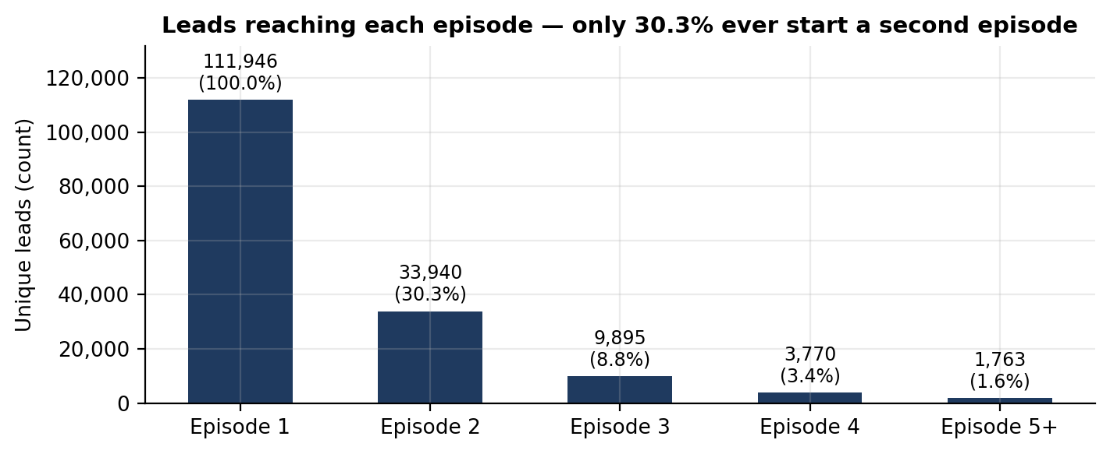
Figure 5 - Lead attrition across episodes.

6.1 Population averages by episode
Feature | Unit | Ep 1 | Ep 2 | Ep 3 | Ep 4 | Ep 5+ | Trend
Web time | seconds | 126.99 | 252.17 | 279.26 | 325.45 | 2,118.38 | Increasing
Web time per session | sec/session | 81.63 | 137.52 | 149.22 | 137.73 | 141.21 | Mixed
Active sessions | sessions | 1.40 | 1.78 | 1.83 | 2.03 | 13.05 | Increasing
Call duration | seconds | 50.59 | 52.06 | 67.20 | 74.02 | 62.17 | Mixed
Attempted calls | calls | 3.15 | 3.15 | 3.33 | 3.32 | 2.74 | Mixed
Pickup ratio | % | 51% | 44% | 41% | 40% | 34% | Decreasing
WhatsApp interactions | interactions | 1.34 | 3.42 | 3.94 | 3.96 | 3.36 | Mixed
Episode duration | days | 4.04 | 101.77 | 83.43 | 76.08 | 41.05 | Mixed
Stage movements | movements | 2.46 | 2.15 | 2.11 | 2.09 | 2.05 | Decreasing
Site visit rate | % | 2% | 3% | 4% | 4% | 7% | Increasing
Resubmission rate | % | 8% | 9% | 9% | 10% | 12% | Increasing
ASBL age at episode start | days | 0.00 | 6.91 | 158.98 | 312.57 | 480.01 | Increasing
Table 10 - Population averages by episode.
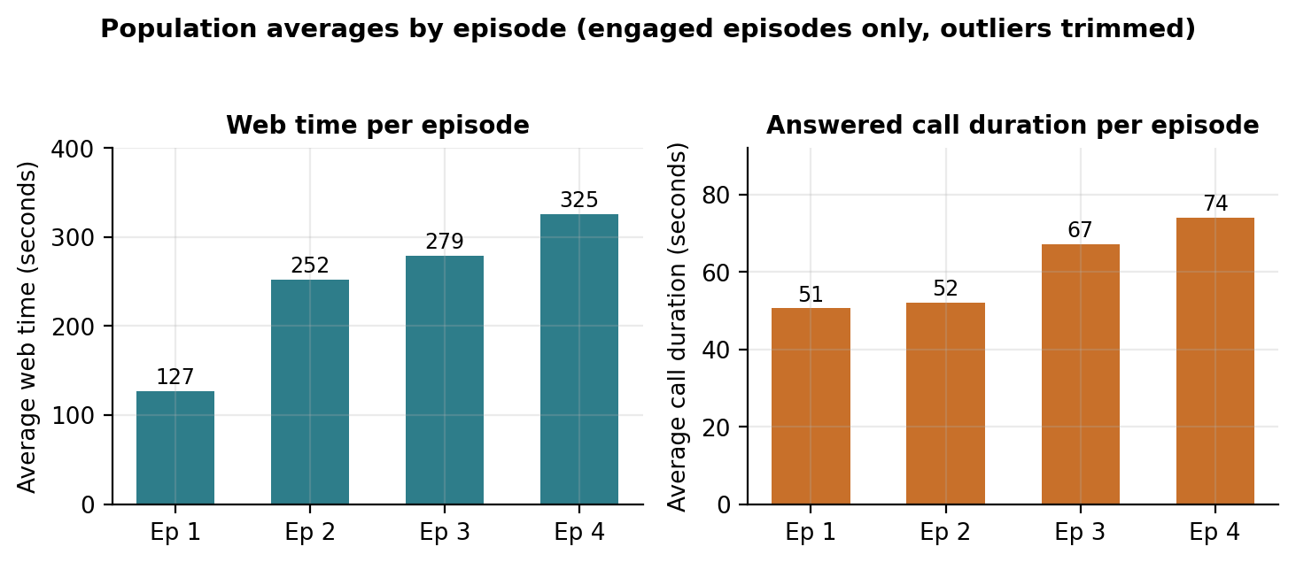
Figure 6 - Web time and call duration by episode (Episode 5+ excluded - see limitations).

6.2 The three clearest episode-level movements

Web time roughly doubles between Episode 1 and Episode 2
- Episode 1: 126.99 seconds → Episode 2: 252.17 seconds
- Change: +125.18 seconds, relative change +98.6%
- Thereafter the increases are much smaller: +27.09s (+10.7%) to Episode 3, +46.19s (+16.5%) to Episode 4.

Call reachability declines at every step
- Pickup ratio: 51% → 44% → 41% → 40% → 34%
- Episode 1 to Episode 5+: −17 percentage points, a relative decline of 33.3%
- Attempted calls stay flat at roughly 3.15 per episode through Episode 4, so this is a decline in answer rate, not in effort.

Episodes become long waiting periods after the first
- Episode duration: 4.04 days → 101.77 days (+97.73 days)
- Then it shortens again: 83.43 → 76.08 → 41.05 days.
Episode 1 is short by construction - it ends at the first Not Interested, which for most leads comes quickly. Later episodes represent long periods during which a lead remains open. The 101.77-day Episode 2 average should be read as "leads that come back stay open for about three months", not as evidence of three months of active work.
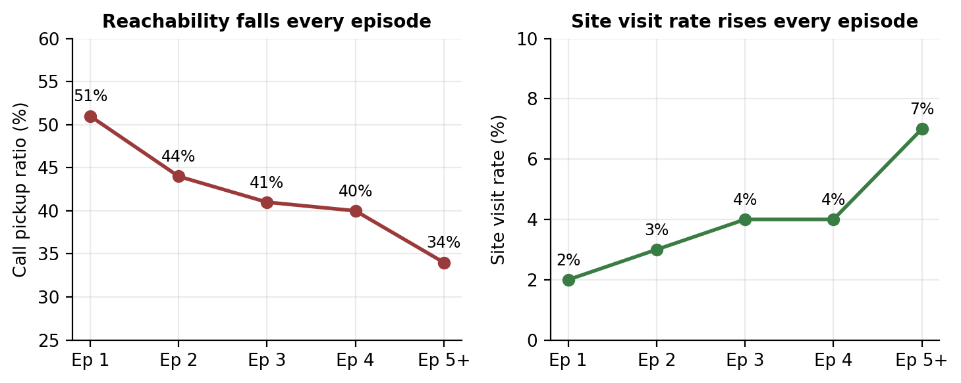
Figure 7 - Two opposing trends: leads get harder to reach, but those who persist convert to site visits at higher rates.

6.3 The engagement paradox
Web time, WhatsApp interactions and site visit rate all rise across episodes while pickup ratio and stage movements fall. These are not contradictory. The leads who survive into later episodes are a progressively more selected group - the disengaged have already exited. Rising averages therefore describe who remains, not improvement in those who stay. Section 7 separates the two effects.

7. Within-Lead Behaviour: Composition versus Real Change
Two different questions produce two different answers, and confusing them is the most common way to misread this dataset.
- Population comparison - how does the average Episode-2 lead compare with the average Episode-1 lead? Different people in each group.
- Within-lead comparison - for the 33,940 leads who personally moved from Episode 1 to Episode 2, how did their own behaviour change? Same people in both groups.
Feature | Population Ep1 → Ep2 | Population change | Within-lead Ep1 → Ep2 | Within-lead change
Web time (seconds) | 126.99 → 252.17 | +125.18 (+98.6%) | 130.23 → 252.17 | +121.94 (+93.6%)
Call duration (seconds) | 50.59 → 52.06 | +1.47 (+2.9%) | 77.67 → 52.06 | −25.61 (−33.0%)
WhatsApp interactions | 1.34 → 3.42 | +2.08 (+155.2%) | 1.43 → 3.42 | +1.99 (+139.2%)
Episode duration (days) | 4.04 → 101.77 | +97.73 | 4.67 → 101.77 | +97.10
Site visit rate | 2% → 3% | +1 pp | 3% → 3% | 0 pp
Pickup ratio | 51% → 44% | −7 pp (−13.7%) | 49% → 44% | −5 pp (−10.2%)
Table 11 - Population versus within-lead change, Episode 1 to Episode 2 (n = 33,940 paired leads).
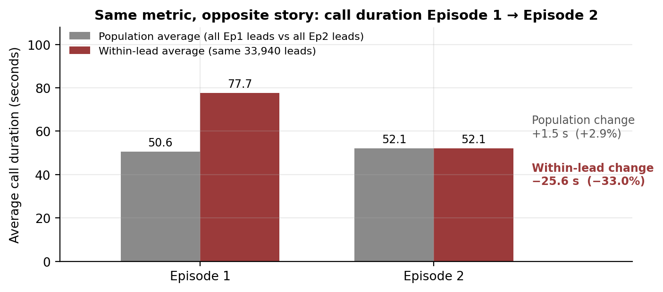
Figure 8 - Call duration is the metric where the two methods disagree, and they disagree in direction.
Call duration is the case that matters. The population view says duration edged up 1.47 seconds. The within-lead view says the same people talked 25.61 seconds less - a third less than in their first episode. The population figure is higher only because Episode 1 contains a large mass of never-contacted leads whose exit removes them from the Episode 2 sample.
Site visit rate behaves the same way in miniature: the population rate appears to rise from 2% to 3%, but among paired leads it does not move at all.
Web time and WhatsApp interactions, by contrast, agree closely under both methods (+93.6% vs +98.6%; +139.2% vs +155.2%). These are real behavioural increases, not composition artefacts.

7.1 Which within-lead changes are statistically real
Transition | Feature | From → To | Change | n pairs | p-value | Significant
Ep1 → Ep2 | Call duration | 77.67 → 52.06 s | −25.61 s (−33.0%) | 33,940 | < 0.001 | Yes
Ep2 → Ep3 | Call duration | 86.29 → 67.20 s | −19.09 s (−22.1%) | 9,895 | < 0.001 | Yes
Ep3 → Ep4 | Call duration | 92.12 → 74.02 s | −18.10 s (−19.7%) | 3,770 | < 0.001 | Yes
Ep1 → Ep2 | Web time | 130.23 → 252.17 s | +121.94 s (+93.6%) | 33,940 | < 0.001 | Yes
Ep2 → Ep3 | Web time | 292.02 → 279.26 s | −12.76 s (−4.4%) | 9,895 | 0.43 | No
Ep3 → Ep4 | Web time | 316.97 → 325.45 s | +8.48 s (+2.7%) | 3,770 | 0.90 | No
Ep1 → Ep2 | Active sessions | 1.41 → 1.78 | +0.37 (+26.2%) | 33,940 | < 0.001 | Yes
Ep1 → Ep2 | Price page time | 148.35 → 178.88 s | +30.53 s (+20.6%) | 33,940 | < 0.001 | Yes
Ep1 → Ep2 | Home page time | 56.88 → 82.85 s | +25.97 s (+45.7%) | 33,940 | < 0.001 | Yes
Table 12 - Within-lead paired changes. Wilcoxon-style paired testing on leads present in both episodes.
The one finding that repeats at every stage
Web-time gains happen once, between Episode 1 and Episode 2, and then stop being statistically detectable. The decline in answered call duration is significant at every transition tested. If the business takes one behavioural signal from this analysis, it is that each time a lead is re-worked, the conversations get measurably shorter - by roughly a third at the first re-work, and by around a fifth at each subsequent one.
One caveat on scale. For web time, 78.4% of paired leads recorded no change at all between Episode 1 and Episode 2 - they had no web activity in either. The average movement is driven by the 12.1% who increased and 9.5% who decreased. Call duration is different: only 17.5% were unchanged, and 48.7% decreased against 33.9% who increased. The call finding rests on a genuine majority movement; the web finding rests on a minority.

8. Fresh versus Cross-Project Behaviour
Metric | Fresh-born | Cross-project-born | Difference | Relative
Leads | 20,832 | 91,114 | - | -
Episodes | 32,439 | 131,996 | - | -
Avg ASBL lead age (days) | 593.32 | 757.54 | +164.22 | -
Web time (seconds) | 73.02 | 298.68 | +225.66 | +309.0%
Call duration (seconds) | 37.04 | 59.46 | +22.42 | +60.5%
Answered calls | 1.47 | 1.38 | −0.09 | −6.1%
WhatsApp interactions | 1.81 | 2.92 | +1.11 | +61.3%
Episode duration (days) | 12.76 | 9.63 | −3.13 | −24.5%
Site visit rate | 1% | 3% | +2 pp | +200%
Pickup ratio | 47% | 48% | +1 pp | +2.1%
Episode has a successor | 36% | 31% | −5 pp | −13.9%
Table 13 - Fresh (1 project) versus cross-project (2+ projects) behaviour. Five of six tested metrics differ significantly (Mann-Whitney U); episode duration does not at p < 0.05.
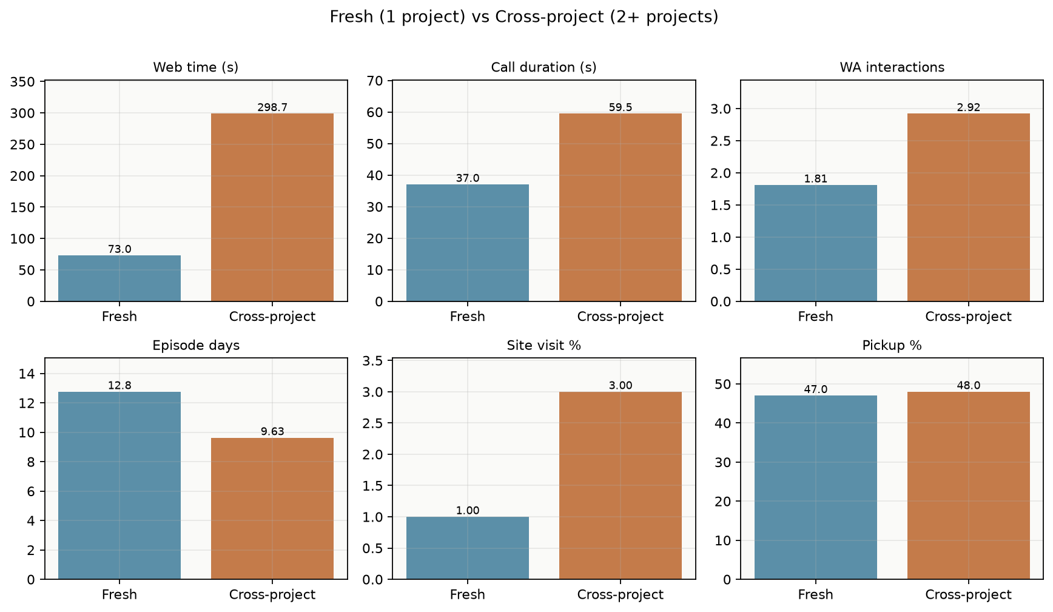
Figure 9 - Cross-project leads show higher web, call and WhatsApp interaction means; Fresh episodes are slightly longer on average.

8.1 Answering the question directly
- Do fresh leads engage more? No on web/calls. Cross-project averages 298.68s web time vs 73.02s and longer answered calls (59.46s vs 37.04s). Fresh keeps higher any-inbound WhatsApp incidence (64% vs 22%) and slightly higher continuation (36% vs 31%).
- Do cross-project leads spend more time? On the web, yes (+225.66s / +309%). Episode length slightly favours Fresh (12.76 vs 9.63 days).
- Are calls different? Yes. Cross-project talks longer when answered (+22.42s / +60.5%); pickup is nearly identical (48% vs 47%).
- Is WhatsApp behaviour different? Yes - Cross-project averages more inbound interactions (2.92 vs 1.81), while Fresh episodes are more likely to contain any inbound WhatsApp (64% vs 22%).
- Are site visits different? Cross-project reaches a site visit in 3% of episodes against 1% for Fresh.

This difference cannot be attributed to cross-project status alone Cross-project leads average 757.54 days of ASBL system age against 593.32 days for Fresh. Both groups are mature; Fresh is not zero-age. Prior multi-project presence and longer ASBL tenure remain related. Separating them cleanly would require comparing Fresh and cross-project leads within the same ASBL age band.

9. Lead Age and Behaviour
Age buckets here are measured at episode start, so a lead can appear in different buckets across its own episodes.
Age at episode start | Episodes | Web time (s) | Call duration (s) | WA interactions | Episode duration (days) | Site visit rate | Pickup ratio
Fresh / 0 days | 3,193 | 125.52 | 54.33 | 1.57 | 62.18 | 0% | 37%
1-7 days | 43,676 | 111.05 | 43.63 | 1.89 | 11.35 | 2% | 48%
8-30 days | 12,088 | 233.32 | 48.71 | 3.13 | 27.61 | 2% | 48%
31-90 days | 17,833 | 248.63 | 43.08 | 3.03 | 8.35 | 2% | 49%
91-180 days | 17,935 | 298.84 | 45.01 | 2.78 | 7.18 | 2% | 50%
181-365 days | 25,640 | 390.89 | 47.28 | 2.78 | 6.44 | 2% | 49%
365+ days | 44,070 | 502.11 | 82.76 | 2.72 | 11.25 | 3% | 48%
Table 14 - Behaviour by ASBL lead age at episode start.
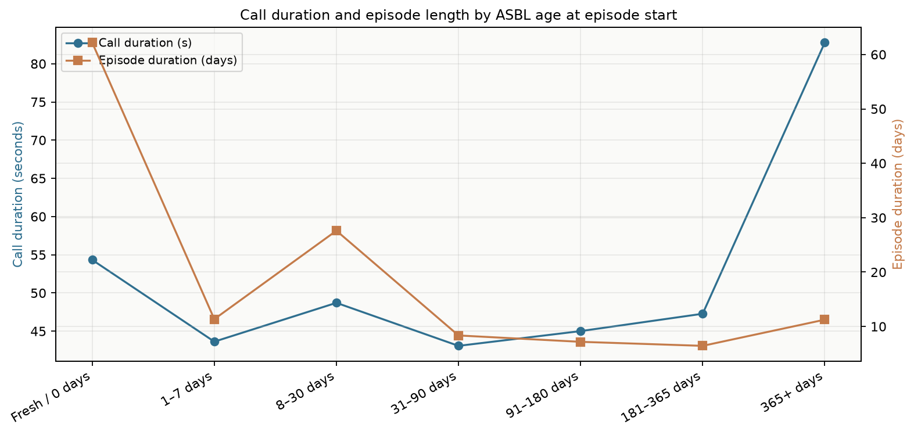
Figure 10 - Call duration rises mainly in the 365+ episode-age band; episode length is longest near Fresh/0 episode-start age.

9.1 What holds up and what does not
At episode start, call duration sits near 43-54 seconds through 181-365 days, then jumps to 82.76 seconds beyond 365 days. Episode duration is longest in the Fresh/0 episode-start band (62 days) and shorter for most older episode-age bands.
Web time versus age is confounded by exposure. The 365+ episode-start band records 502.11 seconds against 111.05 in the 1-7 day band, but episode duration is not uniformly longer there (11.25 vs 11.35 days). The Fresh/0 episode-start band has the longest episodes (62.18 days) with moderate web time (125.52s) - so raw web totals still mix intensity with how long the episode is left open.
Call duration is less exposed to this problem - it measures the length of conversations that occurred, not the count of them - which is why it is the more trustworthy of the two signals.
WhatsApp interaction count is essentially flat beyond the first week. It sits between 3.37 and 3.61 in every band from 8 days onward. The only distinct value is the 1-7 day band at 1.81, which reflects new leads not yet having had a conversation.

9.2 Age does not explain the Orange advantage
If Orange leads simply performed better because they are older, the advantage should disappear once age is held constant. It does not.
Age band | Orange | Purple | WA Born | WA React. | WA Resub.
1-7 days | 69.94 | 44.61 | 39.75 | 42.80 | 38.44
8-30 days | 77.70 | 51.01 | 40.90 | 59.79 | 54.92
91-180 days | 92.47 | 41.85 | 41.60 | 61.47 | 39.05
365+ days | 139.54 | 77.76 | 78.16 | 100.75 | 91.16
Table 15 - Average call duration (seconds) by cohort within age band.
In the 1-7 day band, where 20,617 Orange episodes sit, Orange call duration is 95.08 seconds against 44.13-44.89 for the other cohorts - more than double, among leads of identical maturity. The gap narrows with age (at 365+ days Orange leads by roughly 20% rather than 115%), but Orange is the highest in every band. Orange's call advantage is a property of the cohort, not of its age mix.

9.3 Age does partly explain the WhatsApp-born puzzle
WhatsApp-born leads record only 1.31 WhatsApp interactions per episode overall. By episode-start age the largest share of WA-born episodes sits in 365+ with low ongoing WA activity. The low overall average is pulled by that mature mass, not by a young first-week composition effect.
So WhatsApp-born leads do converse on WhatsApp - but generally not in their first week. Two explanations are consistent with this data and cannot be separated here: either these leads genuinely go quiet after the acquisition message, or the initial WhatsApp contact is recorded as the source event rather than as an inbound episode interaction. The second possibility should be verified against the raw WhatsApp logs before this finding is acted on. Even so, the gap persists partly on a like-for-like basis: in the 1-7 day band Purple-born leads record 3.04 interactions against WhatsApp-born's 1.25.

10. Why the Differences Appear, and When

10.1 Candidate explanations for the main differences
Observed difference | Evidence available | Most consistent explanation
Orange out-performs on calls (101.9s vs ~50s) | Holds within episode-age bands; Orange cross-project share is 90.2% and mean ASBL age is 841 days | Appears to be a property of the Orange cohort itself. Age and cross-project mix contribute but do not fully account for it.
WhatsApp-born has the lowest WhatsApp engagement (1.31) | Largest WA-born episode mass sits in mature episode-start ages with low ongoing WA activity | Largely a composition effect from a mature episode mix - not a Fresh/Cross artefact alone.
Cross-project leads show higher web/call engagement | Web/call gaps are large and significant; both Fresh and Cross are mature on ASBL age (593 vs 758 days) | Associated with multi-project identity and longer ASBL tenure; Fresh is not age-zero under the revised born-date rules.
Web time rises across episodes | Confirmed within-lead at Ep1→Ep2 (+121.94s, p < 0.001) but not significant thereafter | A real one-time behavioural increase when a lead re-engages, followed by no further detectable change.
Call duration appears flat across episodes | Population +1.47s vs within-lead −25.61s on the same 33,940 leads | A composition artefact. The underlying behaviour is a consistent decline.
Site visit rate rises with episode and age | 2% → 7% across episodes; 2% → 6% across age bands; no within-lead movement at Ep1→Ep2 | Survivorship - the leads still present in later episodes were always the more likely converters.
Table 16 - Association-level explanations. None of these relationships has been tested causally.

10.2 When the changes happen
- Between Episode 1 and Episode 2 - the single largest behavioural break. Web time roughly doubles, WhatsApp interactions rise 155%, and within-lead call duration falls 33.0%. This is where almost all of the real change is concentrated.
- At the 7-day lead-age threshold - behaviour shifts sharply between the 1-7 day band and the 8-30 day band: web time 111 → 227 seconds, call duration 45.6 → 66.5 seconds, WhatsApp interactions 1.81 → 3.50. Beyond 30 days the metrics settle into a slow drift.
- Continuously across episodes - pickup ratio (51% → 34%) and stage movements (2.46 → 2.05) decline steadily rather than breaking at one point.
- Beyond 365 days of episode-start age - call duration and site visit rate reach their highest values (82.76s, 3%), but this band is also where survivorship and prior multi-project history concentrate. Treat the top band as a selected mature group, not a simple age effect.

11. Most Significant Changes
Selected for business relevance, not statistical significance alone. Several statistically significant results have been left out because the effect is too small to act on.
Cohort / group | Feature | From | To | Absolute change | Relative | n | Business relevance
Paired leads Ep1→Ep2 | Call duration | 77.67 s | 52.06 s | −25.61 s | −33.0% | 33,940 | Conversations shorten sharply the moment a lead is re-worked.
Paired leads Ep2→Ep3 | Call duration | 86.29 s | 67.20 s | −19.09 s | −22.1% | 9,895 | The decline continues; it is not a one-off.
Paired leads Ep3→Ep4 | Call duration | 92.12 s | 74.02 s | −18.10 s | −19.7% | 3,770 | Still significant even on a small sample.
Paired leads Ep1→Ep2 | Web time | 130.23 s | 252.17 s | +121.94 s | +93.6% | 33,940 | Re-engaged leads research substantially more online.
All leads Ep1→Ep5+ | Pickup ratio | 51% | 34% | −17 pp | −33.3% | 111,946 → 1,763 | Each re-work cycle makes the lead materially harder to reach.
Fresh vs cross-project | Web time | 73.02 s | 298.68 s | +225.66 s | +309.0% | 32,439 / 131,996 | Cross-project leads are far more digitally active.
Fresh vs cross-project | Site visit rate | 1% | 3% | +2 pp | +200% | 32,439 / 131,996 | Conversion gap favours cross-project on a low base.
Age ep-start 1-7 vs 365+ | Call duration | 43.63 s | 82.76 s | +39.13 s | +89.7% | 43,676 / 44,070 | Largest call step is into the 365+ episode-age band.
WA Born vs Orange | WA interactions | 1.31 | 4.80 | +3.49 | +266% | 110,110 / 36,483 | The acquisition channel is not the conversation channel.
Table 17 - Most significant changes by business relevance. All within-lead and fresh/cross entries are significant at p < 0.001.

11.1 Deliberately excluded
- Episode 5+ figures. Web time of 2,118.38 seconds and 14.69 sessions per episode in Episode 5+ are extreme relative to every other episode. The bucket pools all fifth-and-later episodes from just 1,763 leads and behaves nothing like Episodes 1-4. It is reported for completeness but should not be used to draw conclusions.
- "Days to first WhatsApp inbound" changes. The Episode-1 baseline is effectively zero, which produces relative changes such as +1,319,500%. These are arithmetic artefacts of dividing by near-zero, not findings.
- One internal inconsistency exists. The fresh/cross statistical table reports untrimmed means (68.34 s vs 4,081.60 s for web time) while the descriptive table reports trimmed means (73.02 s vs 298.68 s). Direction agrees; magnitude differs. This report quotes trimmed means for description.
- Answered calls Ep1→Ep2 (1.38 → 1.36, −0.02 calls, p < 0.001). Statistically significant on 33,940 pairs, but a change of two hundredths of a call has no operational meaning.

12. Unique and Unexpected Behaviour

12.1 WhatsApp-born leads are the least WhatsApp-active cohort
Finding: 1.31 inbound WhatsApp interactions per episode against 4.80 for Orange, 3.62 for WhatsApp-resubmitted, 3.41 for Purple and 3.14 for WhatsApp-reactivated. The cohort defined by WhatsApp acquisition is last on WhatsApp usage - by a wide margin, and below cohorts that were not acquired on the channel at all.
Qualification: most of this is the very young episode mix (Section 9.3). Part is not: at identical 1-7 day maturity, Purple-born leads record 3.04 interactions against WhatsApp-born's 1.25. This warrants a data check before it is treated as a behavioural fact.

12.2 WhatsApp-resubmitted leads: strong digital interest, weak progression
Finding: the highest web time of any cohort at 549.12 seconds - 2.4 times the born-cohort average of 225.75s and 2.1 times WhatsApp-born - with the highest pickup ratio (51%), yet the lowest call duration of all five cohorts (49.85 seconds) and a site visit rate of only 3%.
Why it is unusual: these leads answer the phone more readily than any other cohort and research more heavily online, but the conversations are the shortest and conversion is not materially better. Unlike the age-driven web-time patterns elsewhere, this is not an exposure effect - resubmitted episodes last 9.73 days against 9.13 for born leads. Something about these conversations is ending early despite evident interest.

12.3 Episode 1 lasts four days; Episode 2 lasts three months
Finding: average episode duration jumps from 4.04 days to 101.77 days - a 25-fold increase - then shortens again to 83.43, 76.08 and 41.05 days.
Interpretation: Episode 1 ends at the first Not Interested, which for most leads arrives within days. Once a lead re-enters the funnel it stays open for months. This is partly definitional, but it has a real operational consequence: second episodes are long-lived open items, and the shortening trend from Episode 2 onward suggests later re-works are closed out faster.

12.4 The 1-7 day age band returns more often than the oldest leads
Finding: on ASBL system age, almost no leads sit under 30 days; continuation is highest in the 365+ band (32%). Fresh identities (1 project) are not age-zero in the system - their mean ASBL age is ~593 days. Episode-start age buckets remain useful for behaviour during the funnel window.
Caution: this band contains only 1,431 leads. The direction is consistent with the wider pattern that any prior ASBL presence raises continuation, but the specific ranking should not be relied on.

12.5 Effort stays flat while returns fall
Finding: attempted calls hold at roughly 3.15 per episode from Episode 1 through Episode 4 while pickup ratio falls from 51% to 40% and within-lead call duration falls by a third and then a fifth.
Why it matters: the sales effort applied per episode does not adapt to the declining response. This is the clearest efficiency signal in the analysis.

13. Key Business Insights

Insight 1 - Re-working a lead produces shorter conversations every time
Evidence | Within-lead call duration falls 77.67 → 52.06 s (−25.61 s, −33.0%) at Ep1→Ep2, 86.29 → 67.20 s (−22.1%) at Ep2→Ep3 and 92.12 → 74.02 s (−19.7%) at Ep3→Ep4. All p < 0.001 on 33,940 / 9,895 / 3,770 paired leads.
Where | All cohorts; the effect is measured on leads that personally progressed between episodes.
When | At every episode transition, beginning with the first re-work.
Why it matters | This is the only behavioural change that holds up under paired testing at every stage. The population view hides it entirely.
Possible action | Review whether later-episode calls are being scripted and staffed differently from first-contact calls, and whether shorter calls reflect lead fatigue or a change in agent approach.

Insight 2 - Only three in ten leads are ever worked a second time, and the rest get progressively harder to reach
Evidence | 33,940 of 111,946 leads (30.3%) reach Episode 2; 3,770 (3.4%) reach Episode 4. Pickup ratio falls 51% → 44% → 41% → 40% → 34% while attempted calls stay flat at ~3.15 per episode.
Where | Whole population; steepest fall between Episode 1 and Episode 2 (−7 pp).
When | Continuously, at every episode boundary.
Why it matters | Effort per episode is constant while the answer rate declines by a third. Contact capacity is being spent at a falling return.
Possible action | Consider whether attempt volume in later episodes should be reallocated toward channels with better response, or toward the cohorts that do continue.

Insight 3 - Orange leads are worth more per episode, and it is not because they are older
Evidence | Call duration 101.90 s vs 50.93 (Purple) and 50.01 (WhatsApp-born); site visit rate 5% vs 2%. Within the 1-7 day episode-age band: 69.94 s vs ~40-45 s; at 365+: 139.54 s.
Where | Orange cohort - 19,464 leads, the smallest of the five.
When | From the first episode onward, at every lead age.
Why it matters | The advantage survives age stratification, so it reflects something about the cohort rather than its maturity mix. Orange is 17% of the lead base but the strongest performer on every engagement measure.
Possible action | Understand what distinguishes Orange lead capture, and test whether volume can be grown without diluting quality.

Insight 4 - Only ~19% of leads are single-project Fresh; ~81% are multi-project under masterLeadId
Evidence | 20,832 leads (18.6%) are Fresh (1 project); 91,114 (81.4%) are cross-project (2+). Orange cross-project share is 90.16%; WhatsApp-born 88.42%. Cross-project web time 298.68 s vs Fresh 73.02 s; ASBL ages average 758 vs 593 days.
Where | All projects; majority cross-project in every cohort; WhatsApp-reactivated is the main Fresh-leaning exception (39.08% Fresh).
When | At the point a new project lead record is created.
Why it matters | Most leads are multi-project under masterLeadId. Counting the full base as new single-project demand overstates Fresh acquisition.
Possible action | Report Fresh (1 project) and cross-project (2+) acquisition separately in project-level lead reporting.

Insight 5 - Day 7 is where lead behaviour changes
Evidence | Between the 1-7 day and 8-30 day episode-start bands: web time 111.05 → 233.32 s; WA interactions 1.89 → 3.13. Call duration jumps most into 365+ (43.63 → 82.76 s). ASBL system age is already mature for almost the entire base (median 600 days).
Where | All cohorts, measured at episode start.
When | Around the seven-day mark after first ASBL appearance.
Why it matters | The first week behaves like a distinct phase. Any engagement-based scoring that treats a 3-day-old lead and a 60-day-old lead on the same scale will misread both.
Possible action | Consider treating lead age band as an explicit input to prioritisation and to any scoring model, rather than relying on raw engagement totals.

Insight 6 - WhatsApp-resubmitted leads show the widest gap between interest and progression
Evidence | Highest web time of any cohort (549.12 s, +114.6% over WhatsApp-born) and highest pickup ratio (51%), but the lowest call duration (49.85 s) and only a 3% site visit rate - in episodes no longer than the born cohorts (9.73 vs 9.13 days).
Where | WhatsApp-resubmitted cohort - 8,138 leads, 13,113 episodes.
When | Throughout the cohort's episodes; not concentrated at one transition.
Why it matters | These leads are demonstrably interested and reachable, yet the conversations are the shortest of any group. It is the clearest instance of engagement not converting into progression.
Possible action | Examine call recordings or dispositions for this cohort specifically - the pattern suggests the conversations are ending for a reason that is not lack of interest.

Insight 7 - Population averages have been telling the opposite story on calls
Evidence | Population comparison shows call duration rising 50.59 → 52.06 s (+2.9%) from Episode 1 to Episode 2. The same 33,940 leads show 77.67 → 52.06 s (−33.0%). Site visit rate shows the same distortion: 2% → 3% in the population, no movement at all within leads.
Where | Any reporting that compares episode-level averages across different lead groups.
When | Wherever episode-over-episode averages are presented.
Why it matters | Two standard metrics move in the wrong direction under the population view because low-engagement leads drop out of later episodes. Decisions taken on those numbers would have been based on an artefact.
Possible action | Adopt within-lead (paired) comparison as the default for any episode-over-episode metric in recurring reporting.

14. Business Questions Answered
Question | Answer from this analysis
What is happening? | Lead volume collapses after the first episode (30.3% reach a second). Among leads who do return, online research roughly doubles while telephone conversations shorten by a third and reachability falls steadily.
Why is it happening? | Partly composition - later episodes contain a self-selected surviving group. Partly real behaviour change, confirmed by paired within-lead testing on call duration and web time.
When is it happening? | The dominant break is between Episode 1 and Episode 2. A second break sits at the 7-day lead-age threshold. Pickup ratio declines continuously rather than at one point.
How large is the difference? | Within-lead call duration −25.61 s (−33.0%) at the first re-work. Web time +121.94 s (+93.6%). Pickup ratio −17 pp across five episodes.
Which cohort is responsible? | The episode patterns hold across all cohorts. Orange drives the engagement highs; WhatsApp-born drives the volume and the per-episode lows; WhatsApp-reactivated drives episode length.
Are fresh and cross-project leads different? | Yes. Fresh = 1 project only (18.6%); Cross = 2+ (81.4%). Cross engages more on web/calls; Fresh has higher WA-inbound incidence. Both have large ASBL ages.
Does ASBL lead age explain the difference? | Partly. Both Fresh and Cross are mature (means 593 vs 758 days). Episode-start age still relates to call duration mainly at 365+. It does not erase the Orange call advantage.
How does behaviour change across episodes? | Web time, WhatsApp interactions, site visit rate and resubmission rate rise. Pickup ratio, stage movements and within-lead call duration fall.
Which features increase? | Web time, sessions, page-level time, WhatsApp interactions, site visit rate, resubmission rate, lead age.
Which features decrease? | Pickup ratio, stage movements per episode, and - within-lead - answered call duration.
Which cohorts behave differently? | Orange (high on everything), WhatsApp-resubmitted (high web, low call), WhatsApp-reactivated (very long episodes).
Which cohorts behave similarly? | Purple and WhatsApp-born are close on call duration (50.93 vs 50.01 s), pickup (50% vs 49%) and site visit rate (2% vs 2%) - unsurprising given 40,806 leads carry both labels.
Where is the largest significant change? | Within-lead web time at Episode 1 → 2: +121.94 seconds (+93.6%) on 33,940 paired leads.
Where is the earliest significant change? | Episode 1 → Episode 2, which is also where the great majority of all detectable change occurs.
Where is the strongest positive change? | Web time and WhatsApp interactions at the first re-work (+93.6% and +139.2% within-lead).
Where is the strongest negative change? | Call duration at the first re-work (−33.0% within-lead), sustained at every later transition.
What is unique or unexpected? | WhatsApp-born leads are the least WhatsApp-active cohort; WhatsApp-resubmitted leads combine the highest web engagement with the shortest calls.
What does this mean for the business? | Contact effort is flat while returns decline; ~81% of leads are multi-project under masterLeadId; and population averages have been misreporting the direction of call engagement across episodes.

15. Conclusion
Overall cohort behaviour. Five cohorts were analysed but they are not five audiences - 68.5% of leads carry more than one label, and only 319 leads are Orange-only. Within that overlap, Orange is consistently the strongest performer per episode and WhatsApp-born the weakest, despite WhatsApp-born being nearly five times larger.
The most important episode-level pattern. Volume collapses after Episode 1: 30.3% of leads reach a second episode and 3.4% a fourth. Among those who continue, online research roughly doubles while telephone conversations shorten by a third and pickup ratio falls from 51% to 34%. Effort per episode stays constant at around 3.15 attempted calls throughout.
The most important lead-age finding. Call duration rises mainly into the oldest episode-start ages, from 43.63 seconds in the 1-7 day band to 82.76 seconds beyond 365 days. ASBL system age (analysis end − first born) is large for nearly all leads (median 600 days) - Fresh is not age-zero.
Fresh versus cross-project. Under masterLeadId, 18.6% of leads are single-project Fresh and 81.4% are cross-project. Cross-project episodes show higher web and call engagement; Fresh shows higher WhatsApp-inbound incidence. Actual ASBL ages are large for both groups (medians in the hundreds of days). Orange remains the engagement leader on a heavily cross-project mix.
The most important source difference. Orange leads sustain roughly double the call duration of every other cohort, and this holds within episode-age bands - 69.94 seconds against ~40-45 for other cohorts in the 1-7 day band, and 139.54 seconds at 365+. This is a property of the cohort itself, not of Fresh/Cross mix alone.
The most significant behavioural change. Within-lead answered call duration declines at every episode transition tested: −33.0%, −22.1% and −19.7%, all significant at p < 0.001. It is the only change that survives paired testing at every stage.
The most useful unique insight. WhatsApp-born leads - the largest cohort - record the fewest inbound WhatsApp interactions of any cohort (1.31 per episode against 4.80 for Orange). Most of this is explained by their very young episode mix, but not all: at identical 1-7 day maturity, Purple-born leads record 3.04 against WhatsApp-born's 1.25. This should be verified against raw WhatsApp logs before being acted on.

Main business takeaway Sales effort is being applied at a constant rate to a lead base whose response declines with every re-work: attempted calls hold near 3.15 per episode while pickup falls from 51% to 34% and conversations shorten by a third at the first re-work and by a fifth at each one after. At the same time, only 18.6% of leads are single-project Fresh - 81.4% are cross-project under masterLeadId - and actual ASBL ages run to hundreds of days for nearly everyone. Adopting within-lead comparison for recurring metrics remains the single highest-value change to how this data is reported.

Source: opw_alltime_episode_bi_analysis.ipynb · ASBL CRM and lead history data · Analysis date 21 August 2026. All figures in this report are taken directly from the notebook output. No values have been estimated, extrapolated or inferred beyond what the analysis supports.

