Lead Reactivation Feature Validation: Insights & Conclusion
Analysis compares historically reactivated leads (POS) vs never-reactivated leads (NEG, NI ≥ 90 days). Metrics are lead-level and capped to avoid leakage (pre-NI + post-NI up to 90 days, never after reactivation).

1. Cohort overview
Labeled NI leads: about 986K. Reactivation rate among labeled leads is ~14.2% (140K POS vs 846K NEG). Cross-project returns are counted separately: same customer NI on one project, later positive on another.
metric | value
POS (reactivated LeadIds) | 140,130
NEG (never reactivated LeadIds) | 846,296
Total labeled LeadIds | 986,426
Reactivation rate % | 14.21
Cross-project customers (unique MLIDs) | 153,962
Cross-project NI leads (later positive elsewhere) | 247,811
Cross-project with project-fit NI (budget/location/availability/vastu) | 28,876
% of cross-project NI leads with project-fit reason | 11.70

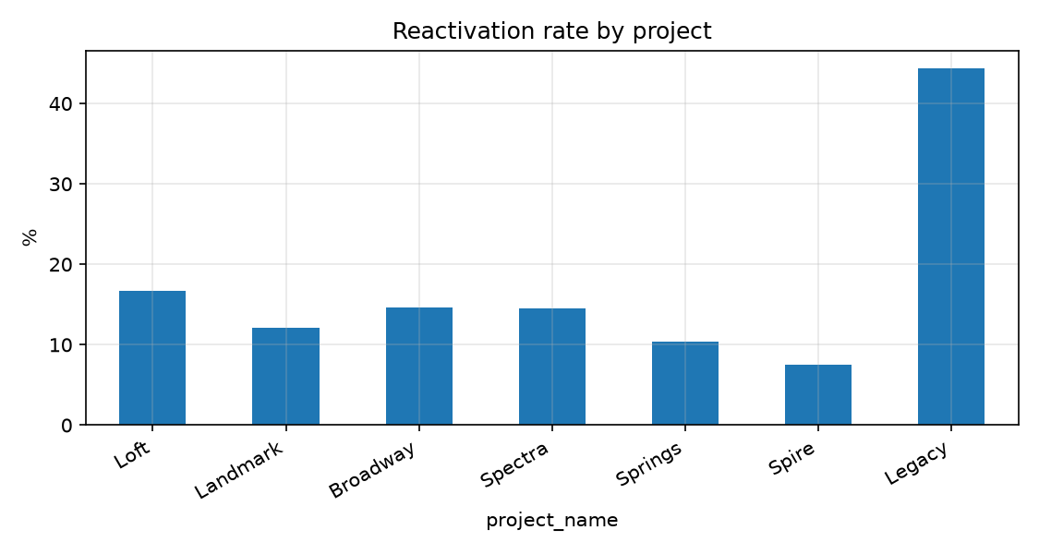
Reactivation rate differs by project - project must be used as a feature or control in any scoring model.

2. Cross-project reactivation
Same masterLeadId went Not Interested on project A, then later reached a positive (non-NI) stage on project B. Project-fit NI = budget / location / availability / vastu.
metric | value
Cross-project pairs (NI lead × later positive on other project) | 724,189
Unique masterLeadIds with cross-project return | 153,962
Unique NI leads that later went positive on another project | 247,811
Of those, NI due to budget/location/availability/vastu | 28,876
% of cross-project NI leads with project-fit reason | 11.70

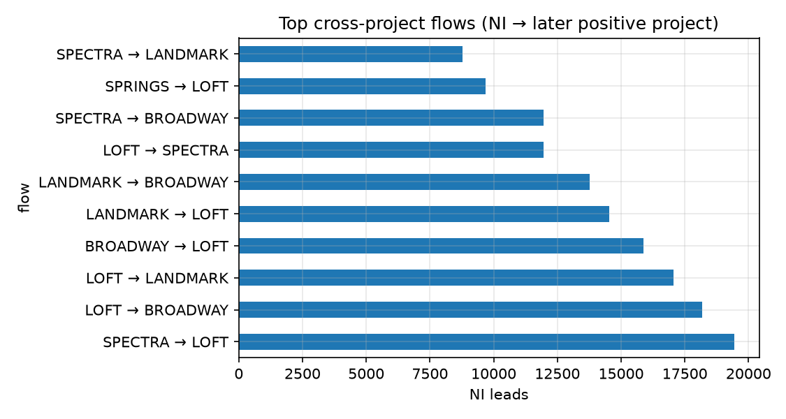
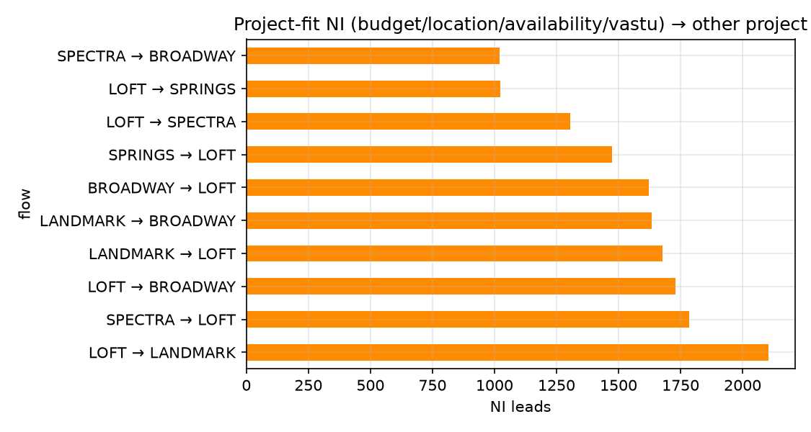
~154K customers show a cross-project return. ~29K of those NI journeys had project-fit reasons - strong candidates for project-switch / cross-sell plays.

3. Which features separate POS from NEG?
Largest positive gaps favour post-NI engagement (calls, especially inbound). Stage depth before NI and NI reason quality also matter.
feature | POS | NEG | diff_pp
Any call after NI (within 90d) | 35,596 / 140,130 (25.4%) | 42,524 / 846,296 (5.0%) | 20.4
Inbound call after NI | 23,534 / 140,130 (16.8%) | 13,834 / 846,296 (1.6%) | 15.2
Website visit after NI | 8,377 / 140,130 (6.0%) | 2,156 / 846,296 (0.3%) | 5.7
WhatsApp inbound after NI | 15,273 / 140,130 (10.9%) | 51,357 / 846,296 (6.1%) | 4.8
Pre Site Visit before NI | 10,463 / 140,130 (7.5%) | 31,610 / 846,296 (3.7%) | 3.7
Post Site Visit before NI | 5,917 / 140,130 (4.2%) | 16,058 / 846,296 (1.9%) | 2.3

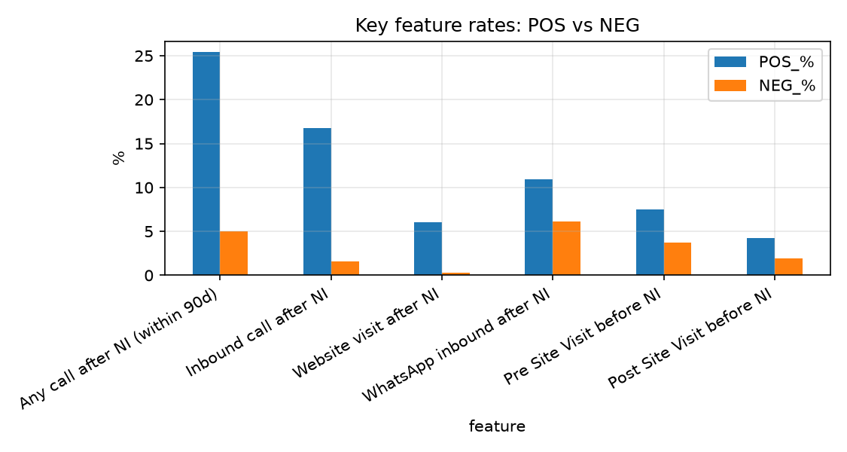
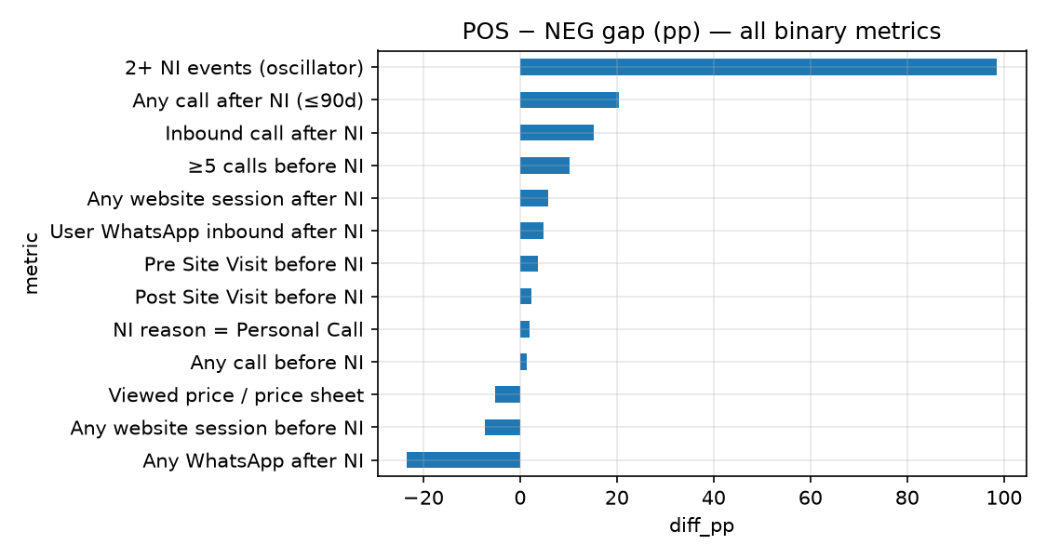

4. Stage & NI reason
stage_before_ni | LeadIds | POS | NEG | reactivation_rate_%
Flat Blocked | 706 | 321 | 385 | 45.47
Post Site Visit | 21,408 | 5,657 | 15,751 | 26.42
Pre Site Visit | 31,667 | 6,947 | 24,720 | 21.94
Lead Initiated | 317,665 | 52,901 | 264,764 | 16.65
New Lead | 614,560 | 74,183 | 540,377 | 12.07

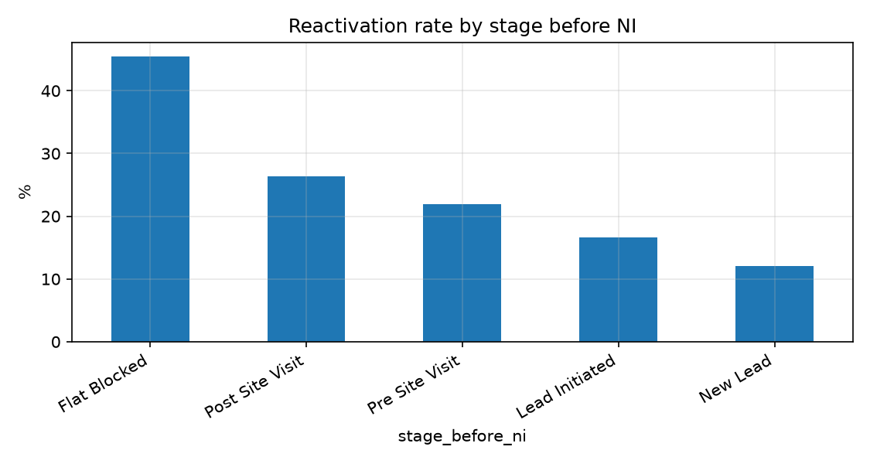
Leads that reached Pre/Post Site Visit before dropping to NI return more often than New Lead drops.
ni_reason_tier | LeadIds | POS | NEG | reactivation_rate_%
SOFT | 42,339 | 8,680 | 33,659 | 20.5
MEDIUM | 833,189 | 121,455 | 711,734 | 14.58
HARD | 5,725 | 800 | 4,925 | 13.97
SYSTEM | 105,173 | 9,195 | 95,978 | 8.74

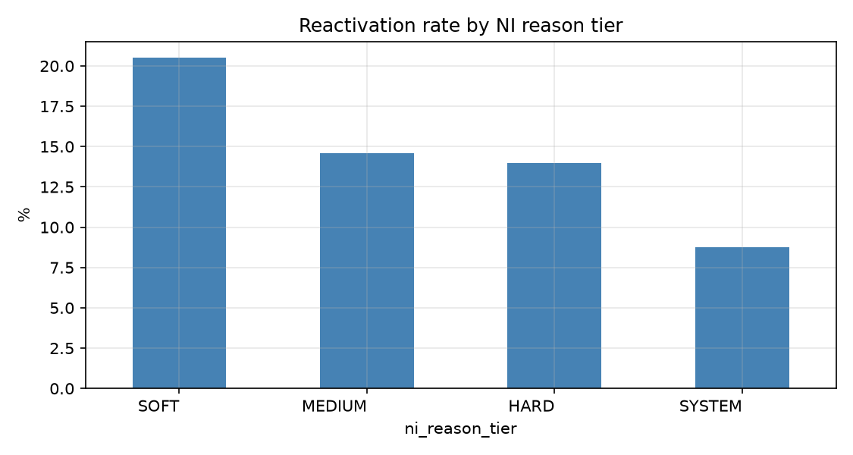
SOFT reasons reactivate more than HARD/SYSTEM. SYSTEM NI (migration / flow builder / dashboard) should be down-weighted.

5. Call analysis
feature | POS | NEG | diff_pp
Any call after NI (≤90d) | 35,596 / 140,130 (25.4%) | 42,524 / 846,296 (5.0%) | 20.4
Inbound call after NI | 23,534 / 140,130 (16.8%) | 13,834 / 846,296 (1.6%) | 15.2
Any call before NI | 133,821 / 140,130 (95.5%) | 795,900 / 846,296 (94.0%) | 1.5

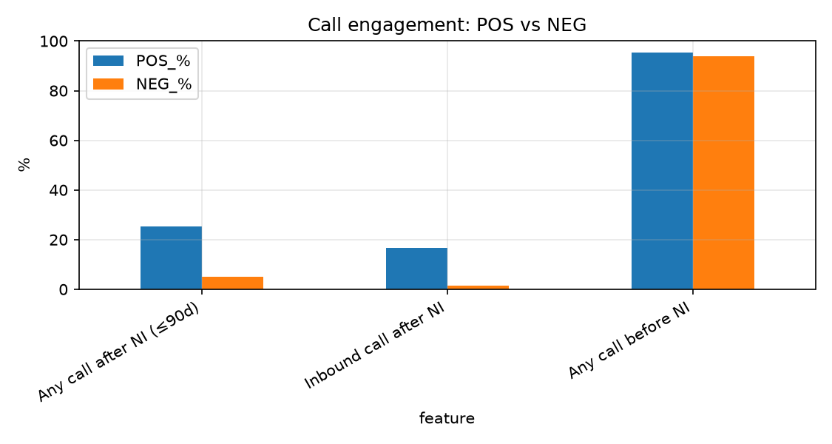
Post-NI calls - especially inbound - are the strongest separators. Pre-NI calling is nearly universal and weak alone.

6. Website analysis
Source: Athena visitorlogs joined on lead (LeadId).
feature | POS | NEG | diff_pp
Any website session after NI | 8,377 / 140,130 (6.0%) | 2,156 / 846,296 (0.3%) | 5.7
Viewed price / price sheet | 53,471 / 140,130 (38.2%) | 366,970 / 846,296 (43.4%) | -5.2
Any website session before NI | 50,276 / 140,130 (35.9%) | 365,518 / 846,296 (43.2%) | -7.3

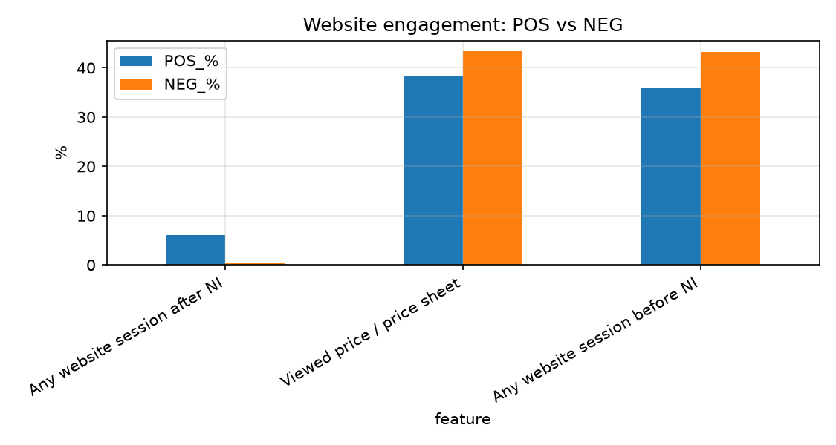
Returning to the website after NI is rare but much more common among POS. Pre-NI browsing / price views are higher in NEG - treat as coverage/confounding, not a chase signal.

7. WhatsApp analysis
feature | POS | NEG | diff_pp
User WhatsApp inbound after NI | 15,273 / 140,130 (10.9%) | 51,357 / 846,296 (6.1%) | 4.8
Any WhatsApp message after NI | 96,113 / 140,130 (68.6%) | 778,462 / 846,296 (92.0%) | -23.4

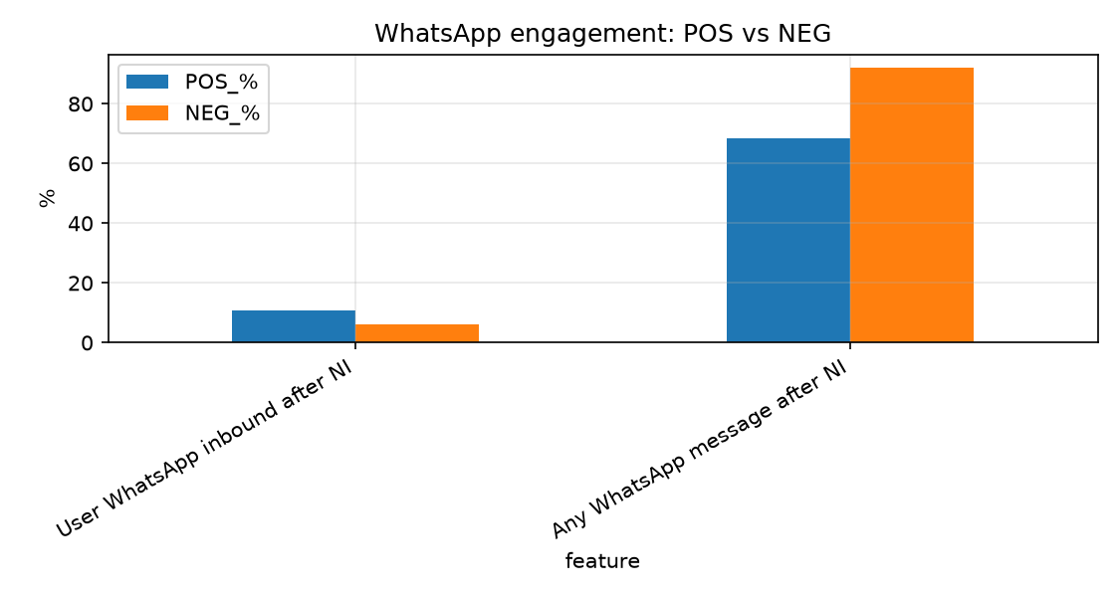
Prefer user inbound WhatsApp after NI. Total WA volume is higher for NEG (likely automation, churn campaigns) - do not use raw WA count as a positive signal.

8. Metrics to use in the Reactivation Model
Shortlist for identifying leads who could be reactivated:
priority | metric | why | use_in_model
HIGH | any_post_ni_inbound / post_ni_inbound | POS 16.8% vs NEG 1.6% (+15 pp). Customer-initiated contact after NI. | Yes - post-NI window
HIGH | any_post_ni_call / post_ni_calls | POS 25.4% vs NEG 5.0% (+20 pp). Strongest engagement separator. | Yes
HIGH | days_since_last_call | POS median 30d vs NEG 90d - recency of contact. | Yes (capped at W)
HIGH | stage_before_ni + had_pre/had_sv before NI | Deeper funnel before NI → higher return rate. | Yes - available at NI time
HIGH | ni_reason_tier (SOFT vs HARD/SYSTEM) | SOFT ~20.5% vs HARD ~14% vs SYSTEM ~8.7%. | Yes - at NI time
HIGH | project_name + born_source | Large rate spread; needed as features/controls. | Yes
HIGH | any_post_web | POS 6.0% vs NEG 0.3% - rare but high lift. | Yes when web coverage exists
HIGH | any_post_wa_inbound | POS 10.9% vs NEG 6.1% (+4.8 pp). | Yes - inbound only
MEDIUM | pre_ni_calls (≥5) | +10 pp; intensity before NI. | Yes
MEDIUM | cross_project / project-fit NI flag | ~154K customers NI on A then positive on B; 29K project-fit. | Separate play / feature for multi-project
MODIFY | is_oscillator (ni_count≥2) | Looks strong but leaks label (post-reactivation NI). | Only as prior-cycle count before index NI
MODIFY | any_post_wa (total) | NEG higher - automation noise. | No - use inbound
MODIFY | any_pre_web / viewed_price | NEG higher (inverse / coverage). | Investigate; not chase signals
REMOVE | pickup_ratio | No POS/NEG median difference. | No
REMOVE | website CTA clicks (WA/Call Now) | Near-zero rates. | No

Feature scorecard - Keep features
feature | category | diff_pp | verdict | note
bornsource | stage | 63.66 | Keep | source rate spread
days_since_last_call | call | 60.0 | Keep | median POS 30.0 vs NEG 90.0 (lower = more recent)
stage_before_ni | stage | 33.4 | Keep | prior stage rate spread
any_post_ni_call | call | 20.38 | Keep | Any call in post-NI window
any_post_ni_inbound | call | 15.16 | Keep | Inbound call in post-NI window
pre_ni_calls | call | 10.16 | Keep | more than equal to 5 calls before NI
any_pre_web | website | -7.31 | Keep | Web session before NI (NEG higher â interpret carefully)
ni_reason_tier | stage | 6.53 | Keep | SOFT 20.5% vs HARD 14.0%
any_post_web | website | 5.72 | Keep | Web session in post-NI window
viewed_price | website | -5.2 | Keep | Price page / sheet viewed
any_post_wa_inbound | whatsapp | 4.83 | Keep | User WA inbound in post-NI window
had_pre_before_ni | stage | 3.73 | Keep | Pre Site Visit before NI
had_sv_before_ni | stage | 2.33 | Keep | Post Site Visit before NI
has_globalid | website | 2.03 | Keep | Has globalId
is_ni_personal_call | stage | 1.9 | Keep | NI reason = Personal Call

9. Conclusion
- Successful reactivation is most associated with post-NI engagement signals (inbound/any call, website return, WhatsApp inbound) inside a fixed observation window - not with lifetime totals after the label.
- Funnel depth before NI (stage before NI, Pre/Post Site Visit) and NI reason quality (SOFT vs HARD/SYSTEM) are strong at-NI predictors and should be in the model.
- Project and born source create large base-rate differences and must be included as features or controls.
- Do not use raw oscillator (2+ NI), total WhatsApp volume, pickup ratio alone, or rare website CTAs as primary predictors.
- Cross-project paths are material (~154K customers): especially when NI was for budget/location/availability/vastu, treat as a project-switch opportunity in addition to same-project reactivation scoring.

