BÀI THỰC HÀNH MẠNG MÁY TÍNH BUỔI 5

TÊN : LÊ KHẮC TÙNG

MSSV : 2351010238

ĐỊNH TUYẾN

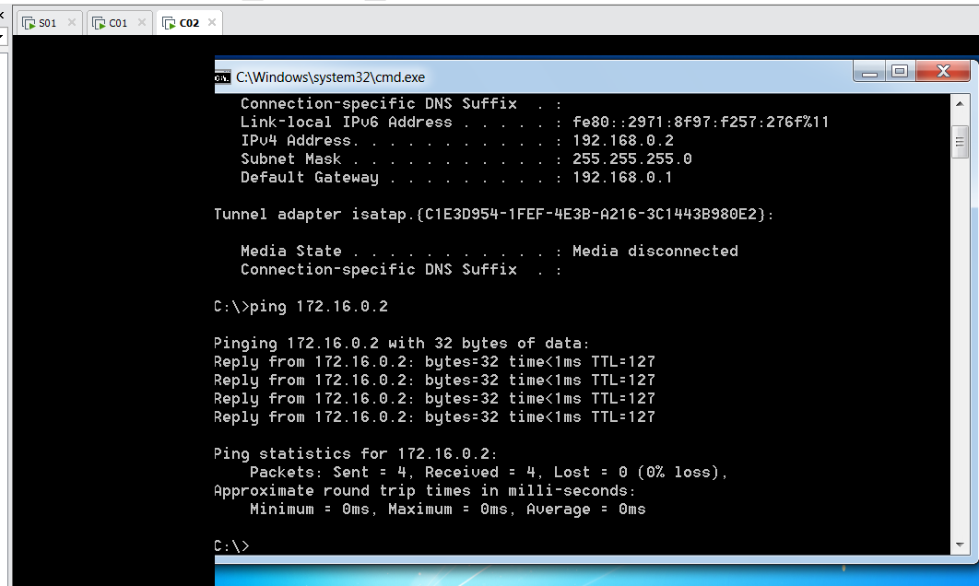

DNS

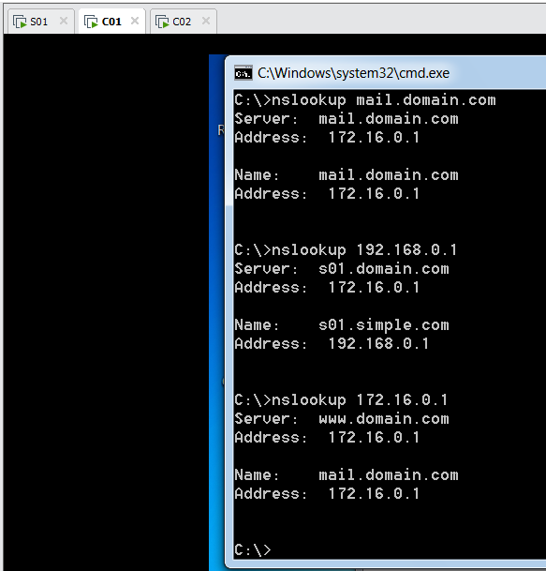

WEB SEVER

MAIL SEVER

