**Library Management System**

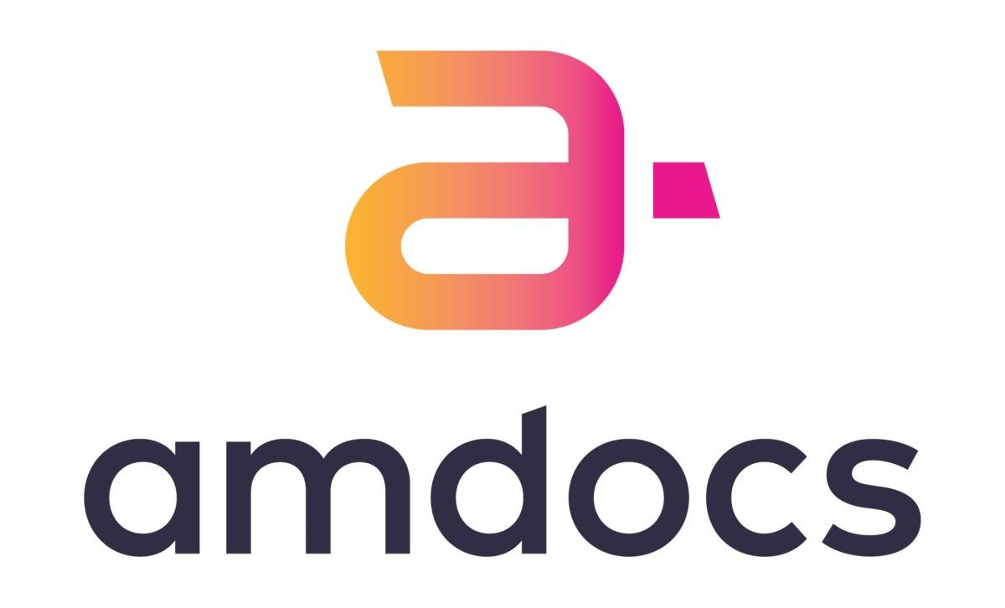

Under The supervision of

**Mr Aliasger Mulla**

**Submitted by – LEKHANA R**

**Employee ID- 200627**

**Table of Contents**

1. Introduction
   1. Purpose of the Document
   2. Project overview
   3. Scope
2. System Requirements
3. Functional Requirements
4. Architecture
   1. High level Architecture
   2. Class Diagram
   3. Sequence Diagrams
5. User Interface
6. Technologies Used
7. Conclusion
8. References

INTRODUCTION

# 

# Purpose of the Document

The purpose of this document is to provide an overview of the library management system project developed using core java and SQL for the database. It outlines the system requirements, architecture , features and user interface.

# Project Overview

Library Management System is an application which refers to library systems which are generally small or medium in size. It is used by librarian to manage the library using a computerized system where he/she can add new books, videos, and Page sources.

Books and student maintenance modules are also included in this system which would keep track of the students using the library and a detailed description about the books a library contains. With this computerized system there will be no loss of book record or member record which generally happens when a non-computerized system is used.

All these modules are able to help librarian to manage the library with more convenience and in a more efficient way as compared to library systems which are not computerized.

# Scope

The scope of the Library Management System project includes the following functionalities:

* Login credential for User
* Add, Delete, Update the book details
* Search the book by Book Id
* Issue the book

SYSTEM REQUIREMENTS

# 

# Functional Requirements

1. Login Credential: The librarian should be able to login with the username and password provided by the campus.

2. Operations by Librarian:

2.1 Add a book

2.2 Delete a book

3.3 Update the book details

3. Search the book: Librarians can search the book-by-book name or author name before issuing the book.

4. Issue the book: Librarians can issue the book if the book quantity is greater than 0.

ARCHITECTURE

# Class Diagram

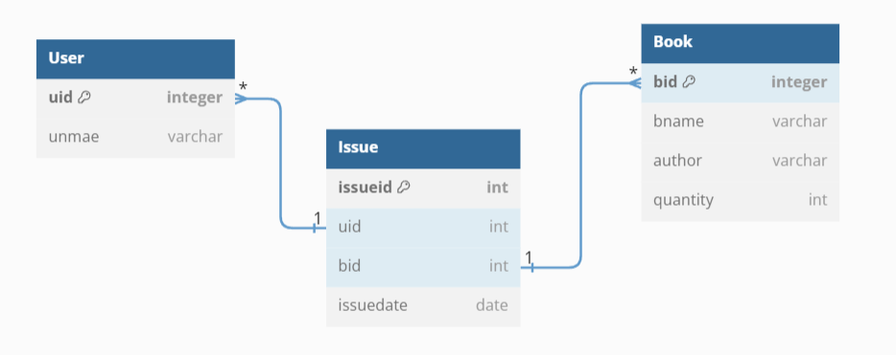

# 

# Sequence Diagram

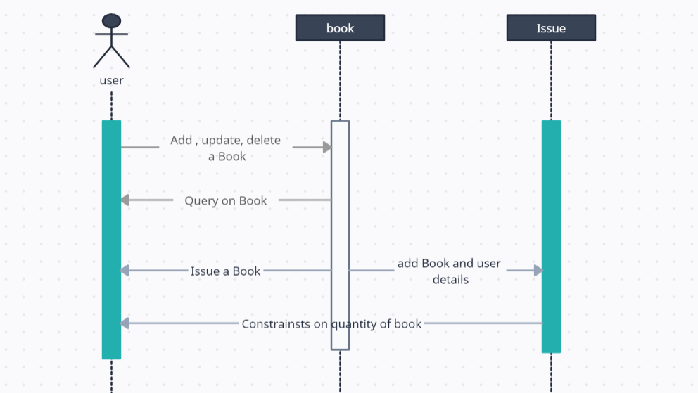

USER INTERFACE

The project uses the terminal to interact with user data and to show it to the user.

The menu gives user option to query and perform activities while the user can exit it with a simple press of a key.

The user must also login using the same terminal to get access to the features of the library management system.

TECHNOLOGIES USED

# Java

Java is a widely used programming language for coding web applications. It has been a popular choice among developers for over two decades, with millions of Java applications in use today.

Java is a multi-platform, object-oriented, and network-centric language that can be used as a platform. It is a fast, secure, reliable programming language for coding everything from mobile apps and enterprise software to big data applications and server-side technologies.

# SQL

MySQL is the world’s most popular open-source database. According to DB-Engines, MySQL ranks as the second-most-popular database, behind Oracle Database. MySQL powers many of the most accessed applications, including Facebook, Twitter, Netflix, Uber, Airbnb, Shopify, and Booking.com.

Since MySQL is open source, it includes numerous features developed in close cooperation with users over more than 25 years. So, it’s very likely that your favorite application or programming language is supported by MySQL Database.

# JDBC

Java™ database connectivity (JDBC) is the Java Soft specification of a standard application programming interface (API) that allows Java programs to access database management systems. The JDBC API consists of a set of interfaces and classes written in the Java programming language.

Using these standard interfaces and classes, programmers can write applications that connect to databases, send queries written in structured query language (SQL), and process the results.

Since JDBC is a standard specification, one Java program that uses the JDBC API can connect to any database management system (DBMS), as long as a driver exists for that particular DBMS.

CONCLUSION

This website provides a computerized version of the library management system which will benefit the students as well as the staff of the library. It makes the entire process online where students can search books, staff can generate reports and do book transactions.

It also has a facility for student login where students can login and can see the status of books issued as well as request for books or give some suggestions. It has a facility of teacher’s login where teachers can add lectures notes and also give necessary suggestions to the library and also add info about workshops or events happening in our college or nearby college in the online notice board.

There is a future scope of this facility that many more features such as online lectures video tutorials can be added by teachers as well as online assignments submission facility, a feature of group chat where students can discuss various issues of engineering can be added to this project thus making it more interactive more user friendly and project which fulfills each users need in the best way possible.