Tạo project

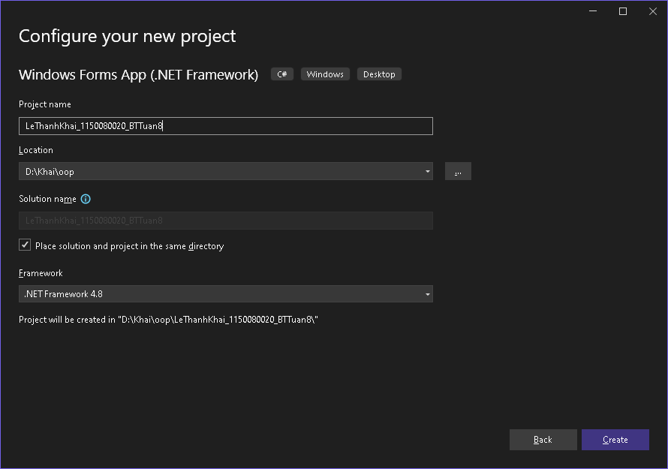

Kết nối CSDL

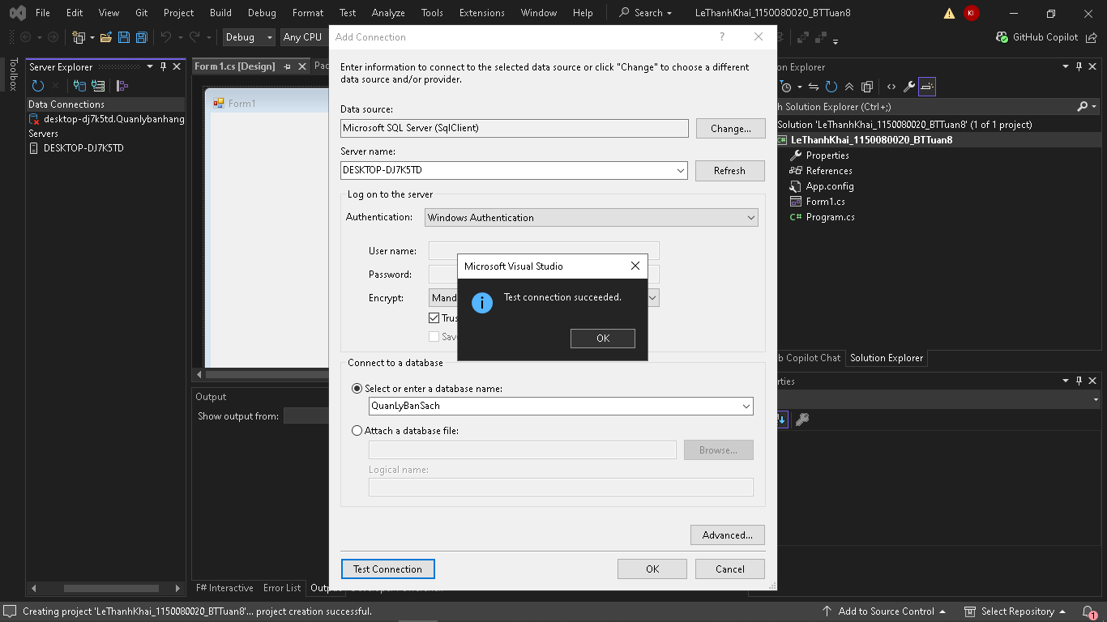

Tạo Procedure

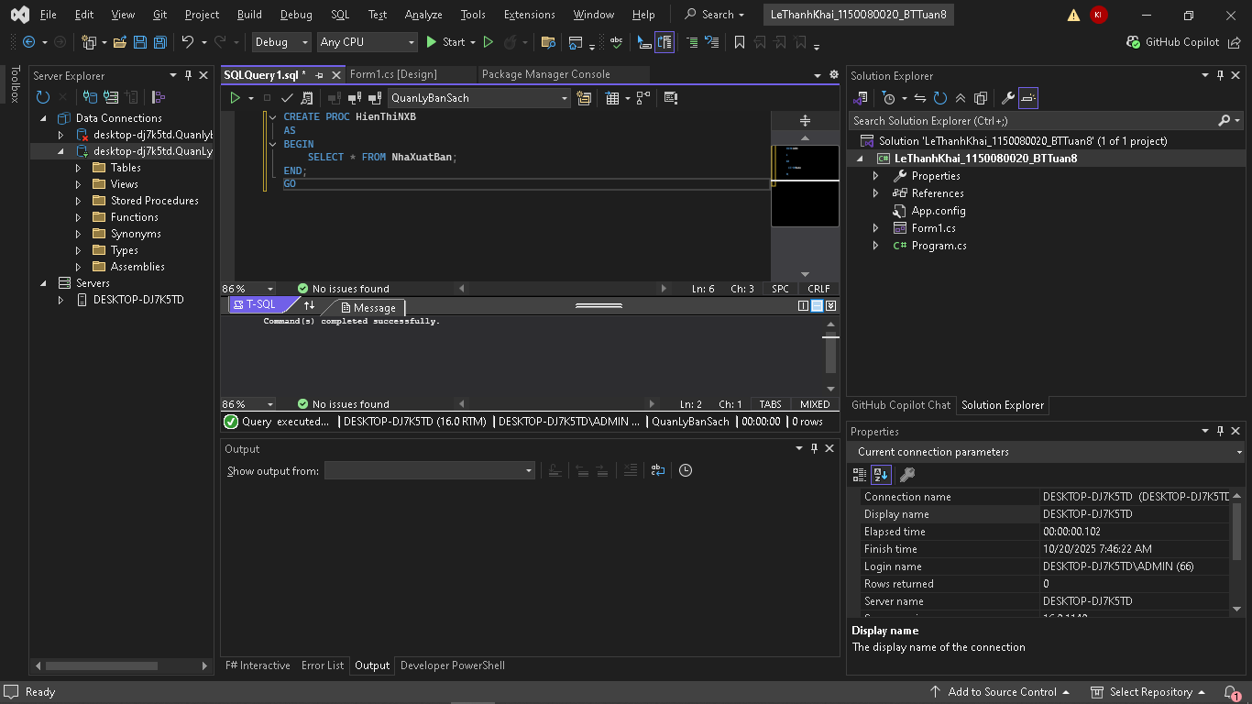

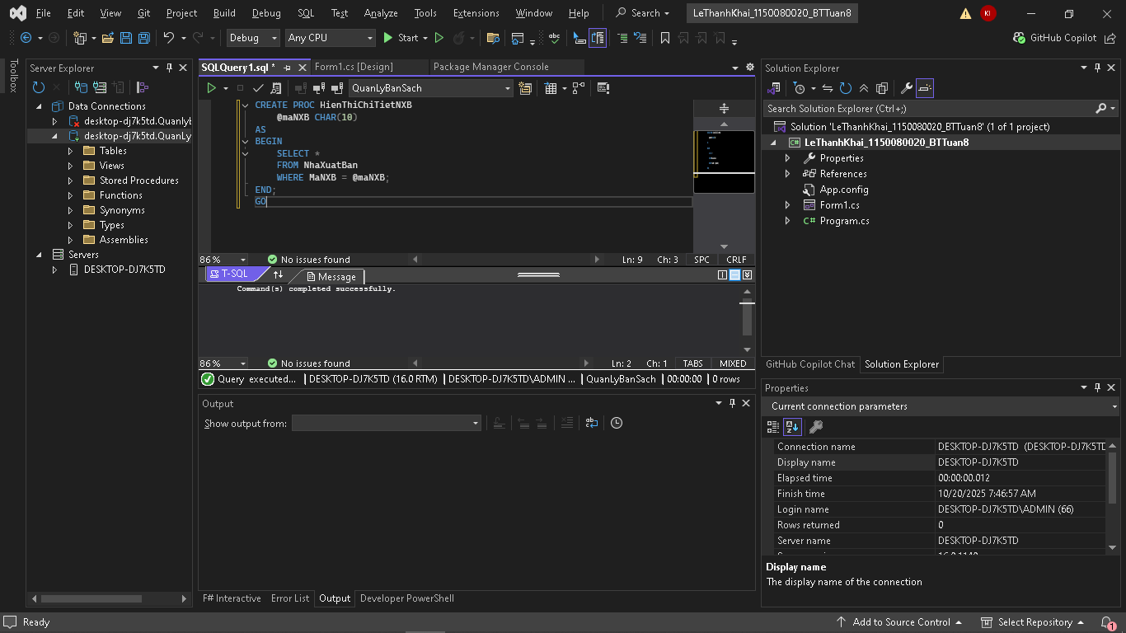

Thực hành 1:

Giao diện:

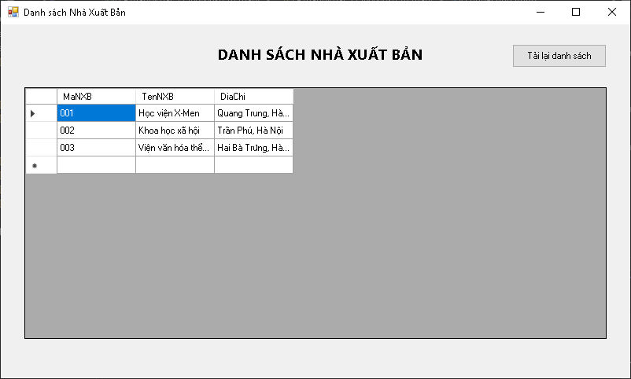

Code Form1.cs:

using System;

using System.Data;

using System.Data.SqlClient;

using System.Windows.Forms;

namespace LeThanhKhai_1150080020_BTTuan8

{

public partial class Form1 : Form

{

private string connectionString = "Data Source=DESKTOP-DJ7K5TD;Initial Catalog=QuanLyBanSach;Integrated Security=True";

public Form1()

{

InitializeComponent();

}

private void Form1_Load(object sender, EventArgs e)

{

LoadNXB();

}

private void LoadNXB()

{

using (SqlConnection conn = new SqlConnection(connectionString))

{

SqlCommand cmd = new SqlCommand("HienThiNXB", conn);

cmd.CommandType = CommandType.StoredProcedure;

SqlDataAdapter da = new SqlDataAdapter(cmd);

DataTable dt = new DataTable();

da.Fill(dt);

dgvNXB.DataSource = dt;

}

}

private void btnTaiLai_Click(object sender, EventArgs e)

{

LoadNXB();

}

}

}

Code Form1.Designer.cs:

namespace LeThanhKhai_1150080020_BTTuan8

{

partial class Form1

{

private System.ComponentModel.IContainer components = null;

protected override void Dispose(bool disposing)

{

if (disposing && (components != null))

{

components.Dispose();

}

base.Dispose(disposing);

}

#region Windows Form Designer generated code

private void InitializeComponent()

{

this.dgvNXB = new System.Windows.Forms.DataGridView();

this.labelTitle = new System.Windows.Forms.Label();

this.btnTaiLai = new System.Windows.Forms.Button();

((System.ComponentModel.ISupportInitialize)(this.dgvNXB)).BeginInit();

this.SuspendLayout();

//

// dgvNXB

//

this.dgvNXB.ColumnHeadersHeightSizeMode = System.Windows.Forms.DataGridViewColumnHeadersHeightSizeMode.AutoSize;

this.dgvNXB.Location = new System.Drawing.Point(30, 80);

this.dgvNXB.Name = "dgvNXB";

this.dgvNXB.Size = new System.Drawing.Size(740, 320);

this.dgvNXB.TabIndex = 0;

//

// labelTitle

//

this.labelTitle.AutoSize = true;

this.labelTitle.Font = new System.Drawing.Font("Segoe UI", 14F, System.Drawing.FontStyle.Bold);

this.labelTitle.Location = new System.Drawing.Point(270, 25);

this.labelTitle.Name = "labelTitle";

this.labelTitle.Size = new System.Drawing.Size(255, 25);

this.labelTitle.TabIndex = 1;

this.labelTitle.Text = "DANH SÁCH NHÀ XUẤT BẢN";

//

// btnTaiLai

//

this.btnTaiLai.Location = new System.Drawing.Point(650, 25);

this.btnTaiLai.Name = "btnTaiLai";

this.btnTaiLai.Size = new System.Drawing.Size(120, 30);

this.btnTaiLai.TabIndex = 2;

this.btnTaiLai.Text = "Tải lại danh sách";

this.btnTaiLai.UseVisualStyleBackColor = true;

this.btnTaiLai.Click += new System.EventHandler(this.btnTaiLai_Click);

//

// Form1

//

this.AutoScaleDimensions = new System.Drawing.SizeF(6F, 13F);

this.AutoScaleMode = System.Windows.Forms.AutoScaleMode.Font;

this.ClientSize = new System.Drawing.Size(800, 450);

this.Controls.Add(this.btnTaiLai);

this.Controls.Add(this.labelTitle);

this.Controls.Add(this.dgvNXB);

this.Name = "Form1";

this.Text = "Danh sách Nhà Xuất Bản";

this.Load += new System.EventHandler(this.Form1_Load);

((System.ComponentModel.ISupportInitialize)(this.dgvNXB)).EndInit();

this.ResumeLayout(false);

this.PerformLayout();

}

#endregion

private System.Windows.Forms.DataGridView dgvNXB;

private System.Windows.Forms.Label labelTitle;

private System.Windows.Forms.Button btnTaiLai;

}

}

Thêm Procedure Thêm nhà xuất bản

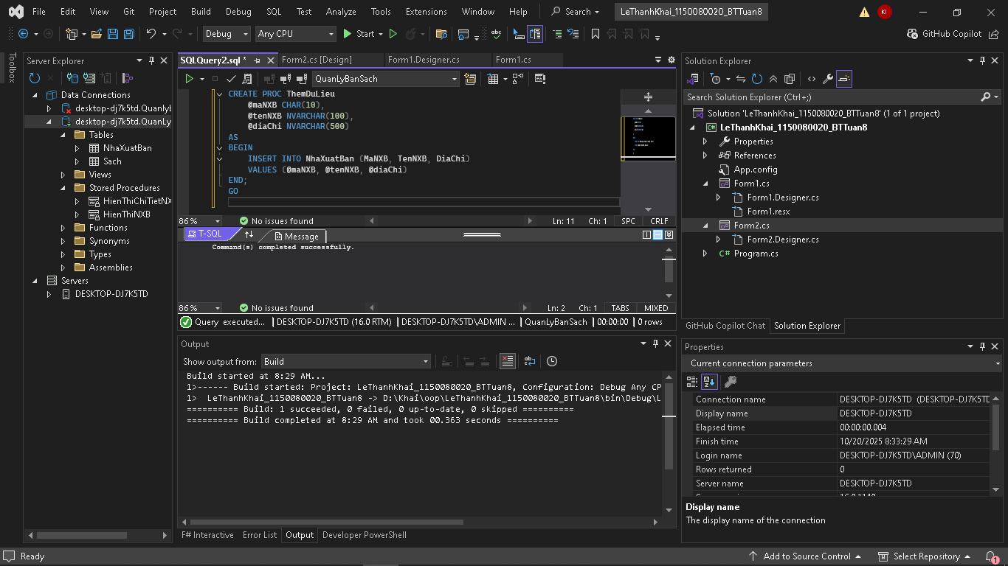

Giao diện:

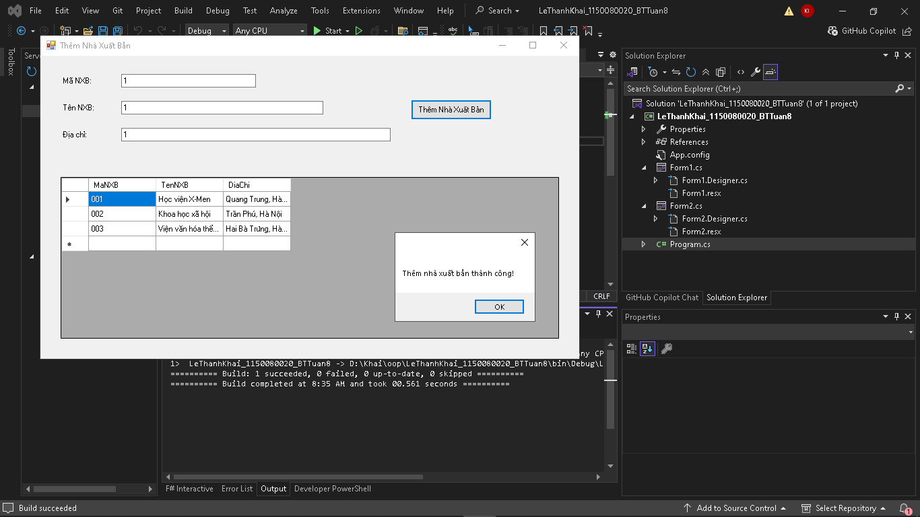

Code Form2.cs:

using System;

using System.Data;

using System.Data.SqlClient;

using System.Windows.Forms;

namespace LeThanhKhai_1150080020_BTTuan8_TH2

{

public partial class Form1 : Form

{

private string connectionString = "Data Source=DESKTOP-DJ7K5TD;Initial Catalog=QuanLyBanSach;Integrated Security=True;Encrypt=False";

public Form1()

{

InitializeComponent();

}

private void Form1_Load(object sender, EventArgs e)

{

LoadNXB();

}

private void LoadNXB()

{

using (SqlConnection conn = new SqlConnection(connectionString))

{

SqlCommand cmd = new SqlCommand("HienThiNXB", conn);

cmd.CommandType = CommandType.StoredProcedure;

SqlDataAdapter da = new SqlDataAdapter(cmd);

DataTable dt = new DataTable();

da.Fill(dt);

dgvNXB.DataSource = dt;

}

}

private void btnThem_Click(object sender, EventArgs e)

{

if (string.IsNullOrWhiteSpace(txtMaNXB.Text) ||

string.IsNullOrWhiteSpace(txtTenNXB.Text) ||

string.IsNullOrWhiteSpace(txtDiaChi.Text))

{

MessageBox.Show("Vui lòng nhập đầy đủ thông tin!");

return;

}

using (SqlConnection conn = new SqlConnection(connectionString))

{

SqlCommand cmd = new SqlCommand("ThemDuLieu", conn);

cmd.CommandType = CommandType.StoredProcedure;

cmd.Parameters.AddWithValue("@maNXB", txtMaNXB.Text.Trim());

cmd.Parameters.AddWithValue("@tenNXB", txtTenNXB.Text.Trim());

cmd.Parameters.AddWithValue("@diaChi", txtDiaChi.Text.Trim());

conn.Open();

cmd.ExecuteNonQuery();

conn.Close();

}

MessageBox.Show("Thêm nhà xuất bản thành công!");

LoadNXB();

}

}

}

Code Form2.Designer.cs

namespace LeThanhKhai_1150080020_BTTuan8_TH2

{

partial class Form1

{

private System.ComponentModel.IContainer components = null;

protected override void Dispose(bool disposing)

{

if (disposing && (components != null))

{

components.Dispose();

}

base.Dispose(disposing);

}

#region Windows Form Designer generated code

private void InitializeComponent()

{

this.dgvNXB = new System.Windows.Forms.DataGridView();

this.label1 = new System.Windows.Forms.Label();

this.label2 = new System.Windows.Forms.Label();

this.label3 = new System.Windows.Forms.Label();

this.txtMaNXB = new System.Windows.Forms.TextBox();

this.txtTenNXB = new System.Windows.Forms.TextBox();

this.txtDiaChi = new System.Windows.Forms.TextBox();

this.btnThem = new System.Windows.Forms.Button();

((System.ComponentModel.ISupportInitialize)(this.dgvNXB)).BeginInit();

this.SuspendLayout();

//

// dgvNXB

//

this.dgvNXB.ColumnHeadersHeightSizeMode = System.Windows.Forms.DataGridViewColumnHeadersHeightSizeMode.AutoSize;

this.dgvNXB.Location = new System.Drawing.Point(30, 180);

this.dgvNXB.Name = "dgvNXB";

this.dgvNXB.Size = new System.Drawing.Size(740, 240);

this.dgvNXB.TabIndex = 0;

//

// label1

//

this.label1.AutoSize = true;

this.label1.Location = new System.Drawing.Point(30, 30);

this.label1.Name = "label1";

this.label1.Size = new System.Drawing.Size(48, 13);

this.label1.TabIndex = 1;

this.label1.Text = "Mã NXB:";

//

// label2

//

this.label2.AutoSize = true;

this.label2.Location = new System.Drawing.Point(30, 70);

this.label2.Name = "label2";

this.label2.Size = new System.Drawing.Size(66, 13);

this.label2.TabIndex = 2;

this.label2.Text = "Tên NXB:";

//

// label3

//

this.label3.AutoSize = true;

this.label3.Location = new System.Drawing.Point(30, 110);

this.label3.Name = "label3";

this.label3.Size = new System.Drawing.Size(47, 13);

this.label3.TabIndex = 3;

this.label3.Text = "Địa chỉ:";

//

// txtMaNXB

//

this.txtMaNXB.Location = new System.Drawing.Point(120, 27);

this.txtMaNXB.Name = "txtMaNXB";

this.txtMaNXB.Size = new System.Drawing.Size(200, 20);

this.txtMaNXB.TabIndex = 4;

//

// txtTenNXB

//

this.txtTenNXB.Location = new System.Drawing.Point(120, 67);

this.txtTenNXB.Name = "txtTenNXB";

this.txtTenNXB.Size = new System.Drawing.Size(300, 20);

this.txtTenNXB.TabIndex = 5;

//

// txtDiaChi

//

this.txtDiaChi.Location = new System.Drawing.Point(120, 107);

this.txtDiaChi.Name = "txtDiaChi";

this.txtDiaChi.Size = new System.Drawing.Size(400, 20);

this.txtDiaChi.TabIndex = 6;

//

// btnThem

//

this.btnThem.Location = new System.Drawing.Point(550, 65);

this.btnThem.Name = "btnThem";

this.btnThem.Size = new System.Drawing.Size(120, 30);

this.btnThem.TabIndex = 7;

this.btnThem.Text = "Thêm Nhà Xuất Bản";

this.btnThem.UseVisualStyleBackColor = true;

this.btnThem.Click += new System.EventHandler(this.btnThem_Click);

//

// Form1

//

this.AutoScaleDimensions = new System.Drawing.SizeF(6F, 13F);

this.AutoScaleMode = System.Windows.Forms.AutoScaleMode.Font;

this.ClientSize = new System.Drawing.Size(800, 450);

this.Controls.Add(this.btnThem);

this.Controls.Add(this.txtDiaChi);

this.Controls.Add(this.txtTenNXB);

this.Controls.Add(this.txtMaNXB);

this.Controls.Add(this.label3);

this.Controls.Add(this.label2);

this.Controls.Add(this.label1);

this.Controls.Add(this.dgvNXB);

this.Name = "Form1";

this.Text = "Thêm Nhà Xuất Bản";

this.Load += new System.EventHandler(this.Form1_Load);

((System.ComponentModel.ISupportInitialize)(this.dgvNXB)).EndInit();

this.ResumeLayout(false);

this.PerformLayout();

}

#endregion

private System.Windows.Forms.DataGridView dgvNXB;

private System.Windows.Forms.Label label1;

private System.Windows.Forms.Label label2;

private System.Windows.Forms.Label label3;

private System.Windows.Forms.TextBox txtMaNXB;

private System.Windows.Forms.TextBox txtTenNXB;

private System.Windows.Forms.TextBox txtDiaChi;

private System.Windows.Forms.Button btnThem;

}

}

Tạo Procedure sửa NXB

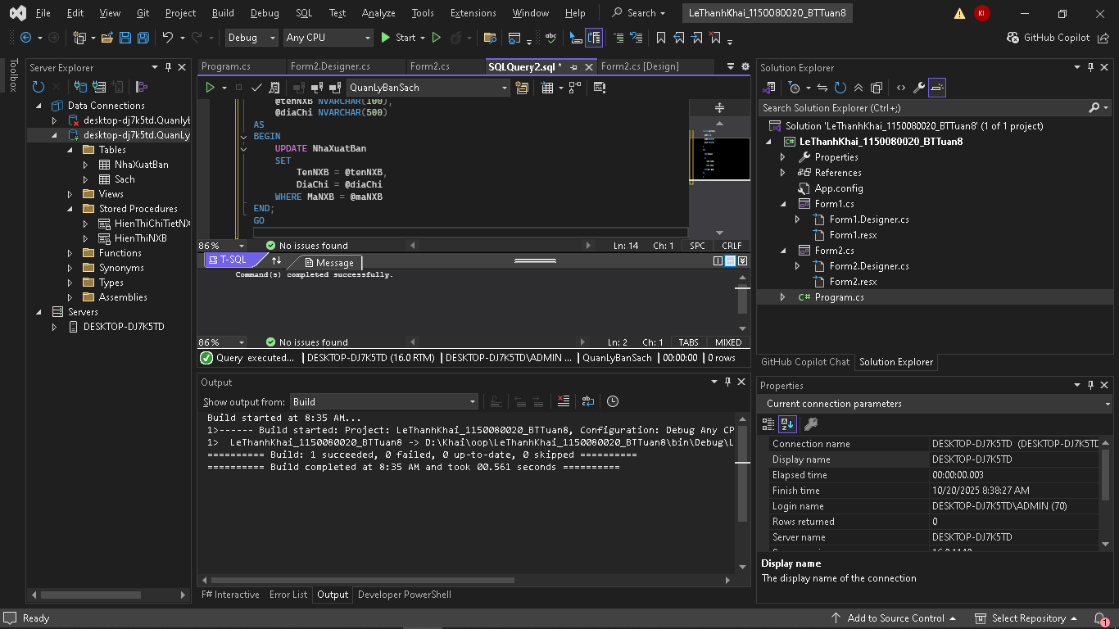

Giao diện:

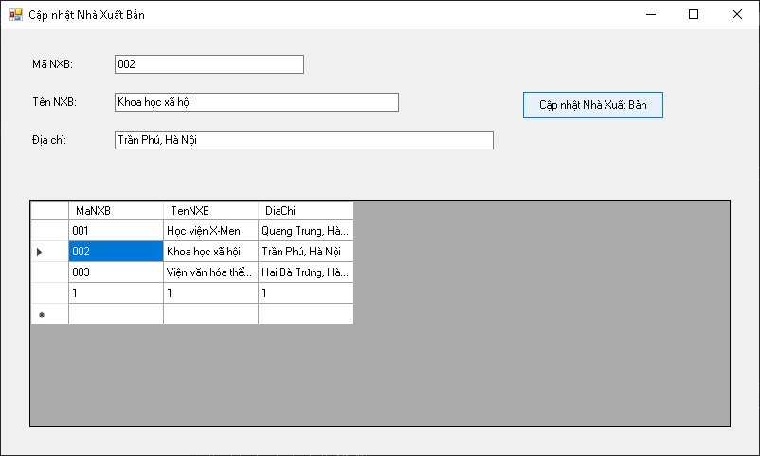

Code Form3.cs

using System;

using System.Data;

using System.Data.SqlClient;

using System.Windows.Forms;

namespace LeThanhKhai_1150080020_BTTuan8_TH3

{

public partial class Form1 : Form

{

private string connectionString = "Data Source=DESKTOP-DJ7K5TD;Initial Catalog=QuanLyBanSach;Integrated Security=True;Encrypt=False";

public Form1()

{

InitializeComponent();

}

private void Form1_Load(object sender, EventArgs e)

{

LoadNXBList();

}

private void LoadNXBList()

{

using (SqlConnection conn = new SqlConnection(connectionString))

{

SqlDataAdapter da = new SqlDataAdapter("SELECT * FROM NhaXuatBan", conn);

DataTable dt = new DataTable();

da.Fill(dt);

dgvNXB.DataSource = dt;

}

}

private void dgvNXB_CellClick(object sender, DataGridViewCellEventArgs e)

{

if (e.RowIndex >= 0)

{

txtMaNXB.Text = dgvNXB.Rows[e.RowIndex].Cells["MaNXB"].Value.ToString();

txtTenNXB.Text = dgvNXB.Rows[e.RowIndex].Cells["TenNXB"].Value.ToString();

txtDiaChi.Text = dgvNXB.Rows[e.RowIndex].Cells["DiaChi"].Value.ToString();

}

}

private void btnCapNhat_Click(object sender, EventArgs e)

{

if (string.IsNullOrWhiteSpace(txtMaNXB.Text))

{

MessageBox.Show("Vui lòng chọn Nhà Xuất Bản cần cập nhật!");

return;

}

using (SqlConnection conn = new SqlConnection(connectionString))

{

SqlCommand cmd = new SqlCommand("CapNhatThongTin", conn);

cmd.CommandType = CommandType.StoredProcedure;

cmd.Parameters.AddWithValue("@maNXB", txtMaNXB.Text.Trim());

cmd.Parameters.AddWithValue("@tenNXB", txtTenNXB.Text.Trim());

cmd.Parameters.AddWithValue("@diaChi", txtDiaChi.Text.Trim());

conn.Open();

cmd.ExecuteNonQuery();

conn.Close();

}

MessageBox.Show("Cập nhật thông tin thành công!");

LoadNXBList();

}

}

}

Code Form3.Designer.cs

namespace LeThanhKhai_1150080020_BTTuan8_TH3

{

partial class Form1

{

private System.ComponentModel.IContainer components = null;

protected override void Dispose(bool disposing)

{

if (disposing && (components != null))

{

components.Dispose();

}

base.Dispose(disposing);

}

#region Windows Form Designer generated code

private void InitializeComponent()

{

this.dgvNXB = new System.Windows.Forms.DataGridView();

this.label1 = new System.Windows.Forms.Label();

this.label2 = new System.Windows.Forms.Label();

this.label3 = new System.Windows.Forms.Label();

this.txtMaNXB = new System.Windows.Forms.TextBox();

this.txtTenNXB = new System.Windows.Forms.TextBox();

this.txtDiaChi = new System.Windows.Forms.TextBox();

this.btnCapNhat = new System.Windows.Forms.Button();

((System.ComponentModel.ISupportInitialize)(this.dgvNXB)).BeginInit();

this.SuspendLayout();

//

// dgvNXB

//

this.dgvNXB.ColumnHeadersHeightSizeMode = System.Windows.Forms.DataGridViewColumnHeadersHeightSizeMode.AutoSize;

this.dgvNXB.Location = new System.Drawing.Point(30, 180);

this.dgvNXB.Name = "dgvNXB";

this.dgvNXB.Size = new System.Drawing.Size(740, 240);

this.dgvNXB.TabIndex = 0;

this.dgvNXB.CellClick += new System.Windows.Forms.DataGridViewCellEventHandler(this.dgvNXB_CellClick);

//

// label1

//

this.label1.AutoSize = true;

this.label1.Location = new System.Drawing.Point(30, 30);

this.label1.Name = "label1";

this.label1.Size = new System.Drawing.Size(48, 13);

this.label1.TabIndex = 1;

this.label1.Text = "Mã NXB:";

//

// label2

//

this.label2.AutoSize = true;

this.label2.Location = new System.Drawing.Point(30, 70);

this.label2.Name = "label2";

this.label2.Size = new System.Drawing.Size(66, 13);

this.label2.TabIndex = 2;

this.label2.Text = "Tên NXB:";

//

// label3

//

this.label3.AutoSize = true;

this.label3.Location = new System.Drawing.Point(30, 110);

this.label3.Name = "label3";

this.label3.Size = new System.Drawing.Size(47, 13);

this.label3.TabIndex = 3;

this.label3.Text = "Địa chỉ:";

//

// txtMaNXB

//

this.txtMaNXB.Location = new System.Drawing.Point(120, 27);

this.txtMaNXB.Name = "txtMaNXB";

this.txtMaNXB.Size = new System.Drawing.Size(200, 20);

this.txtMaNXB.TabIndex = 4;

//

// txtTenNXB

//

this.txtTenNXB.Location = new System.Drawing.Point(120, 67);

this.txtTenNXB.Name = "txtTenNXB";

this.txtTenNXB.Size = new System.Drawing.Size(300, 20);

this.txtTenNXB.TabIndex = 5;

//

// txtDiaChi

//

this.txtDiaChi.Location = new System.Drawing.Point(120, 107);

this.txtDiaChi.Name = "txtDiaChi";

this.txtDiaChi.Size = new System.Drawing.Size(400, 20);

this.txtDiaChi.TabIndex = 6;

//

// btnCapNhat

//

this.btnCapNhat.Location = new System.Drawing.Point(550, 65);

this.btnCapNhat.Name = "btnCapNhat";

this.btnCapNhat.Size = new System.Drawing.Size(150, 30);

this.btnCapNhat.TabIndex = 7;

this.btnCapNhat.Text = "Cập nhật Nhà Xuất Bản";

this.btnCapNhat.UseVisualStyleBackColor = true;

this.btnCapNhat.Click += new System.EventHandler(this.btnCapNhat_Click);

//

// Form1

//

this.AutoScaleDimensions = new System.Drawing.SizeF(6F, 13F);

this.AutoScaleMode = System.Windows.Forms.AutoScaleMode.Font;

this.ClientSize = new System.Drawing.Size(800, 450);

this.Controls.Add(this.btnCapNhat);

this.Controls.Add(this.txtDiaChi);

this.Controls.Add(this.txtTenNXB);

this.Controls.Add(this.txtMaNXB);

this.Controls.Add(this.label3);

this.Controls.Add(this.label2);

this.Controls.Add(this.label1);

this.Controls.Add(this.dgvNXB);

this.Name = "Form1";

this.Text = "Cập nhật Nhà Xuất Bản";

this.Load += new System.EventHandler(this.Form1_Load);

((System.ComponentModel.ISupportInitialize)(this.dgvNXB)).EndInit();

this.ResumeLayout(false);

this.PerformLayout();

}

#endregion

private System.Windows.Forms.DataGridView dgvNXB;

private System.Windows.Forms.Label label1;

private System.Windows.Forms.Label label2;

private System.Windows.Forms.Label label3;

private System.Windows.Forms.TextBox txtMaNXB;

private System.Windows.Forms.TextBox txtTenNXB;

private System.Windows.Forms.TextBox txtDiaChi;

private System.Windows.Forms.Button btnCapNhat;

}

}