pip install folium
Requirement already satisfied: folium in /usr/local/lib/python3.11/dist-packages (0.19.7)
Requirement already satisfied: branca>=0.6.0 in /usr/local/lib/python3.11/dist-packages (from folium) (0.8.1)
Requirement already satisfied: jinja2>=2.9 in /usr/local/lib/python3.11/dist-packages (from folium) (3.1.6)
Requirement already satisfied: numpy in /usr/local/lib/python3.11/dist-packages (from folium) (2.0.2)
Requirement already satisfied: requests in /usr/local/lib/python3.11/dist-packages (from folium) (2.32.3)
Requirement already satisfied: xyzservices in /usr/local/lib/python3.11/dist-packages (from folium) (2025.4.0)
Requirement already satisfied: MarkupSafe>=2.0 in /usr/local/lib/python3.11/dist-packages (from jinja2>=2.9->folium) (3.0.2)
Requirement already satisfied: charset-normalizer<4,>=2 in /usr/local/lib/python3.11/dist-packages (from requests->folium) (3.4.2)
Requirement already satisfied: idna<4,>=2.5 in /usr/local/lib/python3.11/dist-packages (from requests->folium) (3.10)
Requirement already satisfied: urllib3<3,>=1.21.1 in /usr/local/lib/python3.11/dist-packages (from requests->folium) (2.4.0)
Requirement already satisfied: certifi>=2017.4.17 in /usr/local/lib/python3.11/dist-packages (from requests->folium) (2025.4.26)
import pandas as pd
import numpy as np
import matplotlib.pyplot as plt
import seaborn as sns
import plotly.express as px
import plotly.graph_objects as go
from plotly.subplots import make_subplots
import folium
data=pd.read_csv('/content/Uber-Jan-Feb-FOIL.csv')
data.head()
{"summary":"{\n \"name\": \"data\",\n \"rows\": 354,\n \"fields\": [\n {\n \"column\": \"dispatching_base_number\",\n \"properties\": {\n \"dtype\": \"category\",\n \"num_unique_values\": 6,\n \"samples\": [\n \"B02512\",\n \"B02765\",\n \"B02598\"\n ],\n \"semantic_type\": \"\",\n \"description\": \"\"\n }\n },\n {\n \"column\": \"date\",\n \"properties\": {\n \"dtype\": \"object\",\n \"num_unique_values\": 59,\n \"samples\": [\n \"1/1/2015\",\n \"1/6/2015\",\n \"2/4/2015\"\n ],\n \"semantic_type\": \"\",\n \"description\": \"\"\n }\n },\n {\n \"column\": \"active_vehicles\",\n \"properties\": {\n \"dtype\": \"number\",\n \"std\": 1162,\n \"min\": 112,\n \"max\": 4395,\n \"num_unique_values\": 314,\n \"samples\": [\n 1046,\n 234,\n 255\n ],\n \"semantic_type\": \"\",\n \"description\": \"\"\n }\n },\n {\n \"column\": \"trips\",\n \"properties\": {\n \"dtype\": \"number\",\n \"std\": 10648,\n \"min\": 629,\n \"max\": 45858,\n \"num_unique_values\": 348,\n \"samples\": [\n 36844,\n 7206,\n 11720\n ],\n \"semantic_type\": \"\",\n \"description\": \"\"\n }\n }\n ]\n}","type":"dataframe","variable_name":"data"}
data.shape
(354, 4)
data.info()
<class 'pandas.core.frame.DataFrame'>
RangeIndex: 354 entries, 0 to 353
Data columns (total 4 columns):
# Column Non-Null Count Dtype
--- ------ -------------- -----
0 dispatching_base_number 354 non-null object
1 date 354 non-null object
2 active_vehicles 354 non-null int64
3 trips 354 non-null int64
dtypes: int64(2), object(2)
memory usage: 11.2+ KB
data.describe()
{"summary":"{\n \"name\": \"data\",\n \"rows\": 8,\n \"fields\": [\n {\n \"column\": \"active_vehicles\",\n \"properties\": {\n \"dtype\": \"number\",\n \"std\": 1360.9078118550685,\n \"min\": 112.0,\n \"max\": 4395.0,\n \"num_unique_values\": 8,\n \"samples\": [\n 1307.4350282485875,\n 1077.0,\n 354.0\n ],\n \"semantic_type\": \"\",\n \"description\": \"\"\n }\n },\n {\n \"column\": \"trips\",\n \"properties\": {\n \"dtype\": \"number\",\n \"std\": 14705.459824164296,\n \"min\": 354.0,\n \"max\": 45858.0,\n \"num_unique_values\": 8,\n \"samples\": [\n 11667.316384180791,\n 9601.0,\n 354.0\n ],\n \"semantic_type\": \"\",\n \"description\": \"\"\n }\n }\n ]\n}","type":"dataframe"}
data.isnull().sum()
dispatching_base_number 0
date 0
active_vehicles 0
trips 0
dtype: int64
#Conversion of date/time column to datetime object
data['date']=pd.to_datetime(data['date'])
# Extract time components from the 'date' column
data['Hour'] = data['date'].dt.hour
data['Day'] = data['date'].dt.day
data['Month'] = data['date'].dt.month
data['DayOfWeek'] = data['date'].dt.dayofweek # 0=Monday, 6=Sunday
#Removing of duplicates
data = data.dropna()
data = data.drop_duplicates()
data = data.reset_index(drop=True)
print(data.info())
<class 'pandas.core.frame.DataFrame'>
RangeIndex: 354 entries, 0 to 353
Data columns (total 8 columns):
# Column Non-Null Count Dtype
--- ------ -------------- -----
0 dispatching_base_number 354 non-null object
1 date 354 non-null datetime64[ns]
2 active_vehicles 354 non-null int64
3 trips 354 non-null int64
4 Hour 354 non-null int32
5 Day 354 non-null int32
6 Month 354 non-null int32
7 DayOfWeek 354 non-null int32
dtypes: datetime64[ns](1), int32(4), int64(2), object(1)
memory usage: 16.7+ KB
None
EDA(Temporal Analysis)
#Pickups per hour
hourly = data['Hour'].value_counts().sort_index()
plt.figure(figsize=(10, 5))
sns.barplot(x=hourly.index, y=hourly.values, hue=hourly.index, palette='viridis', legend=True) # Changed 'True' to True
plt.title("Pickups per Hour")
plt.xlabel("Hour of the Day")
plt.ylabel("Number of Pickups")
plt.xticks(range(0, 24))
plt.show()
#Pickups per day
daily = data['Day'].value_counts().sort_index()
plt.figure(figsize=(10, 5))
sns.barplot(x=daily.index, y=daily.values, hue=daily.index, palette='rocket', legend=True) # Changed 'True' to True
plt.title("Pickups per Day of the Month")
plt.xlabel("Day")
plt.ylabel("Number of Pickups")
plt.show()
#Pickups per weekday
# 0 = Monday, 6 = Sunday
weekday = data['DayOfWeek'].value_counts().sort_index()
days = ['Mon', 'Tue', 'Wed', 'Thu', 'Fri', 'Sat', 'Sun']
plt.figure(figsize=(10, 5))
sns.barplot(x=days, y=weekday.values, hue=days, palette='coolwarm', legend=True) # Changed 'True' to True
plt.title("Pickups per Day of the Week")
plt.xlabel("Day of the Week")
plt.ylabel("Number of Pickups")
plt.show()
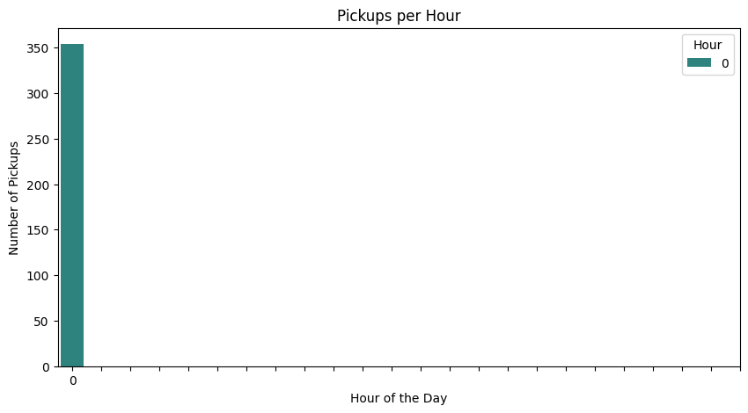
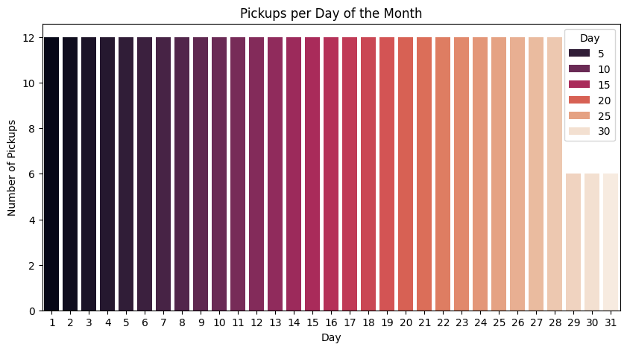
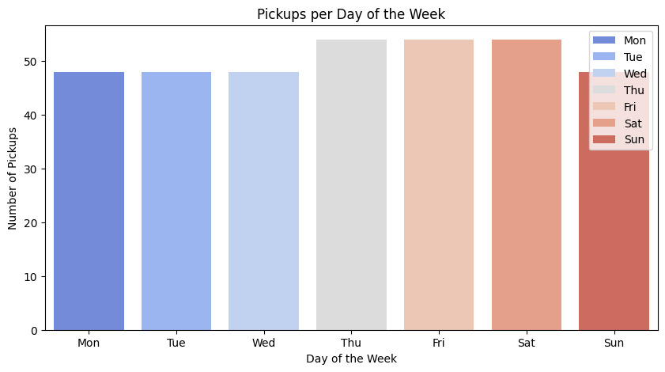
# Create a pivot table with day and hour
heatmap_data = data.groupby(['Day', 'Hour']).size().unstack()
plt.figure(figsize=(12, 6))
sns.heatmap(heatmap_data, cmap="YlGnBu")
plt.title("Heatmap of Pickups: Day vs Hour")
plt.xlabel("Hour of the Day")
plt.ylabel("Day of the Month")
plt.show()
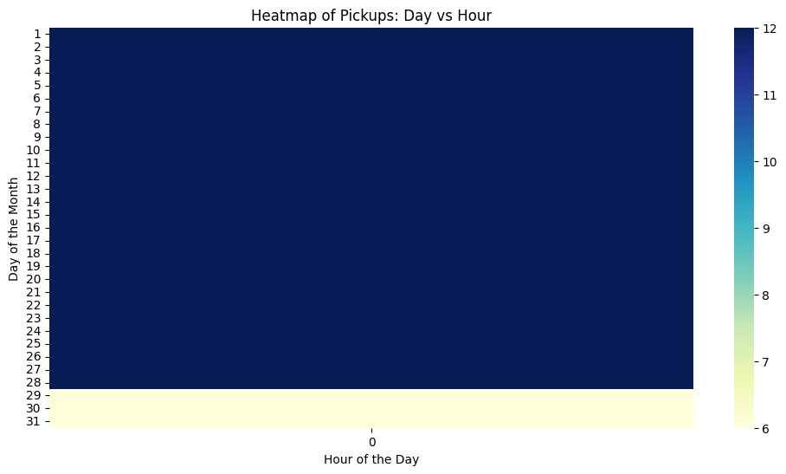
monthly = data['Month'].value_counts().sort_index()
months = ['Jan', 'Feb', 'Mar', 'Apr', 'May', 'Jun',
'Jul', 'Aug', 'Sep', 'Oct', 'Nov', 'Dec']
monthly_df = pd.DataFrame({
'Month': [months[m - 1] for m in monthly.index],
'Count': monthly.values
})
plt.figure(figsize=(10, 5))
sns.barplot(x='Month', y='Count', hue='Month', data=monthly_df, palette='crest', legend=False)
plt.title("Monthly Pickup Trend")
plt.xlabel("Month")
plt.ylabel("Number of Pickups")
plt.show()
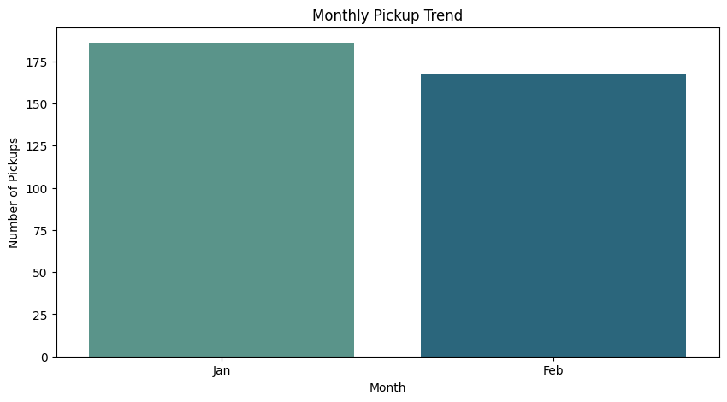
EDA(Spatial Analysis)
data.columns
Index(['dispatching_base_number', 'date', 'active_vehicles', 'trips', 'Hour',
'Day', 'Month', 'DayOfWeek'],
dtype='object')
import folium
from folium.plugins import HeatMap
import pandas as pd
data = pd.read_csv("/content/uber-raw-data-sep14.csv")
# Use the correct column name 'date' as it exists in the CSV file
data['Date/Time'] = pd.to_datetime(data['Date/Time']) # Changed 'Date/Time' to 'date'
data.rename(columns={'Lat': 'Latitude', 'Lon': 'Longitude'}, inplace=True)
print(data[['Latitude', 'Longitude']].head())
Latitude Longitude
0 40.2201 -74.0021
1 40.7500 -74.0027
2 40.7559 -73.9864
3 40.7450 -73.9889
4 40.8145 -73.9444
# Remove rows with missing or invalid coordinates
data = data[(data['Latitude'].between(40.5, 41.0)) & (data['Longitude'].between(-74.3, -73.6))]
#plotting pickups on a folium map
# Center on NYC
nyc_map = folium.Map(location=[40.7128, -74.0060], zoom_start=12)
# Add sample markers (first 100 points to avoid crowding)
for index, row in data.head(100).iterrows():
folium.CircleMarker(
location=[row['Latitude'], row['Longitude']],
radius=2,
color='blue',
fill=True,
fill_opacity=0.5
).add_to(nyc_map)
nyc_map
<folium.folium.Map at 0x77feecc00950>
# Create a heatmap with all pickup points (limit to avoid memory issues)
pickup_locations = data[['Latitude', 'Longitude']].values.tolist()
heat_map = folium.Map(location=[40.7128, -74.0060], zoom_start=12)
HeatMap(pickup_locations[:10000], radius=7, blur=5).add_to(heat_map)
heat_map
<folium.folium.Map at 0x77ff263d5490>
brooklyn_data = data[(data['Latitude'] > 40.65) & (data['Latitude'] < 40.7) &
(data['Longitude'] > -74.0) & (data['Longitude'] < -73.85)]
heat_map
<folium.folium.Map at 0x77ff263d5490>
EDA(Base Analsis)
#Count pickups per base
base_counts = data['Base'].value_counts()
# Plot the counts
plt.figure(figsize=(10, 5))
sns.barplot(x=base_counts.index, y=base_counts.values, hue=base_counts, palette='magma', legend=False)
plt.title("Total Pickups by Base")
plt.xlabel("Base ID")
plt.ylabel("Number of Pickups")
plt.xticks(rotation=45)
plt.tight_layout()
plt.show()
#Time trends for each base
data['Date'] = data['Date/Time'].dt.date
# Group by Date and Base, count number of pickups
daily_base = data.groupby(['Date', 'Base']).size().reset_index(name='Pickups')
#Plot time trends for top 3 bases
# Find top 3 bases
top_bases = base_counts.head(3).index
# Filter data for top bases
filtered = daily_base[daily_base['Base'].isin(top_bases)]
plt.figure(figsize=(12, 6))
for base in top_bases:
subset = filtered[filtered['Base'] == base]
plt.plot(subset['Date'], subset['Pickups'], label=base)
plt.title("Pickup Trends Over Time by Base")
plt.xlabel("Date")
plt.ylabel("Number of Pickups")
plt.xticks(rotation=45)
plt.legend(title="Base")
plt.tight_layout()
plt.show()
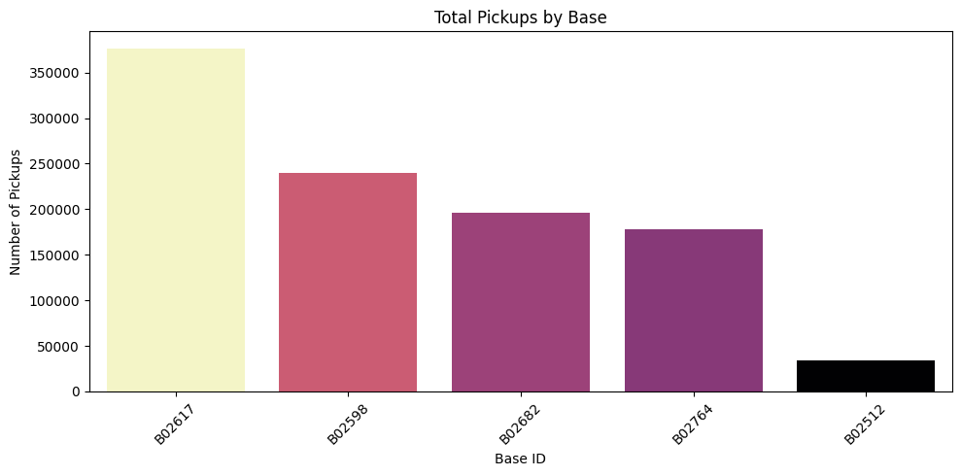
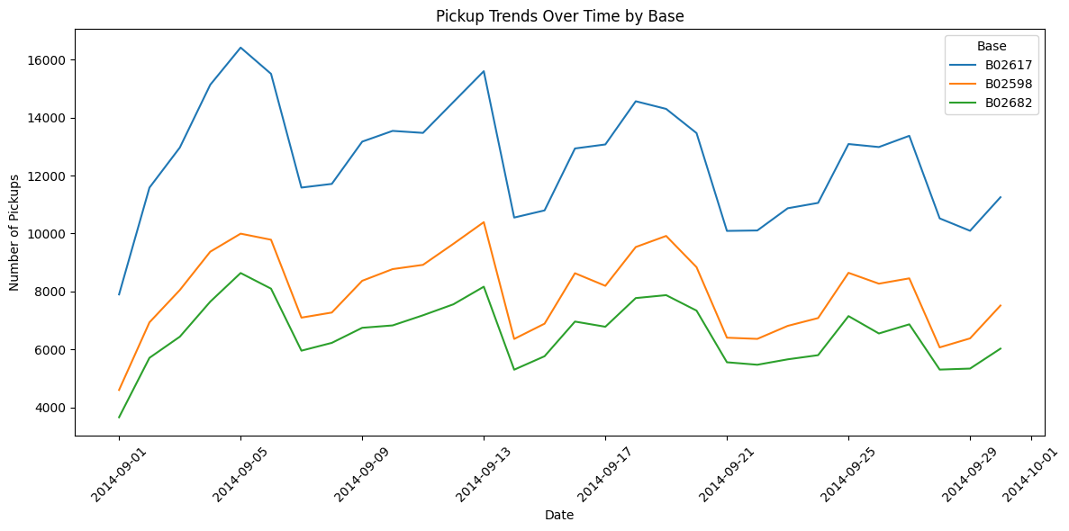

Visualization
#1. Line chart: Hourly Pickups
# Extract hour
data['Hour'] = data['Date/Time'].dt.hour
# Count pickups by hour
hourly = data['Hour'].value_counts().sort_index()
# Plot
plt.figure(figsize=(10, 5))
sns.lineplot(x=hourly.index, y=hourly.values, marker='o')
plt.title("Hourly Uber Pickups")
plt.xlabel("Hour of the Day (0-23)")
plt.ylabel("Number of Pickups")
plt.grid(True)
plt.show()
#2. Bar Plot: Pickups per day of week
# Extract day of the week
data['Weekday'] = data['Date/Time'].dt.day_name()
# Count pickups per weekday
weekday_counts = data['Weekday'].value_counts().reindex([
'Monday', 'Tuesday', 'Wednesday', 'Thursday', 'Friday', 'Saturday', 'Sunday'
])
# Plot
plt.figure(figsize=(10, 5))
sns.barplot(x=weekday_counts.index, y=weekday_counts.values, hue=weekday_counts, palette='viridis')
plt.title("Uber Pickups by Day of the Week")
plt.xlabel("Day of the Week")
plt.ylabel("Number of Pickups")
plt.xticks(rotation=45)
plt.show()
#3. Heatmap: Hour vs Day
# Extract hour and day
data['Day'] = data['Date/Time'].dt.day
# Create pivot table
heatmap_data = data.groupby(['Day', 'Hour']).size().unstack()
# Plot
plt.figure(figsize=(12, 6))
sns.heatmap(heatmap_data, cmap="YlGnBu")
plt.title("Heatmap of Pickups: Day vs Hour")
plt.xlabel("Hour of the Day")
plt.ylabel("Day of the Month")
plt.show()
#4. Geographic Heatmap of Pickup Density
import folium
from folium.plugins import HeatMap
# Convert coordinates to list format
pickup_locations = data[['Latitude', 'Longitude']].dropna().values.tolist()
# Create map centered on NYC
heat_map = folium.Map(location=[40.7128, -74.0060], zoom_start=12)
# Adding of heatmap layer (limited to 10,000 points for performance)
HeatMap(pickup_locations[:10000], radius=7, blur=5).add_to(heat_map)
heat_map
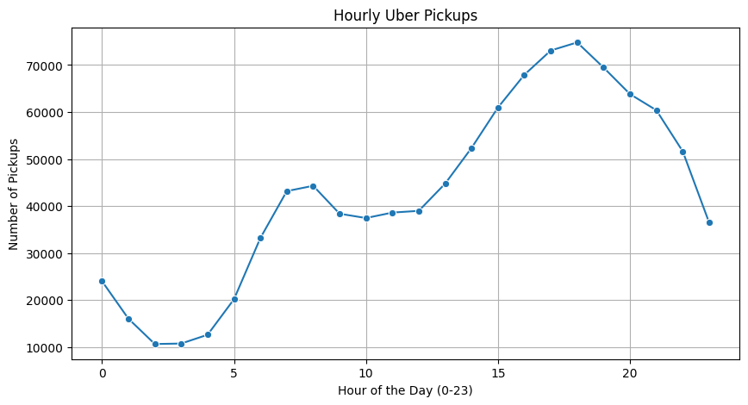
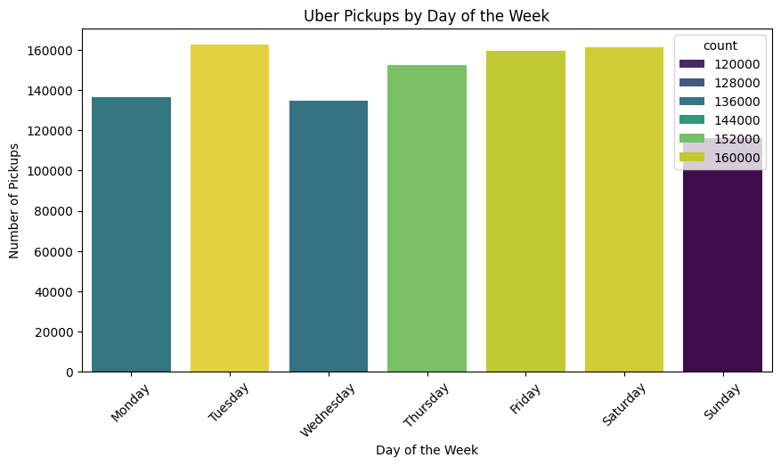
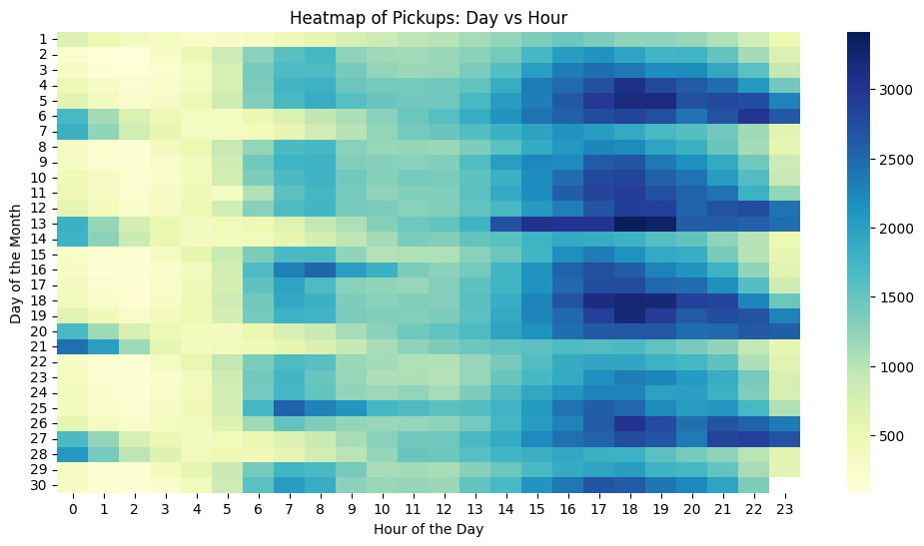
<folium.folium.Map at 0x77fec995dad0>

Feature Engineering
#1. Cluster Pickups Using K-Means
from sklearn.cluster import KMeans
import numpy as np
import matplotlib.pyplot as plt
# Take sample data for faster computation
coords = data[['Latitude', 'Longitude']].dropna().sample(10000, random_state=42)
# Apply K-Means clustering
kmeans = KMeans(n_clusters=5, random_state=42)
kmeans.fit(coords)
# Add cluster labels back to dataframe
coords['Cluster'] = kmeans.labels_
# Plot clusters
plt.figure(figsize=(10, 8))
sns.scatterplot(data=coords, x='Longitude', y='Latitude', hue='Cluster', palette='tab10', s=10)
plt.title("K-Means Clustering of Pickup Locations (5 Zones)")
plt.xlabel("Longitude")
plt.ylabel("Latitude")
plt.legend(title="Cluster")
plt.show()
#2. Applying Haverine Distance
import numpy as np
def haversine(lat1, lon1, lat2, lon2):
R = 6371 # Earth radius in km
phi1 = np.radians(lat1)
phi2 = np.radians(lat2)
d_phi = np.radians(lat2 - lat1)
d_lambda = np.radians(lon2 - lon1)
a = np.sin(d_phi/2)**2 + np.cos(phi1)*np.cos(phi2)*np.sin(d_lambda/2)**2
c = 2 * np.arctan2(np.sqrt(a), np.sqrt(1 - a))
return R * c # Distance in km
# Times Square coordinates
ref_lat, ref_lon = 40.7580, -73.9855
# Apply haversine distance to all points
data['Distance_km'] = data.apply(lambda row: haversine(ref_lat, ref_lon, row['Latitude'], row['Longitude']), axis=1)
# Histogram of distances
plt.figure(figsize=(10, 5))
sns.histplot(data['Distance_km'], bins=50, kde=True)
plt.title("Distribution of Pickup Distances from Times Square")
plt.xlabel("Distance (km)")
plt.ylabel("Number of Pickups")
plt.show()
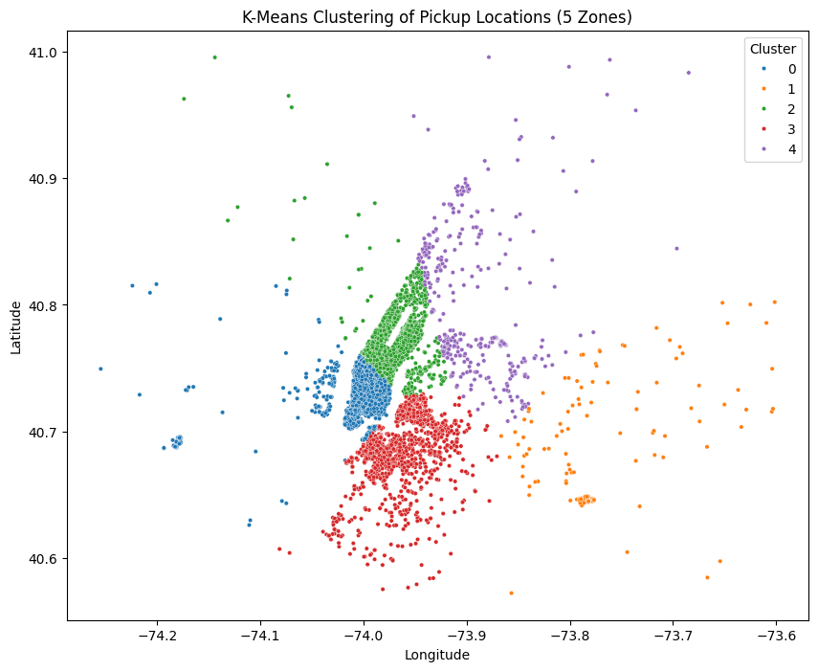
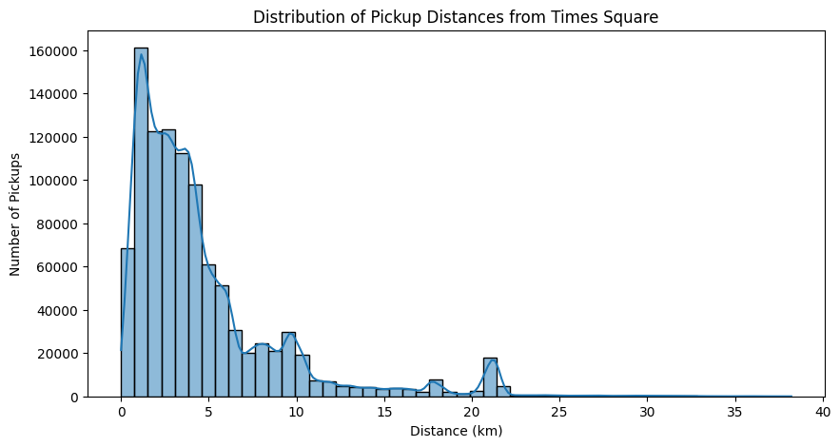

Predictive Modelling
data['Date/Time'] = pd.to_datetime(data['Date/Time'])
# Extract features
data['Hour'] = data['Date/Time'].dt.hour
data['Day'] = data['Date/Time'].dt.day
data['Weekday'] = data['Date/Time'].dt.weekday # 0=Monday
data['Month'] = data['Date/Time'].dt.month
# Round datetime to hourly buckets
data['Datetime_Hour'] = data['Date/Time'].dt.floor('h')
# Group data to get hourly pickup counts
grouped = data.groupby(['Datetime_Hour', 'Hour', 'Day', 'Weekday', 'Month']).size().reset_index(name='Pickup_Count')
from sklearn.model_selection import train_test_split
# Define features and target
X = grouped[['Hour', 'Day', 'Weekday', 'Month']]
y = grouped['Pickup_Count']
# Split into training and test sets
X_train, X_test, y_train, y_test = train_test_split(X, y, test_size=0.2, random_state=42)
#1. Linear Regression
from sklearn.linear_model import LinearRegression
from sklearn.metrics import mean_squared_error
lr = LinearRegression()
lr.fit(X_train, y_train)
y_pred_lr = lr.predict(X_test)
print("Linear Regression RMSE:", mean_squared_error(y_test, y_pred_lr))
#2. Random Forest Regressor
from sklearn.ensemble import RandomForestRegressor
rf = RandomForestRegressor(n_estimators=100, random_state=42)
rf.fit(X_train, y_train)
y_pred_rf = rf.predict(X_test)
print("Random Forest RMSE:", mean_squared_error(y_test, y_pred_rf))
#3.XGBoost Regressor
from xgboost import XGBRegressor
xgb = XGBRegressor(n_estimators=100, learning_rate=0.1, random_state=42)
xgb.fit(X_train, y_train)
y_pred_xgb = xgb.predict(X_test)
print("XGBoost RMSE:", mean_squared_error(y_test, y_pred_xgb))
#Visualizing Predictions
import matplotlib.pyplot as plt
plt.figure(figsize=(10, 5))
plt.plot(y_test.values[:100], label='Actual', marker='o')
plt.plot(y_pred_rf[:100], label='Predicted (RF)', marker='x')
plt.title("Predicted vs Actual Pickup Counts")
plt.xlabel("Sample Index")
plt.ylabel("Pickup Count")
plt.legend()
plt.grid(True)
plt.tight_layout()
plt.show()
Linear Regression RMSE: 318433.54151531396
Random Forest RMSE: 21639.39771180555
XGBoost RMSE: 11536.37109375
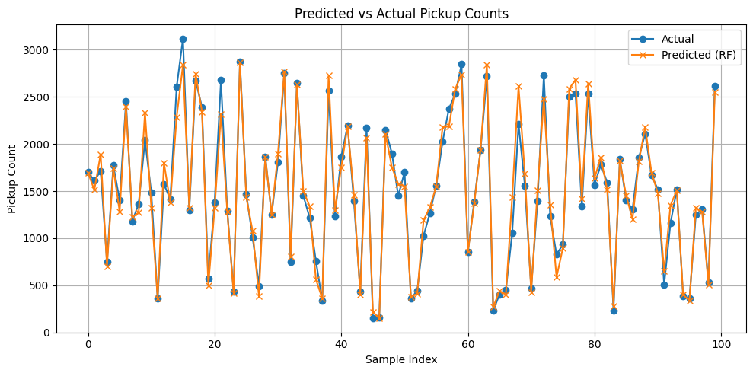

Insights
#1. Estimating the peak pickup hours
import pandas as pd
import seaborn as sns
import matplotlib.pyplot as plt
data['Date/Time'] = pd.to_datetime(data['Date/Time'])
data['Hour'] = data['Date/Time'].dt.hour
# Plot pickups by hour
plt.figure(figsize=(12, 6))
sns.countplot(x='Hour', data=data, hue='Hour', palette='viridis')
plt.title('Uber Pickups by Hour of the Day')
plt.xlabel('Hour of Day (0-23)')
plt.ylabel('Number of Pickups')
plt.show()
#2. Estimating which weekdays have higher demand
data['Weekday'] = data['Date/Time'].dt.day_name()
plt.figure(figsize=(12, 6))
sns.countplot(x='Weekday', data=data,
order=['Monday', 'Tuesday', 'Wednesday', 'Thursday', 'Friday', 'Saturday', 'Sunday'], hue='Weekday',
palette='coolwarm')
plt.title('Uber Pickups by Day of the Week')
plt.xlabel('Day of the Week')
plt.ylabel('Number of Pickups')
plt.show()
#3. How can Uber better allocate drivers?
from sklearn.model_selection import train_test_split
from xgboost import XGBRegressor
from sklearn.metrics import mean_squared_error
# Group by hour and weekday
data['Weekday_num'] = data['Date/Time'].dt.weekday
hourly_data = data.groupby(['Hour', 'Weekday_num']).size().reset_index(name='Pickups')
X = hourly_data[['Hour', 'Weekday_num']]
y = hourly_data['Pickups']
X_train, X_test, y_train, y_test = train_test_split(X, y, test_size=0.2, random_state=42)
model = XGBRegressor(n_estimators=100, learning_rate=0.1)
model.fit(X_train, y_train)
y_pred = model.predict(X_test)
rmse = mean_squared_error(y_test, y_pred)
print("RMSE of pickup prediction model:", rmse)
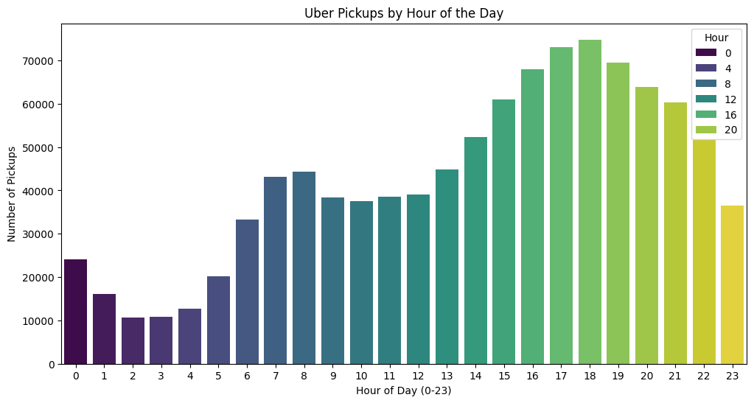
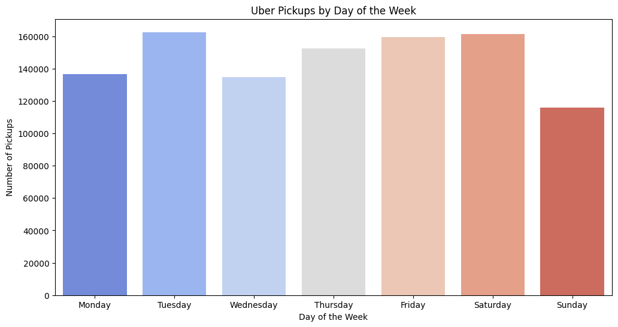
RMSE of pickup prediction model: 361904.65625
#4. Any specific zones with higher concentration of pickups
import folium
from folium.plugins import HeatMap
import matplotlib.pyplot as plt
%matplotlib inline
# Filter to remove invalid coordinates
location_data = data[['Latitude', 'Longitude']].dropna()
location_data = location_data[(location_data['Latitude'] > 40) & (location_data['Latitude'] < 41)]
location_data = location_data[(location_data['Longitude'] > -75) & (location_data['Longitude'] < -72)]
# Heatmap
base_map = folium.Map(location=[40.75, -73.97], zoom_start=11)
HeatMap(data=location_data.values.tolist(), radius=8).add_to(base_map)
base_map
Output hidden; open in https://colab.research.google.com to view.

