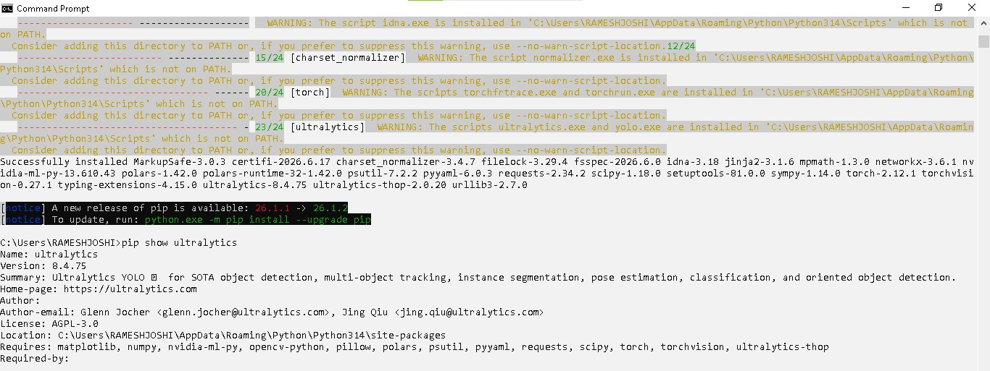
Successful installation and package verification using Command Prompt.

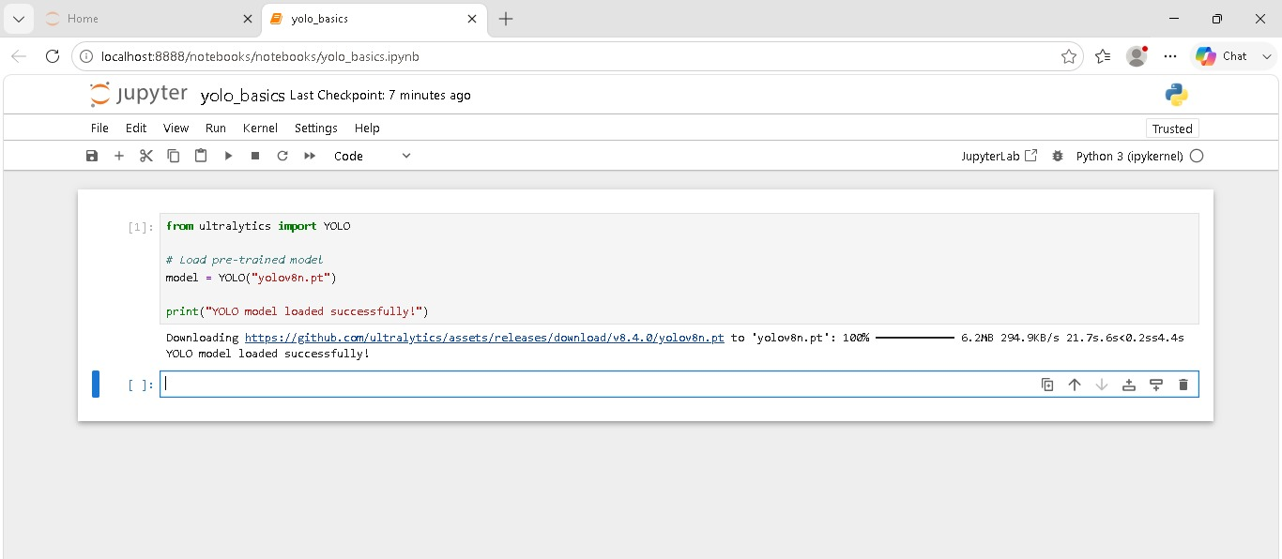
Downloading and initializing the YOLOv8n model for object detection tasks.

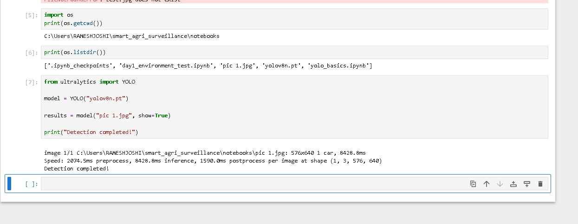
Running YOLOv8 on an image and displaying detection results in Jupyter Notebook.

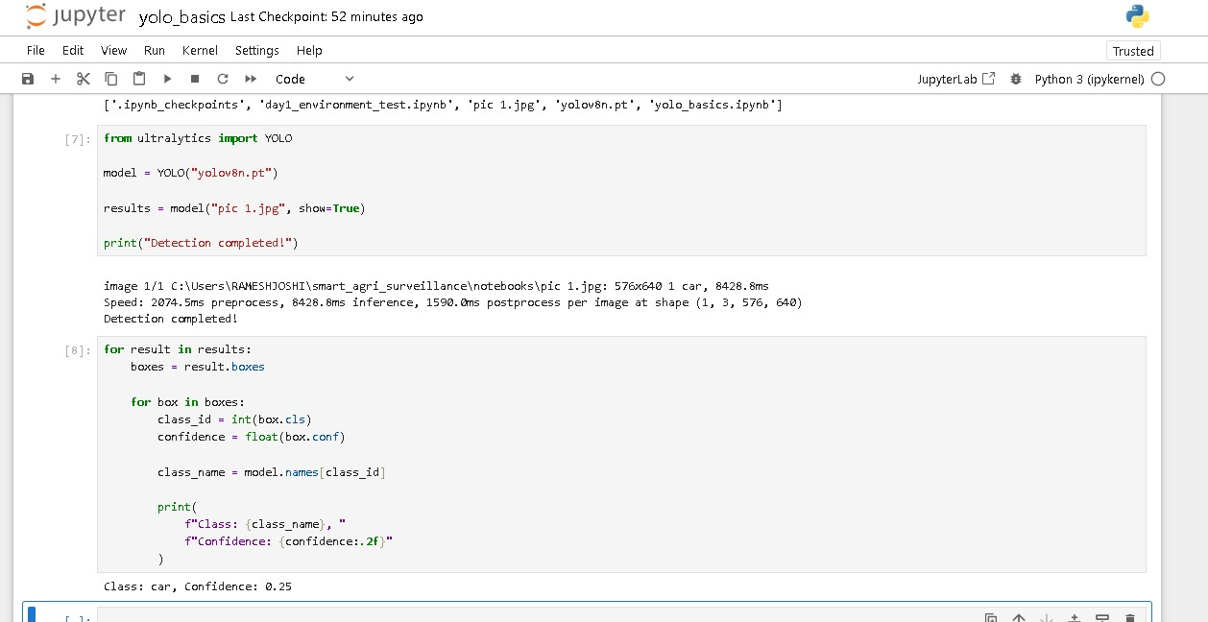
Object detection has been completed according to the given rules.

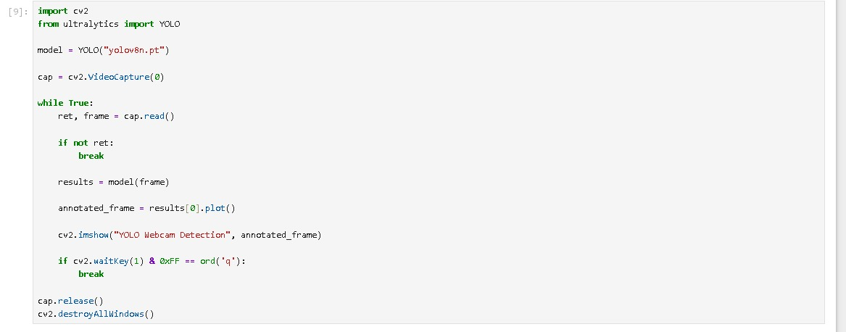
Implementation of YOLOv8 with OpenCV for live object detection.

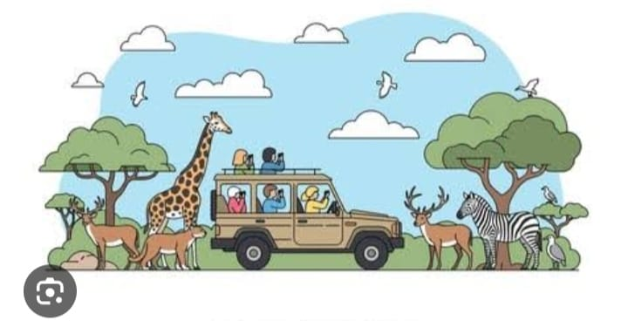
Safari wildlife image used for object detection testing.

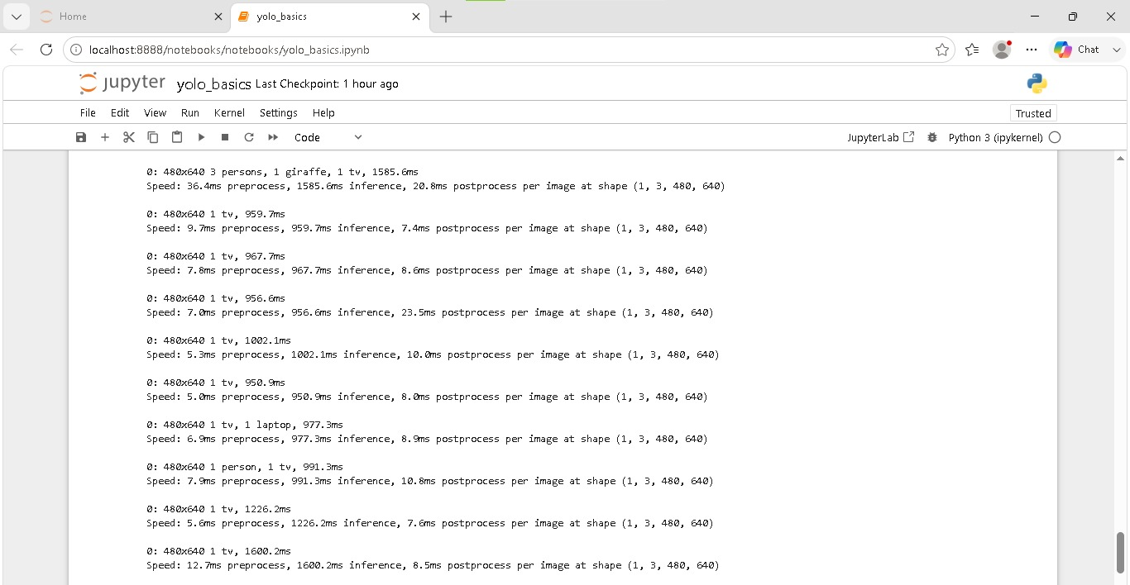
Real-time object recognition and performance analysis in Jupyter Notebook.

