

**FPT International School**

--- o0o ---

**PROJECT REPORT**

**Online Order for digital printing of Photos**

Batch: T1711E

Semester: 4

Group: Group 6

1. Le Khanh Sinh – D00672
2. Nguyen Tien Hoang – D00656
3. Bui Nguyen Thang – D00685

Instructor : Nguyen Tuan

**Hanoi –30 /12/2019**

1. **Introduction of online for digital printing of photos**

Trang web in ảnh này cho phép người dùng đăng ảnh lên trang web và yêu cầu website in ảnh theo yêu cầu người dùng . Người dùng có thể yêu cầu ảnh theo những mục như là số lượng , kích thước , chất liệu để in ảnh.

Source code:

1. **Analysis Project**

In the split system are 2 users. An individual user uses the website to print photos and the other user is the website manager.

1.For users

* Before you want to use the website to print the photo users must register the account to be able to use the functions of the website.
* After logging the user can do the functions in the website such as posting photos, order photos on demand,
* First in the folder the user can post their favorite photo to the site
* Then add the photo you want to print to the shopping cart item along with the requirements like number of sizes and material to print the photo
* Finally, the user orders the item and confirms it

2. For the Webite Manager

* Before entering the manager must log in to control the input
* After login the manager has the right to view and edit order users, photos, order orders,.....
* Can create more managers

1. **Implementation Environment**

Front-End:

-React-JS, Apollo , Redux , Antdesign

Back-End:

-NodeJs , Apollo , Expressjs , Mongoose

Database:

-MongoDB

Requiements: Nodejs, visual studio code

1. **Instructions:**

Please read README.md file.

1. **System Stucture**
2. Customer
3. Order

3.Employee

4.Image

5. Service

1. **Design and Display**

**1.ClientUser**

**Login and Register.**

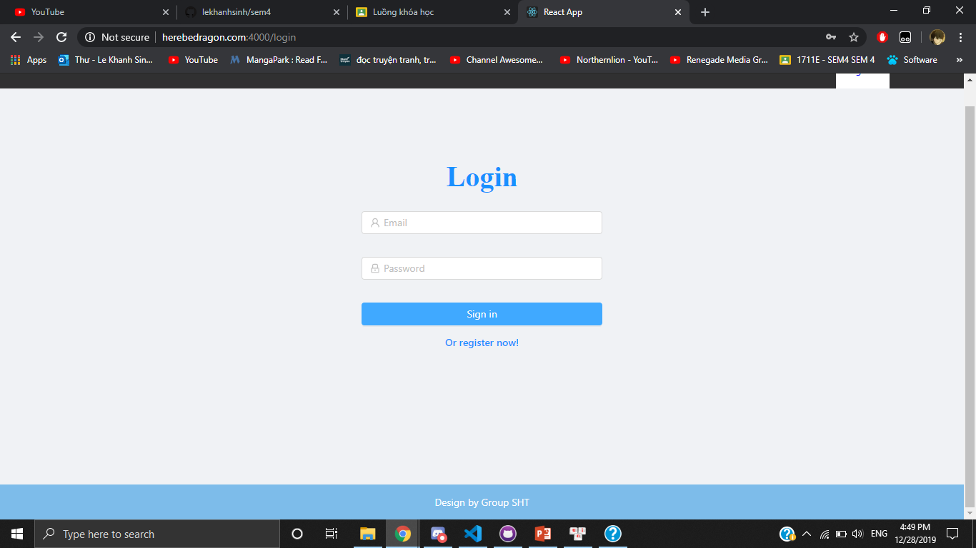

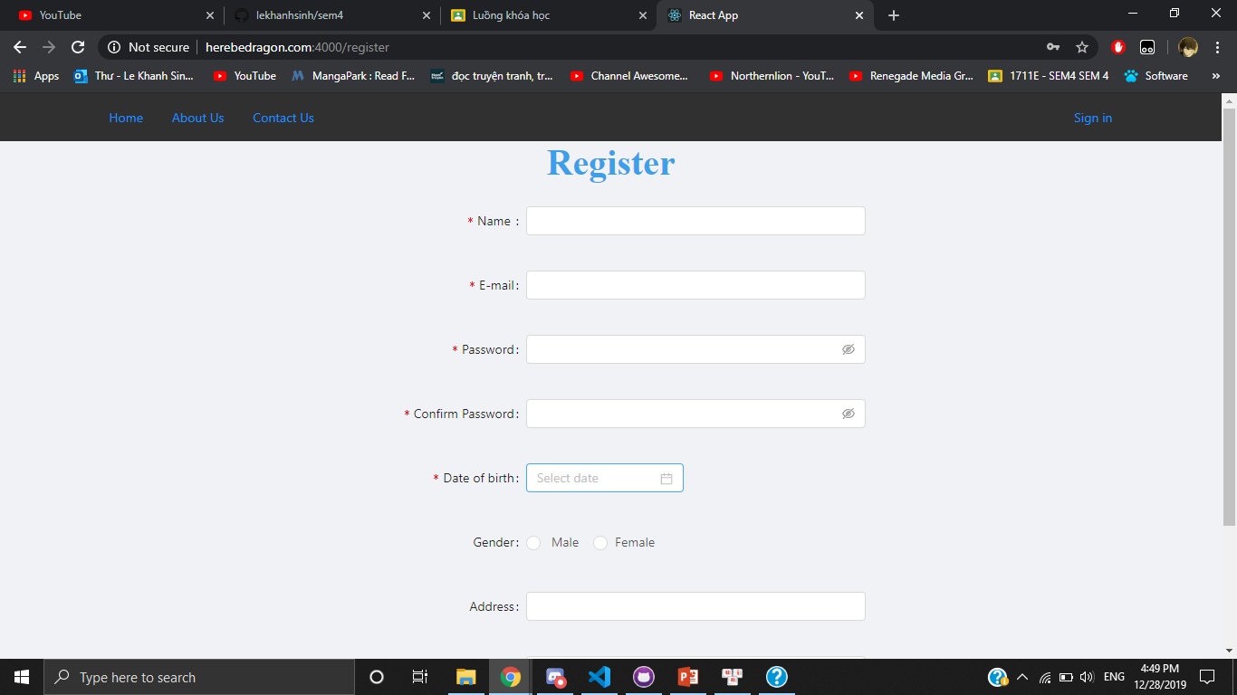

**HomePage**

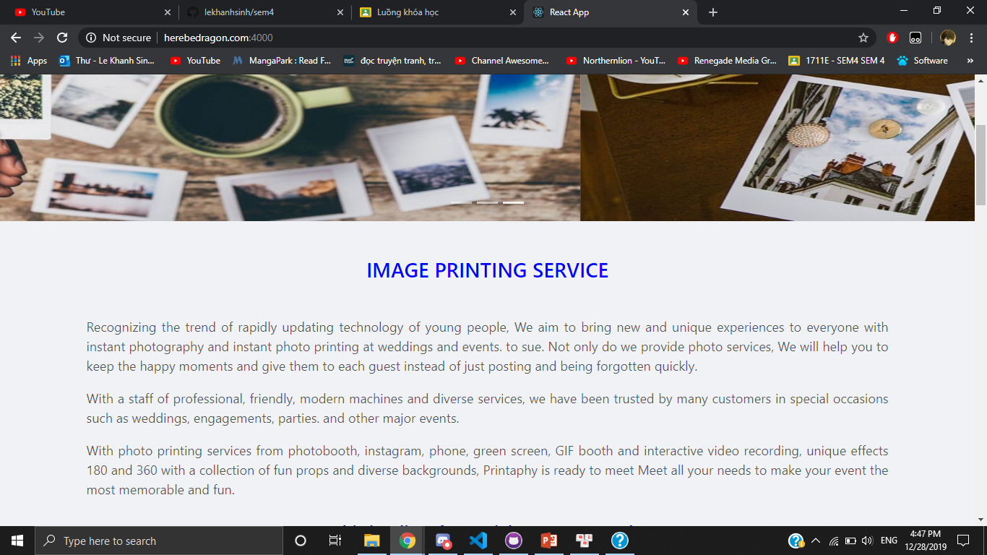

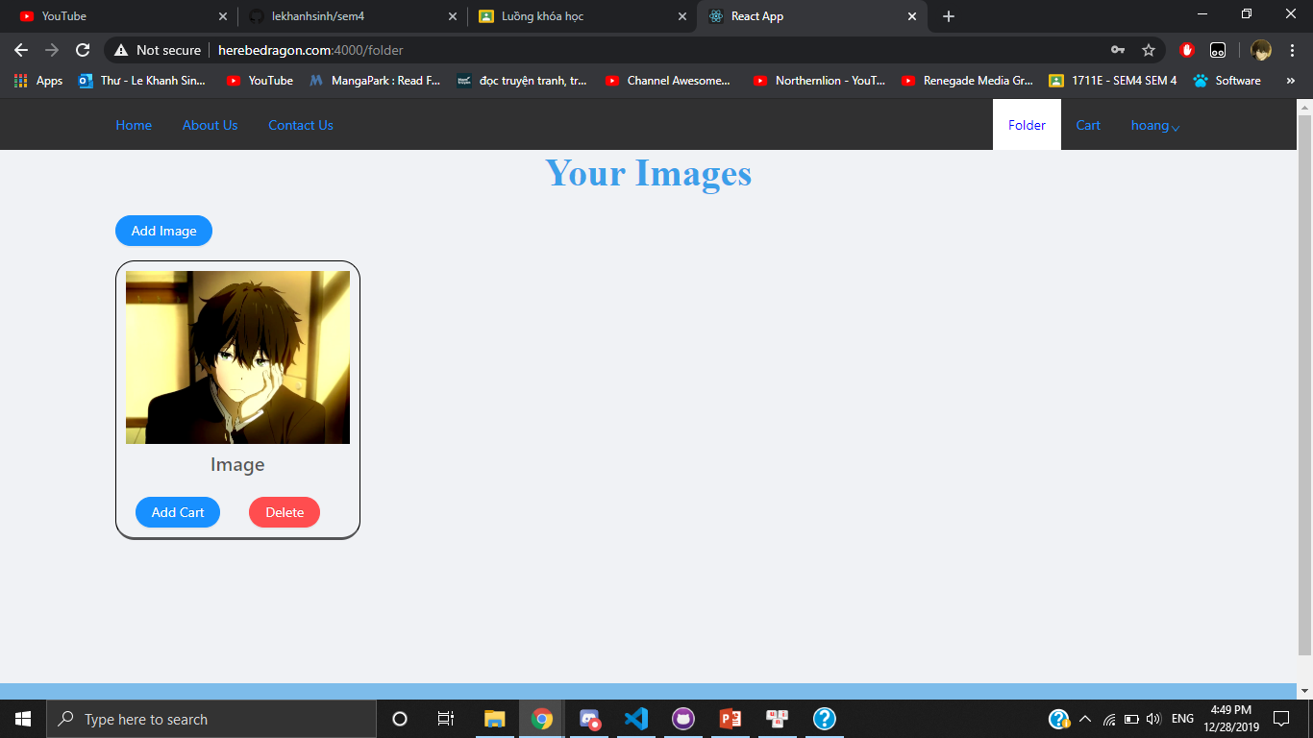

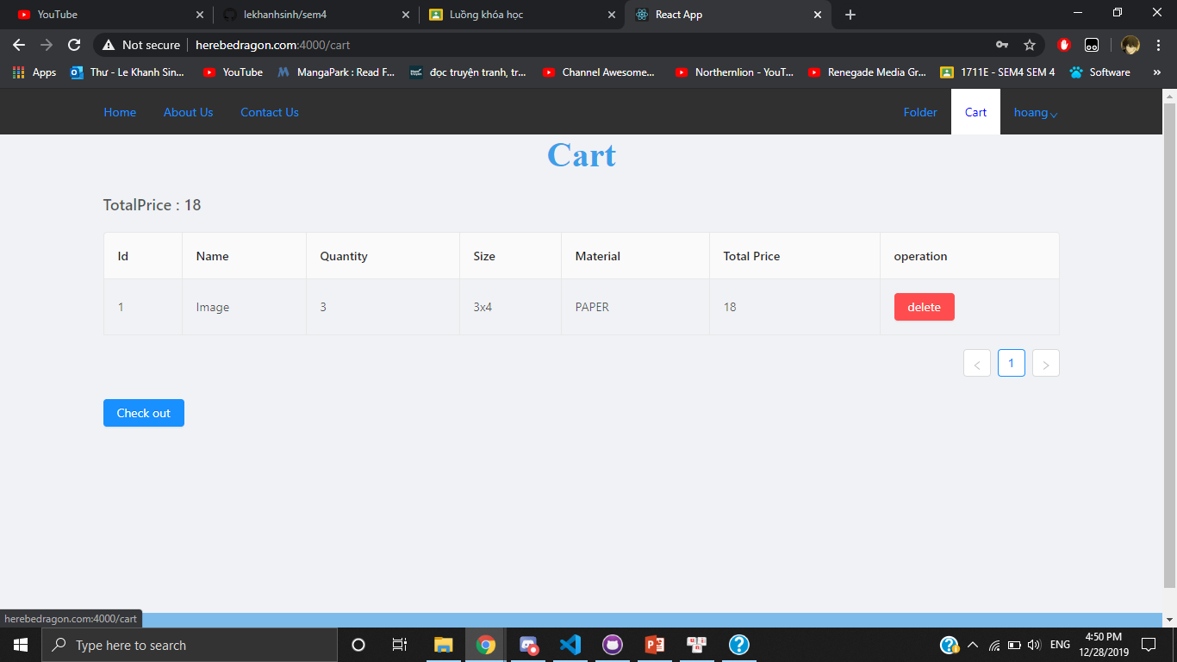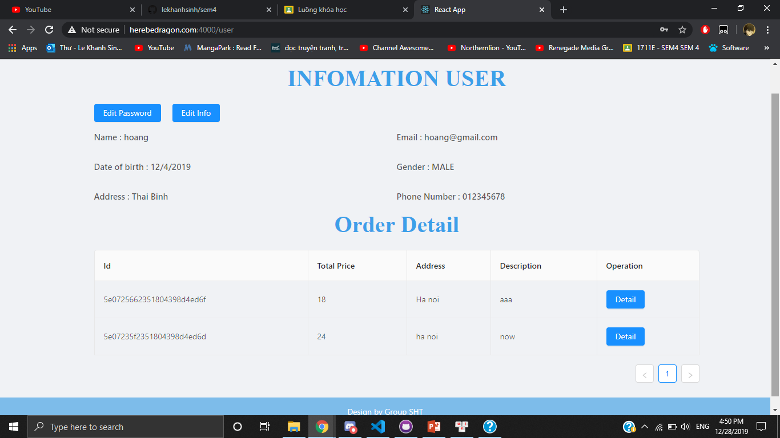

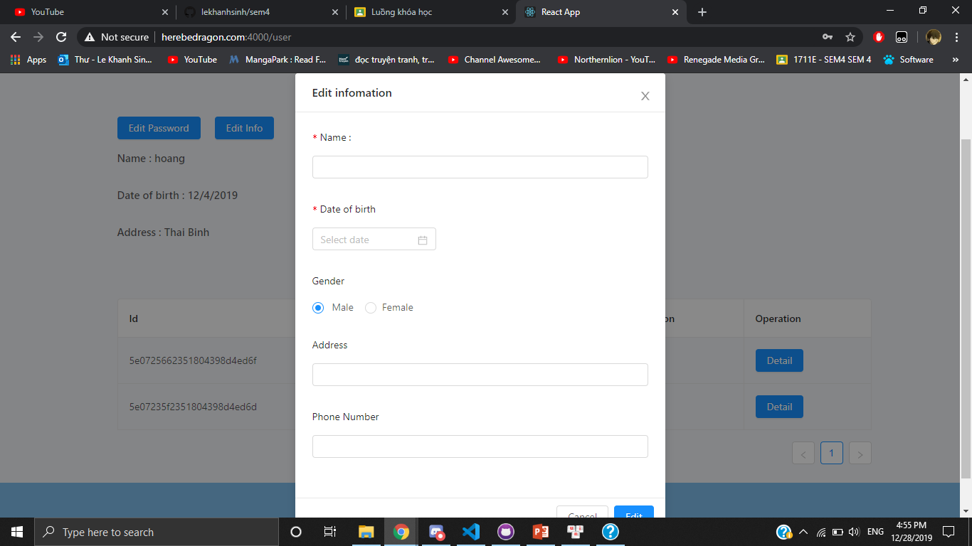

**2.ClienAdmin**

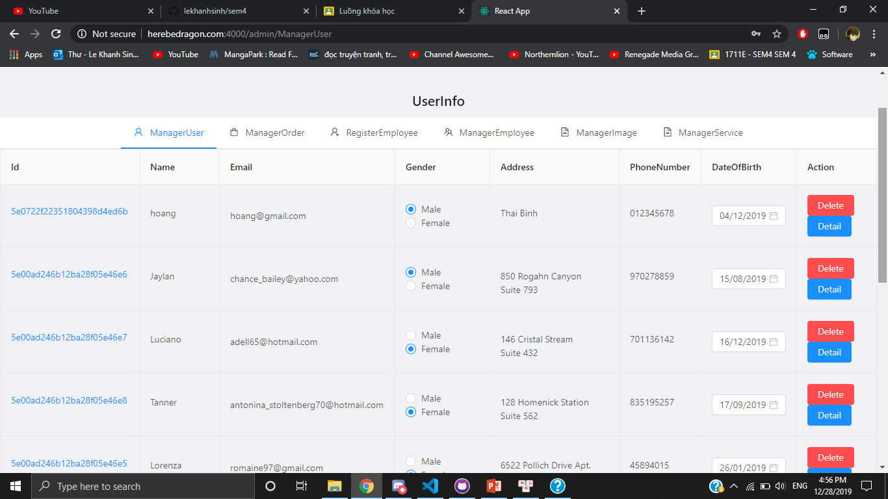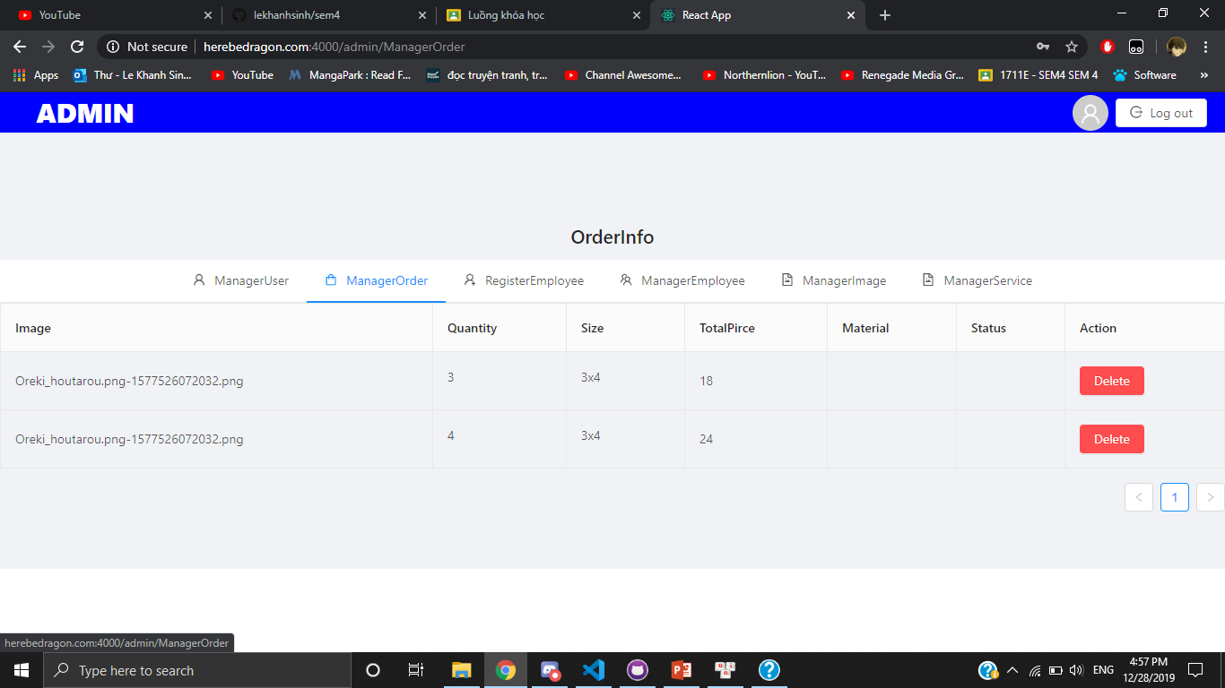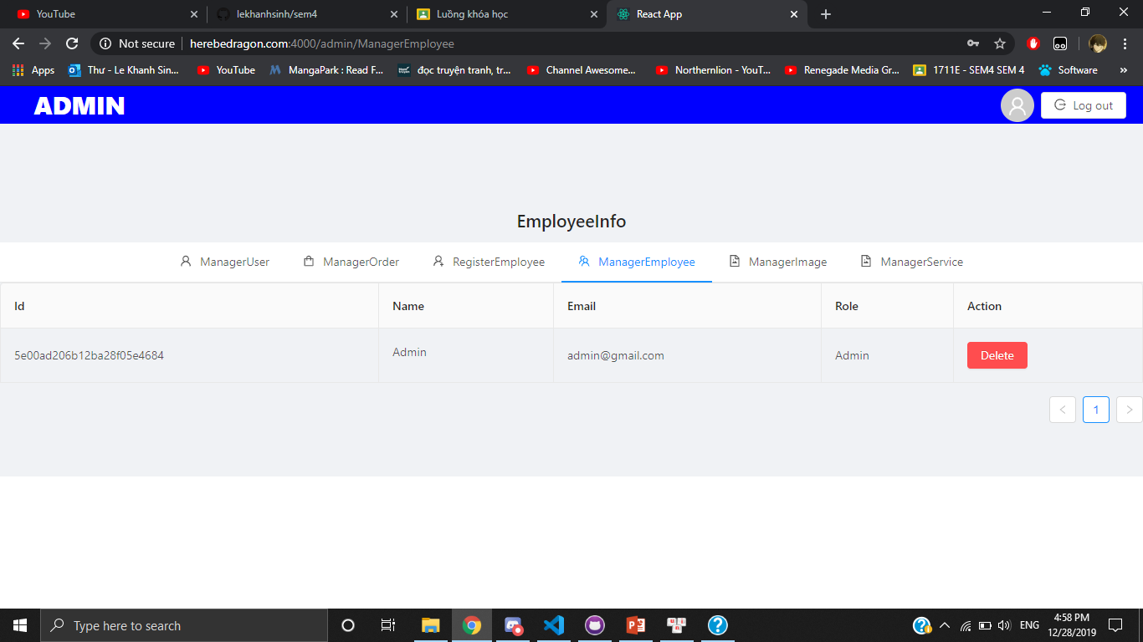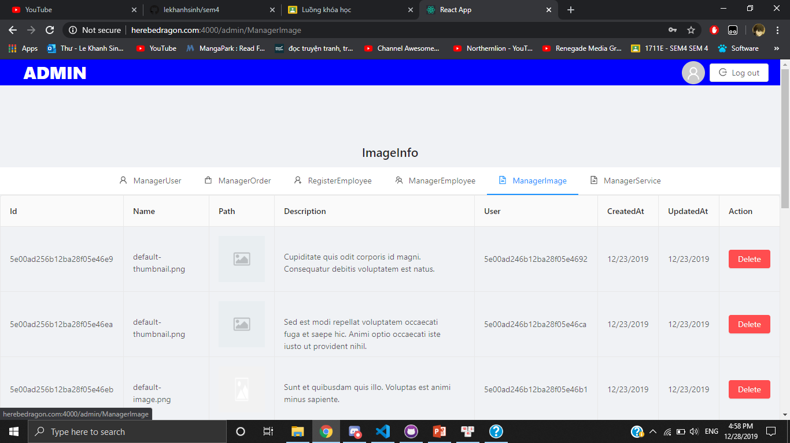

**Database**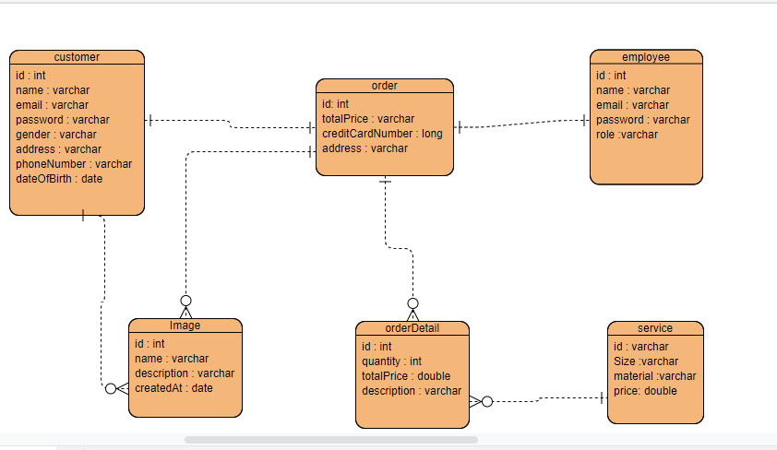

1. **Summary**

Le Khanh Sinh : Database + backend API, Project structurer

Bui Nguyen Thang : Fontend Admin + doc

Nguyen Tien Hoang : Fontend Web + silde