Agentic Evaluation Tool: technical report
Technical report
13 November 2026
Repository | github.com/lekhashashank1704/Agentic-Evaluation-Engine
Branches | feat/governance-engine-prototype (PR #1, engine), feat/eval-harness (PR #2, eval harness, stacked on #1), docs/handover-eval-harness (this package plus the rename, stacked on #2)
Codebase | Backend: about 6,000 lines of Python (backend/app). Frontend: about 2,200 lines of TypeScript/TSX (frontend/src)
Tests | 28 pytest tests (6 evaluators, 5 scoring and decisions, 8 lifecycle API, 9 eval harness). CI: ruff check, pytest, npm ci && npm run build
Runtime | Python 3.11+ and Node 18+. SQLite by default, PostgreSQL via DATABASE_URL. No external services or API keys

1. Scope and system boundary
The system has two layers:
- The governance engine controls and independently evaluates agent work on one change across the SDLC: ticket → coding/fix loop → Risk Gate → hash-bound human approval → canary release → Health Gate → rollback and incident → postmortem → policy proposal.
- The eval harness evaluates agents as versioned artifacts. It runs agent versions on golden datasets with versioned graders, and gates their promotion to ACTIVE.
Simulated: the Coding/Fix, Release and SRE agents (deterministic), the deployment environment, telemetry, the dependency advisory snapshot, the model provider (behind the gateway) and the LLM judge.
Real: every evaluator executes real tools on the generated code. That is pytest against a governance-owned acceptance suite, Ruff, Radon, the AST/regex security rules, and Semgrep when installed. All synthetic evidence carries simulated: true.

2. Architecture
React SPA (Vite, Recharts) ── REST + X-Actor-Id ──► FastAPI
│
api/routes.py ─────────────► orchestration/lifecycle.py ──► agents/ (Coding, Release, SRE; adapter interfaces)
api/harness_routes.py ─┐ │
│ ▼
│ evaluation/engine.py (central EvaluationEngine)
│ functional · security · code_quality · pr_review
│ risk · policy · health · decision · support (Evidence, Thresholds, History)
▼
harness/ runner · targets · graders · suites · registry · gateway · demo
│
core/ rbac (roles, AGENT_FORBIDDEN_ACTIONS) · common (ids, hash-chained audit, notify)
services/ policies (versioned policy store) · incidents (postmortem, feedback engine)
│
SQLAlchemy 2 ORM ──► SQLite / PostgreSQL

Module map
Path | Responsibility
app/main.py | App factory, lifespan seed, serves frontend/dist
app/models.py | ORM: tickets, executions, artifacts, evaluations, approvals, deployments, incidents, postmortems, policy versions and proposals, audit log, notifications, users; harness tables model_calls, gateway_cache, eval_suites, eval_datasets, eval_graders, agent_versions, eval_runs, eval_case_results
app/schemas.py | Pydantic v2: EvaluationResult, Check, Evidence, RiskBreakdown, TicketCreate, SimulationControls, …
app/governance/default_policy.py | Policy v1.0 seed (every weight, threshold, band, role and price)
app/core/rbac.py | Seed identities, permissions, authorize() with agent boundary, human-only and role checks; every denial audited
app/evaluation/* | Evaluators and the decision engine (section 4)
app/orchestration/lifecycle.py | Stage machine, fix loop, Risk Gate, approvals, release, health, rollback
app/services/* | Policy store (active_policy fills missing sections from defaults), incidents, feedback engine
app/harness/* | Eval harness (section 5)
frontend/src/pages/* | Overview, Executions, Execution detail, Evaluation, Approvals, Approval review, Deployments, Incidents, Governance, Audit, Harness, Harness run, Harness compare

3. Lifecycle specification
Execution states: CREATED → IN_PROGRESS → (BLOCKED | ESCALATED | AWAITING_APPROVAL | READY_FOR_RELEASE). Then AWAITING_APPROVAL → (READY_FOR_RELEASE | CHANGES_REQUESTED → IN_PROGRESS | REJECTED) and READY_FOR_RELEASE → DEPLOYING → (DEPLOYED | ROLLED_BACK).
Fix loop limits (policy.loop): max 5 iterations, minimum improvement 0.02, stagnation window 2, regression tolerance 0, max 2 consecutive regressions, budget $2.00, 250k tokens, 300 s timeout, and a stop on critical security findings.
Decision precedence: BLOCK > SUCCESS > BUDGET_EXCEEDED > TIMEOUT > MAX_ITERATIONS_REACHED > STAGNATION_DETECTED > regression streak (ESCALATE) > RETRY.
Release: rollout steps 5 → 25 → 50 → 100%. The Health Gate checks error rate ≤ 1%, p95 ≤ 800 ms, p99 ≤ 1500 ms, CPU ≤ 80%, memory ≤ 85%, availability ≥ 99.9% and SLO ≥ 99%. A breach triggers ROLLBACK, an SRE incident and an on-call notification.
Feedback engine: two or more postmortems sharing a change category within 180 days produce a PENDING PolicyProposal that raises the mapped risk factor by 15 points. A governance_admin approval creates a new policy version (1.0 → 1.1).

4. Evaluation and scoring specification
Quality objective (development threshold 0.95): 0.7 × test_pass_rate + 0.2 × requirement_coverage + 0.1 × code_hygiene. Mandatory gates PG-001 to PG-006 override the score.
Security: CRITICAL findings block. Severity points are CRITICAL 50, HIGH 30, MEDIUM 10, LOW 2. Semgrep is preferred when installed.
Risk = Σ (dimension score × weight). The weights are:
Dimension | Weight
Code change impact | 0.20
Dependency impact | 0.15
Security exposure | 0.25
Business criticality | 0.20
Infrastructure impact | 0.20
The bands and what each one requires:
Band | Score range | Decision | Required approvals
LOW | 0–30 | CONTINUE | none
MEDIUM | 31–60 | human approval | reviewer
HIGH | 61–80 | human approval | tech_lead
CRITICAL | 81–100 | human approval | tech_lead + security_lead
Overrides (for example, a protected-path edit) force BLOCK.
Approvals store the artifact SHA-256. A new artifact version invalidates older approvals, and the release gate re-verifies the hash. The artifact author and the ticket owner cannot approve. Only the engine merges.

5. Eval harness specification

5.1 Data model
Table | Key fields
eval_suites | id, target (coding_agent / risk_evaluator / sre_agent), pass_threshold
eval_datasets | suite_id, version, fixtures (JSON), sha256, notes, created_by
eval_graders | suite_id, version, spec {graders:[{type, weight, …params}]}, sha256
agent_versions | id (coding-agent@1.1), target, config, status (ACTIVE / CANDIDATE / PROMOTION_PENDING / RETIRED / REJECTED), promotion record
eval_runs | suite, dataset, grader and agent versions; mode (run / regrade), parent_run_id, status (PENDING / RUNNING / PAUSED / COMPLETED / BUDGET_EXCEEDED), budget_usd, spent_usd, tokens, summary
eval_case_results | run_id, case_id, output_key, status (DONE / ERROR), attempts, reused_from, output, grades, score, passed, cost_usd, tokens, duration_ms, error
model_calls | caller (production / eval), agent, purpose, model, tokens, cost_usd, cache_hit, request_hash, run_id, execution_id
gateway_cache | request_hash → response

5.2 Targets
Targets reuse production code. run_coding_case runs SimulatedCodingAgent (configured by the agent version) and EvaluationEngine(persist=False) in a harness-owned loop with the same limits. run_risk_case applies the version’s policy_overrides to a copy of the policy, then runs evaluate_security and evaluate_risk. run_sre_case runs SREAgent.summarize.

5.3 Graders
Grader | Description
decision_is_success | 1 if the decision is SUCCESS
expected_decision | 1 if the decision equals the label
final_quality | quality / min_quality; when apply_to_all is false, only cases expecting SUCCESS are scored
iterations_within | 1 within the limit, 1 − (n − limit) / limit beyond it
exact_risk_level | 1 for an exact band match
risk_level_distance | 1 exact, 0.6 one band over, 0.4 one band under, 0 otherwise
keyword_recall | hits / expected points
llm_judge | rubric items met / rubric size, via ModelGateway.complete
The case score is the weighted mean of its graders. A case passes at score ≥ 0.99. The run score is the mean of the case scores, and meets_threshold requires every case to be DONE and the score to be at least the suite threshold.

5.4 Runner semantics
- Durability. Each case is committed on completion. execute() skips DONE cases, so it is idempotent per case and safe to re-invoke.
- Stop conditions, checked before each case: a pause request, max_cases (→ PAUSED) and spent_usd ≥ budget_usd (→ BUDGET_EXCEEDED). A run can overshoot its budget by at most one case.
- Retries. TransientError is retried up to policy.harness.max_retries (2). The fixture field transient_failures injects failures for testing.
- Reuse. output_key = sha256(fixture.input, agent id, agent config, suite). A DONE result with the same key in another run is reused at zero cost, with reused_from set.
- Re-grade. Re-grading creates a regrade run that re-scores the parent’s stored outputs with another grader. Only judge calls are made, and the cache replays them.
- Compare. Compare gives per-case deltas, new_failures, fixed, and the efficiency of each run (agent cost, tokens, average iterations). Attribution works as follows. If only the grader differs, the whole delta is the grader effect. If only the agent differs, it is the agent effect. If both differ, B’s outputs are re-scored with A’s grader to get a midpoint M: the agent effect is M − A and the grader effect is B − M. If the datasets differ, the result is flagged as not comparable.

5.5 Promotion gate
request_promotion must be made by a human. The gate checks:
- the run is for this version;
- the run is COMPLETED;
- it uses the latest dataset;
- it uses the latest grader;
- the score is at least the threshold;
- new failures ≤ promotion_max_case_regressions (0), measured against the latest COMPLETED run of the ACTIVE version with the same dataset and grader. A missing baseline fails this check.
A pass sets PROMOTION_PENDING. decide_promotion requires a human with promote_agent and a role in promotion_approval_roles (tech_lead, governance_admin), who is not the requester. Approval sets the version ACTIVE and the previous version RETIRED. promote_agent is in AGENT_FORBIDDEN_ACTIONS. All steps are audited. The lifecycle resolves the active coding agent per execution (active_coding_agent) and records agent_version in the loop state.

5.6 Model gateway
ModelGateway(db, policy) provides price(), meter() (records calls made by the agent’s own client) and complete() (calls through the gateway with record/replay keyed on sha256(model + prompt)). Prices come from policy.gateway.prices_per_1k_tokens_usd. summary() aggregates by caller and model.

5.7 Seeded suites and measured results (walkthrough)
Suite | Run | Score
coding-agent-core (10 cases, threshold 85%) | 1.0 with grader v1 | 77.6%
 | 1.0 re-graded with v2 | 100% (all grader effect, +22.4 pts)
 | 1.1 with v2 | 100%; agent cost $0.605 → $0.491, average iterations 2.8 → 2.3
 | 0.9-exp with v2 | 72.7%
risk-calibration (8 cases, threshold 80%) | 1.0 with v1 | 75%
 | 1.0 with v2 | 85%
 | 1.1-db60 with v2 | 92.5% (fixes std-high)
sre-incident-summaries (4 cases, threshold 75%) | v1 | 81.3%
 | v2 (with LLM judge) | 82.1%; a repeat re-grade costs $0

6. API surface
The lifecycle endpoints are listed in docs/API.md and the harness endpoints in docs/EVAL_HARNESS.md#api. Interactive OpenAPI docs are at /docs. Identity comes from the X-Actor-Id header.

7. Architecture decisions
# | Decision | Rationale | Trade-off
AD-1 | Evaluation is separate from agents and enforced server side | No agent grades, approves or merges its own work | Every new agent action needs an RBAC entry
AD-2 | Mandatory gates are separate from weighted scores | A good score must never mask a critical finding | More decision states to explain (handled by explanation)
AD-3 | All tunables live in a versioned policy document read through ThresholdManager | Changes are reviewable, auditable and reversible | One JSON document; no schema validation of policy edits yet
AD-4 | Approvals bound to the artifact SHA-256 | An approval cannot carry over to different code | Any rework requires re-approval
AD-5 | Hash-chained, append-only audit log | Tamper evidence without external infrastructure | Single-writer chain; needs a different design at high write volume
AD-6 | Feedback engine proposes, never applies | Humans own policy | Slower adaptation
AD-7 | Deterministic simulated agents behind adapters | Reproducible demos and tests; no keys needed | Real-model behaviour is untested
AD-8 | SQLite with portable types, DATABASE_URL for Postgres | Zero-setup local runs | No Alembic migrations yet
AD-9 | The harness runs production modules (agents, engine) with persist=False | An eval measures what ships; no fork of logic | The harness loop duplicates the lifecycle’s loop control (about 30 lines)
AD-10 | Datasets and graders are immutable and content-hashed | Results are reproducible and comparable | New versions are needed for any change
AD-11 | The grader is a first-class experiment variable (re-grade, attribution) | Separates measurement change from agent change | Attribution is a two-point decomposition, not a full Shapley split
AD-12 | Per-case commits instead of a workflow engine | Durability with no infrastructure | Runs execute inside the HTTP request
AD-13 | Output reuse keyed by content hash | Re-running unchanged work is free | The key excludes the policy version (see OA-2)
AD-14 | A single model gateway for production and eval | One price list, one meter, replay | Every new model client must go through it
AD-15 | Agent promotion requires an eval gate plus a separate human | Treats agent versions like code releases | Needs a baseline run of the active version first
AD-16 | active_policy() back-fills missing sections from defaults | Older databases keep working after upgrades | Defaults silently apply until a new policy version is approved

8. Open action items
ID | Priority | Item | Detail / proposed fix
OA-1 | High | Two price sources | The lifecycle loop budget uses policy.loop.cost_per_1k_tokens_usd (flat $0.012), while the gateway uses per-model prices. Derive the loop cost from ModelCall rows so one price list governs everything
OA-2 | High | Reuse key ignores policy version | Coding outcomes depend on policy thresholds. Add policy_version (or a hash of the relevant sections) to output_key so policy changes don’t reuse stale outputs
OA-3 | High | Real identity | Replace X-Actor-Id with SSO/OIDC and map roles from the IdP
OA-4 | High | Real agent integration | Implement CodingAgentAdapter and LLMClient with a real model, routed through ModelGateway.complete. Run it on coding-agent-core as a CANDIDATE
OA-5 | Medium | Async execution | Move execute() and the lifecycle onto a worker queue (Celery, RQ, Temporal); the API returns run ids and the UI polls. The runner is already resumable
OA-6 | Medium | Schema migrations | Add Alembic. Existing databases do not receive new seeded permissions (promote_agent) without a reset
OA-7 | Medium | Risk calibration gap | crit-high is still under-estimated (HIGH vs labelled CRITICAL) under every evaluator version. Review the factor points or labels with security
OA-8 | Medium | SRE summary recall | errors-auth scores 50 to 57%. Improve the SRE agent’s category-specific recommendations
OA-9 | Medium | Golden data from real history | The fixtures and labels are synthetic. Build datasets from past tickets, incidents and reviewer decisions
OA-10 | Medium | Policy edit validation | Validate policy documents against a JSON schema before activation
OA-11 | Low | Gateway retention | model_calls grows unbounded. Add pagination, aggregation and retention
OA-12 | Low | Frontend bundle size | 674 kB. Code-split Recharts and the pages; opt into the React Router v7 future flags to silence the console warnings
OA-13 | Low | Windows run guide | The steps are written but not yet executed on Windows
OA-14 | Low | Attribution method | Consider symmetric (both-order) attribution when grader and agent both change

9. Verification performed
- ruff check . is clean, pytest passes 28 tests, and npm run build (tsc + vite) succeeds. CI is green on PR #2.
- A clean-clone run followed the Run it locally guide on Linux (Python 3.13, Node 22): install, tests, build, server start, scripts/demo.sh (9 scenarios) and the harness walkthrough.
- UI checks in headless Chromium, with screenshots in docs/screenshots/.
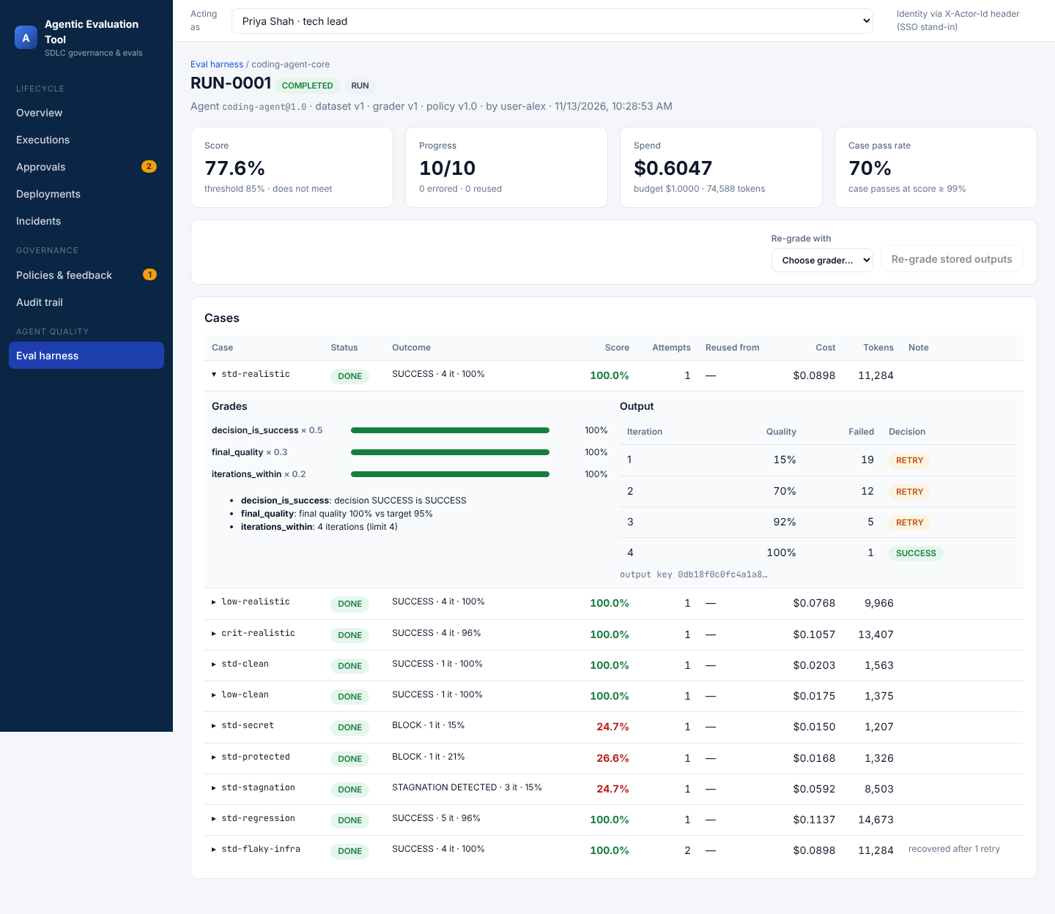
Eval run drill-down

