WEEK 4 – COMPREHENSIVE DATA SCIENCE REPORT & INSIGHTS PLAN
Customer Churn Prediction
Final Report, Insights Presentation and Recommendations
Item | Details
Student Name | Z.Lekha Sonal
Course | - TECH - Data Science
week | Week 4
Planned Effort | 32 hours

1. Executive Summary
This final-week plan consolidates the customer churn project into a professional report and presentation strategy. The purpose is to communicate the main analytical findings, explain their business meaning, and propose practical actions. Since the project is hypothetical, the findings described below are planned insight areas rather than claims about real data.

Project Purpose
The proposed solution identifies customers who may be at risk of leaving a service. The final report will connect customer behavior, churn patterns, model results, visual evidence and recommendations in a clear story for decision-makers.

2. Methodology Overview
The report will briefly explain how the analysis would be conducted, without overwhelming the audience with technical details.
Stage | Purpose | Output
Problem definition | Define churn and business goal | Clear objective
Data preparation | Clean and prepare records | Reliable analysis dataset
EDA & visualization | Find patterns and relationships | Charts and observations
Model development | Estimate churn risk | Classification model
Evaluation | Check predictive performance | Metrics and error analysis
Insight generation | Translate results into meaning | Key findings
Recommendations | Convert findings into actions | Retention action plan

3. Insight-to-Action Story
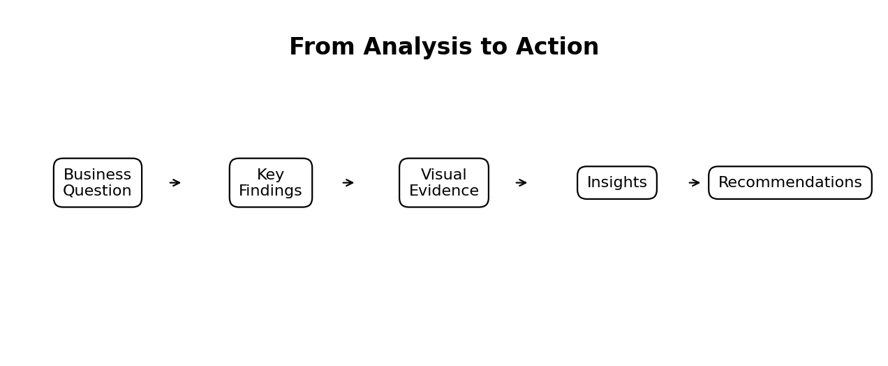
Figure 1. Planned path from analysis to actionable recommendations
- State the business question and why it matters.
- Present only the most important findings.
- Support each finding with clear visual evidence.
- Explain the business impact of each finding.
- End with specific, measurable recommendations.

4. Planned Findings & Analysis
The following areas will be investigated when an actual dataset is available.
Analysis area | Question | Planned visual
Overall churn | What proportion of customers churn? | KPI / bar chart
Churn over time | Is churn changing across periods? | Line chart
Contract type | Do churn levels differ by contract? | Bar chart
Tenure | Are newer customers more likely to churn? | Box plot / bar chart
Charges | Does churn vary with charges? | Box plot / histogram
Services | Are some services linked with higher churn? | Bar chart
Support activity | Does support usage differ by churn status? | Bar chart / box plot
Risk segments | Which groups have highest predicted risk? | Segment chart

5. Visualization Strategy
Visuals will be selected according to the question being answered. Charts will use clear titles, readable labels, consistent terminology and limited visual complexity.
- Use KPI cards for high-level measures.
- Use line charts for trends over time.
- Use bar charts for category comparisons.
- Use box plots and histograms for distributions.
- Use scatter plots for numerical relationships.
- Use concise tables when exact values are important.
- Avoid decorative charts that do not add analytical value.
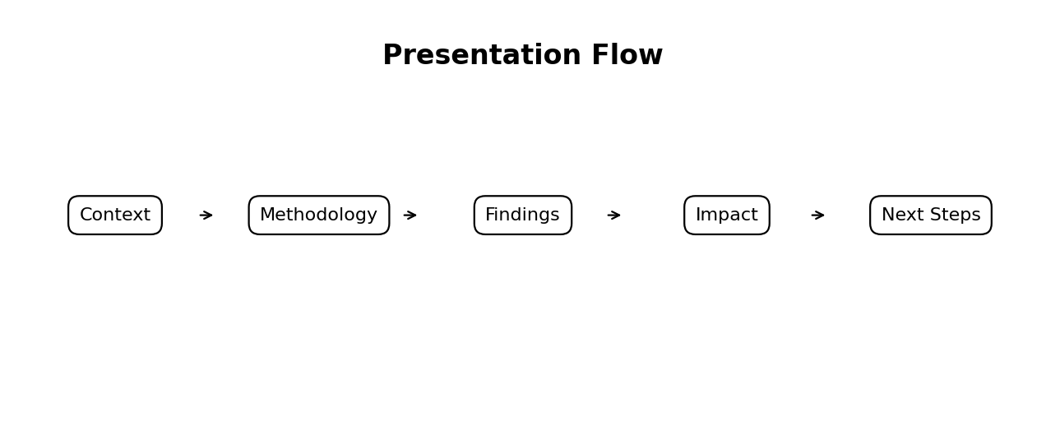
Figure 2. Planned presentation flow

6. Actionable Recommendations
Recommendations will be finalized only after findings are verified. Possible actions include:
Potential insight | Possible action | Success measure
High churn among new customers | Improve onboarding and early engagement | Early-tenure churn rate
Higher churn in certain contract groups | Target renewal offers or suitable plans | Renewal rate
Frequent support issues among high-risk customers | Provide proactive support follow-up | Repeat complaints and churn
High-risk customer segment | Prioritize targeted retention campaigns | Retention rate / campaign response
Small segment accounts for much risk | Focus resources on that segment | Cost per retained customer

7. Communicating to a Non-Technical Audience
The presentation will focus on what happened, why it matters and what should be done. Technical terms will be explained in simple language and detailed model information can be placed in an appendix.
- Lead with the conclusion, then show the evidence.
- Use short explanations and clear visuals.
- Explain metrics through business meaning.
- Avoid presenting technical results without interpretation.
- Keep recommendations specific and measurable.

8. Final Report Structure
- Title page
- Executive summary
- Business problem and objectives
- Methodology overview
- Key findings and visual evidence
- Model performance summary
- Actionable insights
- Recommendations
- Limitations
- Future work
- Conclusion
- Appendix

9. Limitations & Responsible Interpretation
- This is a hypothetical project until real data is analyzed.
- Association should not automatically be treated as causation.
- Accuracy alone may be misleading when churn classes are imbalanced.
- Model predictions can change when customer behavior changes.
- Retention decisions should include business context and human review.
- Only relevant and appropriate customer information should be used.

10. Future Work
- Test the framework on a real dataset.
- Build an interactive churn dashboard.
- Tune prediction thresholds using business costs.
- Monitor model performance and data drift.
- Measure whether recommended retention actions reduce churn.
- Update the model when new outcomes become available.

11. Tools & Technologies
Tool | Purpose
Python | Analysis and modelling
Pandas / NumPy | Data preparation and calculations
Matplotlib / Seaborn / Plotly | Visualizations
Scikit-learn | Machine learning and evaluation
Jupyter Notebook | Analysis documentation
Microsoft Word | Final report
GitHub | Version control and portfolio

12. 32-Hour Work Allocation
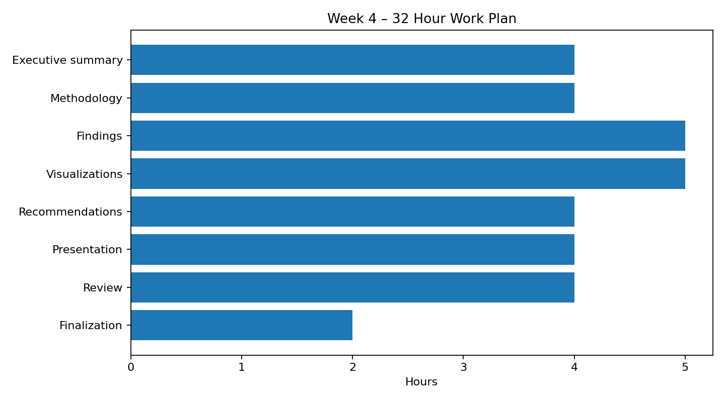
Figure 3. Planned Week 4 work allocation
Activity | Hours
Executive summary & project framing | 4
Methodology review | 4
Findings & insight narrative | 5
Visualizations & mock-ups | 5
Recommendations & action plan | 4
Presentation/storytelling plan | 4
Report editing & quality review | 4
Final documentation | 2
Total planned effort: 32 hours.

13. Expected Outcomes
- A polished report suitable for executive-level review.
- A clear story connecting evidence, insights and recommendations.
- Visual aids that support the main conclusions.
- Practical and measurable recommendations.
- A communication approach suitable for non-technical stakeholders.
- A documented plan for future analysis and monitoring.

14. Assignment Requirements Checklist
Requirement | Covered
Executive summary | Section 1
Methodology overview | Section 2
Insights and analysis | Section 4
Charts, graphs and tables | Sections 4–5
Actionable recommendations | Section 6
Non-technical presentation strategy | Section 7
Future work | Section 10
30–35 hour plan | Section 12 – 32 hours

15. Conclusion
This Week 4 plan brings the customer churn project together as a professional data science reporting and communication exercise. It focuses on turning analytical results into a concise story supported by visual evidence and practical recommendations. Once real data and validated results are available, the planned insight areas can be replaced with verified findings and used for an executive-ready presentation.

