Picture 2

*INVENTORY ANALYSIS SOFTWARE*

**Document Control :**

|  |  |  |  |  |  |  |  |  |
| --- | --- | --- | --- | --- | --- | --- | --- | --- |
| **Project Revision History** | | | | | | | | |
|  |  |  | |  |  |  |  |  |
|  |  |  | |  |  |  |  |  |
| **Date** | **Version** | **Author** | **Brief Description of Changes** | | | | **Approver Signature** | |
| 26.11.2022 | 1.0 | Group 5 |  | | | |  | |
|  |  |  |  | | | |  | |
|  |  |  |  | | | |  | |

**Index**

1.Introduction---------------------------------------------------------------------------------------------3

1.1 Intended audience---------------------------------------------------------------------------3

1.2 Project purpose------------------------------------------------------------------------------3

1.3 Key project objective-----------------------------------------------------------------------3

1.4 Project scope and limitation---------------------------------------------------------------3

1.5 Functional overview------------------------------------------------------------------------3

1.5.1 Header files---------------------------------------------------------------------------3

2.Design overview----------------------------------------------------------------------------------------3

2.1 Design objective-----------------------------------------------------------------------------5

2.2 Design alternative---------------------------------------------------------------------------5

2.3 User interface paradigms-------------------------------------------------------------------5

2.4 Error detection/ Exceptional Handling---------------------------------------------------5

2.5 Performance----------------------------------------------------------------------------------5

2.6 Maintenance----------------------------------------------------------------------------------6

3.System architecture-------------------------------------------------------------------------------------6

4. Detailed system design--------------------------------------------------------------------------------6

4.1 Design overview-----------------------------------------------------------------------------6

4.2 Data flow diagram---------------------------------------------------------------------------7

5. Environment description------------------------------------------------------------------------------8

5.1 Time zone support---------------------------------------------------------------------------8

5.2 Language support----------------------------------------------------------------------------8

5.3 User desktop requirement-------------------------------------------------------------------8 5.3.1 Integration requirements-------------------------------------------------------------8

5.3.2 Network--------------------------------------------------------------------------------8

5.3.3 Configuration--------------------------------------------------------------------------8

6. Implementation-----------------------------------------------------------------------------------------7

6.1 Inventory CSV files--------------------------------------------------------------------------7

6.2 Sales CSV files-------------------------------------------------------------------------------7

7. Reference------------------------------------------------------------------------------------------------7

1. **Introduction: -**
   1. **Intended Audience: -**

The target audience are the clients whose access e-commerce businesses as well as manual businesses and e-portal. The software can be used in every business for managing the stocks.

* 1. **Project Purpose: -**

Inventory analysis helps you determine the right amount of stock to keep on-hand to fill demand while avoiding spending too much on inventory storage. Inventory is an asset on a balance sheet and represents the product a company plans to sell to its customers eventually.

* 1. **Key Project Objectives: -**
* keep the stock in such a way that it is neither overstock nor understock.
* provide the desired level of customer service.
* allow cost-efficient operations.
* minimize the inventory investment.
  1. **Project scope and limitation: -**

This project scope is for creating and maintaining the inventory and sales record for the small and large business clients. Inventory management refers to the process of ordering, storing, using, and selling a company's inventory.

* 1. **Functional Overview: -**

**1.5.1 HEADER FILES:**

* + stdio.h
  + stdlib.h
  + string.h

# Design Overview: -

|  |  |
| --- | --- |
| Name of the Module | Create and read operations and guidelines |
| Handled by | Lekha Vibhudi |
| Description | Developed code on create and read operations and maintained some coding guidelines |

|  |  |
| --- | --- |
| Name of the Module | Created files and researched |
| Handled by | Shreyah Gurram |
| Description | Declared and created files in the valid format and extension and researched about create and read operations |

|  |  |
| --- | --- |
| Name of the Module | Update and Delete operations and error detection |
| Handled by | Abhinaya Vaitla |
| Description | Developed code on update and delete operations and implemented error detection and exceptional handling |

|  |  |
| --- | --- |
| Name of the Module | Update and Delete operations and research |
| Handled by | Oleti Lalita Sowmya |
| Description | Researched and developed all the conditions and functions on update and delete operations |

|  |  |
| --- | --- |
| Name of the Module | Designed algorithm and created sales part |
| Handled by | Mansi Singh |
| Description | Developed code in creating sales record and designed dataflow diagrams and flow charts |

## Design Objectives: -

* To maintain independence of operations.
* To meet variation in product demand.
* To allow flexibility in product scheduling.
* To balance various costs of inventory.
* Conduct a periodic cycle count to track stock.
  1. **Design Alternative: -**

We have used file structures for performing operations in this project. Information is directly changed in file so less space is used during program execution.

### User Interface Paradigms: -

The client would ask authentication from the server and after authentication they would remain in the public group by default. There would be three types of access categories for the user: anonymous, authenticated and admin authenticated. For an anonymous client, the server should support a virtual user with the name anonymous to add contact to a public group only without any password. All the authenticated users should be allowed to add, view and delete contact from the phone directory for the group they belong to. They should view the content of public groups. Users with authenticated admin access can access any contact in addition to add, remove group to phone directory.

### Error Detection / Exceptional Handling: -

* If the user doesn’t have access to group and tries to change group , then it will show error "The user doesn’t belong to the group”.
* If an authenticated user tries to add contact in public group, then it will show error "Authenticated user can't add the data to the public group"
* If the user tries to remove a contact which is not present in the group , then it will show error "Entered contact name is not present".

We have handled these errors by using flags at different parts of our codes and returning that to server for checking and sending the error messages to the clients.

### Performance: -

Inventory analysis helps you determine the right amount of stock to keep on-hand to fill demand while avoiding spending too much on inventory storage. Inventory is an asset on a balance sheet and represents the product a company plans to sell to its customers eventually.

### Maintenance : -

Inventory management is an attempt to have the right stock, in the right place, at the right time, and at the right cost. The goal is to minimize cost by helping facilities know when to purchase more inventory based on normal usage rates.

1. **System Architecture: -**

**The system consists of 4 functions.**

1.Create: The create operation adds a new record to a database

2.Read: The read operation reads previously stored data and the write operation stores a new value in memory.

3.Update: Update operation refers to updating an existing element from the array at a given index.

4.Delete: The delete operation may be performed over one or more objects that satisfy the conditional expression defined for it.

1. **Detailed System Design**

# Design Overview

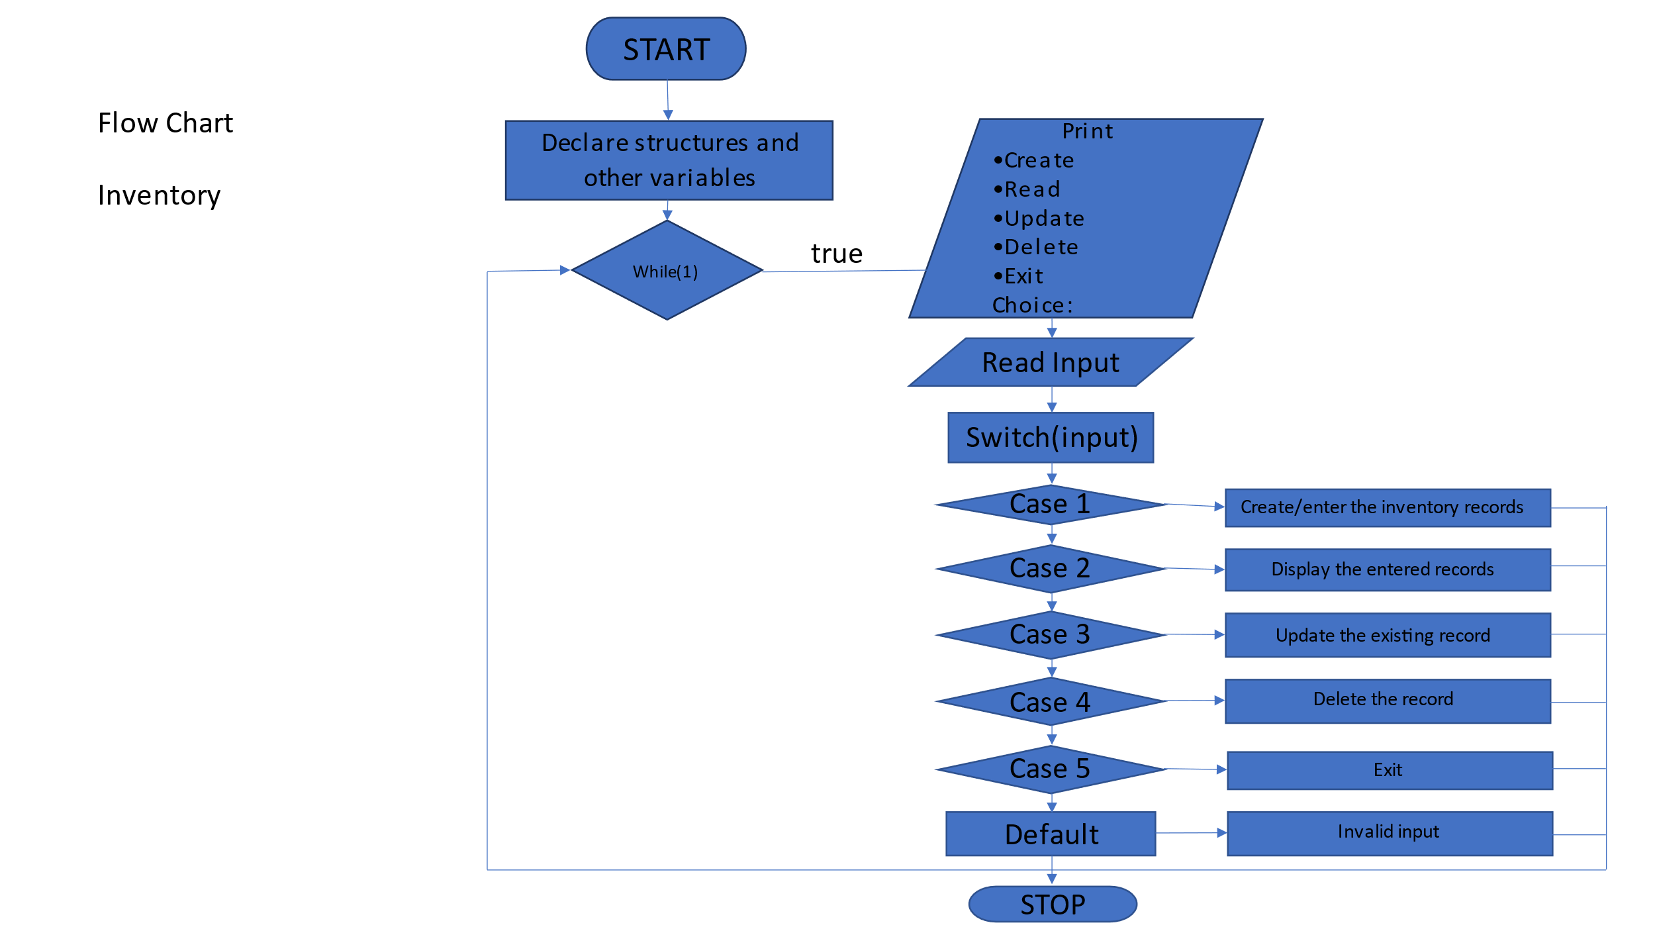

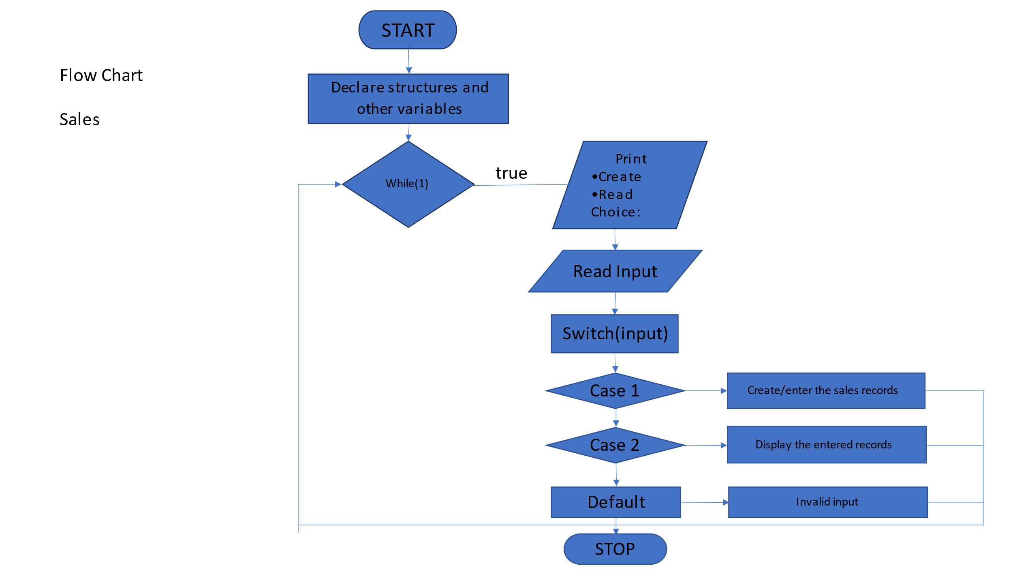

## 

**4.2 Data flow diagrams:**

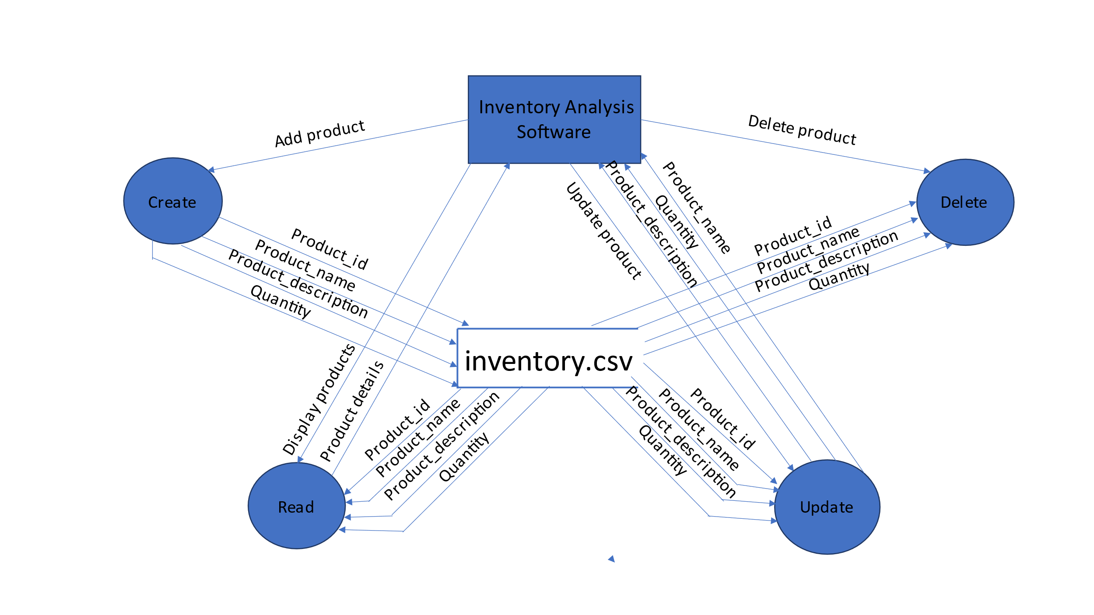

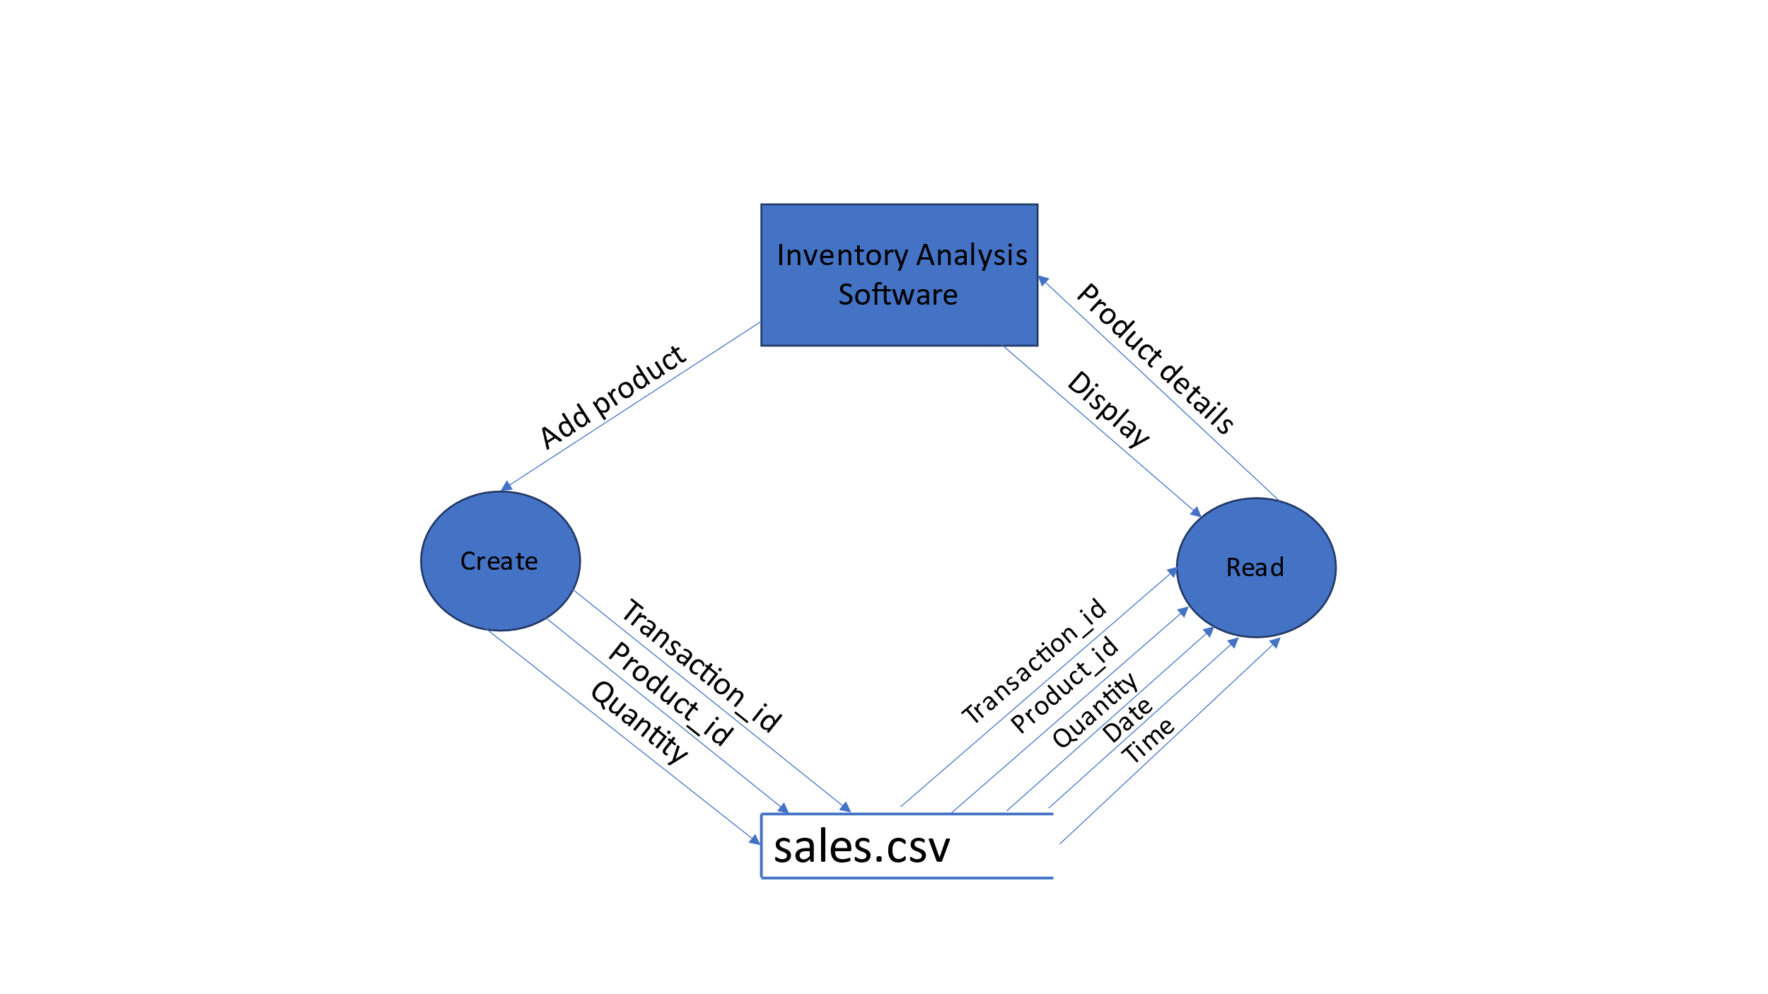

**5.Environment Description: -**

* 1. **Time Zone Support: -** IST- Kolkata
  2. **Language Support: -** English
  3. **User Desktop Requirements: -**
  + 64-bit processor, 1 GHz or faster
  + At least 10 GB free hard drive space
  + At least 1 GB RAM **Server**

**5.3.1** Integration Requirements: -

* + - Language: - C
    - Tools: - Valgrind, splint
    - Complier: - gcc
    - Linux Environment
    1. Network: - End to End

**5.3.3** Configuration**: -**

Operating System: - Linux environment

**6.Implementation:-**

6.1 Inventory CSV file

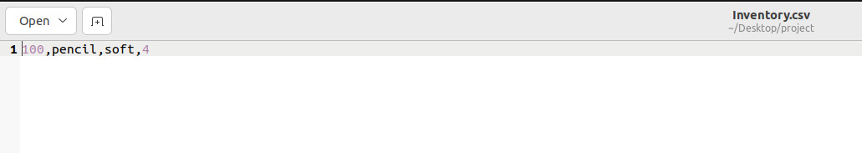

6.2 Sales CSV file

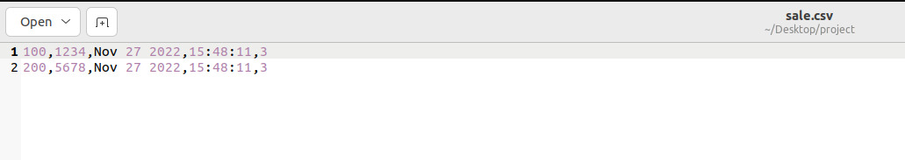

**7.Reference: -**

The references are:

* + - <https://youtu.be/X-IPIfHlrKY>
    - <https://www.geeksforgeeks.org/software-testing-test-analysis/>
    - https://www.javatpoint.com/software-configuration-management