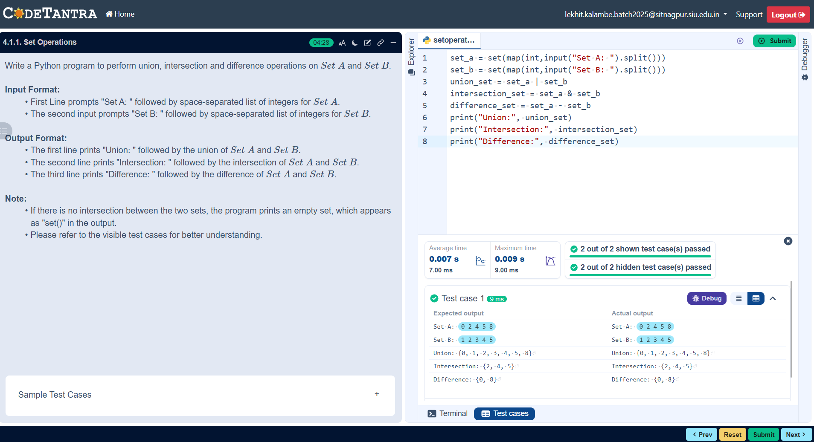
Algorithm: Set Operations (Union, Intersection, Difference)
- Start
- Prompt the user to enter elements of Set A as space-separated integers.
- Read the input and convert it into a set set_a.
- Prompt the user to enter elements of Set B as space-separated integers.
- Read the input and convert it into a set set_b.
- Find the union of set_a and set_b using the union operation.
- Find the intersection of set_a and set_b using the intersection operation.
- Find the difference of set_a and set_b (elements present in Set A but not in Set B).
- Display the union result.
- Display the intersection result.
- Display the difference result.
- Stop
