Ex-5
Practicle 5.1.1
*Aim :- Write a Python program that prompts the user to enter a year. The program should determine if the year is a leap year or not and print the appropriate message.
Step 1: Start
Step 2: Read an integer value year from the user.
Step 3: Check if (year mod 400 = 0)
Step 4:
If YES, then
Print "Leap year"
Go to Step 8
Step 5:
Otherwise, check if
(year mod 4 = 0) AND (year mod 100 ≠ 0)
Step 6:
If YES, then
Print "Leap year"
Step 7:
Else
Print "Not a leap year"
Step 8: Stop
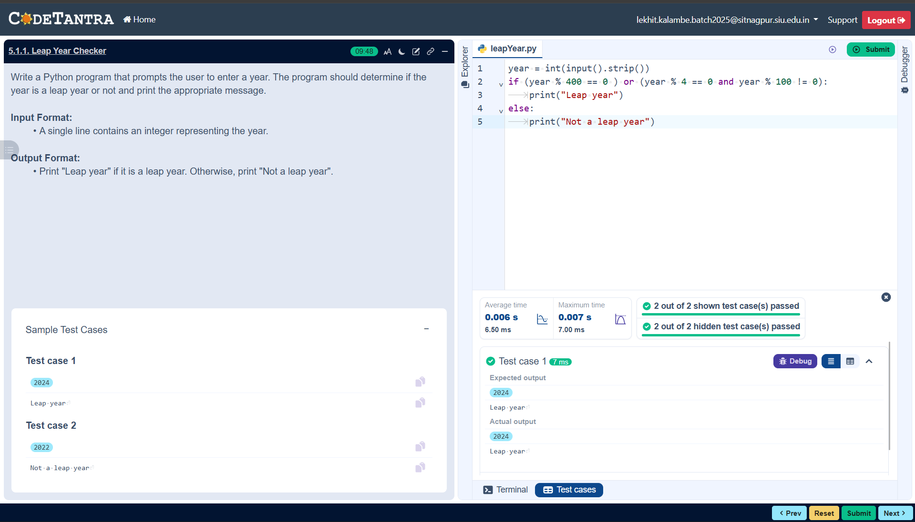
*Flowchart:-
