Practicle 1.1.1
*Aim :- Write a Python program that calculates the area of a circle when the radius is provided by the user. Use π = 3.14 and display the area.
*Algorithm to calculate area of a circle
Step 1. Start
Step 2. Read radius
Step 3. Set π = 3.14
Step 4. Calculate area = π × radius × radius
Step 5. Display area (up to 4 decimal places)
Step 6. Stop
*Flowchart:-
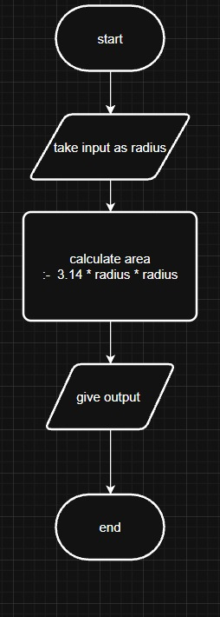
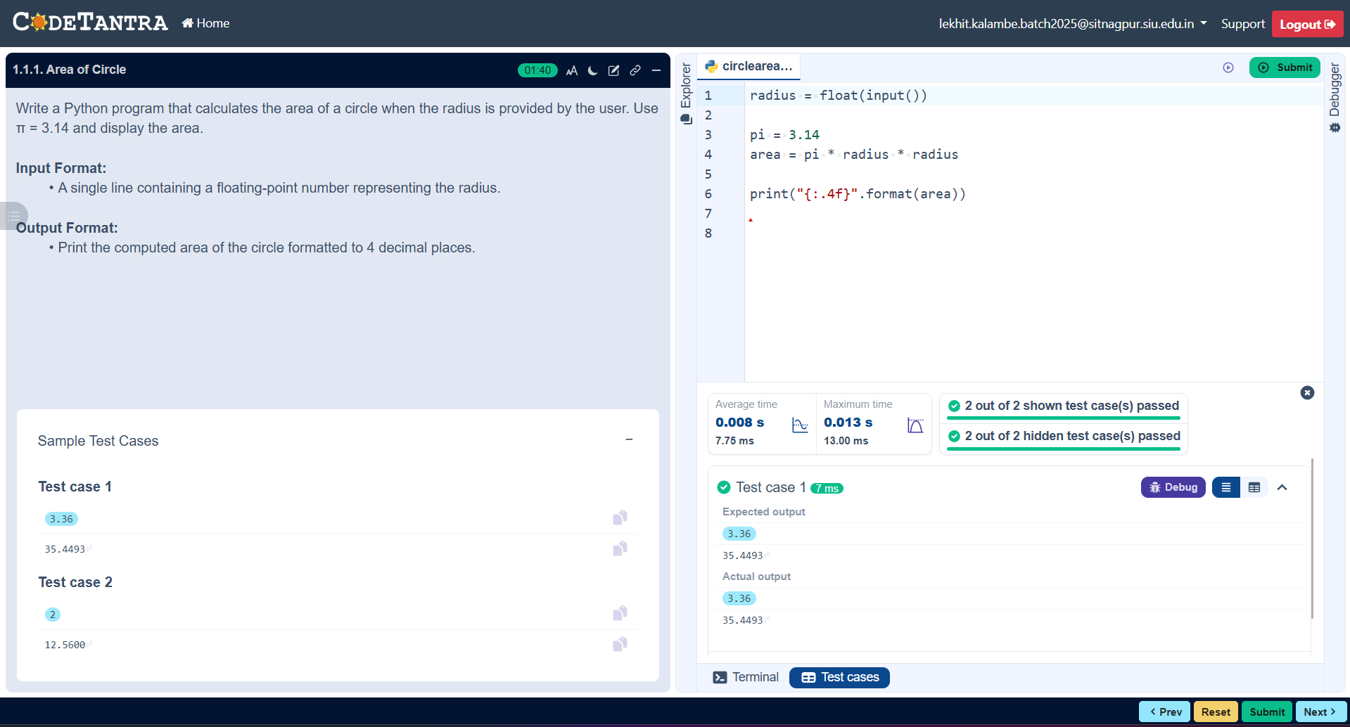
Practicle 1.1.2
Aim:- Write a Python program to calculate the area of a rectangle given its length and width.
*Algorithm: Area of Rectangle
Step 1. Start
Step 2. Input length L and breadth B
Step 3. Calculate area A = L × B
Step 4. Display the value of A
Step 5. Stop
*Flowchart :-
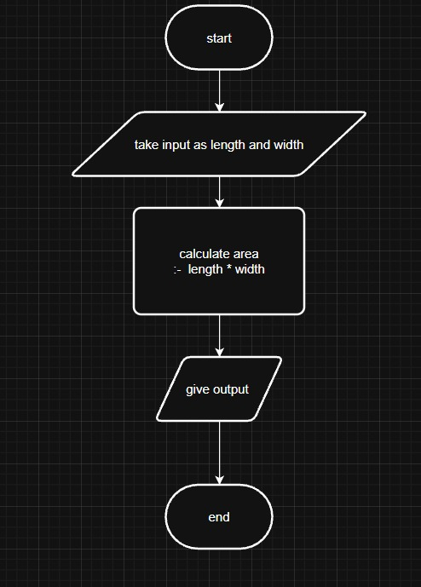
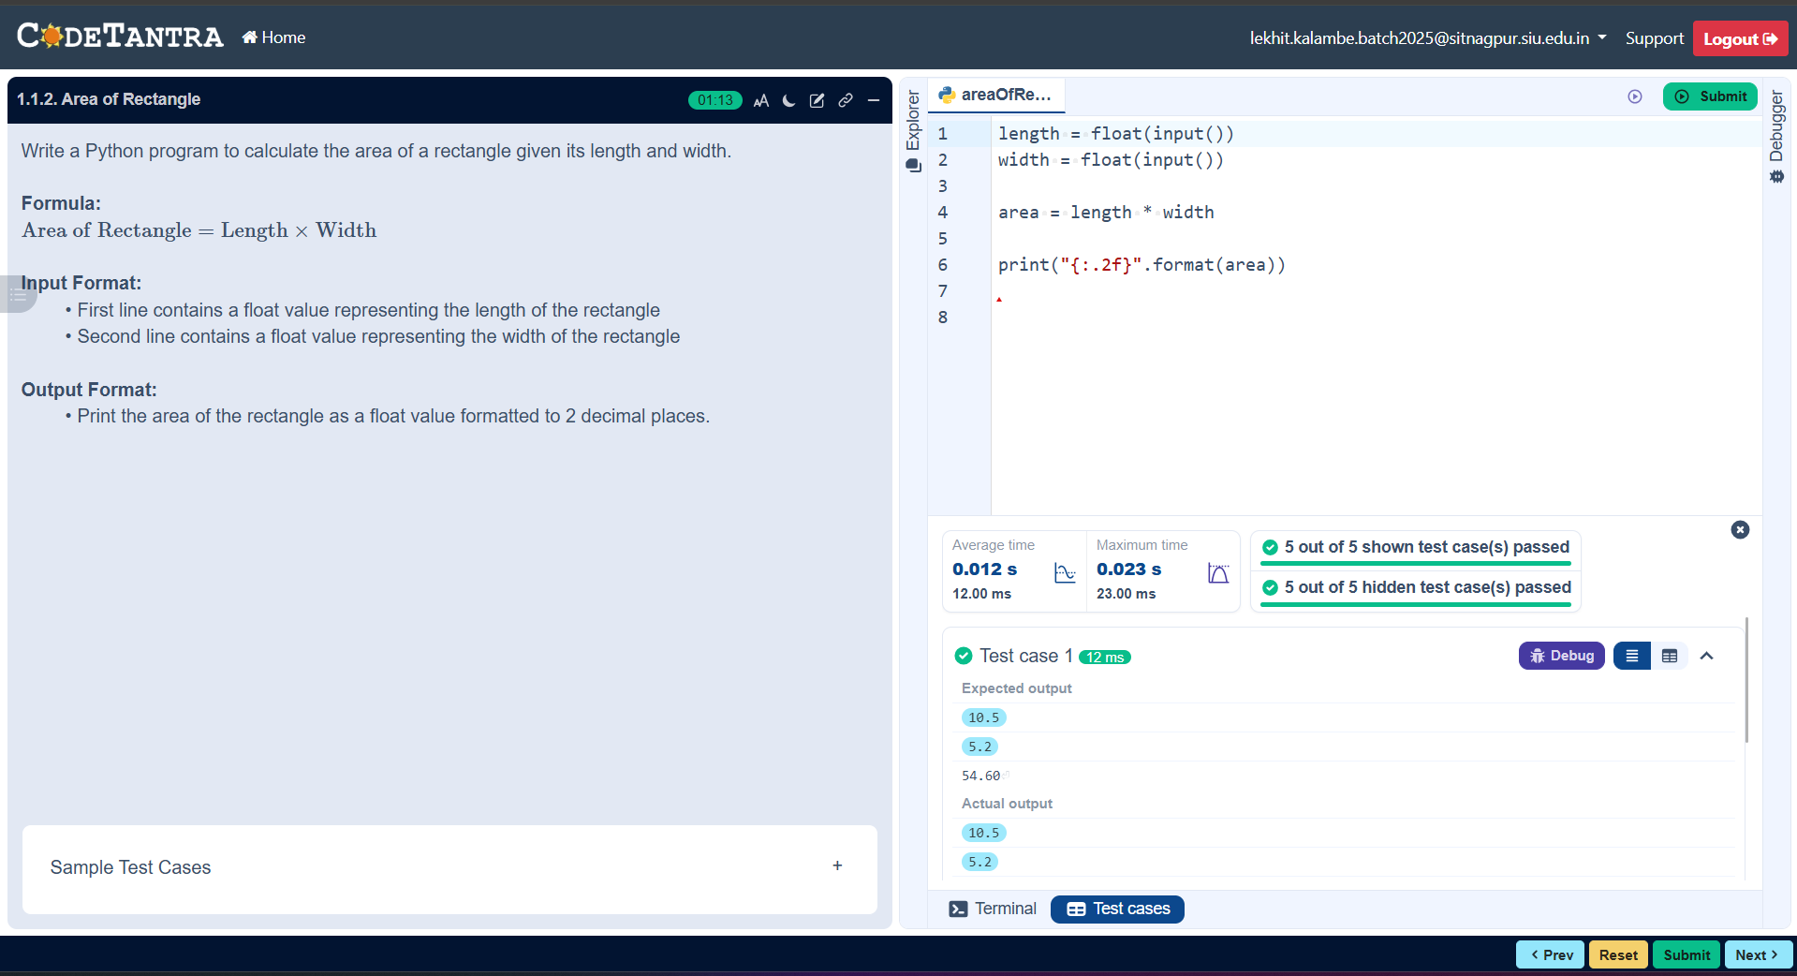
Practicle 1.1.3
Aim:- Write a Python program that prompts the user to enter the of a square and computes the area of the square.
*Algorithm: Area of a Square
Step 1. Start
Step 2. Input the value of side_length
Step 3. Calculate area using formula:
area = side_length × side_length
Step 4. Display the value of area
Step 5. Stop
*Flowchat:-
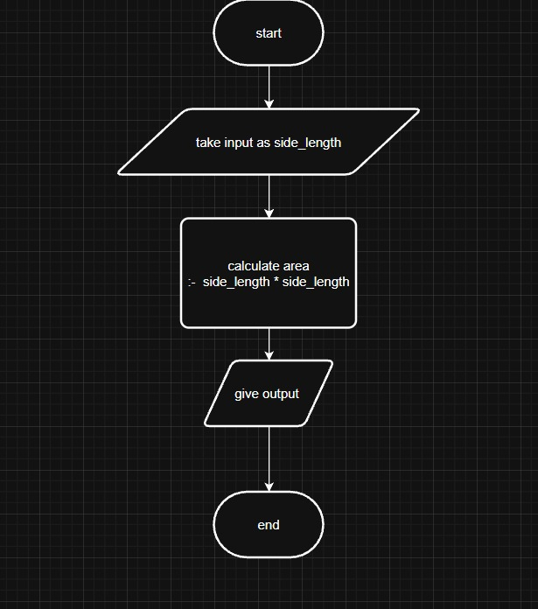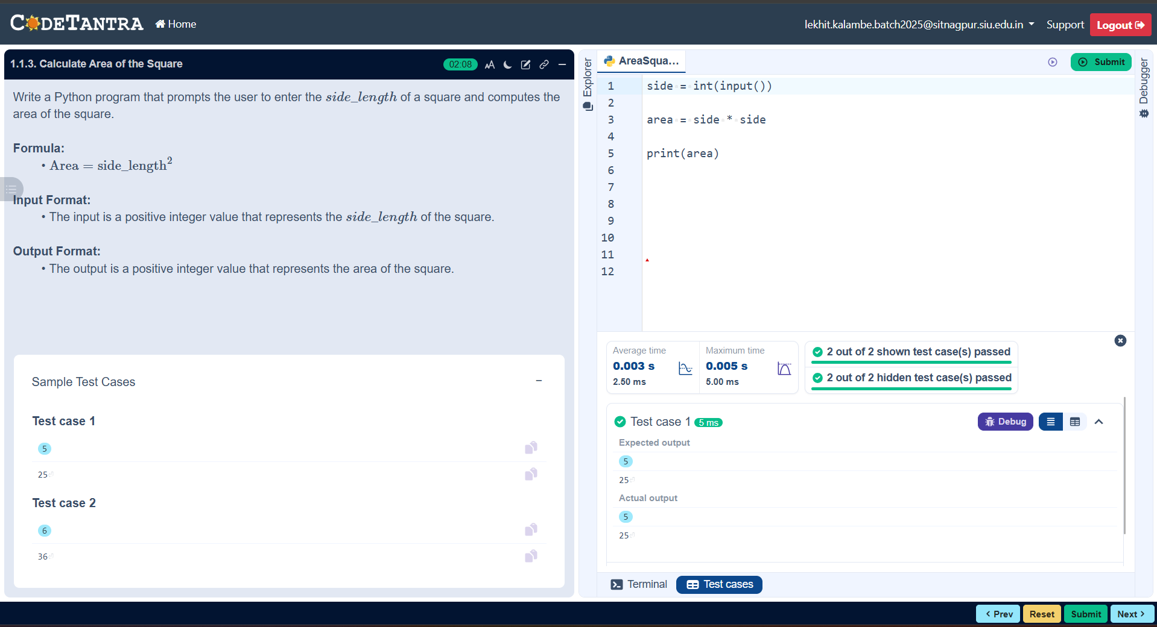
Practicle 1.1.4
Aim:- Write a Python program that prompts the user to enter the triangle's base and height and computes the triangle's area.
*Algorithm: Area of a Triangle
Step 1. Start
Step 2. Input the value of base (B) and height (H)
Step 3. Calculate area using formula:
area = (B × H) / 2
Step 4. Display the value of area
Step 5. Stop
*Flowchat:-
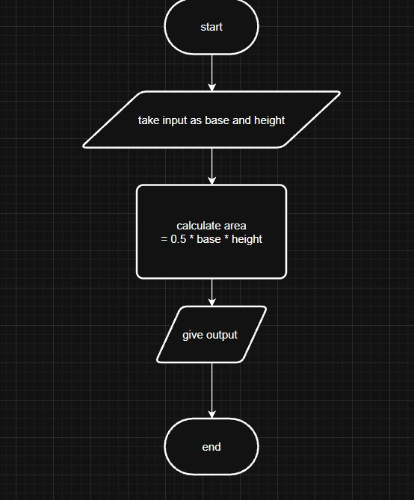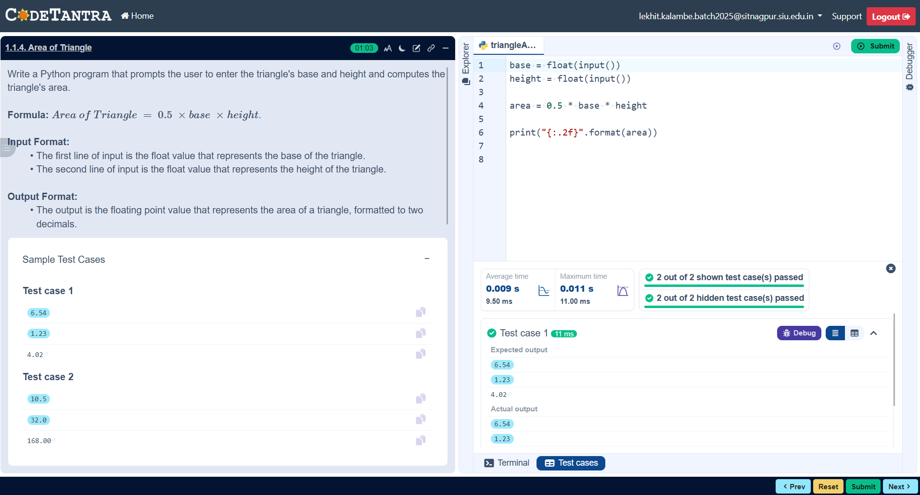
Practicle 1.1.5 :-
Aim :- Write a Python program to determine whether a student passed the exam or not based on their marks.
*Algorithm: Pass or Fail
Step 1. Start
Step 2. Input the marks obtained by the student
Step 3. If marks ≥ 40
→ Display "Pass"
- Else
→ Display "Fail"
Step 4. Stop
Flowchart :-
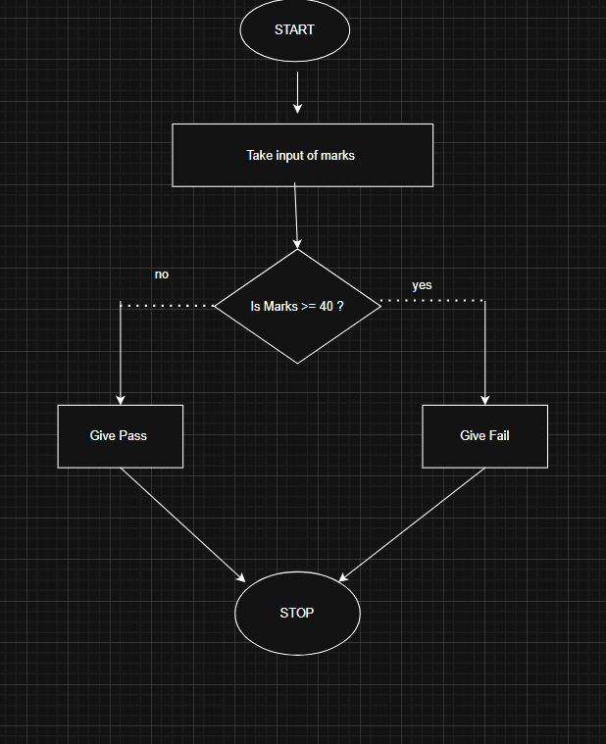
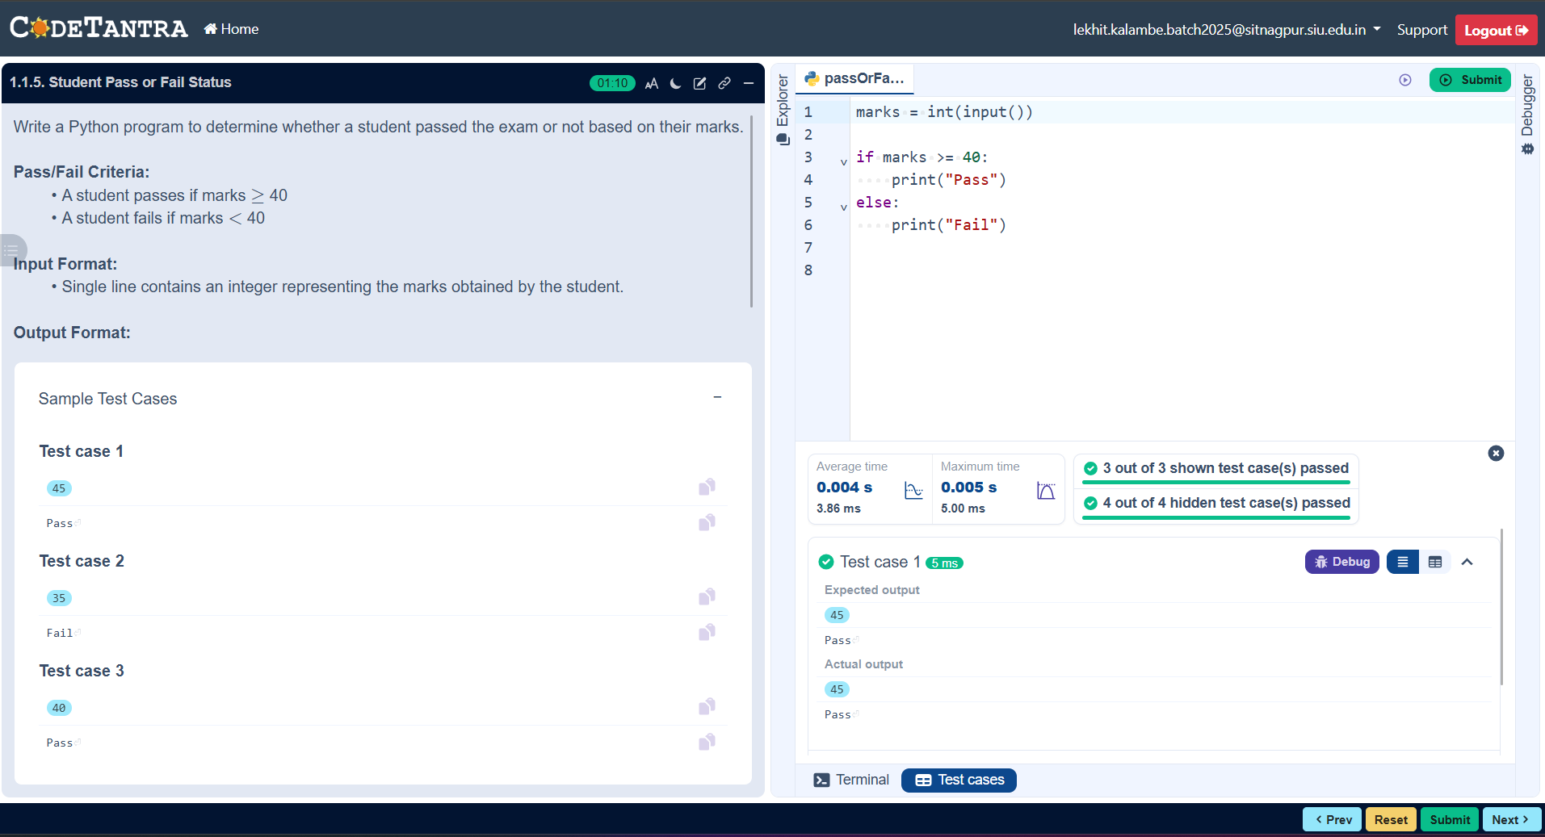
Practicle 2.1.1
Aim :- Write a program to find the roots of a quadratic equation, given its coefficients a, b, and c . Use the quadratic formula:
- Algorithm:- Step 1: Start
- Step 2: Input the coefficients a, b, and c
- Step 3: Calculate the discriminant D = b² − 4ac
- Step 4: If D > 0, calculate root1 = (−b + √D) / (2a) and root2 = (−b − √D) / (2a) and display both roots
- Step 5: Else if D = 0, calculate root = −b / (2a) and display root1 = root2 = root
- Step 6: Else if D < 0, calculate real part = −b / (2a) and imaginary part = √(−D) / (2a) and display root1 = real + imaginary i and root2 = real − imaginary i
- Step 7: Stop
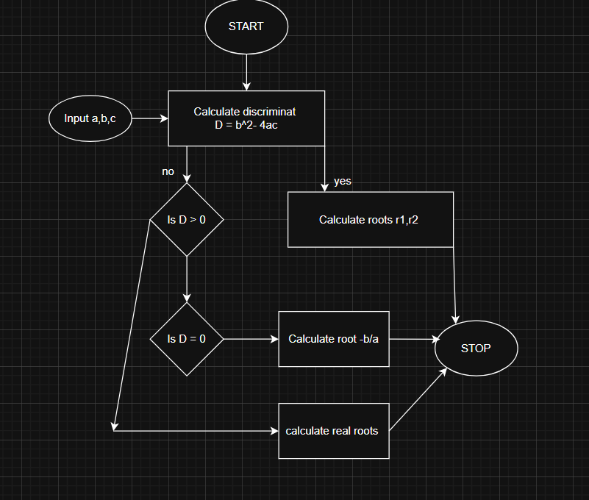
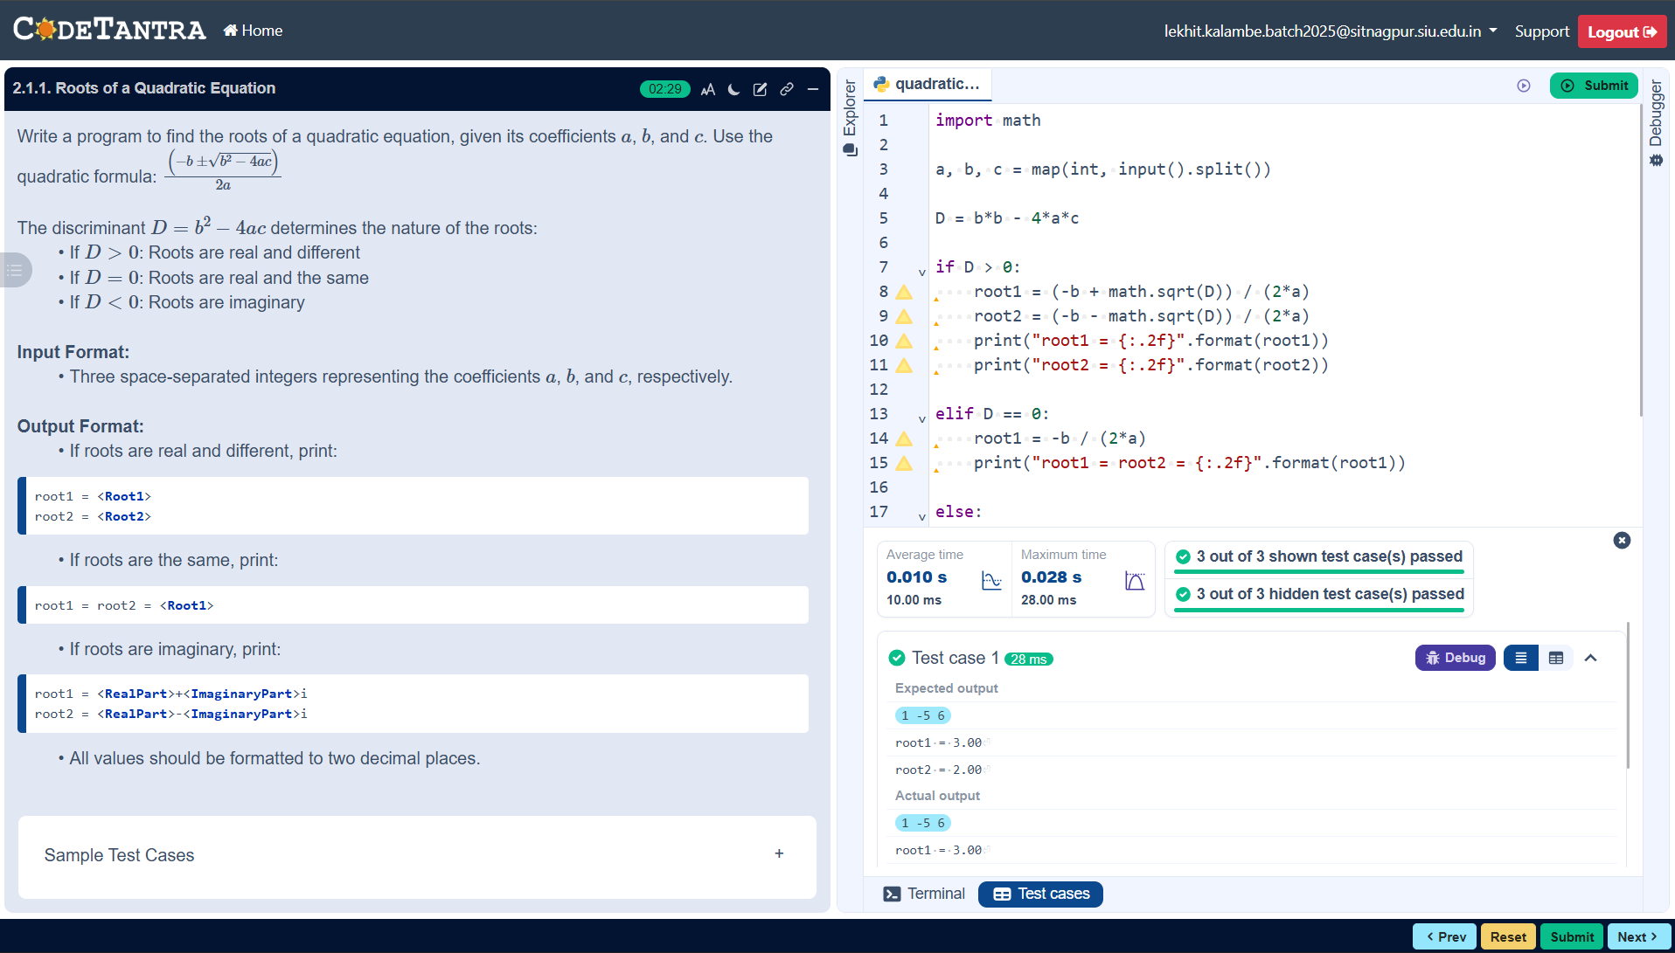
Practicle 3.1.1
*Aim :- Write a Python program that prompts the user to enter three integers. Print the largest of the three integers.
*Algorithm :- Step 1. Start: The entry point of the program.
Step 2. Input a, b, c: You enter the three integers.
Step 3. Decision 1 (is a >= b AND a >= c?):
- Yes: largest = a.
- No: Move to the next check.
Step 4. Decision 2 (is b >= a AND b >= c?):
- Yes: largest = b.
- No: By elimination, largest = c.
Step 5. Output: Print the value of largest.
Step 6. End: The program terminates.
*Flowchart :-
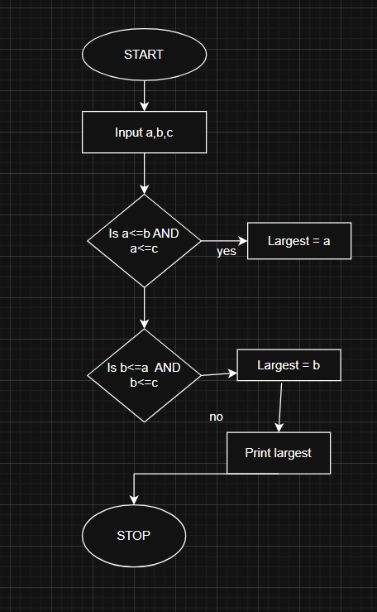
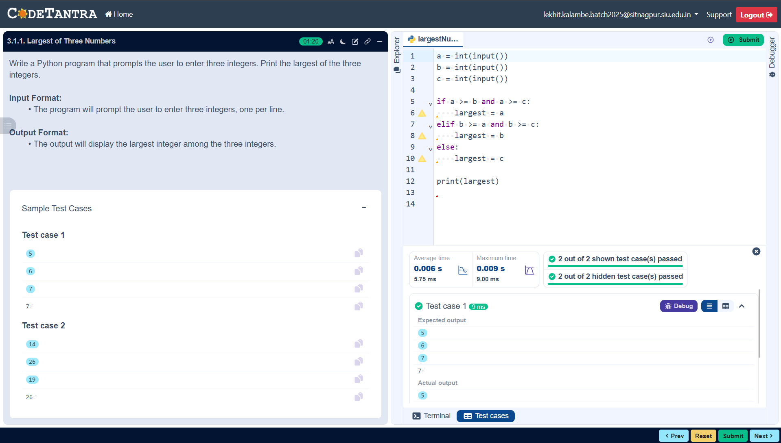

Practicle 3.1.2
*Aim :- Write a Python program to convert temperature from Celsius to Fahrenheit.
*Algorithm:- Celsius to Fahrenheit Conversion
Step 1. Start: Initialize the program.
Step 2. Input: Prompt the user and read a float value representing the temperature in Celsius.
Step 3. Calculation: Apply the conversion formula:
  - Fahrenheit = (Celsius *9/5) + 32
Step 4. Formatting : Format the resulting fahrenheit value to 2 decimal places.
Step 5. Output: Display the formatted Fahrenheit value.
Step 6. End: Terminate the program.

Flowchart:-
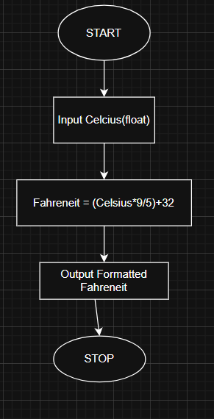

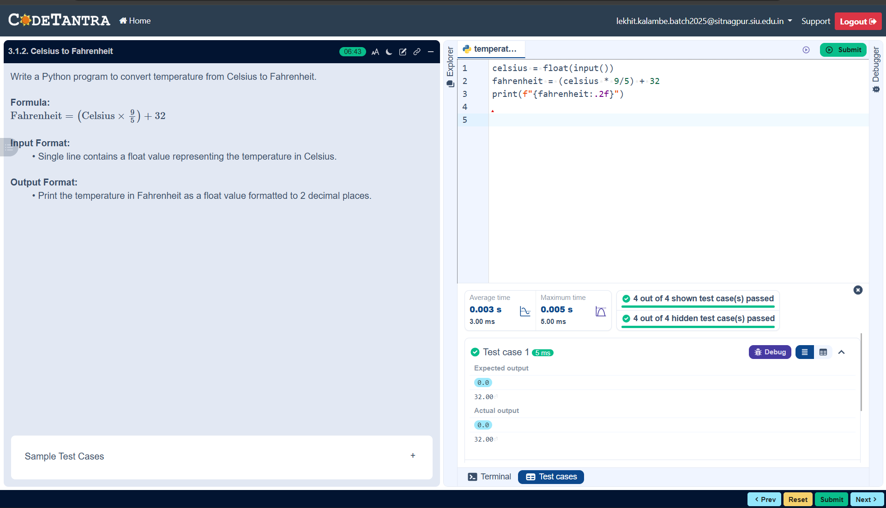

Practicle :- 4.1.1
*Aim:- Write a Python program to perform union, intersection and difference operations on Set A and Set B.
*Algorithm: Set Operations (Union, Intersection, Difference)
Step 1. Start
Step 2 . Prompt the user to enter elements of Set A as space-separated integers.
Step 3. Read the input and convert it into a set set_a.
Step 4. Prompt the user to enter elements of Set B as space-separated integers.
Step 5. Read the input and convert it into a set set_b.
Step 6. Find the union of set_a and set_b using the union operation.
Step 7. Find the intersection of set_a and set_b using the intersection operation.
Step 8. Find the difference of set_a and set_b (elements present in Set A but not in Set B).
Step 9. Display the union result.
Step 10. Display the intersection result.
Step 11. Display the difference result.
Step 12. Stop

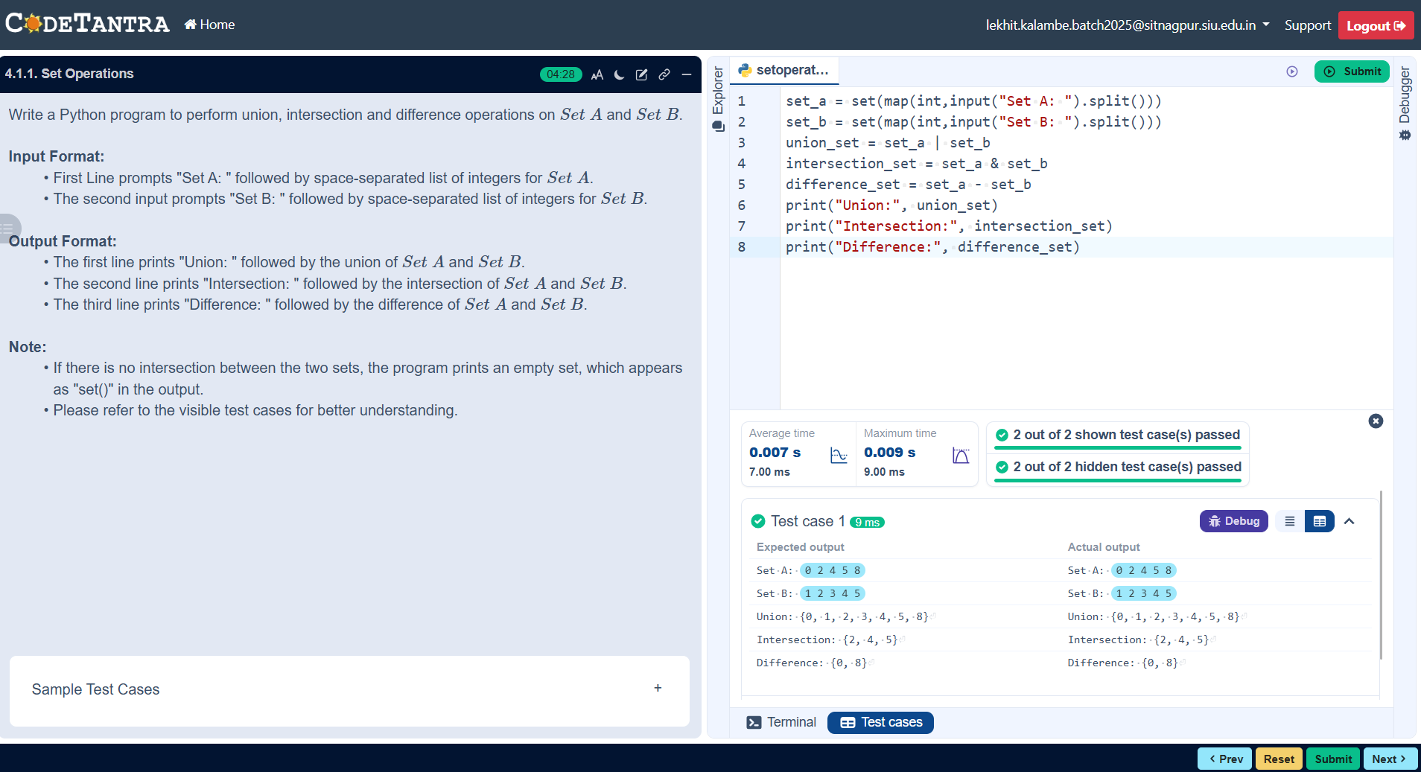
Flowchart :-
