Customer Input Data Cleaning Pipeline
Project Report | NewtonAI | Boston Institute of Analytics

1. Project Overview
Customer comments are noisy. They contain emojis, HTML tags, contractions, repeated characters, special symbols, and inconsistent casing, which makes them hard to analyze. In this project, I built a Python pipeline that reads a file, cleans the “Comment” column, and processes more than 1,000 rows in under 2 minutes.
My objectives were to:
- remove emojis and HTML tags from each comment;
- expand contractions and normalize repeated characters;
- remove non-alphabetic characters and convert text to lowercase;
- remove stopwords while keeping negations such as “not”;
- export a cleaned CSV with the original and cleaned comments;
- verify that the pipeline meets the 2-minute performance target.

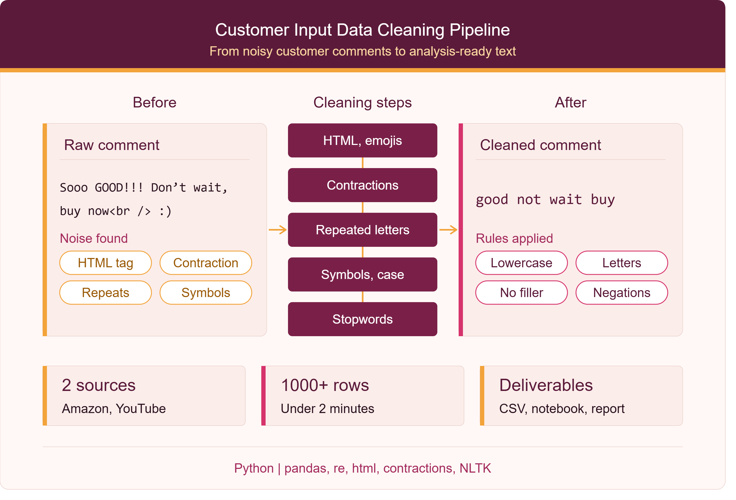
Figure 1. Project overview

2. Dataset
I used the Trending YouTube Video Statistics and Comments dataset from Kaggle (UScomments.csv). It contains real user comments with emojis, informal language, contractions, and repeated letters, which makes it a good test for the pipeline.
- I loaded only the comment_text column, because it is the only column the pipeline needs, and renamed it to “Comment” to match the project brief.
- I dropped empty rows and took a random sample of 2,000 comments with a fixed seed so the results are reproducible.
- After removing duplicate comments, 1,992 rows remained.
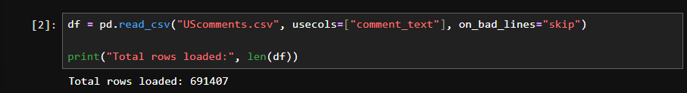
Figure 2. Loading the comment_text column (691,407 rows)
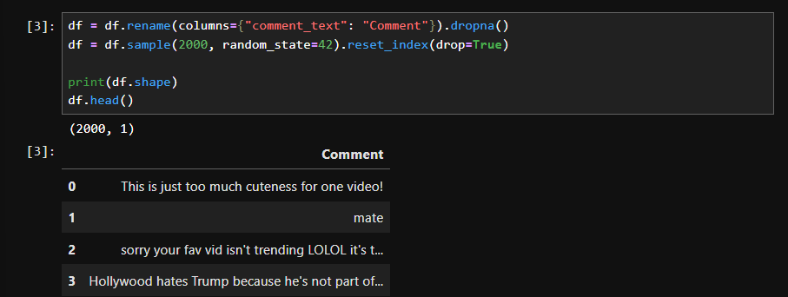
Figure 3. Renaming the column and taking a 2,000-row sample

3. Data Quality Check
Before cleaning, I checked the data for missing values and duplicates, and measured how many comments contain each type of noise. This showed which cleaning rules the data needs.
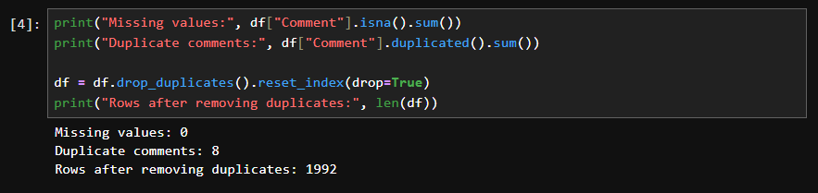
Figure 4. Missing values and duplicate check
I observed that emojis and repeated letters are common in the comments, while HTML tags are rare, so I tested the HTML rule on a hand-written example.

4. Cleaning Pipeline
I built each rule separately, tested it on sample text, and then combined them in this order inside one clean_text() function.
Step | What it does | Example
1. HTML and emojis | Decodes entities, removes tags, replaces emojis and other symbols with spaces | great<br /> → great
2. Contractions | Expands short forms using the contractions library | don’t → do not
3. Repeated letters | Shortens any letter repeated 3+ times to two | sooo → soo
4. Symbols and case | Lowercases text and keeps letters only | GREAT!!! → great
5. Stopwords | Removes filler words using NLTK, but keeps “no”, “nor”, and “not” | this is not good → not good

Design choices. I precompiled the regex patterns and stored the stopwords in a set, so the function stays fast on large inputs. I kept negations because removing them can reverse the meaning of a comment. I also tested the function on edge cases, such as empty values, numbers, and emoji-only text, and it returned an empty string without errors.
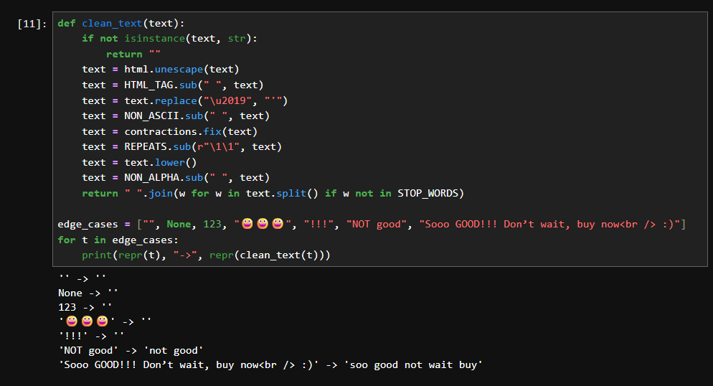
Figure 5. Final clean_text() function and edge case tests

5. Performance
I applied the pipeline to the dataset and timed it. I then repeated the data ten times to check that it scales well beyond the 1,000-row requirement.
Rows cleaned | Time (seconds) | Target
1,992 | 0.03 | Under 120
19,920 | 0.36 | Under 120

The pipeline cleaned 1,992 rows in 0.03 seconds, far below the 2-minute target. With 19,920 rows it took only 0.36 seconds, so it scales well.
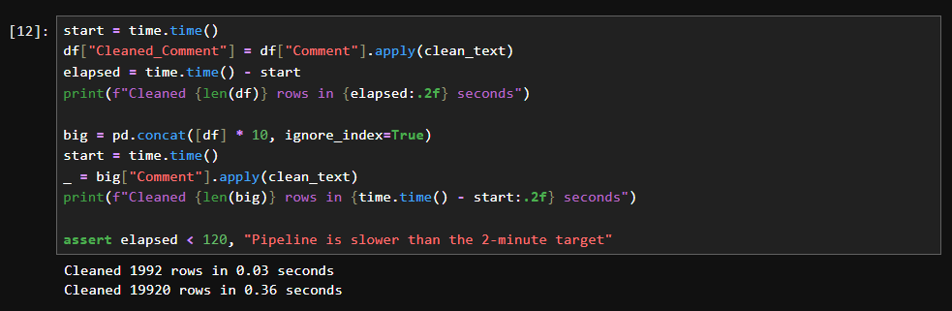
Figure 6. Timing the pipeline on 1,992 and 19,920 rows

6. Before and After Examples
These examples show the effect of the pipeline on noisy comments.
Raw comment | Cleaned comment
Sooo GOOD!!! Don’t wait, buy now<br /> :) | soo good not wait buy
great product<br /> | great product
NOT good | not good
(three smiling emojis only) | (empty string)
!!! | (empty string)

The screenshot below shows real comments from the dataset. Comments that contain only emojis or only non-English text become empty strings, which I discuss in Section 7.
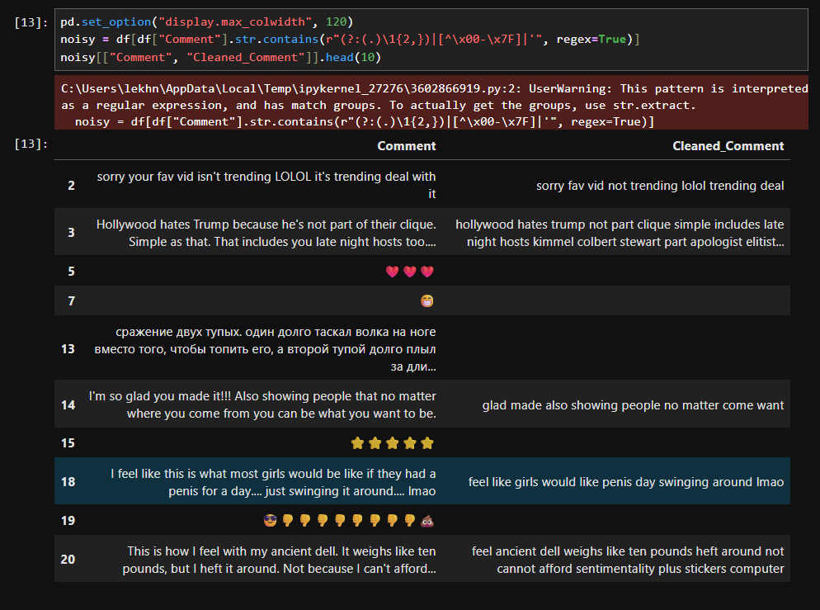
Figure 7. Before and after examples from the dataset

7. Limitations and Future Improvements
Limitations
- Removing non-ASCII characters also removes accented letters and non-English text. For example, a comment written in Russian was reduced to an empty string.
- Emojis are deleted instead of being converted into meaning, so any sentiment they carry is lost.
- Slang and misspellings are not corrected.
Future improvements
- Convert emojis into text instead of deleting them.
- Add lemmatization and spelling correction.
- Drop comments that become empty after cleaning.
- Process very large files in chunks.

8. Deliverables
File | Description
cleaning_notebook.ipynb | Documented notebook with every step, output, and observation
clean_comments.py | Reusable script that cleans the Comment column of a CSV or Excel file
cleaned_output.csv | Original and cleaned comments side by side
This report | Summary of the approach, results, and limitations

Figure 8. Exporting the cleaned CSV
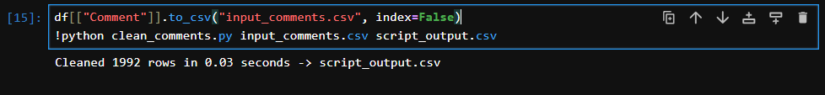
Figure 9. Running clean_comments.py from the command line

