RESEARCH PROJECT REPORT
Classifying News Articles
Multi-class headline classification using classical machine learning and deep learning
Prepared by | Lekhni Maheshchandra Churhe
Institution | Boston Institute of Analytics (BIA)
Submitted to | NewtonAI Technologies, Projects Team (projects@newtonai.tech)
Project type | Research project: multi-class text classification
Dataset | HuffPost News Category Dataset (v3)
Submission deadline | 11 October 2026

1. Executive Summary
News organisations publish large volumes of headlines, and sorting them into sections by hand does not scale. In this project I built a system that reads a news headline and assigns it to one of seven categories: Politics, Entertainment, Travel, Queer Voices, Women, Crime and Tech. I compared five models: three classical models on TF-IDF features (Logistic Regression, Naive Bayes, Linear SVM) and two recurrent neural networks on pretrained GloVe embeddings (LSTM, GRU).
After hyperparameter tuning and a model-improvement round, I selected Linear SVM with TF-IDF as my final model. It reached 85.37% validation accuracy and, after retraining on the combined training and validation data, 85.18% accuracy and 84.73% weighted F1-score on the untouched test set, clearing the 80% accuracy target. The two deep-learning models came within about one percentage point of it, but needed roughly 30 to 70 times more training time. All five models struggled most with the small, topically overlapping categories, particularly Women, and class imbalance was the main limiting factor.
I deployed the final model through a FastAPI prediction service and a Streamlit web interface, so headlines can be classified interactively.

Headline results
Item | Result
Final model | Linear SVM + TF-IDF (unigrams and bigrams)
Validation accuracy / weighted F1 | 85.37% / 85.01%
Test accuracy / weighted F1 | 85.18% / 84.73%
Test macro F1 (all seven classes equally weighted) | 0.76
Best / weakest category (test F1) | Politics (0.90) / Women (0.51)
Project target (80% accuracy) | Met by 4 of 5 models; the final model exceeds it by over 5 points

2. Introduction

2.1 Problem statement
The rapid growth of digital news makes it hard to organise content efficiently. Headlines vary in vocabulary, style and subject, so automatic categorisation is a challenging multi-class classification problem. The task is to assign each headline to exactly one of a small set of predefined categories.

2.2 Objectives
- Explore the dataset and analyse category distribution, headline length and word usage.
- Prepare the data: select categories, remove duplicates, clean the text, encode labels and split into training, validation and test sets.
- Build and compare classical models (Logistic Regression, Naive Bayes, Linear SVM) and deep-learning models (LSTM, GRU) with GloVe embeddings.
- Evaluate with accuracy, precision, recall, F1-score and confusion matrices, and analyse misclassifications.
- Deploy the best model for real-time use and document findings and recommendations.

2.3 Tools and technologies
Python and Jupyter Notebook; pandas and NumPy for data handling; NLTK for stopwords; scikit-learn for TF-IDF, classical models and metrics; TensorFlow/Keras for LSTM and GRU models; matplotlib, seaborn and WordCloud for visualisation; joblib for model persistence; FastAPI and Streamlit for deployment.

3. Dataset

3.1 Source and structure
I used the HuffPost News Category Dataset (version 3), which contains 209,527 articles published between January 2012 and September 2022 across 42 categories. Each record holds a link, headline, category, short description, author and date. I used only the headline as the input text and the category as the target.

3.2 Category selection
I selected seven categories from the 42 available, giving a project dataset of 78,449 headlines. The selection and its class balance are shown below.
Category | Headlines | Share of dataset
Politics | 35,602 | 45.4%
Entertainment | 17,362 | 22.1%
Travel | 9,900 | 12.6%
Queer Voices | 6,347 | 8.1%
Women | 3,572 | 4.6%
Crime | 3,562 | 4.5%
Tech | 2,104 | 2.7%
Total | 78,449 | 100.0%

3.3 Data quality
The dataset has no missing values. The full dataset contains 13 exact duplicate records, and the seven-category subset contained 373 duplicates, which I removed before splitting so that identical headlines could not appear in both training and evaluation data. This left 78,076 headlines.

4. Exploratory Data Analysis

4.1 Class imbalance
The classes are heavily imbalanced. Politics alone makes up about 45% of the data and is more than 17 times larger than Tech, while Women and Crime each hold roughly 4.5%. Politics and Entertainment together account for over two thirds of all headlines. Because a model can reach high accuracy simply by favouring Politics, I report per-class precision, recall and F1 and use stratified splits, rather than relying on accuracy alone.
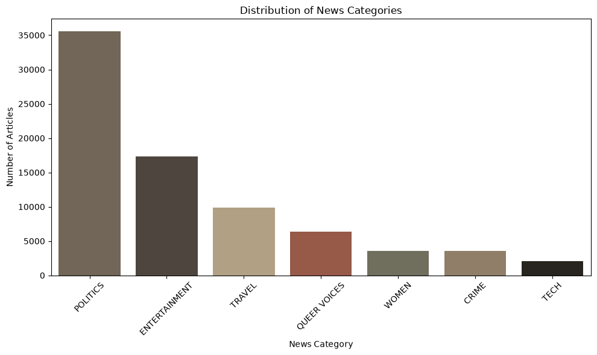
Figure 1. Number of headlines per category

4.2 Headline length
Headlines are short: the mean is about 10 words (median 10), most fall between 8 and 12 words, and the 95th percentile is 15 words. Medians are similar across categories, so length is a weak predictor and the classification must rely on the words themselves. A handful of headlines have zero or one word; these are data-quality outliers.
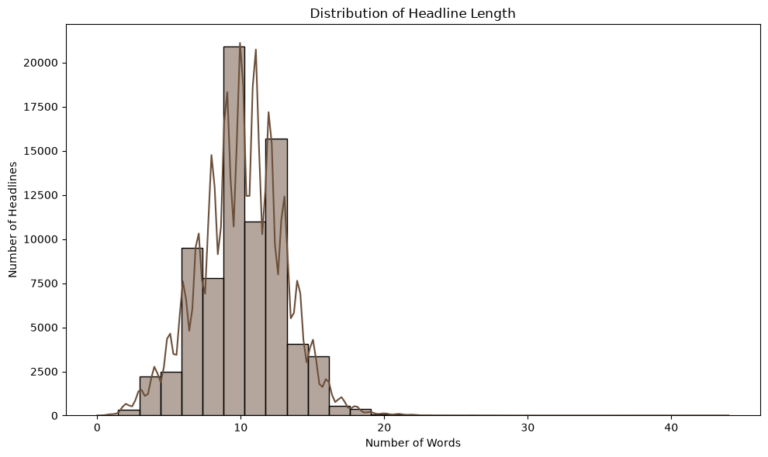
Figure 2. Distribution of headline length (number of words)

4.3 Vocabulary
After stopword removal, the most frequent words are "trump" (11,231), "new" (3,874), "donald" (3,625), "says" (2,376) and "gop" (1,981), reflecting the dominance of US politics. Each category nonetheless has distinctive signature words:
- Tech: apple, facebook, google, iphone, twitter (brand names).
- Crime: police, man, shooting, cops, killed, suspect.
- Queer Voices: gay, queer, lgbt, trans, transgender.
- Travel: photos, travel, world, best, hotel.
- Entertainment: star, movie, show, trailer, video.
- Women: women, woman, tweets, funniest, sexual, abortion (a mix of humour and social-issue content).
Generic headline words such as "new", "says" and "first" appear across categories and carry little discriminative power. Entertainment and Women both contain political names, which foreshadows the overlap with Politics seen later in the error analysis.
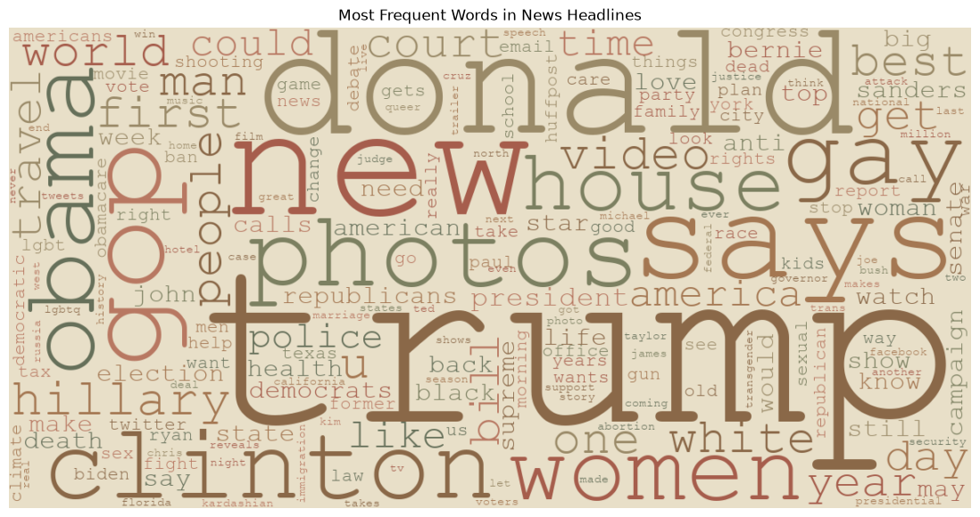
Figure 3. Word cloud of the most frequent headline words (stopwords removed)

5. Data Preparation
- Duplicate removal: 373 duplicate headline-category pairs dropped (78,449 to 78,076).
- Text cleaning: lowercasing, removal of special characters, punctuation and digits, and collapsing of extra spaces. The original headline was kept alongside the cleaned text for error analysis.
- Label encoding: the seven categories were mapped to integers with LabelEncoder (Crime 0, Entertainment 1, Politics 2, Queer Voices 3, Tech 4, Travel 5, Women 6).
- Stratified split: 80% training, 10% validation and 10% test, with the same category proportions in every set (random seed 42). The validation set was used to compare and tune models; the test set was held back for the final evaluation only.

Subset | Headlines | Purpose
Training | 62,460 | Fit models, vectoriser and tokenizer
Validation | 7,808 | Compare, tune and select models
Test | 7,808 | Final unbiased evaluation

Stopword removal was handled inside the TF-IDF vectoriser for the classical models, while the neural models received the cleaned text with stopwords kept, since recurrent networks can learn from word order and function words.

6. Methodology

6.1 TF-IDF features and classical models
TF-IDF (term frequency, inverse document frequency) turns each headline into a numeric vector. A word scores high when it is frequent in a given headline but rare across all headlines: TF-IDF(t, d) = TF(t, d) × log(N / df(t)), where N is the number of headlines and df(t) is the number of headlines containing t. I used unigrams and bigrams so that phrases such as "new movie" are captured, and removed English stopwords. The vectoriser was fitted on the training set only and then applied to the validation and test sets to avoid data leakage. The initial feature space had 293,226 features.
- Logistic Regression: a linear model that outputs class probabilities through the softmax function and is trained by minimising cross-entropy loss. The regularisation strength is controlled by C.
- Multinomial Naive Bayes: a probabilistic model that assumes words are independent given the class; its smoothing parameter alpha prevents zero probabilities.
- Linear SVM: finds the decision boundary that maximises the margin between classes, which suits high-dimensional sparse text features.

6.2 GloVe embeddings and recurrent networks
GloVe (Global Vectors) provides pretrained 100-dimensional word vectors learned from word co-occurrence statistics in a very large text corpus, so words with similar meanings lie close together in vector space. I used the glove.6B.100d file (400,001 words). Headlines were converted to integer sequences with a Keras Tokenizer (vocabulary capped at 20,000 words, with an out-of-vocabulary token), then padded or truncated to 15 tokens, the 95th percentile of headline length. An embedding matrix of shape 20,000 × 100 was built from GloVe and kept frozen in the network.
Both recurrent models share the same structure: Embedding (frozen GloVe) → LSTM or GRU (128 units) → Dropout (0.3) → Dense (64, ReLU) → Dropout (0.3) → Dense (7, softmax). An LSTM keeps a memory cell controlled by forget, input and output gates, which lets it retain information across a sequence; a GRU is a simpler variant with fewer gates and parameters. Training used the Adam optimiser, sparse categorical cross-entropy loss, batch size 64 and up to 10 epochs, with early stopping on validation accuracy (patience 2) to limit overfitting.

6.3 Evaluation metrics
- Accuracy = correct predictions / all predictions.
- Precision = TP / (TP + FP): of the headlines predicted as a class, how many truly belong to it.
- Recall = TP / (TP + FN): of the headlines that truly belong to a class, how many were found.
- F1-score = 2 × Precision × Recall / (Precision + Recall). I report the weighted average (by class size) and the macro average (all classes equal), because the macro value exposes weak small classes.
- Confusion matrix: counts of true versus predicted categories, used to see which categories are mixed up.

7. Results and Model Comparison

7.1 Baseline models
Table 1 compares the five models with default settings on the validation set. Linear SVM was the strongest, and Naive Bayes was clearly the weakest.
Model | Accuracy | Precision | Recall | F1-score | Train time
Logistic Regression | 82.76% | 82.47% | 82.76% | 81.92% | 33.4 s
Naive Bayes | 69.17% | 78.61% | 69.17% | 62.39% | 0.07 s
Linear SVM | 85.68% | 85.26% | 85.68% | 85.30% | 2.5 s
LSTM | 84.11% | 83.78% | 84.11% | 83.84% | 69.6 s
GRU | 84.86% | 84.71% | 84.86% | 84.66% | 81.1 s
Table 1. Baseline validation performance (weighted precision, recall and F1)
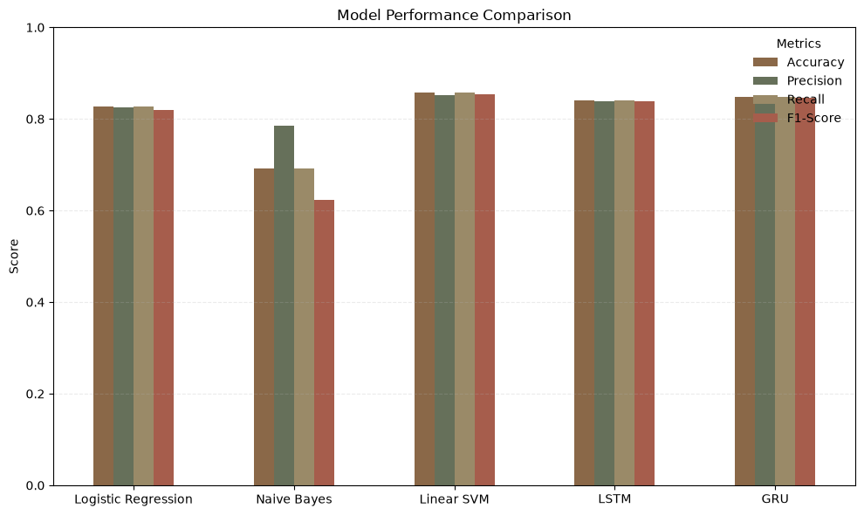
Figure 4. Baseline performance of the five models
Naive Bayes reached 69% accuracy only because it predicted the majority class too often: it recalled 99% of Politics but under 10% of Crime, Queer Voices, Tech and Women, even though its precision on those classes was close to 100%. This is a clear symptom of class imbalance. Training cost also varied widely: Naive Bayes trained in a fraction of a second and the SVM in a couple of seconds, whereas the neural networks needed over a minute.
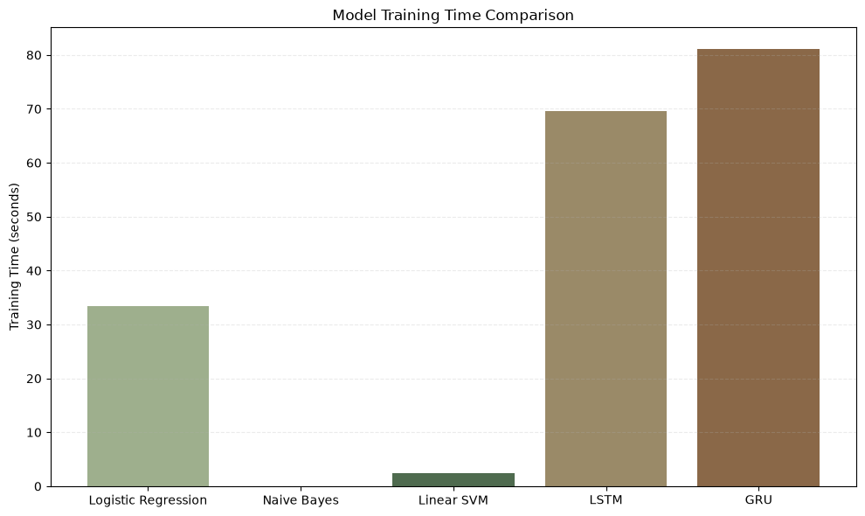
Figure 5. Training time per model (seconds)

7.2 Hyperparameter tuning
For the classical models I tuned one key parameter with 3-fold cross-validated grid search, scoring on weighted F1.
Model | Parameter grid | Best value | CV F1 | Val. accuracy | Val. F1
Logistic Regression | C: 0.01 to 100 | C = 100 | 0.829 | 84.85% | 84.57%
Naive Bayes | alpha: 0.01 to 2.0 | alpha = 0.1 | 0.787 | 80.29% | 77.59%
Linear SVM | C: 0.01 to 100 | C = 10 | 0.837 | 85.50% | 85.22%
Table 2. Tuning results on the original TF-IDF features
Tuning lifted Logistic Regression by about two points and Naive Bayes by more than eleven, but made almost no difference to the SVM, whose accuracy stayed between 85.4% and 85.7% across the configurations I tried. This suggests the SVM was already close to the limit of what TF-IDF features can deliver on this task.

7.3 Model improvement
Informed by the error analysis, I tried two improvements. First, I refined the TF-IDF vectoriser with min_df = 2 (drop words appearing in fewer than two headlines), max_df = 0.95 (drop words in more than 95% of headlines) and sublinear term-frequency scaling, which reduced the feature space from 293,226 to 49,205 features. Second, I deepened the recurrent networks to two stacked layers (128 then 64 units).
Model | Baseline accuracy | Improved accuracy | Baseline F1 | Improved F1
Logistic Regression | 82.76% | 83.58% | 81.92% | 82.82%
Naive Bayes | 69.17% | 76.22% | 62.39% | 71.63%
Linear SVM | 85.68% | 85.37% | 85.30% | 85.01%
Table 3. Effect of the refined TF-IDF configuration (validation set)
The cleaner vectoriser helped the models that were weakest (Logistic Regression and especially Naive Bayes) and was neutral for the SVM, while shrinking the feature space by about 83%, which makes training and deployment lighter. The stacked LSTM and GRU reached 84.57% and 84.55% accuracy: a gain of under half a point for the LSTM and no gain for the GRU, with noticeably longer training. In short, the added depth did not pay for itself.
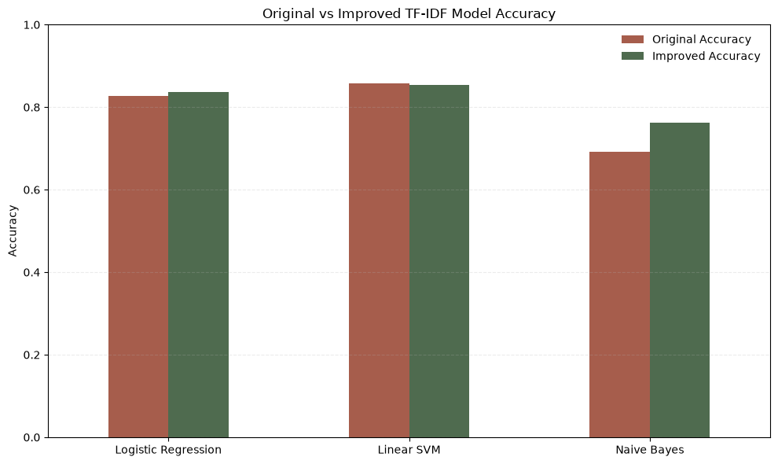
Figure 6. Original versus improved TF-IDF model accuracy

7.4 Final model comparison
Model | Accuracy | Precision | Recall | F1-score
Logistic Regression | 83.58% | 83.32% | 83.58% | 82.82%
Naive Bayes | 76.22% | 79.55% | 76.22% | 71.63%
Linear SVM | 85.37% | 84.97% | 85.37% | 85.01%
LSTM (2-layer) | 84.57% | 84.37% | 84.57% | 84.36%
GRU (2-layer) | 84.55% | 84.80% | 84.55% | 84.57%
Table 4. Final validation comparison of all five models
I selected the final model by the highest weighted F1-score on the validation set, which gave Linear SVM (85.01%), followed closely by GRU (84.57%) and LSTM (84.36%). The three leading models are within one percentage point of each other, so the practical deciding factors were efficiency and simplicity: the SVM trains in about two seconds, needs no GPU or embedding file, and is easy to deploy.
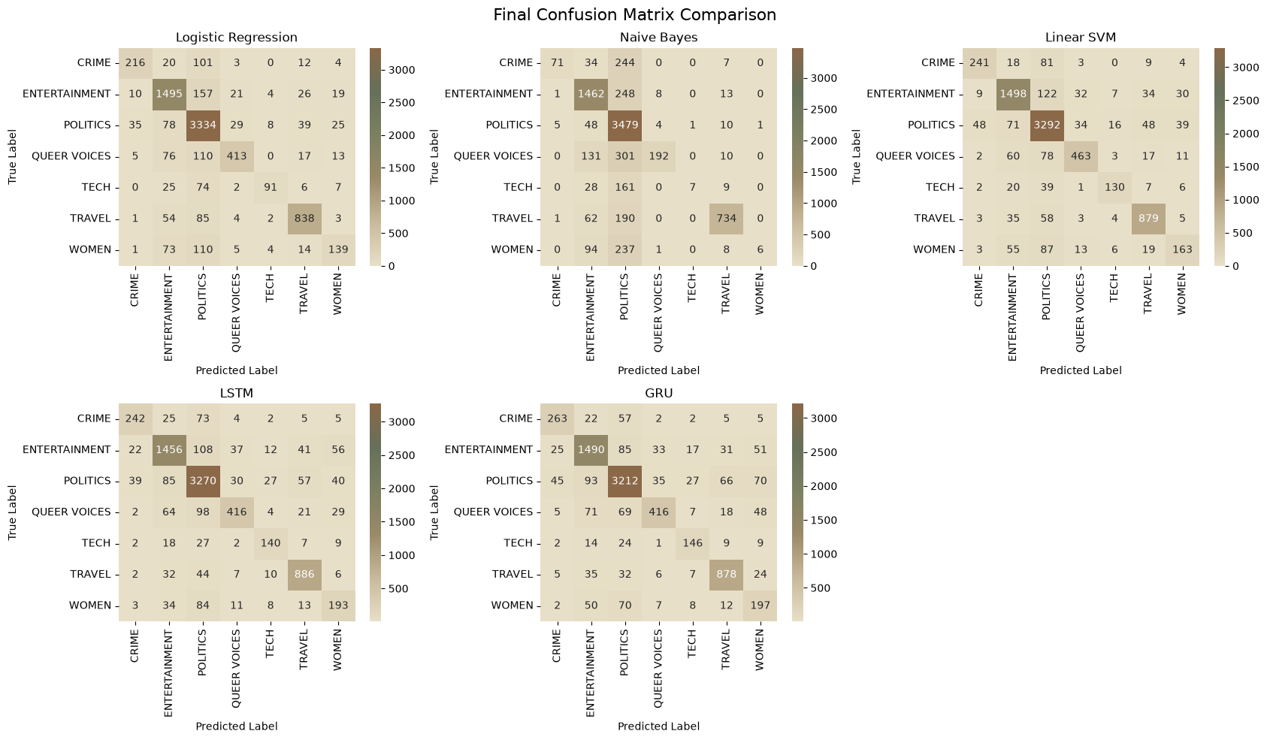
Figure 7. Confusion matrices of all five models on the validation set

7.5 Final evaluation on the test set
For the final evaluation I retrained the selected configuration (Linear SVM with the refined TF-IDF vectoriser) on the combined training and validation data (70,268 headlines) and evaluated it once on the held-out test set. The test accuracy of 85.18% is within 0.2 points of the validation accuracy (85.37%), which indicates the model generalises well and did not overfit the validation data.
Category | Precision | Recall | F1-score | Support
Crime | 0.77 | 0.67 | 0.72 | 356
Entertainment | 0.84 | 0.86 | 0.85 | 1,732
Politics | 0.88 | 0.93 | 0.90 | 3,548
Queer Voices | 0.85 | 0.71 | 0.78 | 634
Tech | 0.73 | 0.63 | 0.68 | 205
Travel | 0.87 | 0.89 | 0.88 | 988
Women | 0.64 | 0.43 | 0.51 | 345
Macro average | 0.80 | 0.73 | 0.76 | 7,808
Weighted average | 0.85 | 0.85 | 0.85 | 7,808
Table 5. Per-category test performance of the final model (accuracy 85.18%)
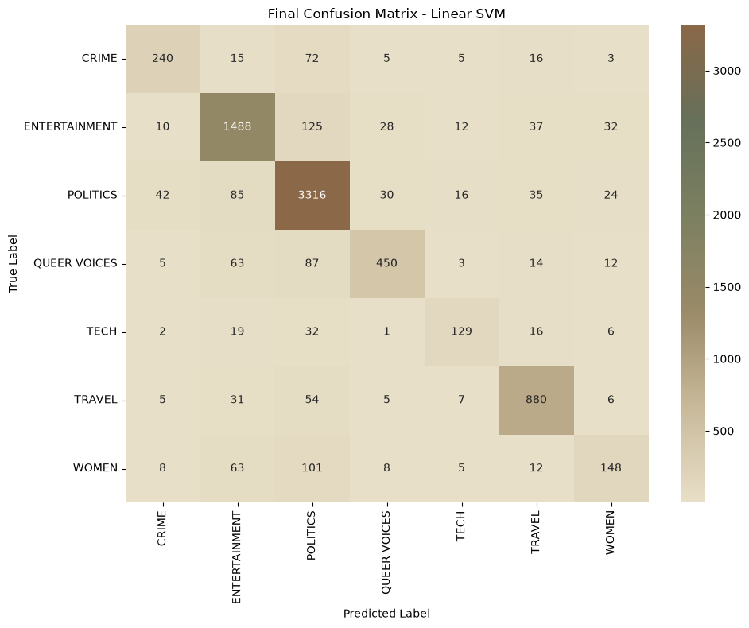
Figure 8. Confusion matrix of the final model on the test set

8. Error Analysis
I analysed the validation errors of the baseline Linear SVM, which misclassified 1,118 of 7,808 headlines (14.3%). The largest absolute error counts fall on Politics (245) and Entertainment (230), but relative to class size the worst categories are Women, Tech, Queer Voices and Crime, whose recall is the lowest.
True category | Predicted as | Errors
Entertainment | Politics | 119
Women | Politics | 85
Queer Voices | Politics | 80
Crime | Politics | 73
Politics | Entertainment | 67
Queer Voices | Entertainment | 62
Women | Entertainment | 62
Travel | Politics | 51
Table 6. Most frequent confusions (baseline Linear SVM, validation set)
Politics acts as an "attractor": most of the biggest confusions send other categories into it. I see four likely reasons:
- Class imbalance. Politics is the largest class, so a model that is uncertain tends to fall back on it.
- Overlapping topics and shared vocabulary. Entertainment, Women and Queer Voices headlines frequently mention politicians, laws or elections.
- Short headlines with little context. Examples such as "elephantback safaris" or "internets sad legacy no more secrets" offer few category-specific cues.
- Ambiguous labels. Some headlines can reasonably belong to more than one category, for example a news item about a politician appearing on a TV show.
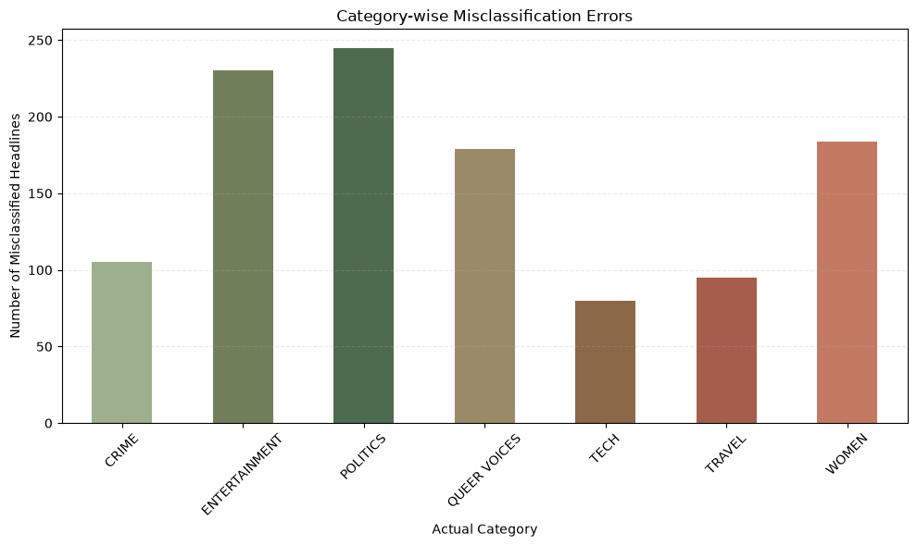
Figure 9. Misclassified headlines by true category

9. Deployment

9.1 FastAPI prediction service
I wrapped the saved model, TF-IDF vectoriser and label encoder in a REST API with FastAPI and Uvicorn. The service exposes a health endpoint (GET /) and a prediction endpoint (POST /predict) that accepts a headline as JSON, applies the same cleaning steps used in training, vectorises the text and returns the predicted category. Swagger UI documents and tests the endpoint. In the test below, the headline "Women and queer people march in Hyderabad to reclaim public spaces" returned a 200 OK response with the category QUEER VOICES.
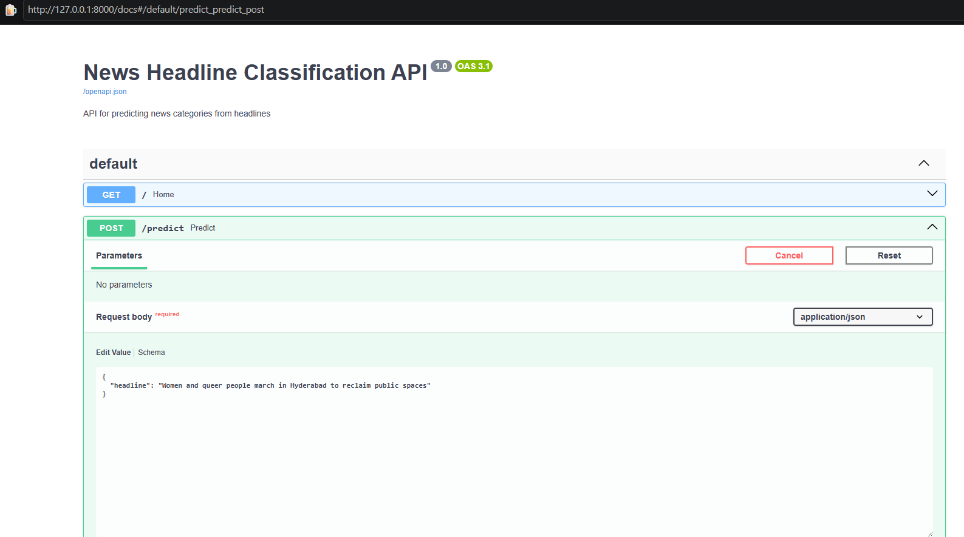
Figure 10. Swagger UI for the News Headline Classification API
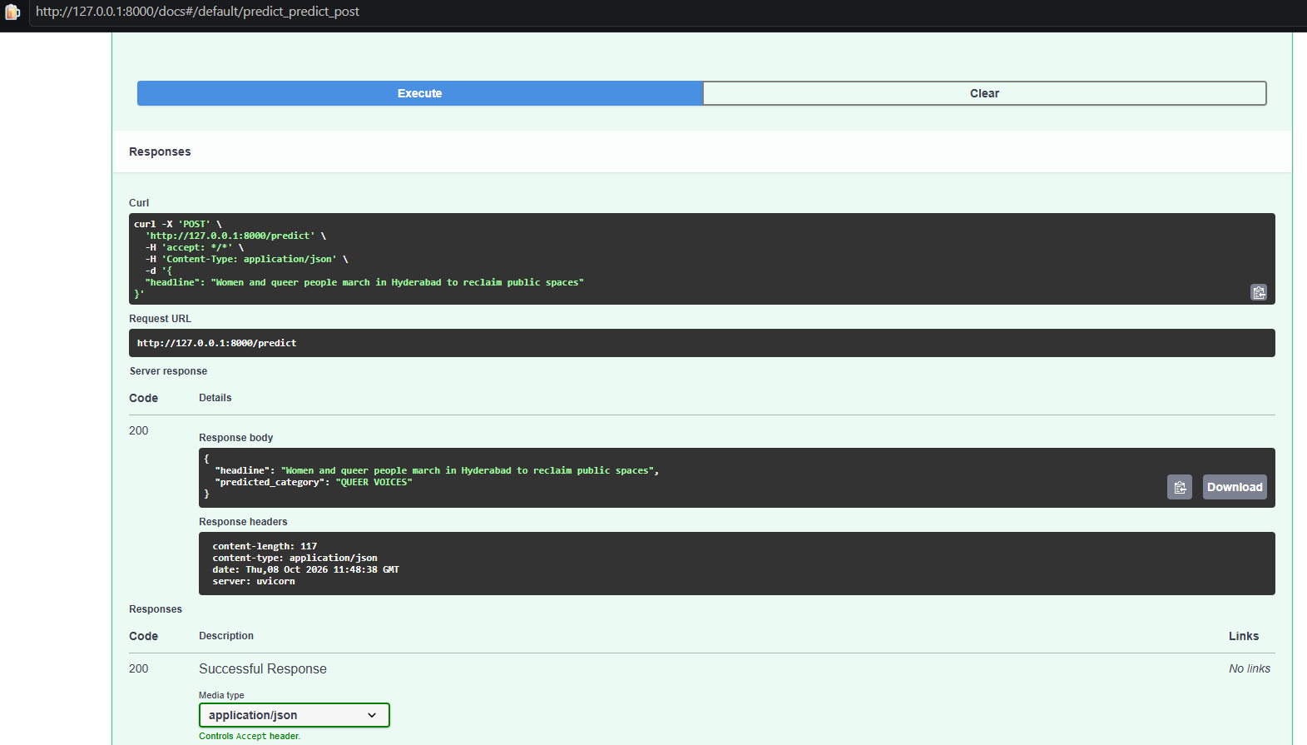
Figure 11. A successful /predict request and response

9.2 Streamlit web application
I also built a Streamlit interface styled as a newspaper front page ("The News Chronicle"). The user enters a headline and the application returns the predicted category, and the page lists the seven categories the model covers. The same saved preprocessing and model files are used, so the app and the API give consistent predictions. Sample sanity checks in the notebook behave sensibly: a headline about Apple and artificial intelligence is labelled Tech, a Hollywood movie announcement is Entertainment, a government policy debate is Politics and a hotel opening for tourists is Travel.

10. Key Findings
- The classical model won. TF-IDF with a Linear SVM achieved the best weighted F1 (85.01% validation, 84.73% test) and was the fastest of the strong models, training in about two seconds against 70 to 130 seconds for the neural networks.
- Deep learning was competitive but not superior. LSTM and GRU with frozen GloVe embeddings scored within about one point of the SVM. For short headlines, word and phrase frequencies carry most of the signal, so sequence modelling adds little.
- Four of the five models exceeded the 80% target. Naive Bayes reached 80.3% only after tuning and was the weakest model overall.
- Class imbalance is the dominant weakness. Overall accuracy (85%) hides a macro F1 of 0.76. Women (F1 0.51) and Tech (0.68) are the hardest categories because they are small and share vocabulary with larger ones.
- Most confusions flow into Politics. The largest error cells all point to the biggest, broadest category.
- Feature cleaning mattered more than model depth. Refining TF-IDF (min_df, max_df, sublinear scaling) cut features by 83% and sharply improved the weaker classical models, whereas stacking extra recurrent layers brought almost no gain.
- The model generalises. Test accuracy was within 0.2 points of validation accuracy.

11. Recommendations
- Adopt Linear SVM with TF-IDF as the primary production model. It offers the best accuracy-to-cost ratio, trains in seconds and is simple to maintain. Keep the GRU as a secondary candidate, for example in an ensemble, if more accuracy is needed.
- Address class imbalance directly. Apply class weighting (for example class_weight="balanced" for the SVM and Logistic Regression and class weights in the neural models), or resample the small classes. This is the most promising route to better recall for Women, Tech and Crime.
- Add confidence handling to the API. Calibrate the SVM scores (for example with CalibratedClassifierCV), return the top-three categories with confidence values and flag low-confidence headlines for human review.
- Use richer text where available. Adding the article short description alongside the headline would give models more context to separate overlapping categories.
- Review the category scheme. Identity-focused categories such as Women and Queer Voices overlap with Politics and Entertainment by nature. Consider a multi-label design or clearer labelling rules.
- Evaluate a transformer model. Fine-tuning a compact model such as DistilBERT is the logical next step and may capture context that TF-IDF cannot.
- Plan for monitoring and retraining. News vocabulary shifts quickly, so track accuracy on fresh headlines and retrain periodically.

12. Limitations
- The system recognises only the seven selected categories; headlines about other topics will still be forced into one of them.
- The data covers 2012 to 2022 and is heavy with US political vocabulary (for example "trump", "clinton", "obama"), so performance on current or non-US news may be lower.
- Class imbalance was observed and measured but not corrected with class weights or resampling in this study.
- Only the headline was used; short headlines often lack enough context to be unambiguous.
- Hyperparameter search was applied to the classical models only. The neural networks used fixed settings, frozen GloVe embeddings and a single training run, and deep-learning results vary slightly between runs because of random initialisation.
- The model classifies by learned patterns and does not verify the factual accuracy of a headline.

13. Future Work
- Fine-tune transformer models (BERT or DistilBERT) and compare against the SVM.
- Test fine-tuned (unfrozen) embeddings, bidirectional recurrent layers and larger GloVe dimensions.
- Add explainability, such as the top TF-IDF terms behind each prediction, and uncertainty warnings for ambiguous headlines.
- Extend coverage to more categories and evaluate on recent, multi-source news.

14. Conclusion
This project showed that news headlines can be classified into seven categories with about 85% accuracy using only the headline text. A carefully prepared TF-IDF representation with a Linear SVM matched or outperformed more complex recurrent models while being far cheaper to train and deploy, and it held its performance on unseen test data. The remaining errors are concentrated in small, overlapping categories, so the next gains are more likely to come from handling class imbalance, adding context and trying transformer models than from adding depth to the current networks. The final system is available through a FastAPI service and a Streamlit application, and the complete workflow is documented in the accompanying Jupyter notebook.

Appendix A. Configuration Summary
Component | Setting
Split | 80/10/10 stratified, random_state = 42 (62,460 / 7,808 / 7,808)
Final TF-IDF | unigrams + bigrams, English stopwords removed, min_df = 2, max_df = 0.95, sublinear_tf = True (54,625 features when fitted on train + validation)
Final classifier | LinearSVC, random_state = 42, trained on 70,268 headlines
Logistic Regression | max_iter = 1000; tuned C = 100 (grid 0.01 to 100)
Naive Bayes | MultinomialNB; tuned alpha = 0.1
Sequence settings | vocabulary 20,000, OOV token, MAX_LEN = 15, post-padding and truncation
Embeddings | GloVe 6B, 100 dimensions, frozen; matrix 20,000 × 100
Recurrent models | 128-unit LSTM/GRU, Dropout 0.3, Dense 64 (ReLU), Dense 7 (softmax); improved variant adds a second 64-unit layer
Training | Adam, sparse categorical cross-entropy, batch 64, max 10 epochs, early stopping on validation accuracy (patience 2)
Environment | Python 3, TensorFlow 2.21, scikit-learn, Windows (CPU only)

Appendix B. Deliverables
- Jupyter notebook: Classifying_news_articles_p1.ipynb (preprocessing pipeline, two required classification models plus three additional models, evaluation metrics and plots).
- This report (model comparison, key findings and recommendations).
- Streamlit classifier demo and FastAPI service, with saved model files.
- Source repository: https://github.com/lekhniya/classifying_news

