**DVS Technologies Aws & Devops**

**Verifying A/C Limits:**

**Step1:**

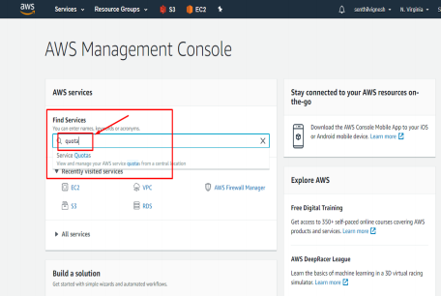**Step2:**

DVS Technologies, Opp Home Town, Beside Biryani Zone, Marathahalli, Bangalore Phone: 9632558585 Mobile: 8892499499 Mail : dvs.training@gmail.com Web: www.dvstechnologies.in

**DVS Technologies Aws & Devops** 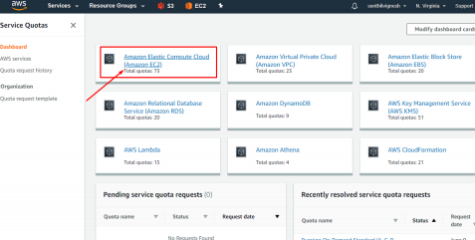

**Step3:**

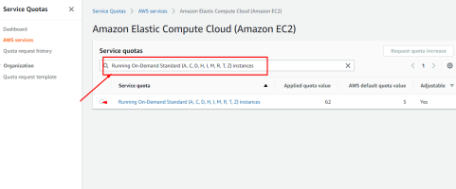**Step4:**

DVS Technologies, Opp Home Town, Beside Biryani Zone, Marathahalli, Bangalore Phone: 9632558585 Mobile: 8892499499 Mail : dvs.training@gmail.com Web: www.dvstechnologies.in

**DVS Technologies Aws & Devops 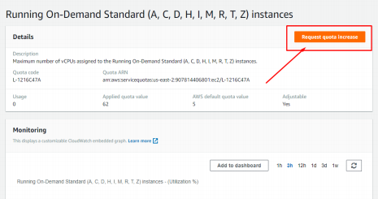Step5:**

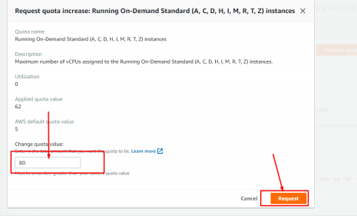

DVS Technologies, Opp Home Town, Beside Biryani Zone, Marathahalli, Bangalore Phone: 9632558585 Mobile: 8892499499 Mail : dvs.training@gmail.com Web: www.dvstechnologies.in

**DVS Technologies Aws & Devops**

**1. Choosing IAM Service:**

**Working With IAM :**

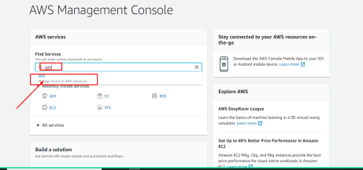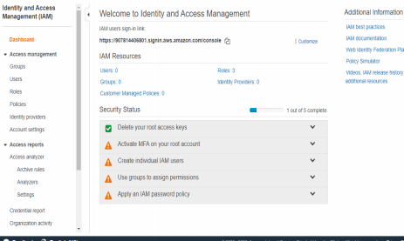

DVS Technologies, Opp Home Town, Beside Biryani Zone, Marathahalli, Bangalore Phone: 9632558585 Mobile: 8892499499 Mail : dvs.training@gmail.com Web: www.dvstechnologies.in

**DVS Technologies Aws & Devops**

**2. Create a New user without any permissions**

**Step1:**

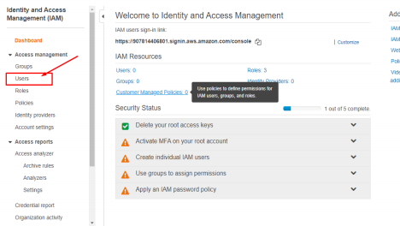

**Step2:**

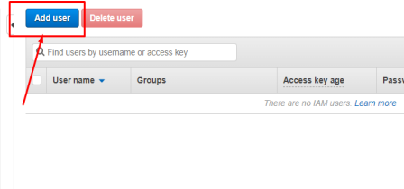**Step3:**

DVS Technologies, Opp Home Town, Beside Biryani Zone, Marathahalli, Bangalore Phone: 9632558585 Mobile: 8892499499 Mail : dvs.training@gmail.com Web: www.dvstechnologies.in

**DVS Technologies Aws & Devops** 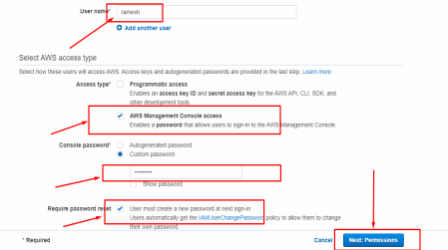

**Step4:**

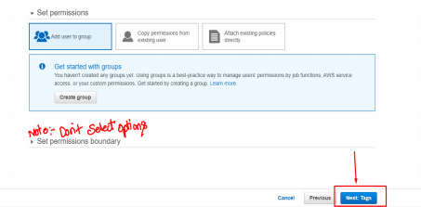**Step5:**

DVS Technologies, Opp Home Town, Beside Biryani Zone, Marathahalli, Bangalore Phone: 9632558585 Mobile: 8892499499 Mail : dvs.training@gmail.com Web: www.dvstechnologies.in

**DVS Technologies Aws & Devops** 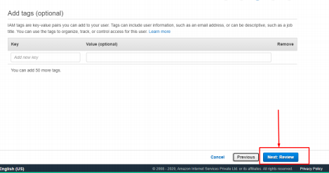

**Step6:**

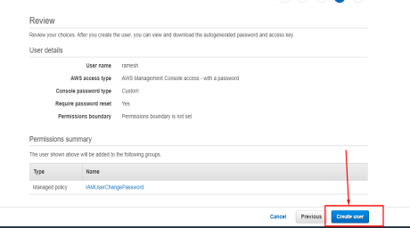**Step7:**

DVS Technologies, Opp Home Town, Beside Biryani Zone, Marathahalli, Bangalore Phone: 9632558585 Mobile: 8892499499 Mail : dvs.training@gmail.com Web: www.dvstechnologies.in

**DVS Technologies Aws & Devops 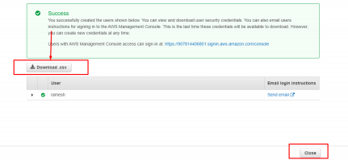3. Granting Access for IAM user**

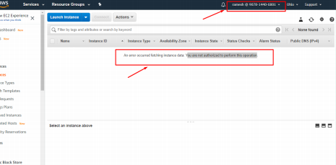

DVS Technologies, Opp Home Town, Beside Biryani Zone, Marathahalli, Bangalore Phone: 9632558585 Mobile: 8892499499 Mail : dvs.training@gmail.com Web: www.dvstechnologies.in

**DVS Technologies Aws & Devops **

DVS Technologies, Opp Home Town, Beside Biryani Zone, Marathahalli, Bangalore Phone: 9632558585 Mobile: 8892499499 Mail : dvs.training@gmail.com Web: www.dvstechnologies.in

**DVS Technologies Aws & Devops **

DVS Technologies, Opp Home Town, Beside Biryani Zone, Marathahalli, Bangalore Phone: 9632558585 Mobile: 8892499499 Mail : dvs.training@gmail.com Web: www.dvstechnologies.in

**DVS Technologies Aws & Devops **

DVS Technologies, Opp Home Town, Beside Biryani Zone, Marathahalli, Bangalore Phone: 9632558585 Mobile: 8892499499 Mail : dvs.training@gmail.com Web: www.dvstechnologies.in

**DVS Technologies Aws & Devops **

DVS Technologies, Opp Home Town, Beside Biryani Zone, Marathahalli, Bangalore Phone: 9632558585 Mobile: 8892499499 Mail : dvs.training@gmail.com Web: www.dvstechnologies.in

**DVS Technologies Aws & Devops **

DVS Technologies, Opp Home Town, Beside Biryani Zone, Marathahalli, Bangalore Phone: 9632558585 Mobile: 8892499499 Mail : dvs.training@gmail.com Web: www.dvstechnologies.in

**DVS Technologies Aws & Devops **

DVS Technologies, Opp Home Town, Beside Biryani Zone, Marathahalli, Bangalore Phone: 9632558585 Mobile: 8892499499 Mail : dvs.training@gmail.com Web: www.dvstechnologies.in

**DVS Technologies Aws & Devops **

DVS Technologies, Opp Home Town, Beside Biryani Zone, Marathahalli, Bangalore Phone: 9632558585 Mobile: 8892499499 Mail : dvs.training@gmail.com Web: www.dvstechnologies.in

**DVS Technologies Aws & Devops **

DVS Technologies, Opp Home Town, Beside Biryani Zone, Marathahalli, Bangalore Phone: 9632558585 Mobile: 8892499499 Mail : dvs.training@gmail.com Web: www.dvstechnologies.in

**DVS Technologies Aws & Devops **

DVS Technologies, Opp Home Town, Beside Biryani Zone, Marathahalli, Bangalore Phone: 9632558585 Mobile: 8892499499 Mail : dvs.training@gmail.com Web: www.dvstechnologies.in

**DVS Technologies Aws & Devops **

**4. Reset user password**



DVS Technologies, Opp Home Town, Beside Biryani Zone, Marathahalli, Bangalore Phone: 9632558585 Mobile: 8892499499 Mail : dvs.training@gmail.com Web: www.dvstechnologies.in

**DVS Technologies Aws & Devops **

DVS Technologies, Opp Home Town, Beside Biryani Zone, Marathahalli, Bangalore Phone: 9632558585 Mobile: 8892499499 Mail : dvs.training@gmail.com Web: www.dvstechnologies.in

**DVS Technologies Aws & Devops **

DVS Technologies, Opp Home Town, Beside Biryani Zone, Marathahalli, Bangalore Phone: 9632558585 Mobile: 8892499499 Mail : dvs.training@gmail.com Web: www.dvstechnologies.in

**DVS Technologies Aws & Devops **

DVS Technologies, Opp Home Town, Beside Biryani Zone, Marathahalli, Bangalore Phone: 9632558585 Mobile: 8892499499 Mail : dvs.training@gmail.com Web: www.dvstechnologies.in

**DVS Technologies Aws & Devops 5. Working with MFA**

**Activating MFA for Root Account:**



DVS Technologies, Opp Home Town, Beside Biryani Zone, Marathahalli, Bangalore Phone: 9632558585 Mobile: 8892499499 Mail : dvs.training@gmail.com Web: www.dvstechnologies.in

**DVS Technologies Aws & Devops **

DVS Technologies, Opp Home Town, Beside Biryani Zone, Marathahalli, Bangalore Phone: 9632558585 Mobile: 8892499499 Mail : dvs.training@gmail.com Web: www.dvstechnologies.in

**DVS Technologies Aws & Devops **

DVS Technologies, Opp Home Town, Beside Biryani Zone, Marathahalli, Bangalore Phone: 9632558585 Mobile: 8892499499 Mail : dvs.training@gmail.com Web: www.dvstechnologies.in

**DVS Technologies Aws & Devops **

DVS Technologies, Opp Home Town, Beside Biryani Zone, Marathahalli, Bangalore Phone: 9632558585 Mobile: 8892499499 Mail : dvs.training@gmail.com Web: www.dvstechnologies.in

**DVS Technologies Aws & Devops Verification:**



**Troubleshooting MFA:**



DVS Technologies, Opp Home Town, Beside Biryani Zone, Marathahalli, Bangalore Phone: 9632558585 Mobile: 8892499499 Mail : dvs.training@gmail.com Web: www.dvstechnologies.in

**DVS Technologies Aws & Devops **

**Deactivate MFA :**



DVS Technologies, Opp Home Town, Beside Biryani Zone, Marathahalli, Bangalore Phone: 9632558585 Mobile: 8892499499 Mail : dvs.training@gmail.com Web: www.dvstechnologies.in

**DVS Technologies Aws & Devops **

DVS Technologies, Opp Home Town, Beside Biryani Zone, Marathahalli, Bangalore Phone: 9632558585 Mobile: 8892499499 Mail : dvs.training@gmail.com Web: www.dvstechnologies.in

**DVS Technologies Aws & Devops **

DVS Technologies, Opp Home Town, Beside Biryani Zone, Marathahalli, Bangalore Phone: 9632558585 Mobile: 8892499499 Mail : dvs.training@gmail.com Web: www.dvstechnologies.in

**DVS Technologies Aws & Devops **

Post above changes try to login to the console again with your mail id and password & check the results.

**Activate MFA for IAM Users:**



DVS Technologies, Opp Home Town, Beside Biryani Zone, Marathahalli, Bangalore Phone: 9632558585 Mobile: 8892499499 Mail : dvs.training@gmail.com Web: www.dvstechnologies.in

**DVS Technologies Aws & Devops **

DVS Technologies, Opp Home Town, Beside Biryani Zone, Marathahalli, Bangalore Phone: 9632558585 Mobile: 8892499499 Mail : dvs.training@gmail.com Web: www.dvstechnologies.in

**DVS Technologies Aws & Devops **

DVS Technologies, Opp Home Town, Beside Biryani Zone, Marathahalli, Bangalore Phone: 9632558585 Mobile: 8892499499 Mail : dvs.training@gmail.com Web: www.dvstechnologies.in

**DVS Technologies Aws & Devops **

DVS Technologies, Opp Home Town, Beside Biryani Zone, Marathahalli, Bangalore Phone: 9632558585 Mobile: 8892499499 Mail : dvs.training@gmail.com Web: www.dvstechnologies.in

**DVS Technologies Aws & Devops Verification:**



DVS Technologies, Opp Home Town, Beside Biryani Zone, Marathahalli, Bangalore Phone: 9632558585 Mobile: 8892499499 Mail : dvs.training@gmail.com Web: www.dvstechnologies.in

**DVS Technologies Aws & Devops **

DVS Technologies, Opp Home Town, Beside Biryani Zone, Marathahalli, Bangalore Phone: 9632558585 Mobile: 8892499499 Mail : dvs.training@gmail.com Web: www.dvstechnologies.in

**DVS Technologies Aws & Devops 6. Working with Groups**

**Requirement:**



DVS Technologies, Opp Home Town, Beside Biryani Zone, Marathahalli, Bangalore Phone: 9632558585 Mobile: 8892499499 Mail : dvs.training@gmail.com Web: www.dvstechnologies.in

**DVS Technologies Aws & Devops **

DVS Technologies, Opp Home Town, Beside Biryani Zone, Marathahalli, Bangalore Phone: 9632558585 Mobile: 8892499499 Mail : dvs.training@gmail.com Web: www.dvstechnologies.in

**DVS Technologies Aws & Devops **

DVS Technologies, Opp Home Town, Beside Biryani Zone, Marathahalli, Bangalore Phone: 9632558585 Mobile: 8892499499 Mail : dvs.training@gmail.com Web: www.dvstechnologies.in

**DVS Technologies Aws & Devops **

DVS Technologies, Opp Home Town, Beside Biryani Zone, Marathahalli, Bangalore Phone: 9632558585 Mobile: 8892499499 Mail : dvs.training@gmail.com Web: www.dvstechnologies.in

**DVS Technologies Aws & Devops **

DVS Technologies, Opp Home Town, Beside Biryani Zone, Marathahalli, Bangalore Phone: 9632558585 Mobile: 8892499499 Mail : dvs.training@gmail.com Web: www.dvstechnologies.in

**DVS Technologies Aws & Devops **

**Creating rajesh user:**



DVS Technologies, Opp Home Town, Beside Biryani Zone, Marathahalli, Bangalore Phone: 9632558585 Mobile: 8892499499 Mail : dvs.training@gmail.com Web: www.dvstechnologies.in

**DVS Technologies Aws & Devops **

DVS Technologies, Opp Home Town, Beside Biryani Zone, Marathahalli, Bangalore Phone: 9632558585 Mobile: 8892499499 Mail : dvs.training@gmail.com Web: www.dvstechnologies.in

**DVS Technologies Aws & Devops **

DVS Technologies, Opp Home Town, Beside Biryani Zone, Marathahalli, Bangalore Phone: 9632558585 Mobile: 8892499499 Mail : dvs.training@gmail.com Web: www.dvstechnologies.in

**DVS Technologies Aws & Devops **

**Note: Please replicate same for "sysadmin group" & "Suresh" user:**

DVS Technologies, Opp Home Town, Beside Biryani Zone, Marathahalli, Bangalore Phone: 9632558585 Mobile: 8892499499 Mail : dvs.training@gmail.com Web: www.dvstechnologies.in

**DVS Technologies Aws & Devops Replicating access from existing user:**



DVS Technologies, Opp Home Town, Beside Biryani Zone, Marathahalli, Bangalore Phone: 9632558585 Mobile: 8892499499 Mail : dvs.training@gmail.com Web: www.dvstechnologies.in

**DVS Technologies Aws & Devops **

DVS Technologies, Opp Home Town, Beside Biryani Zone, Marathahalli, Bangalore Phone: 9632558585 Mobile: 8892499499 Mail : dvs.training@gmail.com Web: www.dvstechnologies.in

**DVS Technologies Aws & Devops **

DVS Technologies, Opp Home Town, Beside Biryani Zone, Marathahalli, Bangalore Phone: 9632558585 Mobile: 8892499499 Mail : dvs.training@gmail.com Web: www.dvstechnologies.in

**DVS Technologies Aws & Devops 7. Custom Policies**

**1. Requirement:**

**Working with Custom policies perform the steps as below.**

DVS Technologies, Opp Home Town, Beside Biryani Zone, Marathahalli, Bangalore Phone: 9632558585 Mobile: 8892499499 Mail : dvs.training@gmail.com Web: www.dvstechnologies.in

**DVS Technologies Aws & Devops **

DVS Technologies, Opp Home Town, Beside Biryani Zone, Marathahalli, Bangalore Phone: 9632558585 Mobile: 8892499499 Mail : dvs.training@gmail.com Web: www.dvstechnologies.in

**DVS Technologies Aws & Devops **

DVS Technologies, Opp Home Town, Beside Biryani Zone, Marathahalli, Bangalore Phone: 9632558585 Mobile: 8892499499 Mail : dvs.training@gmail.com Web: www.dvstechnologies.in

**DVS Technologies Aws & Devops **

DVS Technologies, Opp Home Town, Beside Biryani Zone, Marathahalli, Bangalore Phone: 9632558585 Mobile: 8892499499 Mail : dvs.training@gmail.com Web: www.dvstechnologies.in

**DVS Technologies Aws & Devops **

DVS Technologies, Opp Home Town, Beside Biryani Zone, Marathahalli, Bangalore Phone: 9632558585 Mobile: 8892499499 Mail : dvs.training@gmail.com Web: www.dvstechnologies.in

**DVS Technologies Aws & Devops **

**Verifying dvsbatch4 access for s3 buckets:**



DVS Technologies, Opp Home Town, Beside Biryani Zone, Marathahalli, Bangalore Phone: 9632558585 Mobile: 8892499499 Mail : dvs.training@gmail.com Web: www.dvstechnologies.in

**DVS Technologies Aws & Devops **

DVS Technologies, Opp Home Town, Beside Biryani Zone, Marathahalli, Bangalore Phone: 9632558585 Mobile: 8892499499 Mail : dvs.training@gmail.com Web: www.dvstechnologies.in

**DVS Technologies Aws & Devops **

DVS Technologies, Opp Home Town, Beside Biryani Zone, Marathahalli, Bangalore Phone: 9632558585 Mobile: 8892499499 Mail : dvs.training@gmail.com Web: www.dvstechnologies.in

**DVS Technologies Aws & Devops Now lets work on custom policies:**



DVS Technologies, Opp Home Town, Beside Biryani Zone, Marathahalli, Bangalore Phone: 9632558585 Mobile: 8892499499 Mail : dvs.training@gmail.com Web: www.dvstechnologies.in

**DVS Technologies Aws & Devops **

DVS Technologies, Opp Home Town, Beside Biryani Zone, Marathahalli, Bangalore Phone: 9632558585 Mobile: 8892499499 Mail : dvs.training@gmail.com Web: www.dvstechnologies.in

**DVS Technologies Aws & Devops Creating Custom Policy:**



DVS Technologies, Opp Home Town, Beside Biryani Zone, Marathahalli, Bangalore Phone: 9632558585 Mobile: 8892499499 Mail : dvs.training@gmail.com Web: www.dvstechnologies.in

**DVS Technologies Aws & Devops **

**Attaching Policy to user:**



DVS Technologies, Opp Home Town, Beside Biryani Zone, Marathahalli, Bangalore Phone: 9632558585 Mobile: 8892499499 Mail : dvs.training@gmail.com Web: www.dvstechnologies.in

**DVS Technologies Aws & Devops **

DVS Technologies, Opp Home Town, Beside Biryani Zone, Marathahalli, Bangalore Phone: 9632558585 Mobile: 8892499499 Mail : dvs.training@gmail.com Web: www.dvstechnologies.in

**DVS Technologies Aws & Devops **

DVS Technologies, Opp Home Town, Beside Biryani Zone, Marathahalli, Bangalore Phone: 9632558585 Mobile: 8892499499 Mail : dvs.training@gmail.com Web: www.dvstechnologies.in

**DVS Technologies Aws & Devops Upload some data to buckets:**



DVS Technologies, Opp Home Town, Beside Biryani Zone, Marathahalli, Bangalore Phone: 9632558585 Mobile: 8892499499 Mail : dvs.training@gmail.com Web: www.dvstechnologies.in

**DVS Technologies Aws & Devops **

DVS Technologies, Opp Home Town, Beside Biryani Zone, Marathahalli, Bangalore Phone: 9632558585 Mobile: 8892499499 Mail : dvs.training@gmail.com Web: www.dvstechnologies.in

**DVS Technologies Aws & Devops **

**Note: Do the same for other bucket**

DVS Technologies, Opp Home Town, Beside Biryani Zone, Marathahalli, Bangalore Phone: 9632558585 Mobile: 8892499499 Mail : dvs.training@gmail.com Web: www.dvstechnologies.in

**DVS Technologies Aws & Devops 8. Extending Customized Policies**

**Granting the permission for a user to a particular buckets data**



DVS Technologies, Opp Home Town, Beside Biryani Zone, Marathahalli, Bangalore Phone: 9632558585 Mobile: 8892499499 Mail : dvs.training@gmail.com Web: www.dvstechnologies.in

**DVS Technologies Aws & Devops **

DVS Technologies, Opp Home Town, Beside Biryani Zone, Marathahalli, Bangalore Phone: 9632558585 Mobile: 8892499499 Mail : dvs.training@gmail.com Web: www.dvstechnologies.in

**DVS Technologies Aws & Devops **

DVS Technologies, Opp Home Town, Beside Biryani Zone, Marathahalli, Bangalore Phone: 9632558585 Mobile: 8892499499 Mail : dvs.training@gmail.com Web: www.dvstechnologies.in

**DVS Technologies Aws & Devops **

DVS Technologies, Opp Home Town, Beside Biryani Zone, Marathahalli, Bangalore Phone: 9632558585 Mobile: 8892499499 Mail : dvs.training@gmail.com Web: www.dvstechnologies.in

**DVS Technologies Aws & Devops **

CLICK ON ADD PERMISSIONS

DVS Technologies, Opp Home Town, Beside Biryani Zone, Marathahalli, Bangalore Phone: 9632558585 Mobile: 8892499499 Mail : dvs.training@gmail.com Web: www.dvstechnologies.in

**DVS Technologies Aws & Devops **

Let's try to delete the object via dvsbatch4 user and let's see if he can delete the data or not

DVS Technologies, Opp Home Town, Beside Biryani Zone, Marathahalli, Bangalore Phone: 9632558585 Mobile: 8892499499 Mail : dvs.training@gmail.com Web: www.dvstechnologies.in

**DVS Technologies Aws & Devops **

DVS Technologies, Opp Home Town, Beside Biryani Zone, Marathahalli, Bangalore Phone: 9632558585 Mobile: 8892499499 Mail : dvs.training@gmail.com Web: www.dvstechnologies.in

**DVS Technologies Aws & Devops **

User dvsbatch4 failed to delete the data which is there in dvs-hyd10 bucket



DVS Technologies, Opp Home Town, Beside Biryani Zone, Marathahalli, Bangalore Phone: 9632558585 Mobile: 8892499499 Mail : dvs.training@gmail.com Web: www.dvstechnologies.in

**DVS Technologies Aws & Devops **

DVS Technologies, Opp Home Town, Beside Biryani Zone, Marathahalli, Bangalore Phone: 9632558585 Mobile: 8892499499 Mail : dvs.training@gmail.com Web: www.dvstechnologies.in

**DVS Technologies Aws & Devops **

DVS Technologies, Opp Home Town, Beside Biryani Zone, Marathahalli, Bangalore Phone: 9632558585 Mobile: 8892499499 Mail : dvs.training@gmail.com Web: www.dvstechnologies.in

**DVS Technologies Aws & Devops **

DVS Technologies, Opp Home Town, Beside Biryani Zone, Marathahalli, Bangalore Phone: 9632558585 Mobile: 8892499499 Mail : dvs.training@gmail.com Web: www.dvstechnologies.in

**DVS Technologies Aws & Devops 9. Password Policy**



DVS Technologies, Opp Home Town, Beside Biryani Zone, Marathahalli, Bangalore Phone: 9632558585 Mobile: 8892499499 Mail : dvs.training@gmail.com Web: www.dvstechnologies.in