**If you are getting below error then please raise the support case as below.**

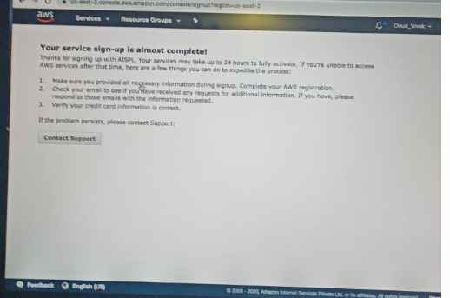

**Step1:**

**Login in to your aws account and select the option “Support Center” as per the below screen shot.**

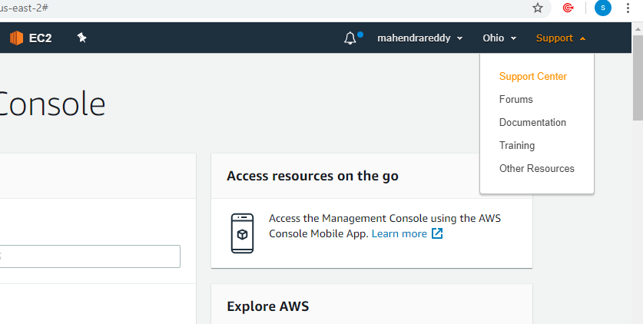

**Step2:**

**Click on “Create Case”**

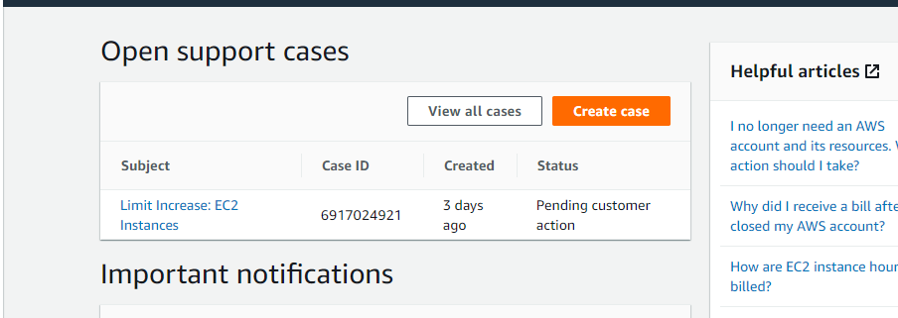

**Step3:**

**Since its account related issue then select “Account billing & Support”**

**Our issue is related to the account hence we need to raise the case as “Account billing & support”**

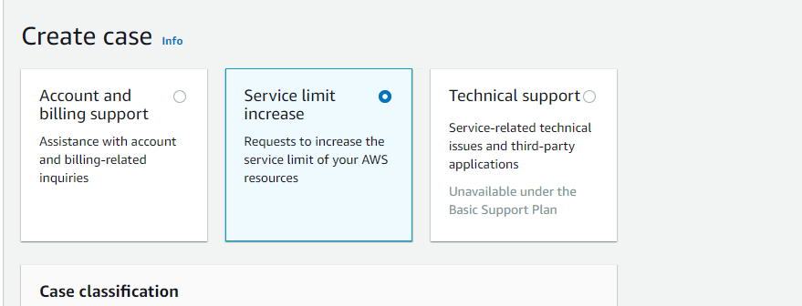

**Select the options below.**

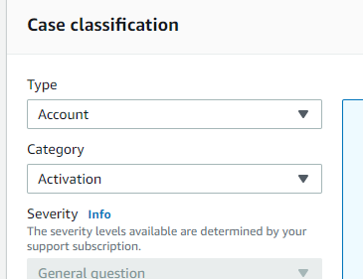

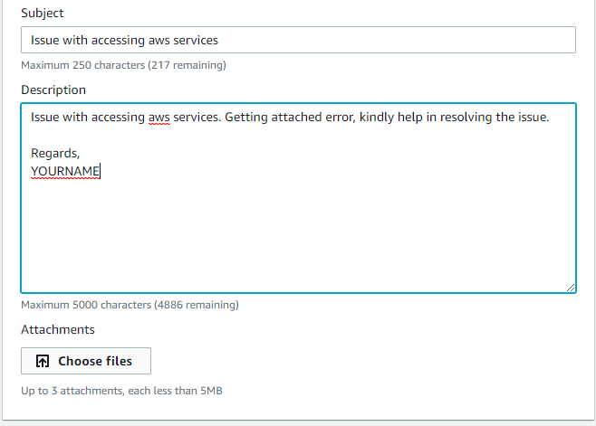

**Click on “Choose Files” and upload your error message (screenshot)**

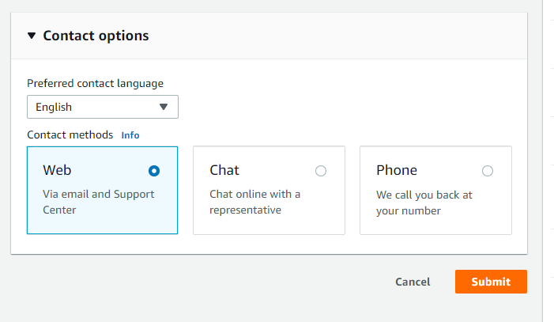

**Finally click on submit.**