**If you want to raise the service limit increase request then perform the below actions.**

**Step1:**

**Login in to your aws account and select the option “Support Center” as per the below screen shot.**

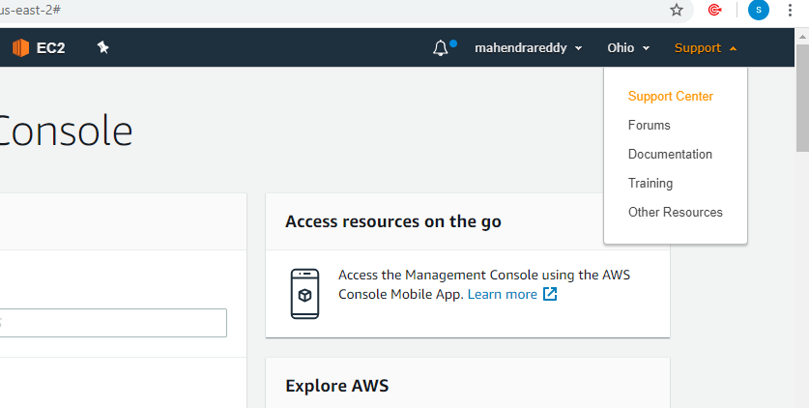

**Step2:**

**Click on “Create Case”**

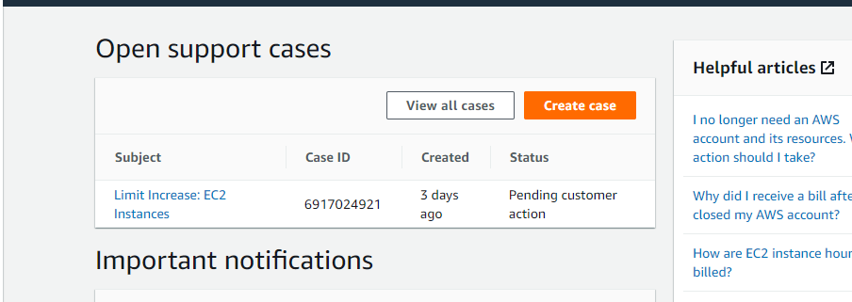

**Step3:**

**Our issue is related to the Service limit increase we need to raise the case as “Service limit increase”**

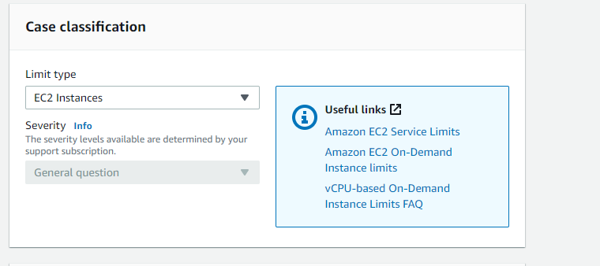

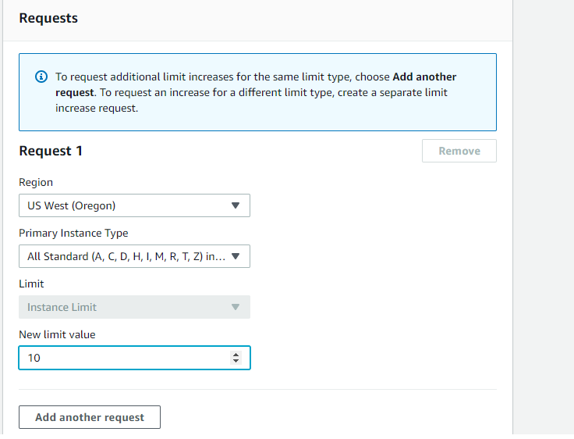

**If you want to raise request for other regions as well, you can click on “add another request” and select respective regions and give the server limit.**

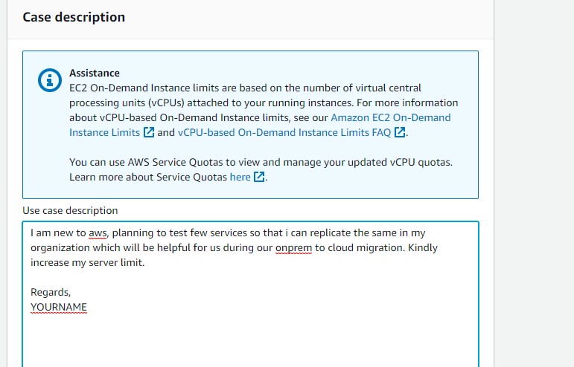

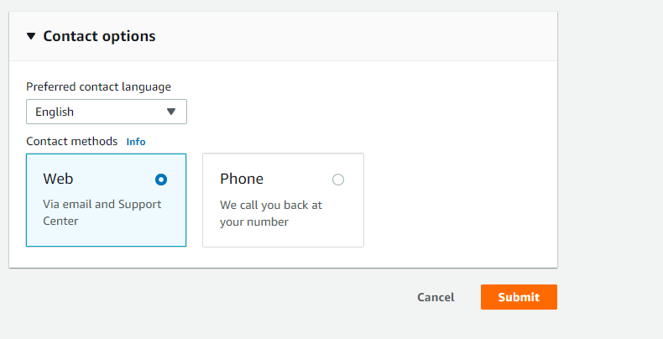

**Finally click on the submit button.**