**ARISE-NUTRINT and DASH**

**Data Request**

|  |  |
| --- | --- |
| **Document Number (Version)** | **Developed by** |
| NUTRINT-DASH_datarequest.v1 | Lukas Kurniawan, Christine Neumann, Haley Newell |
| NUTRINT-DASH_datarequest.v2 | Jacob Burns, Sachin Shinde, David Guwatudde, Innocent Mboya |

All partners, including students, post-doctoral fellows, and other ARISE-NUTRINT and DASH researchers, who wish to use the ARISE-NUTRINT and DASH primary data collected within datasets for their research, either for single-country (site-specific) or cross-country (multi-country) analyses, **MUST** follow the process described in this document.

This process also applies to partners wishing to perform analyses using their local datasets, and to other cross-partner combinations wishing to use any of the datasets collected by the ARISE-NUTRINT and DASH projects in any of the seven sub-Saharan African countries. This is important for documentation and to keep track of what datasets, analyses or publications have been done using the ARISE-NUTRINT and DASH datasets.

REMARK: All partners who wish to use a dataset from both projects MUST follow this process.

**Process description:**

The following steps are required to access the ARISE-NUTRINT and DASH datasets. The flow chart below shows the detailed process.

1. Applicant needs to fill in the **“Manuscript Tracklist”** to express their ideas on the research topics and analysis. The manuscript tracklist can be found [here](https://docs.google.com/spreadsheets/d/1xuk3V-81iAZuTOMeMRkt3AXe3kcbl7L7/edit?gid=1760100009#gid=1760100009).

*(For example, see list No. 5 in the online document)*

1. The Knowledge Management Cascade Group will review the manuscript tracklist to find duplicate ideas or research topics during their monthly meeting. If the Knowledge Management Cascade Group finds duplicate ideas and research topics, they will advise the partner(s) to do a joint analysis instead of a separate analysis. If there are no duplicate ideas and research topics, the applicant will be allowed to continue with the next step (No.4).
2. Applicants with overlapping research topics will be recommended to meet, discuss and decide who will lead and take the next step to complete the data request.
3. The applicant must complete the **"Data Request Form"** attached to this document and send the completed and signed form in PDF format to Christine Neumann, Joy Mauti and Amani Tinkasimile, [christine.neumann@uni-heidelberg.de](mailto:christine.neumann@uni-heidelberg.de); [joy.mauti@uni-heidelberg.de](mailto:joy.mauti@uni-heidelberg.de); atinkasi@aaph.or.tz.
4. The ARISE-NUTRINT and DASH Steering Committees will review and approve the Data Request Forms and, if necessary, ask to revise and submit the revised version during their monthly meeting.
5. If approved, we (Christine Neumann) will notify the applicant and forward the Data Request Form to the data managers at the Africa Academy for Public Health (AAPH), for releasing the requested data
6. In the case of the applicants wishing to access their own local country data, they will not be allowed to start the analysis until they have received approval of the Data Request Form from the ARISE-NUTRINT and DASH Steering Committee.
7. Applicants are required to always update the manuscript tracklist to reflect whether their research has been published and provide the link or DOI and name of the journal.

IMPORTANT: Applicants are not allowed to share the data with third parties, outside of the ARISE-NUTRINT and DASH consortium. Except as previously approved by the Permit-Issuing Organization, and with the written consent of the Provider, the Recipient shall not transfer or distribute the data to a third party. Any third parties who are interested in accessing DASH or ARISE-NUTRINT data must submit a duly filled Data Request Form to the respective Steering Committee and receive approval from the ARISE-NUTRINT and DASH Steering Committees.

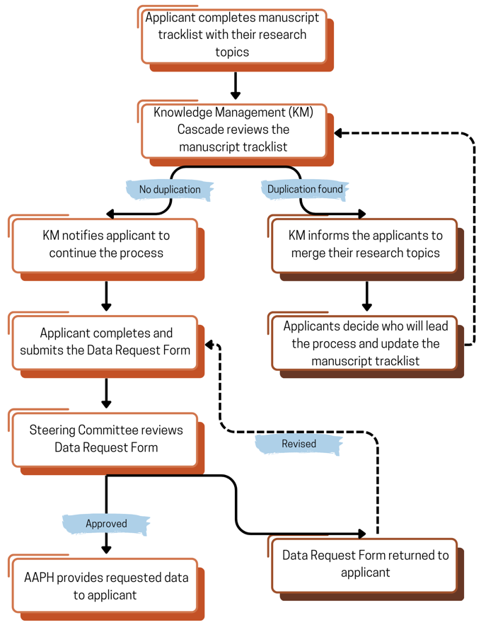

**Figure 1. Flowchart of the data request process**

**Some important notes to consider:** (1) Please always send an email to Christine Neumann ([christine.neumann@uni-heidelberg.de](mailto:christine.neumann@uni-heidelberg.de)), when the applicant has filled in new research topics in the Manuscript Tracklist document for awareness of the new request. (2) It is advisable for the applicant to complete the manuscript tracklist by the third week of each month to be reviewed by the Steering Committee. (3) It is estimated that it will take **3-4 weeks** from the completion of the manuscript track list to the approval of the data request.

**DATA REQUEST FORM**

|  |  |  |  |
| --- | --- | --- | --- |
| **Manuscript No. based on the manuscript tracklist: _______** | | | |
| **1. Name of applicant** | *Name:* | | |
| *Institution name and location:* | | |
| *Email address and phone number:* | | |
| *Name, institution, and email of Principal Investigator:* | | |
| **2. Working title of research/subject of the proposed analysis** |  | | |
| **3. Project**  *(Indicate which project)* | ARISE-NUTRINT □  DASH □  Both □ | | |
| **4. Proposed authors and affiliations** |  | | |
| Third parties list:  (Please provide a list of authors who are not part of the ARISE-NUTRINT and DASH consortium) | | |
| **5. First author’s contact details (if different from applicant details). If similar, write N/A** | *Name:*  *Institution and email:* | | |
| **6. Short background and rationale** |  | | |
| **7. Aim and research question(s)/specific objectives** |  | | |
| **8. Data from which country/countries** | Ghana: □  Burkina Faso: □  Nigeria: □  Ethiopia: □ | | Tanzania: □  Uganda: □  South Africa: □  All countries: □ |
| Wave 1 (baseline): □  Wave 2: □  Wave 3: □  Wave 4: □ | | |
| **9. Analysis plan**  *(The analysis plan must describe a detailed plan and specifics on how the data will be held, managed and processed)* | **Descriptive characteristics:**  **Objective 1:**  **Objective 2:** | | |
| **10. Time plan** | Analyses:  Manuscript writing and review:  Manuscript finalization and submission: | | |
| **Recipient obligation:** The Recipient agrees to use, store, or dispose of the data in compliance with all applicable regulations including those relating to research involving the use of human subjects.The data shall remain the property of the Provider (Africa Academy for Public Health (AAPH)) and Provider hereby consents to the data being made available as a service to the research community.The Recipient shall use the data for teaching or academic research purposes only.Except as previously approved by the Permit-Issuing Organization, and with the written consent of the Provider, the Recipient shall not transfer or distribute the data to a third party**.** The Recipient shall acknowledge the source of the data in any publications reporting use of it.The Recipient and the Recipient Investigator shall sign two copies of the Data Sharing Agreement and return one signed copy to the Provider. The Provider shall then transfer the data.  **I agree:** □ | | | |
| **11. Signatures** | Signature of applicant: | | |
| Signature of Principal Investigator or mentor: | | |
| Approval and Signature of the Steering Committee | | |
| **12. Decision**  *(To be completed by ARISE-NUTRINT and DASH Steering Committee)* | Approved:  Revision needed: | | |
| **Date of submission: (DD/MM/YYYY)** | | **Date of approval: (DD/MM/YYYY)** | |