**BIOS**

BIOS (basic input/output system) is the program a personal computer's [microprocessor](https://whatis.techtarget.com/definition/microprocessor-logic-chip) uses to get the computer system started after you turn it on. It also manages data flow between the computer's [operating system](https://whatis.techtarget.com/definition/operating-system-OS) and attached devices such as the [hard disk](https://searchstorage.techtarget.com/definition/hard-disk), [video adapter](https://whatis.techtarget.com/definition/video-adapter), [keyboard](https://whatis.techtarget.com/definition/keyboard), [mouse](https://whatis.techtarget.com/definition/mouse) and [printer](https://whatis.techtarget.com/definition/printer).

BIOS is an integral part of your computer and comes with it when you bring it home. (In contrast, the operating system can either be pre-installed by the manufacturer or vendor or installed by the user.) BIOS is a program that is made accessible to the microprocessor on an erasable programmable read-only memory ([EPROM](https://whatis.techtarget.com/definition/EPROM)) chip. When you turn on your computer, the microprocessor passes control to the BIOS program, which is always located at the same place on EPROM.

When BIOS boots up (starts up) your computer, it first determines whether all of the attachments are in place and operational and then it loads the operating system (or key parts of it) into your computer's random access memory ([RAM](https://searchstorage.techtarget.com/definition/RAM-random-access-memory)) from your hard disk or diskette drive.

Purpose of BIOS

BIOS enables computers to perform certain operations as soon as they are turned on. The principal job of a computer's BIOS is to govern the early stages of the startup process, ensuring that the operating system is correctly loaded into memory. BIOS is vital to the operation of most modern computers, and knowing some facts about it could help you troubleshoot issues withyour machine.

**Booting process**

Booting is a process or set of operations that loads and hence starts the operating system, starting from the point when user switches on the power button.

Booting (also known as booting up) is the initial set of operations that a computer system performs when electrical power is switched on. The process begins when a computer that has been turned off is re-energized, and ends when the computer is ready to perform its normal operations. On modern general purpose computers, this can take tens of seconds and typically involves performing power-on self-test, locating and initializing peripheral devices, and then finding, loading and starting an operating system.

**Booting process in linux**

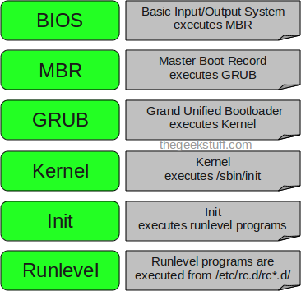

**Booting process in windows**

## 1. Use "Shift + Restart" on the Windows 10 Sign In screen

If you cannot log into Windows 10, but you can get to the [Sign In screen](https://www.digitalcitizen.life/how-switch-between-user-accounts-windows-10), press and hold the SHIFT key on the keyboard. With this key still pressed, click or tap the Power button and, in the menu that opens, click Restart.

## 2.Interrupt the normal boot process of Windows 10 three times in a row

If Windows 10 fails to boot normally three times over, the fourth time it enters by default in an Automatic Repair mode. Using this mode, you can boot into Safe Mode. To trigger the Automatic Repair mode, you must interrupt the normal boot process three consecutive times: use the Reset or the Power button on your Windows 10 PC to stop it during boot, before it finishes loading Windows 10. If you use the Power button, you might have to keep it pressed for at least 4 seconds to force the power off. When Windows 10 enters the Automatic Repair mode, the first thing you see is a screen that tells you that the operating system is "Preparing Automatic Repair."